

**PRIVATE CLINIC SYSTEM**

**Software Requirement Specification**

Version 1.0

– Da Nang, September2024 –

**TABLE OF CONTENTS**

**TABLE OF FIGURE** **8**

**I. Record of Changes** **8**

**II. Software Requirement Specification 9**

1. Product Overview 9

2. User Requirements 10

2.1 Actors 10

2.2 Use Cases 10

2.2.1 Diagram(s) 10

2.2.2 Descriptions 13

2.2.3. Business Rules for each use cases 17

UC 01: Edit self profile 17

Business Rules: 17

UC 02: Make appointment 18

Business Rules: 18

UC 03: View treatment history 19

Business Rules: 19

UC 04: View booked appointment 20

Business Rules: 20

UC 06: Request a consultation 20

Business Rules: 21

UC 07: View medical reported 22

Business Rules: 22

UC 08: Feedback to Doctor 23

Business Rules: 23

UC 09: View Appointment 24

Business Rules: 24

UC 10: Make prescription 25

Business Rules: 25

UC 11: Make Medical Reported 26

Business Rules: 26

UC 12: Make Indication Reported 27

Business Rules: 27

UC 13: CRUD Self-Treatment Schedule 28

Business Rules: 28

UC 14: View request consult list 29

Business Rules: 29

UC 15 Consult patient online 30

Business Rules: 30

UC 16 View patients 31

Business Rules: 31

UC 17 Create account for guests 32

Business Rules: 33

UC 18 Set treatment scheduler for all doctor 34

Business Rules: 34

UC 19 View and Reset System User 35

Business Rules: 35

UC 20 CRUD Doctors 37

Business Rules: 37

UC 21 CRUD Staffs 38

Business Rules: 38

UC 22 CRUD system notification 39

Business Rules: 39

UC 23 CRUD Contacts 40

Business Rules: 41

UC 24 View Feedbacks 42

Business Rules: 42

UC 25 View landing page 43

Business Rules: 43

UC 26 Send Email 44

Business Rules: 45

UC 27 Send Real-time Notification 46

Business Rules: 46

UC 28 CRUD Medical Article 47

Business Rules: 48

UC 29 View medical report 49

Business Rules: 49

3. Functional Requirements 50

3.1 System Functional Overview 50

3.1.1 Screens Flow 50

3.1.2 Screen Descriptions 55

3.1.3 Screen Authorization 63

3.1.4 Non-Screen Functions 65

3.1.5 Entity Relationship Diagram 68

3.2 Authentication 70

3.2.1 Login 70

3.2.2 Register 72

3.2.3 Request forgot password 75

3.2.4 Forgot Password 76

3.2.5 Login admin 78

3.3 Landing Page 79

3.4 Patient 82

3.4.1 User Overview Screen 82

3.4.2 User general information screen 84

3.4.3 Manage User Profile 87

3.4.3.1 User profile screen 87

3.4.3.2 Change user’s avatar 90

3.4.3.3 Edit user’s informations 92

3.4.3.4 Delete user’s account 94

3.4.3.5 Changing user password 96

3.4.4 Make an appointment screen 98

3.4.4.1 Doctor Selection 98

3.4.4.2 Date Picker 101

3.4.4.3 Time Picker 102

3.4.4.4 Confirmation 104

3.4.4.5 Proceed to Payment 105

3.4.5 Examined Information 106

3.4.5.1 User appointment history 106

3.4.5.2 Medical report screen 108

3.4.5.3 Service indication 111

3.4.5.4 Prescription indication 113

3.4.5.5 Feedback 115

3.4.6 Consultation Screen 117

3.4.6.1 Create Consultation Request 117

3.4.6.2 View Consultation Request 121

3.4.6.3 Message 122

3.5 Doctor 123

3.5.1 User Overview Screen 123

3.5.2 User general information screen 126

3.5.3 Manage User Profile 129

3.5.3.1 User profile screen 129

3.5.3.2 Change user’s avatar 132

3.5.3.3 Edit user’s informations 132

3.5.3.4 Changing user password 132

3.5.4 Appointments during the day 132

3.5.4.1 View appointment 132

3.5.4.2 Create/Update medical report 134

3.5.4.3 Create/Update service indication 137

3.5.4.4 Create/Update prescription indication 139

3.5.5 Cancelled Appointment 141

3.5.5.1 View cancelled appointment 141

3.5.6 Treatment Resultation 142

3.5.6.1 View all medical report 142

3.5.6.2 View medical report 144

3.5.6.3 View service indication 146

3.5.6.4 View prescription 147

3.5.7 Manage Personal Schedule 149

3.5.7.1 View calendar 149

3.5.7.1 Create working hours: 150

3.5.8 View history appointment 151

3.5.9 Re-Examination notification 153

3.5.9.1 View all patients 153

3.5.9.2 View all appointment 154

3.5.9.3 Create re-examination notification 156

3.5.10 Chat with patients 157

3.5.10.1 View waiting room 157

3.5.10.2 Message 159

3.5.11 Feedback 160

3.6 Staff 162

3.6.1 Staff Overview Screen 162

3.6.2 User general information screen 164

3.6.3 Manage User Profile 164

3.6.4 Appointments during the day 164

3.6.4.1 View doctors on duty 164

3.6.4.2 View appointment 166

3.6.4.5 Create/Update prescription indication 166

3.6.5 Cancelled Appointments 166

3.6.6 Treatment Resultation 166

3.6.6.1 View all medical report 166

3.6.6.2 View medical report 166

3.6.6.3 View service indication 166

3.6.6.4 View prescription 166

3.6.7 Doctor Management 167

3.6.7.1 View all doctors 167

3.6.8 Schedule Management 168

3.6.8.1 Schedule doctor’s appointment overview 168

3.6.8.2 Schedule doctor’s appointment 170

3.4.5.3 Schedule doctor 173

3.6.9 Scheduled Appointment 175

3.6.9.1 View all doctors 175

3.6.9.2 Scheduled doctor’s appointment view 176

3.6.10 Re-Examination notification 178

3.6.10.1 View all patients 178

3.6.10.2 View all appointment 178

3.6.10.3 Create re-examination notification 178

3.6.11 Patient Management 178

3.6.11.1 View all patients 178

3.6.11.2 View patient’s appointment 180

3.6.11.3 Create patient’s account manually 182

3.6.12 Chat with patients 184

3.6.12.1 View waiting room 184

3.6.12.2 Message 184

3.7 Admin 184

3.7.1 Overview ( Chưa có figma ) 184

3.7.2 Manage doctor 187

3.7.2.1 View Doctor List 187

3.7.2.2 Create new doctor’s account 188

3.7.2.3 Update staff or doctor’s account 190

3.7.3 Manage patient 192

3.7.3.1 View Patient List 192

3.7.4 Manage medicine 194

3.7.4.1 View List Medicine 194

3.7.4.2 Create medicine 196

3.7.4.3 Update medicine 197

3.7.4.4 View detail 199

3.7.5 Manage service 200

3.7.5.1 View List Service 200

3.7.5.2 Create service 202

3.7.5.3 Update service 203

3.7.5.4 View detail 205

4. Non-Functional Requirements 206

4.1 External Interfaces 206

4.2 Quality Attributes 207

4.2.1 Usability 207

4.2.2 Reliability 208

4.2.3 Performance 210

4.2.4 Security 211

4.2.5 Scalability 213

4.2.6 Maintainability 214

4.2.7 Availability 215

4.2.8 Portability 216

5. Requirement Appendix 216

5.1 Business Rules 216

5.3 Application Messages List 217

# TABLE OF FIGURE

# I. Record of Changes

| **Date** | **A* M, D** | **In charge** | **Change Description** |
| --- | --- | --- | --- |
| 16/09/2024 | A | All | Initial project |
| 21/09/2024 | A | All | Microservice for generate medical service reports |
| 29/09/2024 | A | All | Notification feature, in-app notifications for all users, email notifications for users, and SMS notifications for users. |
| 29/09/2024 | A | All | Feedback feature, collecting feedback from users after each medical consultation. |
| 01/10/2024 | A | All | Medical article posting feature, allowing the clinic to update and publish health-related articles on the system. |
| 13/10/2024 | A | Vu | Service for medical services reported forms |
| 14/10/2024 | D | All | Create account for guest |
| 20/10/2024 | M | Vu | Microservice Forms and Generators PDF Documents |
|  |  |  |  |
|  |  |  |  |
|  |  |  |  |
|  |  |  |  |
|  |  |  |  |
|  |  |  |  |
|  |  |  |  |
|  |  |  |  |

*A - Added M - Modified D - Deleted

# II. Software Requirement Specification

## 1. Product Overview

The Private Clinic Management System is designed to streamline the operations of private healthcare clinics by allowing doctors, staff, and patients to connect and manage clinic services efficiently from any location. This system aims to provide doctors with the flexibility to manage appointments, patient records, and prescriptions while enabling online consultations from the comfort of their homes. For patients, the system simplifies the process of scheduling appointments, ordering medicines, and communicating with healthcare providers remotely.

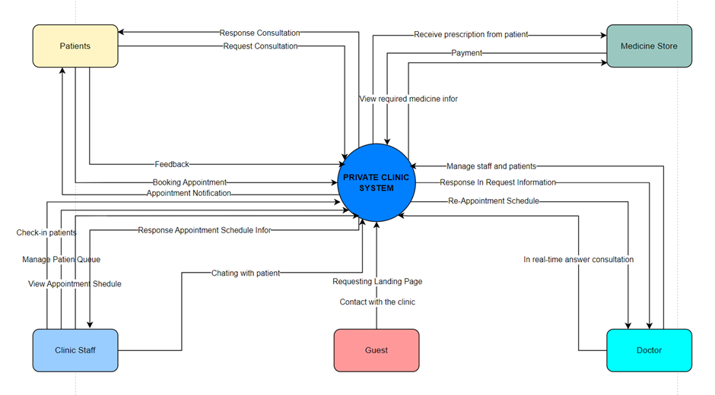

## 2. User Requirements

### 2.1 Actors

|  |  |  |
| --- | --- | --- |
| **#** | **Actor** | **Description** |
| 1 | Doctor | A medical professional who interacts with the clinic management system to provide healthcare services to patients. Doctors are responsible for updating schedules, prescribing medication, making resultation for patients, consulting online with patients and scheduling appointments. They are notified of patient appointments so that they can view patients list, view patient’s history of treatment and search for patients. |
| 2 | Patient | A person who uses the clinic management system to access healthcare services. Patients can book appointments, review their treatment history, receive online consultations, view treatment results, and provide feedback on doctors and clinic services. They are notified of upcoming appointments, updates to their treatment plans, and other health-related alerts. |
| 3 | Staff | |  | | --- | | A clinic employee who manages administrative tasks within the clinic management system. Staff are responsible for viewing and updating appointment schedules, managing patient queues, placing service orders for patients, checking patients in for their appointments, and updating doctors' schedules. Staff are notified of any changes or updates in patient appointments and service orders. | |
| 4 | Guest | An unauthenticated user who interacts with the clinic management system to explore general information. Guests can view the landing page, search for available services, view doctors' profiles, and contact the clinic for inquiries. They are not notified of any updates or system changes as they do not have an account. |

### 2.2 Use Cases

#### 2.2.1 Diagram(s)

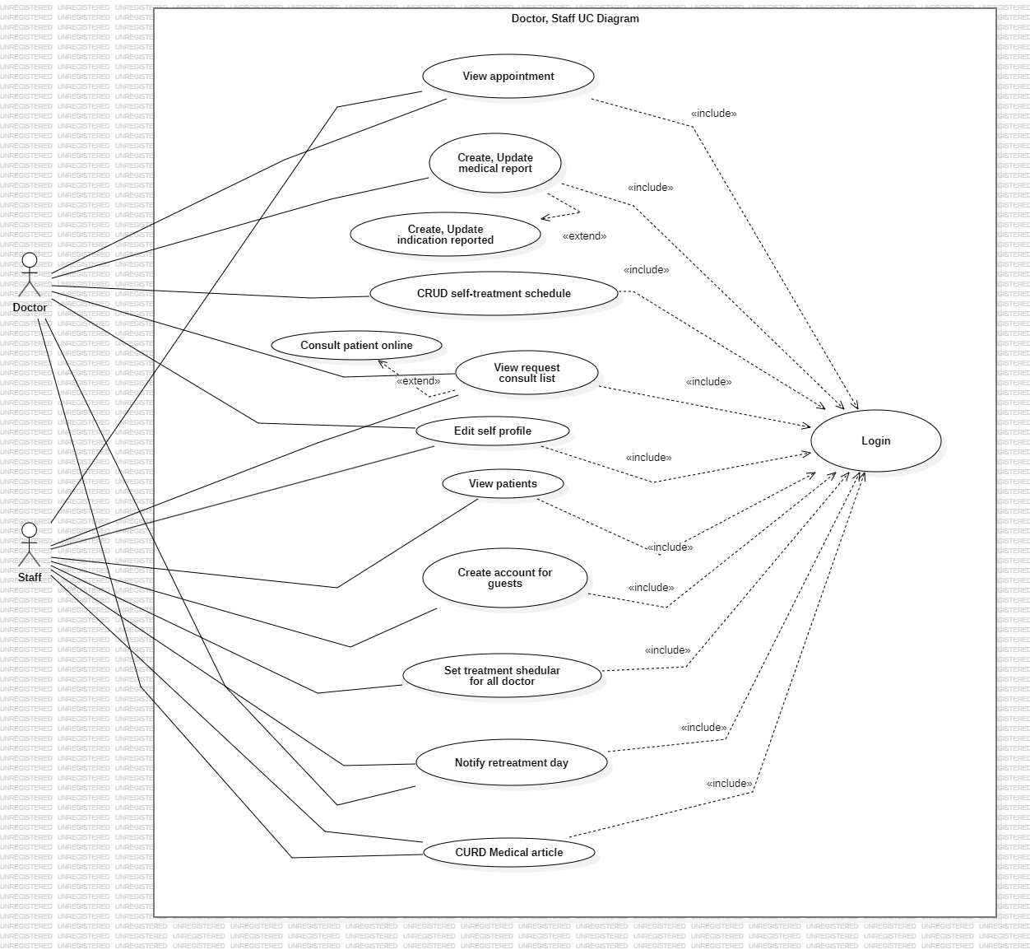

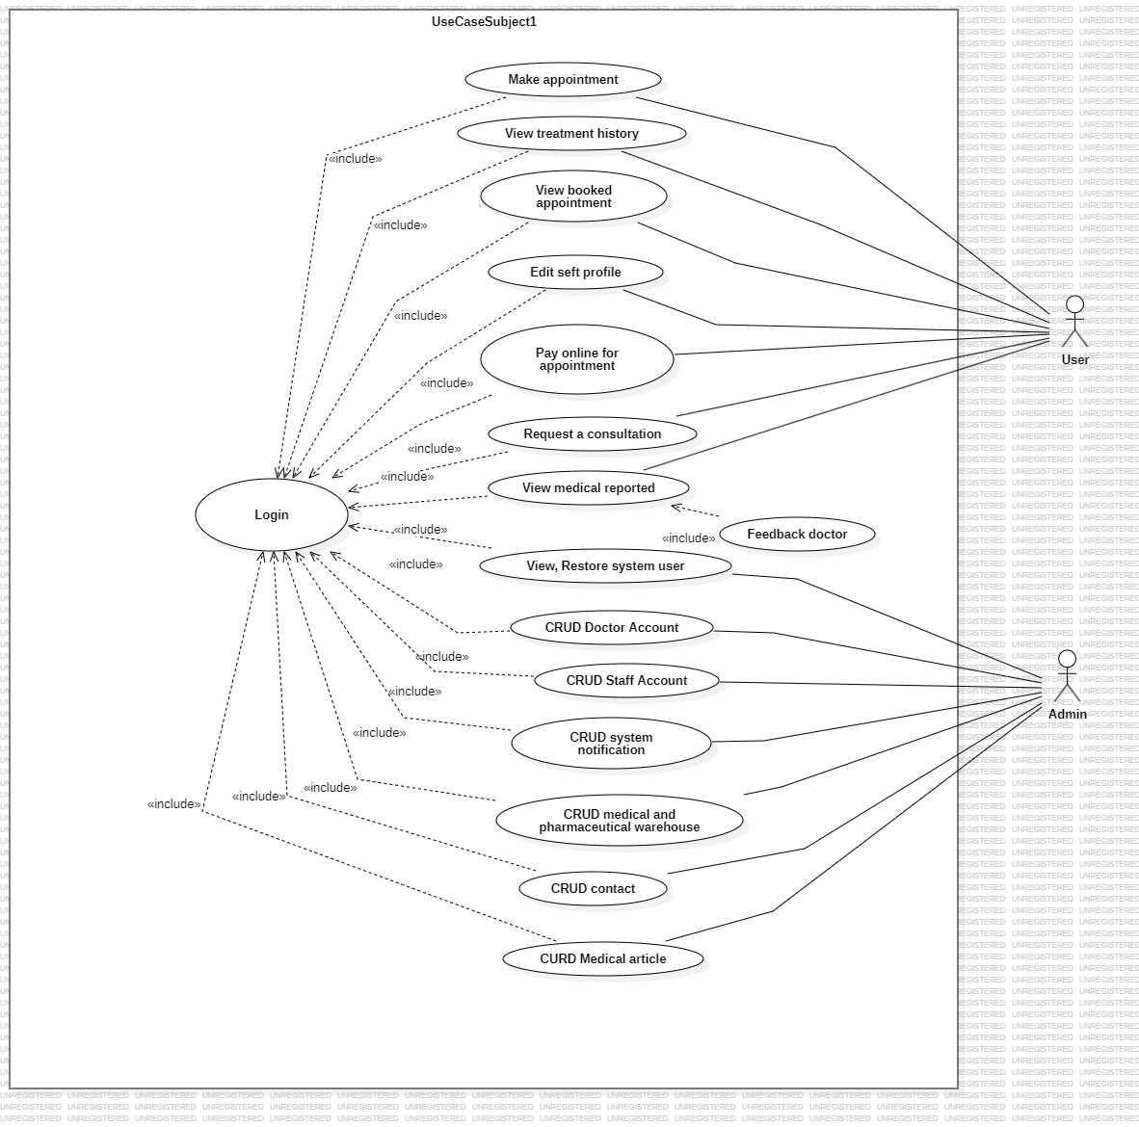

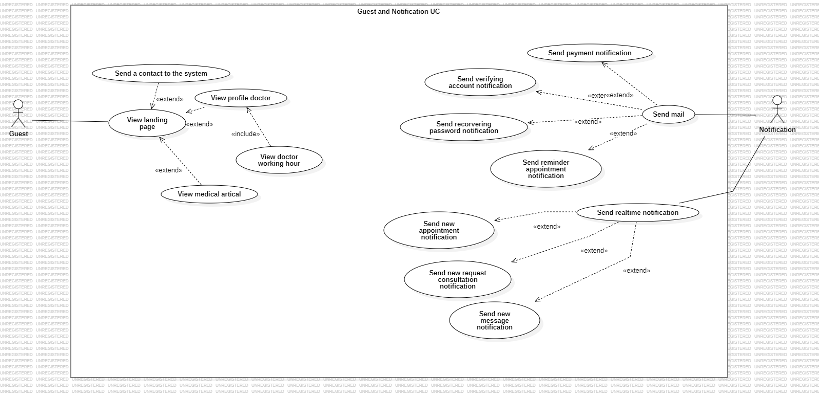

#### 2.2.2 Descriptions

|  |  |  |  |  |
| --- | --- | --- | --- | --- |
| **ID** | **Feature** | **Use Case** | **Actors** | **Use Case Description** |
| 01 | Manage Profile | Edit self profile | User, Doctor, Staff | This use case allows users to edit their personal profile, such as their full name, location, or some personal status (Bio or description). |
| 02 | Make an appointment | Make appointment | User | Allow users to schedule an appointment with a doctor through the online system based on the doctor's working days and specific time slots. Integrate an online payment system that enables users to easily pay for the consultation in advance, helping the clinic efficiently process and verify appointment information. |
| 03 | View Medical Report | View treatment history | User | Allow users to review their previous medical appointment history. |
| 04 | View Appointment | View booked appointment | User | Allow users to review their scheduled appointments, including the specific date and time, along with the doctor's information. |
| 05 | Make an Appointment | Pay online for appointment | User | Appointment payment. |
| 06 | Online Consultation | Request a consultation | User | Allow users to send a consultation request to the clinic, where the message will wait to be answered by one of the doctors on duty at the clinic. |
| 07 | View Medical Report | View medical reported | User | Allow users to review their medical records from past appointments. The report contains some informations such as: prescription, treatment resulted, ordered medical services |
| 08 | View Medical Report | Feedback to doctor | User | Allow users to rate the doctor after finishing the treatment appointment . |
| 09 | View Appointment | View appointment | Doctor | Allow doctors to view and manage patient appointments through the system, including valid appointments and canceled ones. |
| 10 | Make medical report | Make prescription | Doctor | Allow doctors to create prescriptions for patients, based on which patients can purchase the prescribed medications. |
| 11 | Make medical report | Create, Update medical report | Doctor | Allow doctors to create and update all patient examination records within the system. |
| 12 | Make medical report | Make indication reported | Doctor | Create a referral slip for patients to undergo tests related to their medical records. |
| 13 | Manage Schedule | CRUD self-treatment schedule | Doctor | Allow doctors to Create, Update, Delete and View their own treatment schedules, planning appointments according to their working days at the clinic. |
| 14 | Online Consultation | View request consult list | Doctor, Staff | View all pending consultation requests. |
| 15 | Online Consultation | Consult patient online | Doctor, Staff | The system allows doctors and staffs to provide direct consultations with patients through online channels, supporting both messaging and video calls. |
| 16 | View Patients | View patients | Staff | Allow healthcare staff in the clinic to monitor all patients, enabling them to understand each patient's condition and adjust the appointment schedules accordingly. |
| 17 | Manage Schedule | Set treatment scheduler for all doctor | Staff | Allow healthcare staff to schedule appointments for all doctors available in the clinic. |
| 18 | Notifications | Notify retreatment day | Doctor, Staff | Allow healthcare staff and doctor notify to patients' retreatment day |
| 19 | View patients | View and restore system user | Admin | Allow the admin to view and reset the users of the system. |
| 20 | Manage doctor/staff | CURD doctors | Admin | Allow the admin to manage the doctors of the system |
| 21 | Manage doctor/staff | CRUD staffs | Admin | Allow the admin to manage the staffs of the system |
| 22 | Notifications | CRUD system notification | Admin | Allow the admin to manage and send notifications to all users on the system. |
| 23 | Manage Contacts | CRUD Contacts | Admin | Allow the admin to manage all contact form submissions sent to the system. |
| 24 | View Medical Report | View Feedbacks | Admin | Allow the admin to manage all user feedback submissions. |
| 25 | Landing page | View landing page | Guest | Guest users visiting the system can view the landing page. The landing page allows users to see information about the doctors in the clinic, submit a contact form, and view the doctors' work schedules. |
| 26 | Notifications | Send mail | Notification (Third Party Actor) | Send automated email notifications to system users. Some example scenarios where email notifications should be sent include: sending payment information after a successful transaction, sending account verification emails, sending reminders for upcoming appointments, and notifications for various events, etc. |
| 27 | Notifications | Send real time notification | Notification (Third Party Actor | Send real-time notifications within the web system. Example notifications include: sending a notification after successfully completing an appointment payment, notifying the user when a doctor has accepted a consultation request, sending reminders for follow-up appointments from the doctor, or notifying the doctor when a patient successfully books an appointment,etc. |
| 28 | Manage Medical article | CRUD Medical article | Admin, Doctor, Staff | Allow admin to create view update delete medical article |
| 29 | View Medical Report | View medical report | User | User can view medical report from landing page |

#### 

#### 2.2.3. Business Rules for each use cases

##### UC 01: Edit self profile

| **Objective:** | This use case allows user to edit profile |
| --- | --- |
| **Actor:** | * Doctor * User * Staff |
| **Trigger:** | User clicks “Profile -> Settings” to edit profile |
| **Pre-condition:** | Is logged in successfully as the actor above. |
| **Post-condition:** | Profile is edited successfully. |

###### Business Rules:

|  |  |  |
| --- | --- | --- |
| **Step** | **BR Code** | **Description** |
| (1) | **BR 01** | **Displaying Rules:** The system will display a screen as like as user profile but with interface comfortable to edit the information |
| (2) | **BR 02** | **Validation Rules:** The system will validate the input fields to ensure that full name, location, and bio are not left blank. |
| (3) | **BR 03** | **Update Rules:** The system will update the user's profile in the database upon confirmation from the user. |
| (4) | **BR 04** | **Error Handling Rules:** If there is a database connection error during the update, the system will display an error message indicating that the update could not be completed. |
| (5) | **BR 05** | **Session Management Rules:** The system will use JWT stored in cookies for session management. If the JWT token expires during the update process, the user will be redirected to the login page and prompted to log in again. |

##### UC 02: Make appointment

| **Objective:** | This use case allows users to schedule an appointment with a doctor through the online system based on the doctor's working days and specific time slots. It integrates an online payment system that enables users to pay for the consultation in advance, helping the clinic efficiently process and verify appointment information. |
| --- | --- |
| **Actor:** | User |
| **Trigger:** | User selects a doctor and clicks “Book Appointment.” |
| **Pre-condition:** | Is logged in successfully as actor above. |
| **Post-condition:** | Appointment is scheduled and payment is processed successfully. |

###### Business Rules:

|  |  |  |
| --- | --- | --- |
| **Step** | **BR Code** | **Description** |
| (1) | **BR 06** | **Appointment Scheduling Rules:** Users can schedule an appointment with a doctor based on available working days and time slots. |
| (2) | **BR 07** | **Date and Time Selection Rules:** Users must select a valid date and time for the appointment that falls within the doctor's working schedule. |
| (3) | **BR 08** | **Personal Information Requirement:** Users must provide their personal information (name, contact details) when scheduling an appointment (auto fill if logged in). |
| (4) |  | **Payment Requirement:** Users are required to make an advance payment for the consultation through the integrated online payment system. |
| (5) |  | **Confirmation Rules:** The appointment will only be confirmed once the payment has been successfully processed. |
| (6) | **BR 09** | **Notification Rules:** Users will receive a confirmation notification (via email or system notification) after successfully scheduling and paying for the appointment. |
| (7) |  | **Time Slot Availability:** If the selected time slot is no longer available by the time the user completes the payment, the system will notify the user and prompt them to select a different slot. |
| (8) |  | **Cancellation Policy:** The system must allow users to cancel or reschedule their appointments within a specified time frame before the appointment date. |
| (9) |  | **Refund Policy Compliance:** Any cancellation or rescheduling must comply with the clinic’s policy regarding refunds for the payment made. |

##### UC 03: View treatment history

| **Objective:** | This use case allows users to review their previous medical appointment history |
| --- | --- |
| **Actor:** | User |
| **Trigger:** | User clicks “Treatment schedule -> History” to view their past appointments. |
| **Pre-condition:** | Is logged in successfully as actor above. |
| **Post-condition:** | User can view a list of their previous medical appointments along with relevant details. |

###### Business Rules:

|  |  |  |
| --- | --- | --- |
| **Step** | **BR Code** | **Description** |
| (1) |  | **Appointment History Retrieval:** Users can view a list of all their previous medical appointments. |
| (2) |  | **Details Display Rules:** The system will display appointment details, including date, time, doctor, and treatment received. |
| (3) | **BR 04** | **Error Handling:** If there is an error retrieving the appointment history, the system will display an appropriate error message. |
| (4) |  | **Session Management Rules:** The system will use JWT stored in cookies for session management. If the JWT token expires while viewing the history, the user will be redirected to the login page. |
| (5) | **BR 09** | **Security Compliance:** Users must have the appropriate permissions to view their treatment history, ensuring that privacy and security protocols are followed. |

##### UC 04: View booked appointment

| **Objective:** | This use case allows users to review their scheduled appointments, including the specific date and time, along with the doctor's information. |
| --- | --- |
| **Actor:** | User |
| **Trigger:** | User clicks “Treatment schedule -> Appointment” to view their past appointments. |
| **Pre-condition:** | User is logged in successfully. |
| **Post-condition:** | User can view a list of their scheduled appointments with relevant details. |

###### Business Rules:

|  |  |  |
| --- | --- | --- |
| **Step** | **BR Code** | **Description** |
| (1) |  | **Appointment Listing:** Users can view a list of all their scheduled appointments. |
| (2) |  | **Appointment Details:** The system will display appointment details, including date, time, doctor’s name, and specialty. |
| (3) | **BR 04** | **Error Handling:** If there is an error retrieving the appointment history, the system will display an appropriate error message. |
| (4) |  | **Session Management Rules:** The system will use JWT stored in cookies for session management. If the JWT token expires while viewing the history, the user will be redirected to the login page. |
| (5) | **BR 09** | **Security Compliance:** Users must have the appropriate permissions to view their treatment history, ensuring that privacy and security protocols are followed. |

##### UC 06: Request a consultation

| **Objective:** | This use case allows users to send a consultation request to the clinic, where the message will wait to be answered by one of the doctors on duty. |
| --- | --- |
| **Actor:** | User |
| **Trigger:** | User clicks “Consultation -> Request Room” and submits their message to the clinic. |
| **Pre-condition:** | User is logged in successfully. |
| **Post-condition:** | Consultation request is submitted successfully, and the user is notified of the request status. |

###### Business Rules:

|  |  |  |
| --- | --- | --- |
| **Step** | **BR Code** | **Description** |
| (1) |  | **Request Submission**: Users can submit a consultation request with a message detailing their inquiry. |
| (2) | **BR 11** | **Message Validation**: The system will validate that the request message is not empty and meets character limits. |
| (3) | **BR 12** | **Acknowledgment Notification:** After submitting the request, the user will receive a confirmation notification indicating that their request has been received. |
| (4) |  | **Response Timeframe:** Users will be informed of the expected response time from the clinic for their consultation request. |
| (5) | **BR 04** | **Error Handling:** If there is an error submitting the request, the system will display an appropriate error message. |
| (7) |  | **Session Management Rules:** The system will use JWT stored in cookies for session management. If the JWT token expires during the request process, the user will be redirected to the login page. |
| (8) | **BR 10** | **Security Compliance:** Users must have the appropriate permissions to send consultation requests, ensuring privacy and security protocols are followed. |

##### UC 07: View medical reported

| **Objective:** | This use case allows users to review their medical records from past appointments, which includes information such as prescriptions, treatment results, and ordered medical services. |
| --- | --- |
| **Actor:** | User |
| **Trigger:** | User clicks “Treatment schedule -> History -> Pick Item” to view their medical reports. |
| **Pre-condition:** | User is logged in successfully. |
| **Post-condition:** | User can view a list of their medical reports with relevant details from past appointments. |

###### Business Rules:

|  |  |  |
| --- | --- | --- |
| **Step** | **BR Code** | **Description** |
| (1) |  | **Medical Report Retrieval:** Users can view a list of their medical records from past appointments. |
| (2) |  | **Report Details Display:** The system will display report details, including prescriptions, treatment results, and ordered medical services. |
| (3) | **BR 04** | **Error Handling:** If there is an error submitting the request, the system will display an appropriate error message. |
| (4) |  | **Session Management Rules:** The system will use JWT stored in cookies for session management. If the JWT token expires during the request process, the user will be redirected to the login page. |
| (5) | **BR 10** | **Security Compliance:** Users must have the appropriate permissions to send consultation requests, ensuring privacy and security protocols are followed. |

##### UC 08: Feedback to Doctor

| **Objective:** | This use case allows users to rate the doctor after finishing their treatment appointment. |
| --- | --- |
| **Actor:** | User |
| **Trigger:** | User clicks “Rate Doctor” after completing the treatment appointment. |
| **Pre-condition:** | User is logged in successfully and has completed a treatment appointment with the doctor. |
| **Post-condition:** | User's feedback is submitted successfully, and the doctor’s rating is updated. |

###### Business Rules:

|  |  |  |
| --- | --- | --- |
| **Step** | **BR Code** | **Description** |
| (1) |  | **Feedback Submission:** Users can submit a rating and optional comments about their experience with the doctor. |
| (2) |  | **Rating Scale:** The system will provide a defined rating scale (e.g., 1 to 5 stars) for users to rate the doctor. |
| (3) |  | **Comment Validation:** The system will validate that any comments provided do not exceed the character limit. |
| (4) | **BR 09** | **Confirmation Notification:** After submitting the feedback, the user will receive a confirmation notification indicating that their feedback has been received. |
| (5) |  | **Feedback Update:** The system will update the doctor’s overall rating based on the submitted feedback. |
| (6) | **BR 04** | **Error Handling:** If there is an error submitting the feedback, the system will display an appropriate error message. |
| (7) |  | **Session Management Rules:** The system will use JWT stored in cookies for session management. If the JWT token expires during the feedback submission, the user will be redirected to the login page. |
| (8) | **BR 10** | **Security Compliance:** Users must have the appropriate permissions to submit feedback, ensuring privacy and security protocols are followed. |

##### UC 09: View Appointment

| **Objective:** | This use case allows doctors to view patient appointments through the system, including valid appointments and canceled ones. |
| --- | --- |
| **Actor:** | Doctor |
| **Trigger:** | Doctor clicks “Manage Appointments” to view and manage patient appointments. |
| **Pre-condition:** | Doctor is logged in successfully. |
| **Post-condition:** | Doctor can view, edit, or cancel appointments as needed. |

###### Business Rules:

|  |  |  |
| --- | --- | --- |
| **Step** | **BR Code** | **Description** |
| (1) |  | **Appointment Listing:** Doctors can view a list of all upcoming and canceled patient appointments. |
| (2) |  | **Appointment Details:** The system will display details of each appointment, including patient information, date, time, and status. |
| (3) |  | **Edit Appointment:** Doctors can edit appointment details, such as rescheduling or updating the status. |
| (4) |  | **Cancel Appointment:** Doctors can cancel appointments and must provide a reason for the cancellation. |
| (5) | **BR 09** | **Confirmation Notification:** After making changes to an appointment, the doctor will receive a confirmation notification indicating that the changes have been saved successfully. |
| (6) | **BR 04** | **Error Handling:** If there is an error submitting the feedback, the system will display an appropriate error message. |
| (7) |  | **Session Management Rules:** The system will use JWT stored in cookies for session management. If the JWT token expires during the feedback submission, the user will be redirected to the login page. |
| (8) | **BR 10** | **Security Compliance:** Users must have the appropriate permissions to submit feedback, ensuring privacy and security protocols are followed. |

##### UC 10: Make prescription

| **Objective:** | This use case allows doctors to create prescriptions for patients, enabling them to purchase the prescribed medications. |
| --- | --- |
| **Actor:** | Doctor |
| **Trigger:** | Doctor clicks “Create Prescription” after evaluating a patient. |
| **Pre-condition:** | Doctor is logged in successfully and has completed a patient consultation. |
| **Post-condition:** | Prescription is created and saved successfully in the system. |

###### Business Rules:

|  |  |  |
| --- | --- | --- |
| **Step** | **BR Code** | **Description** |
| (1) |  | **Prescription Creation:** Doctors can create a new prescription by entering medication details, dosage, and instructions. |
| (2) |  | **Patient Information:** The system will require the doctor to select the patient for whom the prescription is being created. |
| (3) | **BR 13** | **Validation Rules:** The system will validate that all required fields (medication name, dosage, and instructions) are completed. |
| (4) |  | **Save Prescription:** The system will save the prescription to the patient’s medical record upon confirmation from the doctor. |
| (5) | **BR 09** | **Confirmation Notification:** After making changes to an appointment, the doctor will receive a confirmation notification indicating that the changes have been saved successfully. |
| (6) | **BR 04** | **Error Handling:** If there is an error submitting the feedback, the system will display an appropriate error message. |
| (7) |  | **Session Management Rules:** The system will use JWT stored in cookies for session management. If the JWT token expires during the feedback submission, the user will be redirected to the login page. |
| (8) | **BR 10** | **Security Compliance:** Users must have the appropriate permissions to submit feedback, ensuring privacy and security protocols are followed. |

##### UC 11: Make Medical Reported

| **Objective:** | This use case allows doctors to manage all patient examination records within the system. |
| --- | --- |
| **Actor:** | Doctor |
| **Trigger:** | Doctor clicks “Create Medical Reports” to access patient examination records. |
| **Pre-condition:** | Doctor is logged in successfully |
| **Post-condition:** | Doctor can view, edit patient examination records as needed. |

###### Business Rules:

|  |  |  |
| --- | --- | --- |
| **Step** | **BR Code** | **Description** |
| (1) |  | **Medical Report Listing:** Doctors can view a list of all patient examination records available in the system. |
| (2) |  | **Report Details:** The system will display details of each examination record, including patient information, examination results, and treatment recommendations. |
| (3) |  | **Edit Medical Report:** Doctors can edit examination records to update findings or treatment recommendations. |
| (4) | **BR 04** | **Error Handling:** If there is an error submitting the feedback, the system will display an appropriate error message. |
| (5) | **BR 09** | **Confirmation Notification:** After making changes to a medical report, the doctor will receive a confirmation notification indicating that the changes have been saved successfully. |
| (6) |  | **Session Management Rules:** The system will use JWT stored in cookies for session management. If the JWT token expires during the feedback submission, the user will be redirected to the login page. |
| (7) | **BR 10** | **Security Compliance:** Users must have the appropriate permissions to submit feedback, ensuring privacy and security protocols are followed. |

##### UC 12: Make Indication Reported

| **Objective:** | This use case allows doctors to create a referral slip for patients to undergo tests related to their medical records. |
| --- | --- |
| **Actor:** | Doctor |
| **Trigger:** | Doctor clicks “Create Indication” after evaluating a patient’s medical needs. |
| **Pre-condition:** | Doctor is logged in successfully and has assessed the patient’s medical condition. |
| **Post-condition:** | Referral slip is created and saved successfully in the system. |

###### Business Rules:

|  |  |  |
| --- | --- | --- |
| **Step** | **BR Code** | **Description** |
| (1) |  | **Referral Slip Creation**: Doctors can create a referral slip by entering patient details, test types, and any additional instructions. |
| (2) |  | **Patient Information:** The system will automatic get the patient information for whom the referral slip is being created base on the appointment. |
| (3) |  | **Test Selection:** The doctor must select from a predefined list of tests available for referral. |
| (4) | **BR 13** | **Validation Rules:** The system will validate that all required fields (patient details, test types, and instructions) are completed. |
|  |  | **Save Referral Slip:** The system will save the referral slip to the patient’s medical record upon confirmation from the doctor. |
| (5) | **BR 04** | **Error Handling:** If there is an error submitting the feedback, the system will display an appropriate error message. |
| (6) | **BR 09** | **Confirmation Notification:** After making changes to a medical report, the doctor will receive a confirmation notification indicating that the changes have been saved successfully. |
| (7) |  | **Session Management Rules:** The system will use JWT stored in cookies for session management. If the JWT token expires during the feedback submission, the user will be redirected to the login page. |
| (8) | **BR 10** | **Security Compliance:** Users must have the appropriate permissions to submit feedback, ensuring privacy and security protocols are followed. |

## 

##### UC 13: CRUD Self-Treatment Schedule

| **Objective:** | This use case allows doctors to manage their own treatment schedules, planning appointments according to their working days at the clinic. |
| --- | --- |
| **Actor:** | Doctor |
| **Trigger:** | Doctor clicks “Treatment Schedule” to view and adjust their appointment availability. |
| **Pre-condition:** | Doctor is logged in successfully. |
| **Post-condition:** | Doctor's treatment schedule is updated successfully in the system |

###### Business Rules:

|  |  |  |
| --- | --- | --- |
| **Step** | **BR Code** | **Description** |
| (1) |  | **Schedule Viewing:** Doctors can view their current treatment schedule, including all planned appointments. |
| (2) |  | **Availability Setting**: Doctors can set their availability by selecting specific working days and time slots. |
| (3) |  | **Edit Schedule:** Doctors can edit their existing appointments, including rescheduling or canceling them. |
| (4) | **BR 13** | **Validation Rules:** The system will validate that all required fields (patient details, test types, and instructions) are completed. |
|  |  | **Save Changes:** The system will save the updated treatment schedule upon confirmation from the doctor. |
| (5) | **BR 04** | **Error Handling:** If there is an error submitting the feedback, the system will display an appropriate error message. |
| (6) | **BR 09** | **Confirmation Notification:** After making changes to a medical report, the doctor will receive a confirmation notification indicating that the changes have been saved successfully. |
| (7) |  | **Session Management Rules:** The system will use JWT stored in cookies for session management. If the JWT token expires during the feedback submission, the user will be redirected to the login page. |
| (8) | **BR 10** | **Security Compliance:** Users must have the appropriate permissions to submit feedback, ensuring privacy and security protocols are followed. |

##### UC 14: View request consult list

| **Objective:** | This use case allows doctors and staff to view all pending consultation requests |
| --- | --- |
| **Actor:** | Doctor, Staff |
| **Trigger:** | Doctor and Staff clicks “Consultation Requests” to access the list of all pending consultation requests. |
| **Pre-condition:** | User (Doctor or Staff) is logged in successfully. |
| **Post-condition:** | All pending consultation requests are displayed successfully. |

###### Business Rules:

|  |  |  |
| --- | --- | --- |
| **Step** | **BR Code** | **Description** |
| (1) |  | **Request Listing:** The system will display all pending consultation requests in a list format, including details such as the patient’s name and consultation message. |
| (2) |  | **Request Details:** Users can click on any consultation request to view the full details of the request, including the patient’s message and any relevant medical information. |
| (3) |  | **Real-time Updates:** The list of consultation requests will update in real-time as new requests are submitted by patients. |
| (4) | **BR 04** | **Error Handling:** If there is an error submitting the feedback, the system will display an appropriate error message. |
| (5) |  | **Session Management Rules:** The system will use JWT stored in cookies for session management. If the JWT token expires during the feedback submission, the user will be redirected to the login page. |
| (6) | **BR 10** | **Security Compliance:** Users must have the appropriate permissions to submit feedback, ensuring privacy and security protocols are followed. |

##### UC 15 Consult patient online

| **Objective:** | This use case allows doctors and staff to provide direct consultations with patients through online channels, supporting both messaging and video calls. |
| --- | --- |
| **Actor:** | Doctor, Staff |
| **Trigger:** | Doctor clicks “Start Online Consultation” to begin a consultation session with a patient. |
| **Pre-condition:** | User (Doctor or Staff) is logged in successfully and a consultation request is pending or scheduled. |
| **Post-condition:** | Consultation session is completed, and all communication records are saved. |

###### Business Rules:

|  |  |  |
| --- | --- | --- |
| **Step** | **BR Code** | **Description** |
| (1) |  | **Channel Selection:** Doctors and staff can choose between messaging or video call channels to communicate with the patient. |
| (2) |  | **Availability Rules:** The system will check both the doctor’s and the patient’s availability before initiating the consultation. |
| (3) |  | **Secure Communication:** All messaging and video call communications must be encrypted to ensure patient privacy and confidentiality. |
| (4) |  | **Patient Information Display:** During the consultation, the system will display the patient’s relevant medical history and previous records for reference. |
| (5) |  | **Messaging History:** For message-based consultations, the system will store and display the entire conversation history for both parties. |
| (6) |  | **Session Management:** The system will use JWT stored in cookies for session management. If the JWT token expires during the consultation, the user will be prompted to log in again. |
| (7) | **BR 04** | **Error Handling:** If the video call or messaging session is interrupted (due to connectivity issues or system errors), the system will display an error message and attempt to reconnect. |
| (8) | **BR 10** | **Security Compliance:** Only authorized users (doctors or staff) can access the consultation system, following security and privacy protocols. |
| (9) |  | **Session Conclusion:** After the consultation is completed, the doctor or staff member will mark the session as "Completed," and the system will save the communication logs in the patient’s records. |

##### UC 16 View patients

| **Objective:** | This use case allows healthcare staff to monitor all patients in the clinic, view their medical conditions, and adjust appointment schedules as needed. |
| --- | --- |
| **Actor:** | Staff |
| **Trigger:** | Staff clicks “View Patients” to access the list of all patients in the system. |
| **Pre-condition:** | Staff is logged in successfully. |
| **Post-condition:** | All patient information is displayed successfully, and staff can adjust appointment schedules if necessary. |

###### Business Rules:

|  |  |  |
| --- | --- | --- |
| **Step** | **BR Code** | **Description** |
| (1) |  | **Patient List Display:** The system will display a list of all registered patients, along with key details such as their names, appointment history, and medical conditions. |
| (2) |  | **Patient Details View:** Staff can click on a patient’s name to view more detailed information, including medical history, ongoing treatments, and upcoming appointments. |
| (3) |  | **Sorting and Filtering:** The system will allow staff to sort or filter patients based on criteria such as condition severity, appointment dates, or patient name. |
| (4) |  | **Patient Information Display:** During the consultation, the system will display the patient’s relevant medical history and previous records for reference. |
| (6) |  | **Session Management:** The system will use JWT stored in cookies for session management. If the JWT token expires during the consultation, the user will be prompted to log in again. |
| (7) | **BR 04** | **Error Handling:** If the video call or messaging session is interrupted (due to connectivity issues or system errors), the system will display an error message and attempt to reconnect. |
| (8) | **BR 10** | **Security Compliance:** Only authorized users (doctors or staff) can access the consultation system, following security and privacy protocols. |
| (9) |  | **Session Conclusion:** After the consultation is completed, the doctor or staff member will mark the session as "Completed," and the system will save the communication logs in the patient’s records. |

##### UC 17 Create account for guests

| **Objective:** | This use case allows healthcare staff to create accounts for external patients who have not previously used the system but come to the clinic for medical consultations. |
| --- | --- |
| **Actor:** | Staff |
| **Trigger:** | Staff clicks "Create Account" to register a new patient who has come for consultation but is not registered in the system. |
| **Pre-condition:** | Staff is logged in successfully. |
| **Post-condition:** | A new account is created successfully, and the patient can access the system for future consultations. |

###### Business Rules:

|  |  |  |
| --- | --- | --- |
| **Step** | **BR Code** | **Description** |
| (1) |  | **Account Creation Rules:** The system will display a form allowing staff to enter the patient’s personal information (name, contact details, etc.) to create a new account. |
| (2) |  | **Validation Rules:** The system will validate the input fields to ensure that all required fields (e.g., name, phone number, and email) are filled out correctly. |
| (3) |  | **Duplicate Account Check:** The system will check if an account with the same email or phone number already exists to avoid duplicate accounts. |
| (4) |  | **Temporary Password Rules:** Upon successful account creation, the system will generate a temporary password, which will be sent to the patient via email or SMS. |
| (6) |  | **Session Management:** The system will use JWT stored in cookies for session management. If the JWT token expires during the consultation, the user will be prompted to log in again. |
| (7) | **BR 04** | **Error Handling:** If the video call or messaging session is interrupted (due to connectivity issues or system errors), the system will display an error message and attempt to reconnect. |
| (8) | **BR 10** | **Security Compliance:** Only authorized users (doctors or staff) can access the consultation system, following security and privacy protocols. |
| (9) |  | **Session Conclusion:** After the consultation is completed, the doctor or staff member will mark the session as "Completed," and the system will save the communication logs in the patient’s records. |

##### UC 18 Set treatment scheduler for all doctor

| **Objective:** | This use case allows healthcare staff to schedule appointments for all doctors available in the clinic. |
| --- | --- |
| **Actor:** | Staff |
| **Trigger:** | Staff clicks "Schedule Appointment" and selects a doctor from the available list to set up an appointment for a patient. |
| **Pre-condition:** | Staff is logged in successfully and has access to the list of doctors |
| **Post-condition:** | Appointments are scheduled successfully for the selected doctor(s), and the schedule is updated in the system. |

###### Business Rules:

|  |  |  |
| --- | --- | --- |
| **Step** | **BR Code** | **Description** |
| (1) |  | **Doctor Availability Rules:** The system will display the availability of all doctors in the clinic, including their working days and time slots. |
| (2) |  | **Scheduling Validation Rules:** The system will validate the selected date and time to ensure that it falls within the doctor’s working hours and doesn’t conflict with other appointments. |
| (3) |  | **Patient Information Requirement:** Staff must provide the patient’s personal information when scheduling an appointment (auto-fill if the patient is already registered in the system). |
| (4) |  | **Notification Rules:** Both the doctor and the patient will receive notifications (via email or system notification) confirming the scheduled appointment. |
| (6) |  | **Time Slot Conflict Handling:** If a selected time slot becomes unavailable by the time the appointment is being scheduled, the system will notify staff and prompt them to choose another slot. |
| (7) |  | **Rescheduling Rules:** The system will allow staff to reschedule appointments for any doctor if needed, based on their updated availability. |
| (8) | **BR 04** | **Error Handling:** If the video call or messaging session is interrupted (due to connectivity issues or system errors), the system will display an error message and attempt to reconnect. |
| (9) | **BR 10** | **Security Compliance:** Only authorised users (doctors or staff) can access the consultation system, following security and privacy protocols. |
| (10) |  | **Session Conclusion:** After the consultation is completed, the doctor or staff member will mark the session as "Completed," and the system will save the communication logs in the patient’s records. |

##### UC 19 View and Reset System User

| **Objective:** | This use case allows the admin to view and reset the users of the system. |
| --- | --- |
| **Actor:** | Admin |
| **Trigger:** | Admin clicks on the "Manage Users" section to view and reset user accounts. |
| **Pre-condition:** | Admin is logged in successfully with appropriate privileges. |
| **Post-condition:** | Admin can view user details and reset user accounts as necessary. |

###### Business Rules:

|  |  |  |
| --- | --- | --- |
| **Step** | **BR Code** | **Description** |
| (1) |  | **User Access Rules:** The system will display a list of all users with relevant details (e.g., username, email, status) for the admin. |
| (2) |  | **User Detail Viewing Rules:** The admin can select a user to view more detailed information, including their roles and account activity. |
| (3) |  | **Reset User Account Rules:** The admin can reset a user's password, requiring them to create a new password upon their next login. |
| (4) |  | **Notification Rules:** The system will notify the user via email when their account has been reset, providing instructions for creating a new password. |
| (5) | **BR 04** | **Error Handling:** If the video call or messaging session is interrupted (due to connectivity issues or system errors), the system will display an error message and attempt to reconnect. |
| (6) | **BR 10** | **Security Compliance:** Only authorised users (doctors or staff) can access the consultation system, following security and privacy protocols. |
| (7) |  | **Session Conclusion:** After the consultation is completed, the doctor or staff member will mark the session as "Completed," and the system will save the communication logs in the patient’s records. |

|  |  |  |
| --- | --- | --- |
| **Step** | **BR Code** | **Description** |
| (1) |  | **Notification Rules**: The system will allow staff and doctors to send notifications regarding the retreatment day to patients via email or SMS. |
| (2) |  | **Patient Information Requirement:** The system must verify that the patient’s contact information (email or phone number) is up to date before sending notifications. |
| (3) |  | **Notification Content Rules:** Notifications will include the retreatment date, time, and any relevant instructions or information the patient needs to know. |
| (4) |  | **Confirmation of Notification:** The system will confirm that the notification has been successfully sent to the patient and log this action in the patient’s record. |
| (6) |  | **Rescheduling Notifications:** If the retreatment date is rescheduled, the system will automatically send an updated notification to the patient with the new date and time. |
| (7) | **BR 04** | **Error Handling:** If the video call or messaging session is interrupted (due to connectivity issues or system errors), the system will display an error message and attempt to reconnect. |
| (8) | **BR 10** | **Security Compliance:** Only authorised users (doctors or staff) can access the consultation system, following security and privacy protocols. |
| (9) |  | **Session Conclusion:** After the consultation is completed, the doctor or staff member will mark the session as "Completed," and the system will save the communication logs in the patient’s records. |

##### UC 20 CRUD Doctors

| **Objective:** | This use case allows the admin to manage doctors in the system, including creating, reading, updating, and deleting doctor profiles. |
| --- | --- |
| **Actor:** | Admin |
| **Trigger:** | Admin clicks on the "Manage Doctors" section to perform CRUD operations on doctor profiles. |
| **Pre-condition:** | Admin is logged in successfully with appropriate privileges. |
| **Post-condition:** | Admin can create, view, update, and delete doctor profiles as necessary. |

###### Business Rules:

|  |  |  |
| --- | --- | --- |
| **Step** | **BR Code** | **Description** |
| (1) |  | **Doctor Listing Rules:** The system will display a list of all doctors with relevant details (e.g., name, specialty, availability) for the admin. |
| (2) |  | **Create Doctor Rules:** The admin can create a new doctor profile, requiring essential information such as name, specialty, contact information, and working hours. |
| (3) |  | **Read Doctor Rules:** The admin can view detailed information about a doctor by selecting their profile from the list. |
| (4) |  | **Update Doctor Rules:** The admin can update existing doctor profiles, ensuring that all required fields are validated and not left blank. |
| (5) |  | **Delete Doctor Rules:** The admin can delete a doctor’s profile, prompting a confirmation dialog to prevent accidental deletions. |
| (6) |  | **Notification Rules:** The system will notify the doctor via email upon successful creation or updating of their profile. |
| (7) |  | **Access Control:** Only users with admin privileges can perform CRUD operations on doctor profiles to ensure data security. |
| (8) |  | **Session Management:** The system will use JWT stored in cookies for session management. If the session expires while managing doctors, the admin will be redirected to the login page. |
| (9) |  | **Error Handling:** If there is an error during any CRUD operation (e.g., database connection error), the system will display an appropriate error message to the admin. |

##### UC 21 CRUD Staffs

| **Objective:** | This use case allows the admin to manage staff in the system, including creating, reading, updating, and deleting staff profiles. |
| --- | --- |
| **Actor:** | Admin |
| **Trigger:** | Admin clicks on the "Manage Staff" section to perform CRUD operations on staff profiles. |
| **Pre-condition:** | Admin is logged in successfully with appropriate privileges. |
| **Post-condition:** | Admin can create, view, update, and delete staff profiles as necessary. |

###### Business Rules:

|  |  |  |
| --- | --- | --- |
| **Step** | **BR Code** | **Description** |
| (1) |  | **Staff Listing Rules:** The system will display a list of all staff members with relevant details (e.g., name, role, contact information) for the admin. |
| (2) |  | **Create Staff Rules:** The admin can create a new staff profile, requiring essential information such as name, role, contact information, and working hours. |
| (3) |  | **Read Staff Rules:** The admin can view detailed information about a staff member by selecting their profile from the list. |
| (4) |  | **Update Staff Rules:** The admin can update existing staff profiles, ensuring that all required fields are validated and not left blank. |
| (5) |  | **Delete Staff Rules:** The admin can delete a staff member’s profile, prompting a confirmation dialog to prevent accidental deletions. |
| (6) |  | **Notification Rules:** The system will notify the staff member via email upon successful creation or updating of their profile. |
| (7) | **BR 04** | **Error Handling:** If there is an error during any CRUD operation (e.g., database connection error), the system will display an appropriate error message to the admin. |
| (8) |  | **Session Management:** The system will use JWT stored in cookies for session management. If the session expires while managing doctors, the admin will be redirected to the login page. |
|  |  | **Access Control:** Only users with admin privileges can perform CRUD operations on staff profiles to ensure data security. |

##### UC 22 CRUD system notification

| **Objective:** | This use case allows the admin to manage and send notifications to all users in the system, ensuring effective communication regarding updates, alerts, and important information. |
| --- | --- |
| **Actor:** | Admin |
| **Trigger:** | Admin clicks on the "Manage Notifications" section to perform CRUD operations on system notifications. |
| **Pre-condition:** | Admin is logged in successfully with appropriate privileges. |
| **Post-condition:** | Admin can create, view, update, and delete notifications for users in the system. |

###### Business Rules:

|  |  |  |
| --- | --- | --- |
| **Step** | **BR Code** | **Description** |
| (1) |  | **Notification Listing Rules:** The system will display a list of all notifications with relevant details (e.g., title, content, status) for the admin. |
| (2) |  | **Create Staff Rules:** The admin can create a new staff profile, requiring essential information such as name, role, contact information, and working hours. |
| (3) |  | **Read Notification Rules:** The admin can view detailed information about a notification by selecting it from the list. |
| (4) |  | **Update Notification Rules:** The admin can update existing notifications, ensuring that all required fields are validated and not left blank. |
| (5) |  | **Delete Notification Rules:** The admin can delete a notification, prompting a confirmation dialog to prevent accidental deletions. |
| (6) |  | **Sending Notification Rules**: The system will allow the admin to send notifications immediately or schedule them for a future date and time. |
| (7) | **BR 04** | **Notification Delivery Rules:** Notifications will be sent to users via the appropriate channels (e.g., in-app notifications, email, SMS) based on their preferences. |
| (8) |  | **Session Management:** The system will use JWT stored in cookies for session management. If the session expires while managing doctors, the admin will be redirected to the login page. |
| (9) |  | **Access Control:** Only users with admin privileges can perform CRUD operations on staff profiles to ensure data security. |
| (10) |  | **Error Handling:** If there is an error during any CRUD operation (e.g., database connection error), the system will display an appropriate error message to the admin. |

##### UC 23 CRUD Contacts

| **Objective:** | This use case allows the admin to manage all contact form submissions sent to the system, ensuring that inquiries and feedback from users are properly addressed. |
| --- | --- |
| **Actor:** | Admin |
| **Trigger:** | Admin clicks on the "Manage Contacts" section to perform manage operations on contact submissions. |
| **Pre-condition:** | Admin is logged in successfully with appropriate privileges. |
| **Post-condition:** | Admin can create, view, update, and delete contact submissions as necessary. |

###### Business Rules:

|  |  |  |
| --- | --- | --- |
| **Step** | **BR Code** | **Description** |
| (1) |  | **Contact Submission Listing Rules:** The system will display a list of all contact submissions with relevant details (e.g., name, email, message, status) for the admin. |
| (2) |  | **Create Contact Rule:** The system will allow the admin to create a new contact entry for inquiries that may require additional follow-up or response. |
| (3) |  | **Read Contact Rules:** The admin can view detailed information about a contact submission by selecting it from the list. |
| (4) |  | **Update Contact Rules:** The admin can update existing contact submissions, ensuring that all required fields are validated and not left blank. |
| (5) |  | **Delete Contact Rules:** The admin can delete a contact submission, prompting a confirmation dialog to prevent accidental deletions. |
| (6) |  | **Response Management Rules:** The system will allow the admin to send responses to users regarding their contact submissions. |
| (7) |  | **Notification Rules:** The system may notify users when their contact submissions are addressed or responded to, based on their preferences. |
| (8) |  | **Session Management:** The system will use JWT stored in cookies for session management. If the session expires while managing doctors, the admin will be redirected to the login page. |
| (9) |  | **Access Control:** Only users with admin privileges can perform CRUD operations on staff profiles to ensure data security. |
| (10) |  | **Error Handling:** If there is an error during any CRUD operation (e.g., database connection error), the system will display an appropriate error message to the admin. |

##### UC 24 View Feedbacks

| **Objective:** | This use case allows the admin to view all user feedback submissions, ensuring that valuable insights and suggestions from users are reviewed and addressed appropriately. |
| --- | --- |
| **Actor:** | Admin |
| **Trigger:** | Admin clicks on the "Manage Feedbacks" section to view user feedback submissions. |
| **Pre-condition:** | Admin is logged in successfully with appropriate privileges. |
| **Post-condition:** | Admin can view and manage all user feedback submissions. |

###### Business Rules:

|  |  |  |
| --- | --- | --- |
| **Step** | **BR Code** | **Description** |
| (1) |  | **Feedback Submission Listing Rules:** The system will display a list of all user feedback submissions with relevant details (e.g., user name, submission date, content, status) for the admin. |
| (2) |  | **Read Feedback Rules:** The admin can view detailed information about a feedback submission by selecting it from the list. |
| (3) |  | **Update Feedback Status Rules:** The admin can update the status of feedback submissions (e.g., marked as reviewed, resolved, or needing response). |
| (4) |  | **Notification Rules:** The system may notify users when their feedback has been addressed or responded to, based on their preferences. |
| (5) |  | **Sending Notification Rules**: The system will allow the admin to send notifications immediately or schedule them for a future date and time. |
| (6) | **BR 04** | **Notification Delivery Rules:** Notifications will be sent to users via the appropriate channels (e.g., in-app notifications, email, SMS) based on their preferences. |
| (7) |  | **Session Management:** The system will use JWT stored in cookies for session management. If the session expires while managing doctors, the admin will be redirected to the login page. |
| (8) |  | **Access Control:** Only users with admin privileges can perform CRUD operations on staff profiles to ensure data security. |
| (9) |  | **Error Handling:** If there is an error during any CRUD operation (e.g., database connection error), the system will display an appropriate error message to the admin. |

##### UC 25 View landing page

| **Objective:** | This use case allows guest users visiting the system to view the landing page, which provides information about the doctors in the clinic, a contact form for inquiries, and the doctors' work schedules. |
| --- | --- |
| **Actor:** | Guest |
| **Trigger:** | Guest accesses the website or application to view the landing page. |
| **Pre-condition:** | None (Guest users do not need to be logged in to view the landing page). |
| **Post-condition:** | Guest users can view the landing page with relevant information and functionalities. |

###### Business Rules:

|  |  |  |
| --- | --- | --- |
| **Step** | **BR Code** | **Description** |
| (1) |  | **Landing Page Display Rules:** The system will display a well-structured landing page that includes information about doctors, the contact form, and work schedules. |
| (2) |  | **Doctor Information Display Rules:** The landing page will show a list of doctors with their names, specialties, and brief descriptions. |
| (3) |  | **Work Schedule Display Rules:** The landing page will include the work schedules of all doctors available at the clinic, indicating their working days and hours. |
| (4) |  | **Contact Form Availability:** The landing page will provide a contact form for guests to submit inquiries or messages to the clinic. |
| (5) |  | **Form Validation Rules:** The system will validate the contact form fields (name, email, message) to ensure they are not left blank before submission. |
| (6) |  | **Error Handling for Contact Form:** If there is an error during the submission of the contact form (e.g., server error), the system will display an appropriate error message. |
| (7) |  | **Accessibility Rules:** The landing page will be accessible to all users without requiring an account or login. |
| (8) |  | **Performance Standards:** The landing page should load within an acceptable time frame to ensure a good user experience. |
| (9) |  | **Session Management:** The system does not require session management for guest users viewing the landing page. |
|  |  | **Responsive Design:** The landing page must be designed to be responsive, ensuring it is usable on various devices (desktop, tablet, mobile). |

##### UC 26 Send Email

| **Objective:** | This use case allows the system to send automated email notifications to users based on various scenarios, such as payment confirmations, account verifications, appointment reminders, and other notifications. |
| --- | --- |
| **Actor:** | Notification (Third Party Actor) |
| **Trigger:** | An event occurs within the system that requires an email notification to be sent to users. |
| **Pre-condition:** | The system must have the necessary user information (e.g., email addresses) and the email notification service configured. |
| **Post-condition:** | Users receive the appropriate email notifications based on the triggered events. |

###### Business Rules:

|  |  |  |
| --- | --- | --- |
| **Step** | **BR Code** | **Description** |
| (1) |  | **Notification Criteria Rules:** The system will define specific criteria for when to send email notifications, including successful transactions, account verifications, and appointment reminders. |
| (2) |  | **Email Template Rules:** The system will use predefined email templates for different types of notifications to ensure consistency in messaging. |
| (3) |  | **Personalization Rules:** The system will personalize emails by including the user's name and relevant details specific to the notification (e.g., appointment date and time). |
| (4) |  | **Email Sending Mechanism:** The system will use a third-party email service to send notifications, ensuring reliability and scalability. |
| (5) |  | **Error Handling Rules:** If there is an error in sending the email (e.g., invalid email address or service outage), the system will log the error and notify an administrator. |
| (6) |  | **Delivery Confirmation:** The system will track email delivery status and confirm successful delivery where possible, providing feedback for undelivered emails. |
| (7) |  | **User Preferences:** The system will allow users to manage their email notification preferences, including opting in or out of specific types of notifications. |
| (8) |  | |  | | --- | |  |  |  | | --- | | **Scheduled Notifications:** The system may support sending notifications at scheduled times, such as reminders for upcoming appointments 24 hours in advance. | |
| (9) |  | **Session Management:** The system does not require session management for guest users viewing the landing page. |
|  |  | **Responsive Design:** The landing page must be designed to be responsive, ensuring it is usable on various devices (desktop, tablet, mobile). |

##### UC 27 Send Real-time Notification

| **Objective:** | This use case allows the system to send real-time notifications to users within the web application based on specific events, such as successful appointment payments, consultation request acceptances, follow-up appointment reminders, and successful patient bookings. |
| --- | --- |
| **Actor:** | Notification (Third Party Actor) |
| **Trigger:** | An event occurs within the system that requires a real-time notification to be sent to users. |
| **Pre-condition:** | The system must have the necessary user information and an integrated real-time notification service. |
| **Post-condition:** | Users receive timely notifications based on the events that triggered them. |

###### Business Rules:

|  |  |  |
| --- | --- | --- |
| **Step** | **BR Code** | **Description** |
| (1) |  | **Notification Event Criteria:** The system will define specific events that trigger real-time notifications, such as successful appointment payments, consultation request acceptances, and reminders for follow-up appointments. |
| (2) |  | **Notification Delivery Mechanism:** The system will utilize WebSocket or similar technology to send notifications in real-time to users without requiring page refreshes. |
| (3) |  | **Notification Content:** The system will ensure that notifications contain relevant information, such as appointment details, confirmation messages, and actionable links when applicable. |
| (4) |  | **User Interface Presentation:** The system will display notifications in a user-friendly manner within the web application, ensuring they are prominent but not intrusive. |
| (5) |  | **Delivery Confirmation:** The system will track the status of notifications sent, ensuring successful delivery and allowing for retries in case of delivery failure. |
| (6) |  | **User Preferences:** Users will have the option to manage their notification preferences, including opting in or out of specific types of notifications. |
| (7) |  | **Error Handling:** In case of a failure to send a notification, the system will log the error and notify the system administrator for further investigation. |
| (8) |  | **Compliance with Regulations:** The system will comply with relevant regulations regarding user notifications, ensuring users can opt out of notifications if required. |
| (9) |  | **Notification History:** The system will maintain a history of all real-time notifications sent to users for auditing and reference purposes. |

##### UC 28 CRUD Medical Article

| **Objective:** | This use case allows Admin, Doctor, and Staff to create, view, update, and delete medical articles in the system. |
| --- | --- |
| **Actor:** | Admin, Doctor, Staff |
| **Trigger:** | The actor selects the option to manage medical articles. |
| **Pre-condition:** | The user is logged in as an Admin, Doctor, or Staff.  The user has appropriate permissions to manage medical articles. |
| **Post-condition:** | Medical articles are created, updated, deleted, or viewed successfully as per the admin's actions. |

###### Business Rules:

|  |  |  |
| --- | --- | --- |
| **Step** | **BR Code** | **Description** |
| (1) |  | **Access Rules:** Only Admin, Doctor, and Staff can access the CRUD operations for medical articles. |
| (2) |  | **Creation Rules:** When creating a new medical article, the system requires the actor to input a title, content, author, and publication date. |
| (3) |  | **Update Rules:** Only Admin or the author of the article (Doctor or Staff) can edit an article. |
| (4) |  | **Deletion Rules:** Admin has full rights to delete any medical article. Doctors and Staff can only delete their own articles. |
| (5) |  | **Viewing Rules:** All users with appropriate roles can view medical articles, while the general public or other users may only see published articles. |
| (6) |  | **Publishing Rules:** Articles need approval by Admin before they are published, depending on the clinic's internal policy. |
| (7) |  | **Compliance with Regulations:** All articles must comply with the clinic's guidelines for medical information sharing and any applicable legal regulations. |
| (8) |  | **Article History Tracking:** The system maintains a history of changes made to medical articles for auditing purposes. |

## 

##### UC 29 View medical report

| **Objective:** | This use case allows guest users to view medical reports directly from the landing page. |
| --- | --- |
| **Actor:** | Guest |
| **Trigger:** | Guest navigates to the landing page and selects the option to view medical reports. |
| **Pre-condition:** | User is a guest and not logged into the system |
| **Post-condition:** | Medical reports are displayed successfully to the guest user. |

###### Business Rules:

|  |  |  |
| --- | --- | --- |
| **Step** | **BR Code** | **Description** |
| (1) |  | **Access Rules:** The system allows guests to view medical reports without requiring a user account or login. |
| (2) |  | **Report Availability Rules:** The system only displays medical reports that are publicly accessible or designated for guest viewing. |
| (3) |  | **Navigation Rules:** The landing page provides a clear and easy navigation option for guests to access the medical reports section. |
| (4) |  | **Error Handling Rules:** If there is an issue retrieving the medical reports, the system displays a user-friendly error message indicating the problem. |
| (5) |  | **Report Format Rules:** Medical reports are presented in a readable format, ensuring clarity and ease of understanding for the guest user. |
| (6) |  | **Compliance with Regulations:** The system ensures that all displayed medical reports comply with relevant regulations regarding patient information and privacy. |

## 3. Functional Requirements

### 3.1 System Functional Overview

#### 3.1.1 Screens Flow

**In the screen flow diagram you're using:**

* Rectangles represent the main screens.
* Ovals represent pop-up screens.

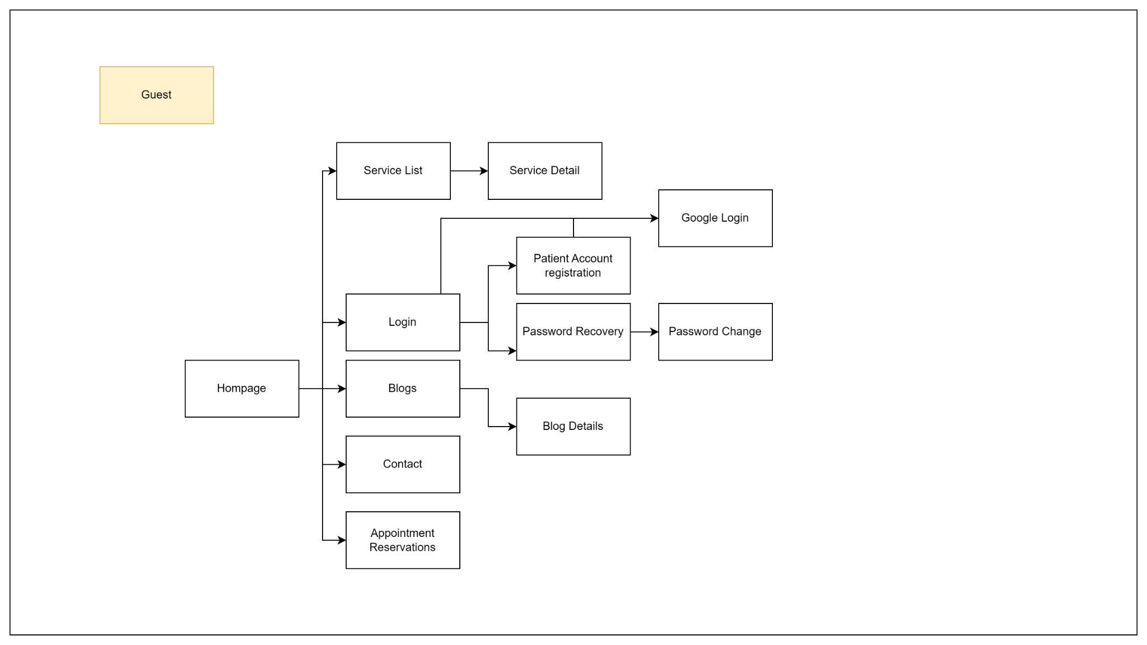

**Figure 3a: Screen flow Diagram – Guest**

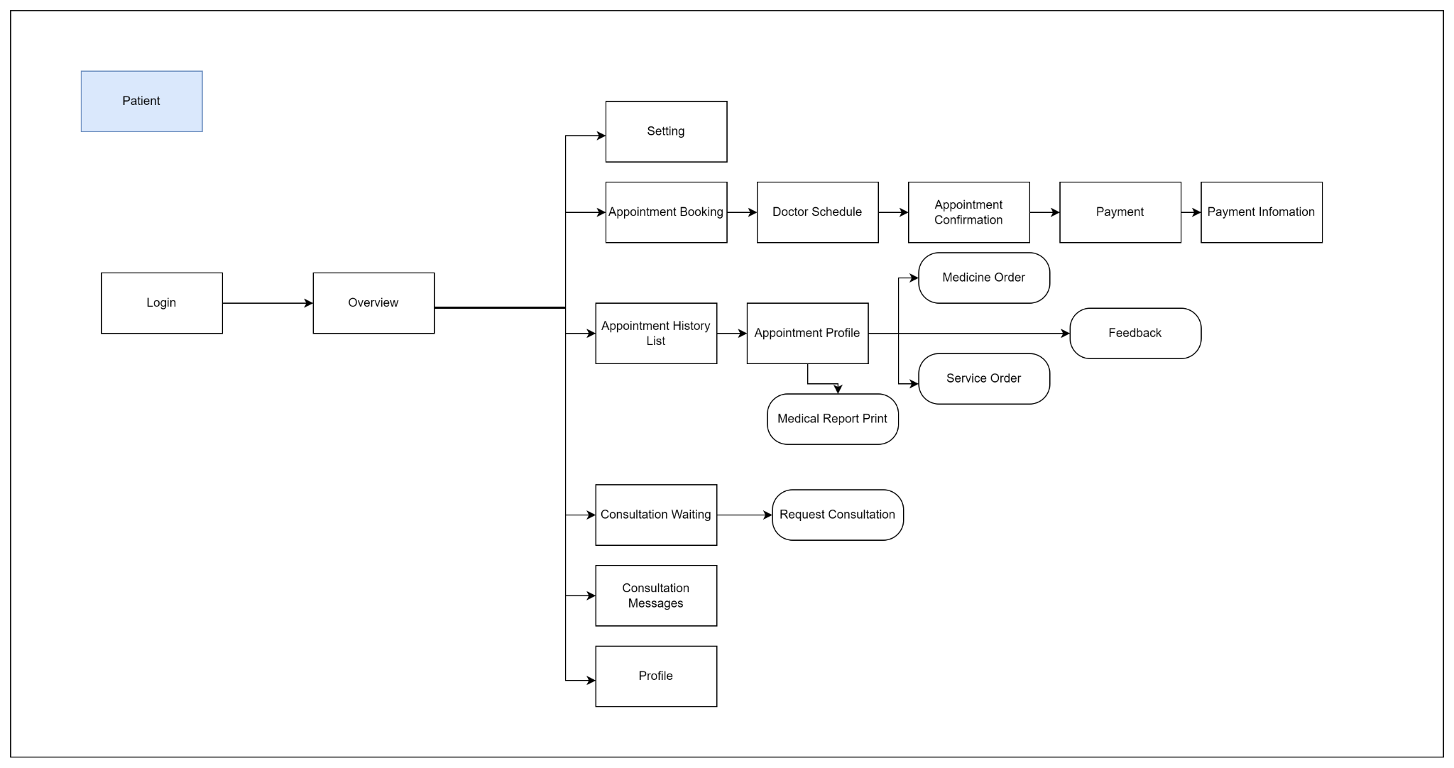

**Figure 3b: Screen flow Diagram – Patient**

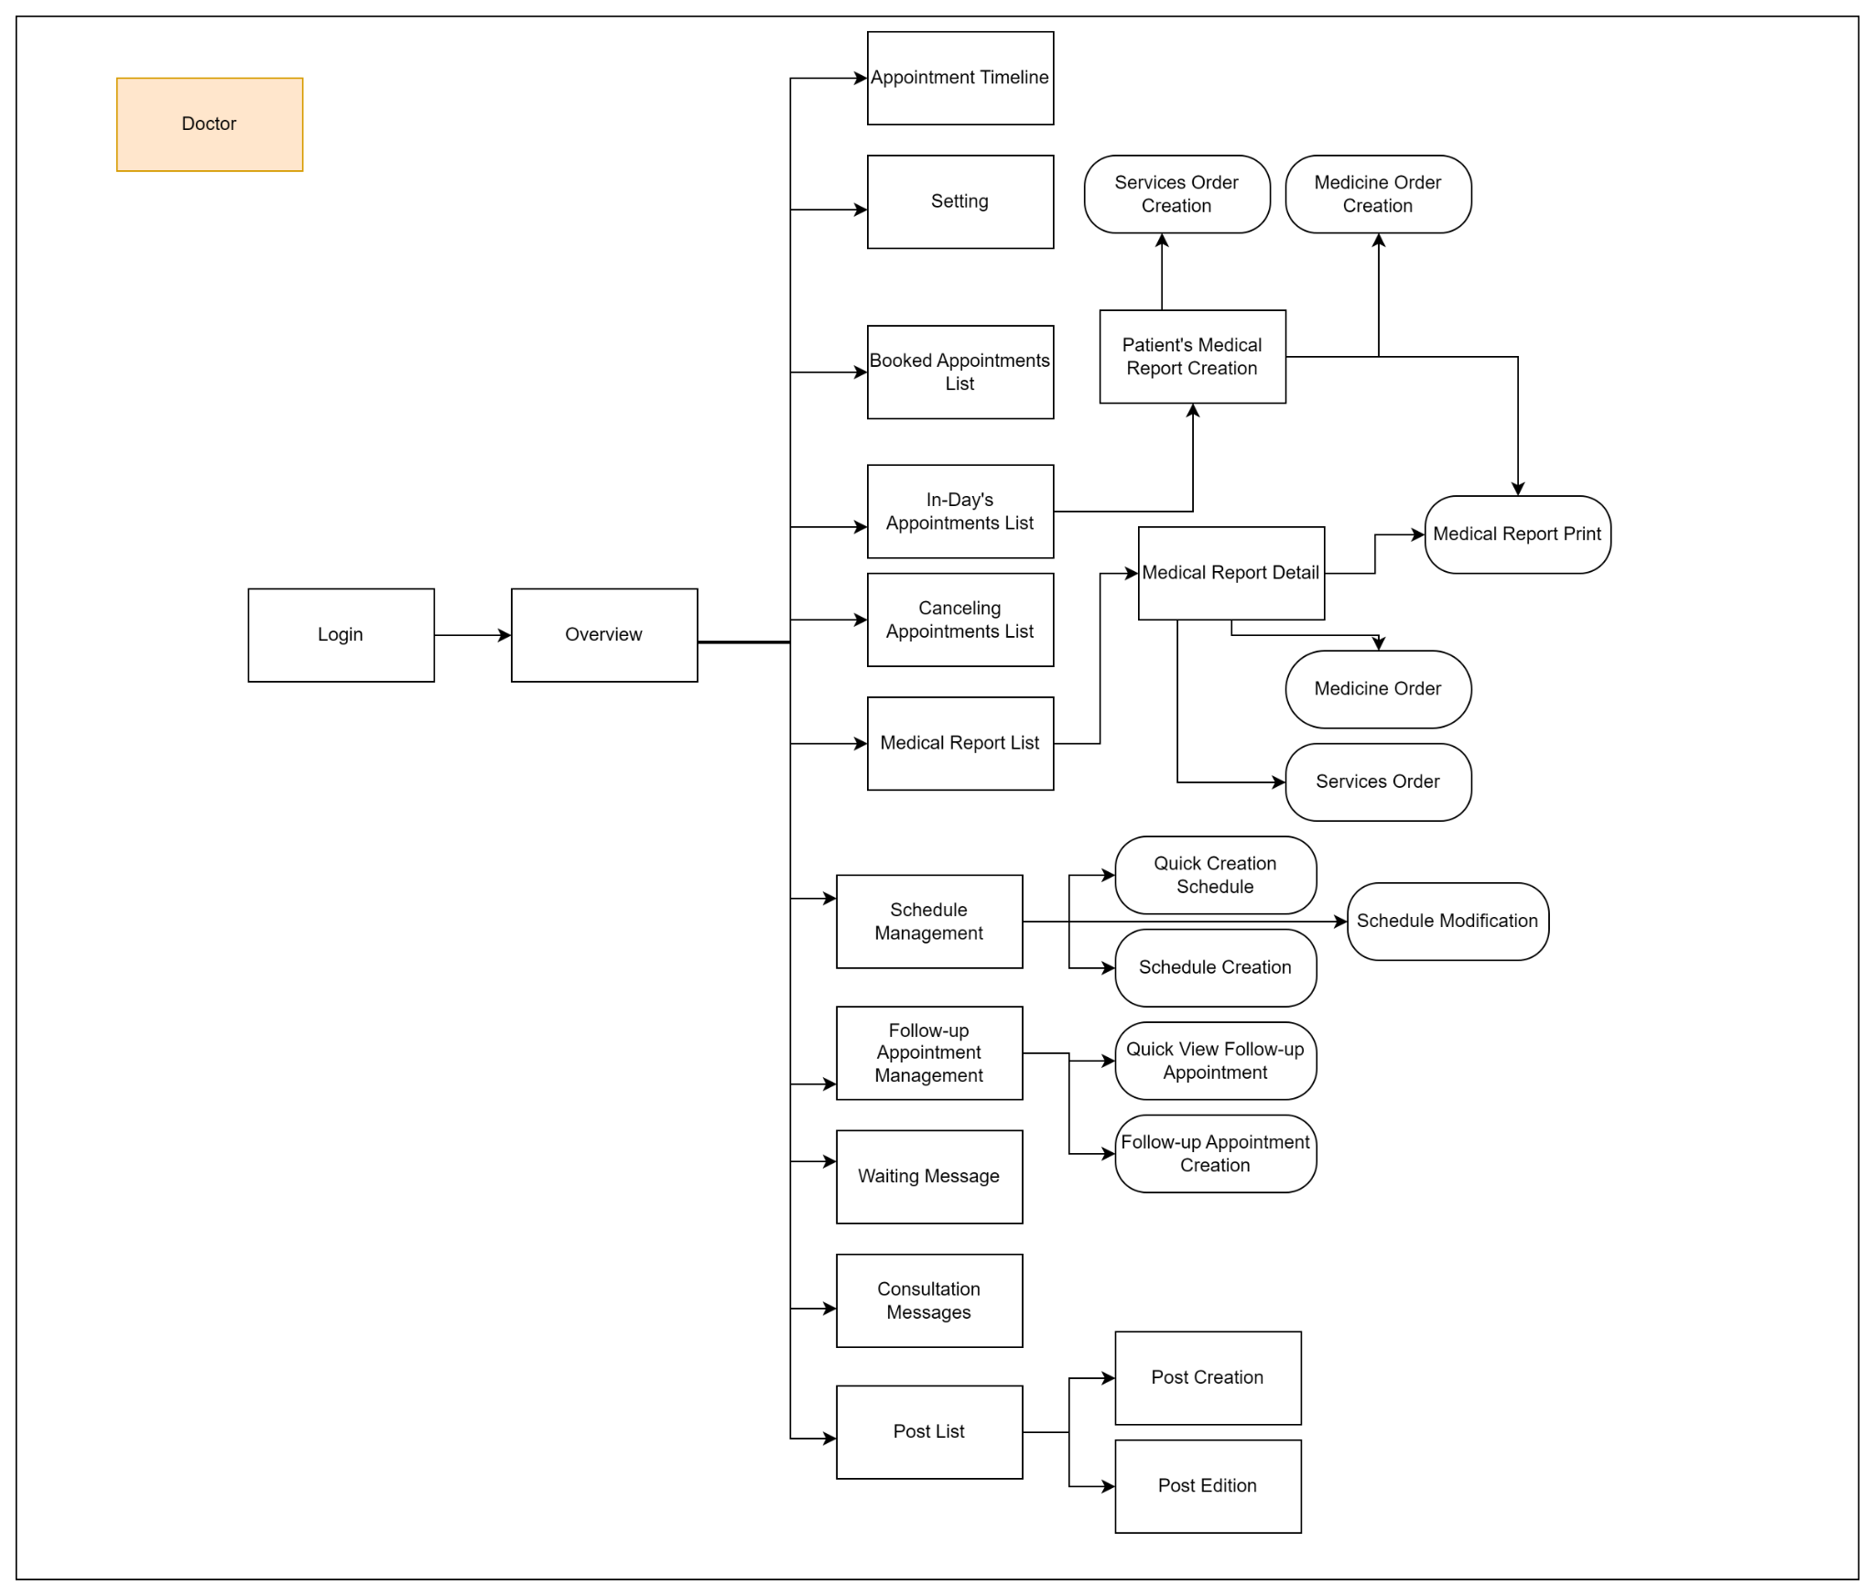

**Figure 3c: Screen flow Diagram – Doctor**

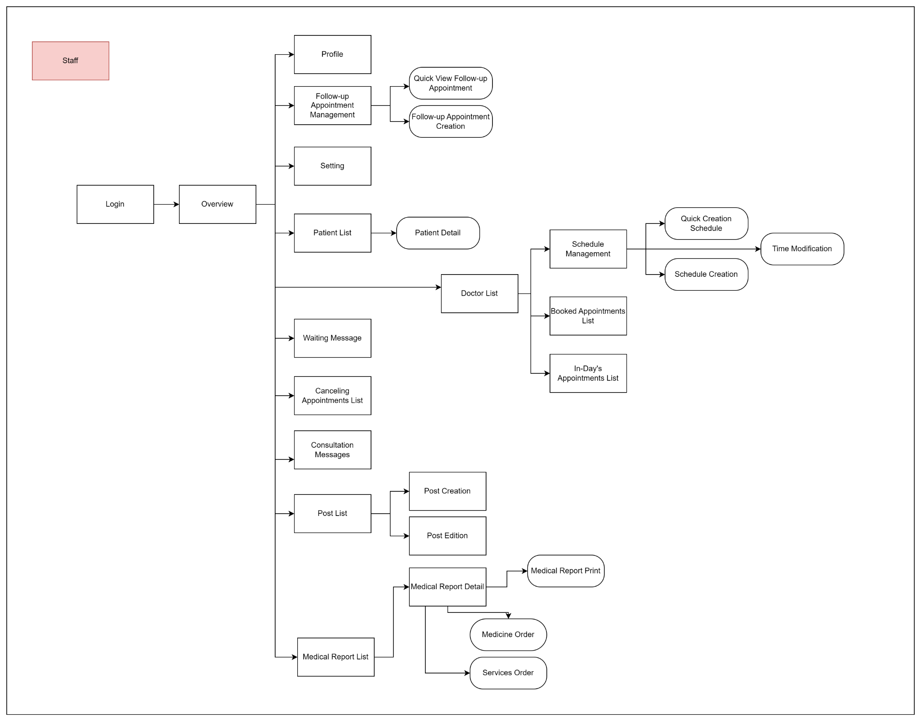

**Figure 3d: Screen flow Diagram – Staff**

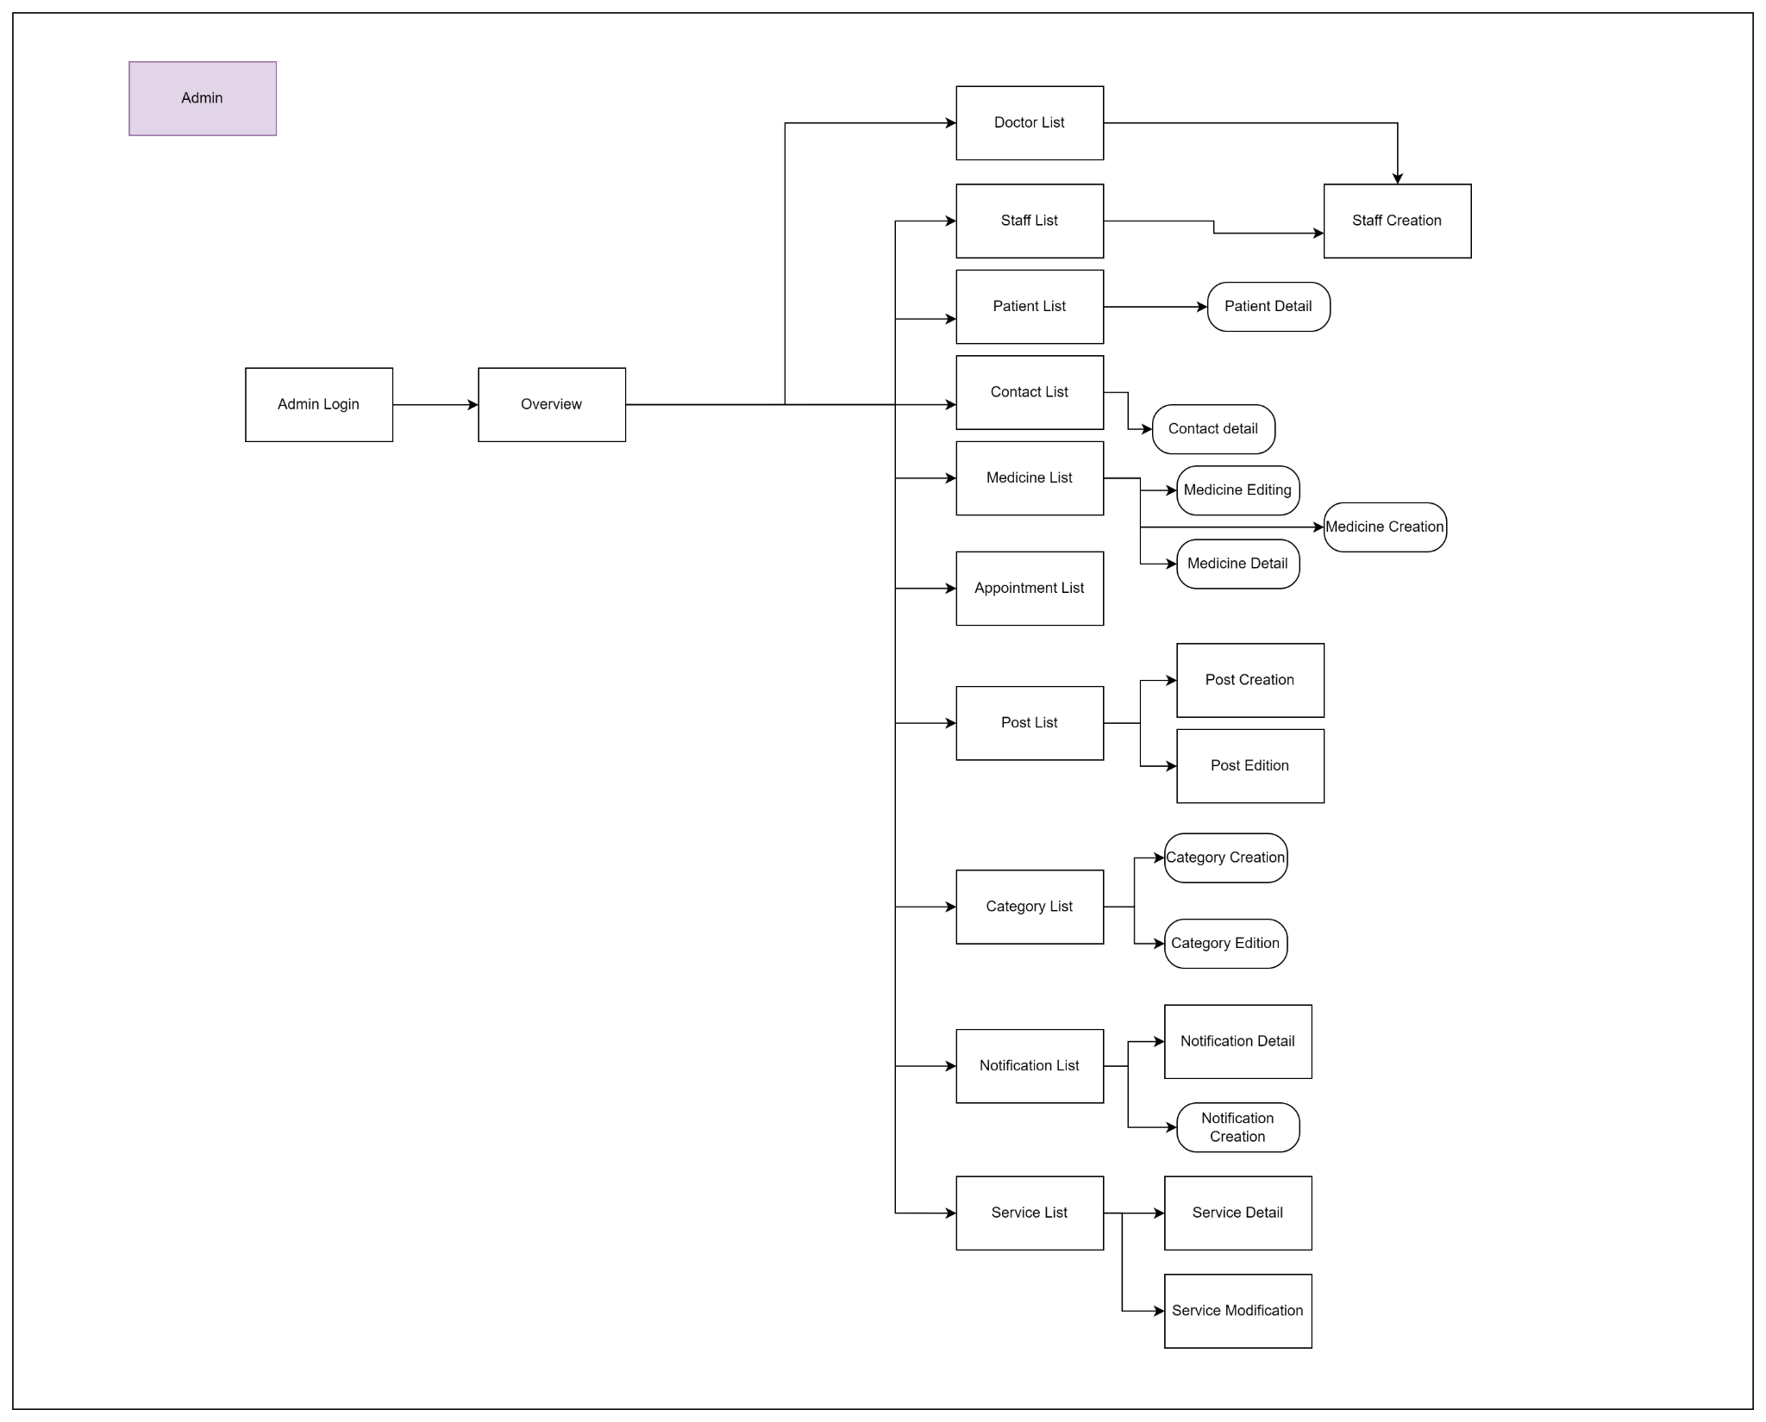

**Figure 3e: Screen flow Diagram – Admin**

**Administrator screens flow:**

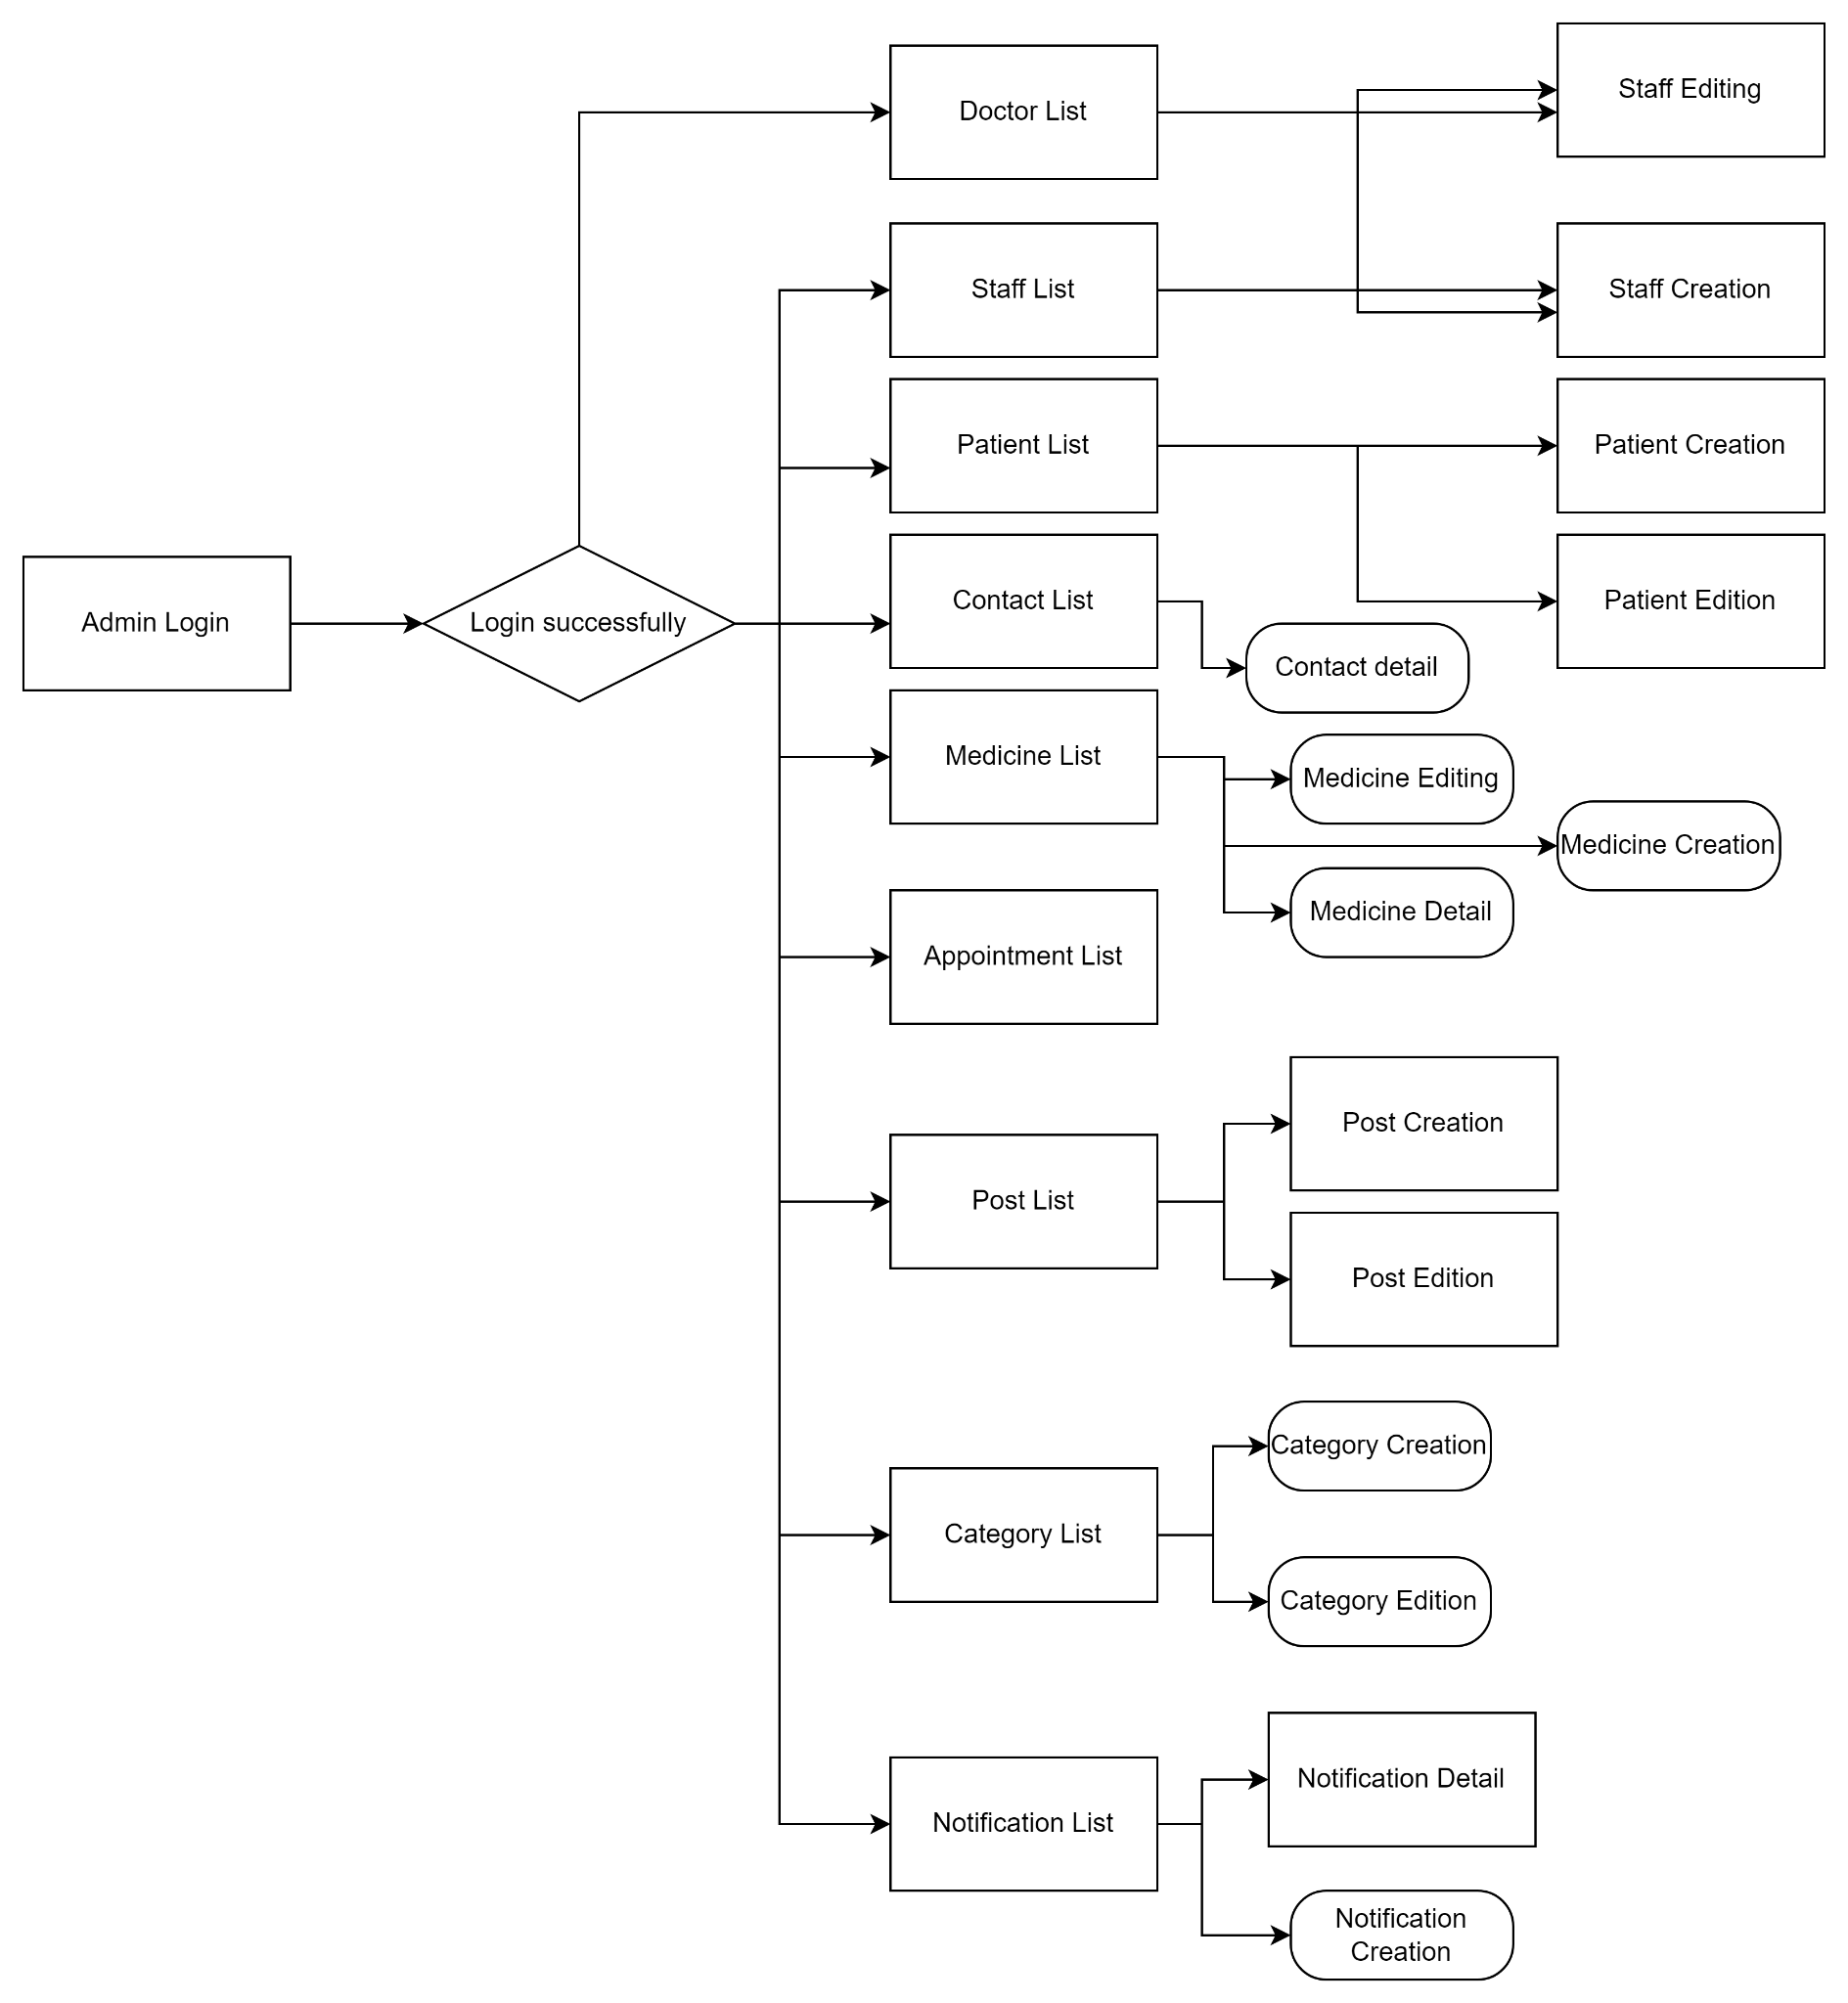

#### 3.1.2 Screen Descriptions

|  |  |  |  |
| --- | --- | --- | --- |
| **#** | **Feature** | **Screen** | **Description** |
| 1 | Patient’s Appointment | Appointment Booking | The screen displays all appointments and doctor information, including the doctor's name, consultation fee, specialty, rating, and a short description. From this screen, users can select a doctor to make an appointment. Additionally, users can filter doctors by name, specialty, and gender. |
| 2 | Patient’s Appointment | Doctor schedule | The screen displays all the days that a doctor or staff member has scheduled, allowing patients to choose the date and time for their appointment. |
| 3 | Patient’s Appointment | Appointment Confirmation | The screen allows patients to review and confirm their appointment details, add any additional descriptions, and still have the option to return to the Doctor Schedule screen to modify the date and time if needed. |
| 4 | Patient’s Appointment | Payment | The screen is a third-party interface where patients can complete their payments using VNPay. |
| 5 | Patient’s Appointment | Payment Information | The screen shows whether the payment was successful or failed. If the payment is successful, it displays the transaction ID, price, payment date, doctor's name, and appointment date. If the payment fails, it prompts the user to retry. |
| 7 | Appointment History | Appointment History List | The screen displays all completed appointments, including information such as the appointment date, examination results, and doctor's name. |
| 8 | Appointment History | Appointment Profile | The screen displays detailed information about the appointment, including the following details: patient’s full name, address, patient ID, phone number, date of birth, examination ticket number, medical history, general condition, height, pulse, temperature, weight, blood pressure, diagnosis, services rendered, and prescription. If the user has not yet provided a rating, they can do so; if the user has already rated, they can view their previous rating. Additionally, the examination ticket can be printed again. |
| 9 | Patient’s Consultation | Consultation Waiting | The screen allows users to create a new consultation request, with each patient allowed only one consultation request. If a request already exists, the patient can edit the content and title of that request. |
| 10 | Patient’s Consultation | Consultation Messages | The screen presents the conversation history or consultations between patients and doctors, as well as between patients and staff. It shows messages exchanged during ongoing or past consultations. |
| 11 | Doctor’s Appointment | Appointment Timeline | The screen shows a doctor's weekly appointments in a timeline format, enabling them to easily monitor and manage their schedule for the week. |
| 12 | Doctor’s Appointment | Booked Appointments List | The screen shows all appointments scheduled for a doctor, enabling them to easily keep track of their entire appointment list. |
| 13 | Doctor’s Appointment | In-Day's Appointments List | The screen will display all appointments for a particular day in a queue format, allowing easy tracking of the day's schedule. |
| 14 | Doctor’s Appointment | Cancelling Appointments List | The screen shows all the appointments that have been missed, helping doctors and staff keep track of these cancelled or missed bookings. |
| 15 | Patient’s Medical Report | Medical Report List | The screen provides a concise overview of all the patient's examination results within the system, allowing for quick reference and review. |
| 16 | Patient’s Medical Report | Medical Report Detail | The screen provides detailed examination results, featuring two pop-up screens: one displaying the services the patient has used and the other showing the patient’s prescription. Doctors can also print the medical report directly from this screen. |
| 17 | Schedule Management | Schedule Management | The screen shows a doctor's duty schedule, enabling them to view their shifts, add new ones, and check detailed working hours for any specific day. |
| 18 | Patient’s Appointment | Follow-up Appointment Management | The screen enables doctors or staff to schedule follow-up appointments for patients. It allows them to view the patient's recent examination history and check the dates of upcoming follow-up visits. |
| 19 | Doctor and Staff Consultation | Waiting Message | The screen shows consultation requests from patients, enabling doctors or staff to accept these requests for consultation. |
| 20 | Doctor and Staff Consultation | Consultation Messages | The screen displays the consultation messages from patients, allowing for easy communication and tracking of ongoing consultations. |
| 21 | Doctor List | Doctor List | The screen shows a list of all doctors, featuring their names, specialties, and ratings. It may include filters for searching by specialty, name, or availability, and allow patients to view detailed profiles. |
| 22 | Patient Management | Patient List | The screen displays all patients in the system and includes two pop-up screens: one for viewing detailed patient information and another for adding new patients. |
| 23 | Landing Page | Home page | The showcases information about the private clinic, including sections like "Who we are?", doctors at the clinic, available services, specialties, news updates, customer feedback, and contact details. |
| 24 | Landing Page | Blogs | The screen displays all news articles. |
| 25 | Landing Page | Blog Details | The screen provides detailed information about individual news articles. |
| 26 | Landing Page | Appointment Reservations | The screen shows all doctors, featuring their names, consultation fees, and specialties, enabling users to choose a doctor to book an appointment. |
| 27 | Authentication | Login | The screen enables users to log into the system. |
| 28 | Authentication | Patient Account registration | The screen allows users to create an account. |
| 29 | Authentication | Password Recovery | The screen allows patients to submit a password reset request via their email. |
| 30 | Authentication | Password Change | The screen allows users to change their password by verifying an OTP. |
| 31 | Authentication | Google Login | The screen enables users to quickly log in using their Google account. |
| 32 | Profile Management | Profile | The screen shows all information related to the user. |
| 33 | Profile Management | Setting | The screen enables users to add, edit, or delete their information and change their password. |
| 34 | Profile Management | Overview | The screen provides an overview of user information. |
| 35 | Admin Authentication | Admin Login | The screen allows administrators to log into the system. |
| 36 | Doctor and Staff Management | Doctor List | The screen allows administrators to view all doctors in the system. |
| 37 | Doctor and Staff Management | Staff List | The screen allows administrators to view all staff in the system. |
| 38 | Doctor and Staff Management | Staff Creation | The screen enables administrators to add new staff members or doctors to the system. |
| 39 | Medicine Order Creation | Medicine Order Creation | The screen allows healthcare professionals to place orders for medications for patients by selecting the patient, choosing medications from a list, and specifying quantities. |
| 40 | Patient Management | Patient List | The screen displays all information related to patients. |
| 41 | Notification Management | Notification Creation | The screen allows administrators to easily create and send notifications to users, staff, or doctors. It includes fields for the notification title and message, options to select the target audience. |
| 42 | Category Management | Category Edition | The screen allows administrators to manage existing categories by editing names and descriptions, adding new categories, and activating or deactivating them. |
| 43 | Contact Management | Contact List | The screen displays all contact information submitted from the landing page and includes a pop-up screen to show detailed contact information. |
| 44 | Medicine Management | Medicine List | The screen displays all medications in the clinic system and includes three pop-up screens: one for viewing medication details, one for editing medication, and one for creating a new type of medication. |
| 45 | Appointment List | Appointment List | The screen displays all appointments in the system. |
| 46 | Post Management | Post Creation | The screen allows users to create new news articles. |
| 47 | Post Management | Post List | The screen provides a concise overview of all articles. |
| 48 | Post Management | Post Editing | The screen allows administrators to modify articles. |
| 49 | Notification Management | Notification List | The screen displays all notifications created by the administrator and includes a pop-up for creating new notifications. |
| 50 | Notification Management | Notification Detail | The screen displays detailed information about notifications, including who has viewed the notification if it was sent through the system. |
| 51 | Category Management | Category List | The screen displays a list of news categories and includes pop-up screens for creating new categories and editing existing ones. |
| 52 | Service Management | Service List | The screen displays all the services of the system. It allows administrators to delete services. |
| 53 | Service Management | Service Creation | The screen allows administrators to create new services for the clinic. |
| 54 | Service Management | Service Modification | The screen provides administrators with the ability to update or make changes to existing services offered by the clinic. |
| 55 | Authentication | Admin Login | The screen allows administrators to log into the system. Through this interface, administrators can securely enter their credentials, such as username and password, to gain access to the system's management features. Once logged in, they are granted full access to administrative functions, enabling them to manage and oversee various aspects of the clinic's operations. |
| 56 | Patient’s Consultation | Request Consultation | The screen allows patients to request a consultation from a doctor or staff member. When making a consultation request, the patient can also enter additional details or a description of their condition to provide more context for the consultation. |
| 57 | Schedule Management | Quick Creation Schedule | The screen enables fast creation of appointment time slots. For example, by entering a start time of 7:30, an end time of 8:30, and an interval of 30 minutes, the system will generate two appointments: one from 7:30 to 8:00, and another from 8:00 to 8:30. This feature helps streamline the scheduling process by automatically dividing the time into multiple appointments. |
| 58 | Schedule Management | Schedule Creation | The screen allows for manual creation of appointments. Doctors or staff can manually select specific time slots, set start and end times, and configure appointments individually according to the clinic’s needs. This provides greater flexibility in scheduling, ensuring that appointments can be customised to fit specific requirements. |
| 59 | Schedule Management | Time Modification | The screen allows doctors or staff to adjust or modify the time of existing appointments. This includes changing the start and end times of appointments or shifting appointments to new time slots. The feature ensures that schedules remain flexible, allowing for adjustments when necessary to accommodate both the clinic's and patients' needs. |
| 60 | Patient Management | Patient Detail | The screen provides comprehensive information about a patient. This includes personal details such as full name, date of birth, contact information, patient ID, and medical history. |
| 61 | Category Management | Category Creation | The screen allows administrators to add new categories by entering a name and description. It includes options to save the new category or cancel the process, ensuring efficient content organisation. |
| 62 | Medicine Management | Medicine Editing | The screen allows administrators to modify details of existing medications. It includes fields for updating the medicine's name, manufacturer, dosage form, and ingredients. This screen ensures that all medication information is accurate and up-to-date for effective management within the system. |
| 63 | Medicine Management | Medicine Creation | The screen allows administrators to add new medications by entering details such as the medicine name, manufacturer, dosage form, and active ingredients. It includes validation checks and options to save or cancel the entry, ensuring accurate medication management. |
| 64 | Medicine Management | Medicine Detail | The screen provides comprehensive information about a specific medication. |
| 65 | Contact Management | Contact Detail | The screen provides detailed information about a specific contact, including their full name, phone number, email address, and notes. |
| 66 | Patient’s Appointment | Follow-up Appointment Creation | The screen allows the doctor or staff to schedule follow-up appointment notifications for patients by selecting the patient, choosing the date and time, and specifying the reason for the follow-up. It includes options to save the appointment or cancel the process, facilitating efficient patient care management. |
| 67 | Patient’s Appointment | Quick View Follow-up Appointment | The screen provides a concise overview of a patient's follow-up appointments, including their medical history and any existing follow-up schedules. It displays essential patient information, such as their name and contact details, along with a summary of past medical reports and upcoming appointments, facilitating efficient management of patient care. |
| 68 | Appointment History | Medical Report Print | The screen allows healthcare professionals to generate and print detailed medical reports for patients, including patient information, medical history, and examination results. |
| 69 | Appointment History | Medicine Order | The screen allows healthcare professionals to manage medicine orders during patient appointments, displaying patient information, enabling selection of prescribed medications, and specifying quantities. |
| 70 | Appointment History | Service Order | The screen enables healthcare professionals to view services during patient appointments. It displays patient information, selected services, and specifies details such as dates and times. |
| 71 | Appointment History | Feedback | The screen allows patients to provide feedback on their appointment experience. It includes fields for rating the service, leaving comments, and suggestions for improvement. |
| 72 | Patient's Medical Report Management | Patient's Medical Report Creation | The screen allows healthcare professionals to generate detailed medical reports by entering patient information, medical history, examination results, and treatment plans. |
| 73 | Services Order Creation | Services Order Creation | The screen allows healthcare professionals to create service orders for patients by selecting the patient, choosing available services, and specifying the date and time. |
|  |  |  |  |

#### 3.1.3 Screen Authorization

|  |  |  |  |  |  |
| --- | --- | --- | --- | --- | --- |
| **Screen** | **Doctor** | **Staff** | **Patient** | **Guest** | **Admin** |
| Appointment Booking |  |  | X |  |  |
| Doctor schedule |  |  | X |  |  |
| Appointment Confirmation |  |  | X |  |  |
| Payment |  |  | X |  |  |
| Payment Information |  |  | X |  |  |
| Appointment History List |  |  | X |  |  |
| Appointment Profile |  |  | X |  |  |
| Consultation Waiting |  |  | X |  |  |
| Consultation Messages | X | X | X |  |  |
| Appointment Timeline | X |  |  |  |  |
| Booked Appointments List | X | X |  |  |  |
| In-Day's Appointments List | X | X |  |  |  |
| Cancelled Appointments List | X | X |  |  |  |
| Medical Report List | X | X |  |  |  |
| Medical Report Detail | X | X |  |  |  |
| Schedule Management | X | X |  |  |  |
| Follow-up Appointment Management | X | X |  |  |  |
| Waiting Message | X | X |  |  |  |
| Doctor List |  | X |  |  | X |
| Patient List |  | X |  |  | X |
| Home Page | X | X | X | X | X |
| Blogs | X | X | X | X | X |
| Blog Details | X | X | X | X | X |
| Appointment Reservations |  |  |  | X |  |
| Login |  |  |  | X |  |
| Patient Account Registration |  |  |  | X |  |
| Password Recovery |  |  |  | X |  |
| Password Change |  |  |  | X |  |
| Google Login |  |  |  | X |  |
| Profile | X | X | X |  | X |
| Settings | X | X | X |  | X |
| Admin Login |  |  |  |  | X |
| Notification Creation |  |  |  |  | X |
| Medicine List |  |  |  |  | X |
| Appointment List | X | X |  |  |  |
| Post Creation | X | X |  |  | X |
| Post List | X | X |  |  | X |
| Post Editing | X | X |  |  | X |
| Notification List |  |  |  |  | X |
| Service List |  |  |  |  | X |
| Contact List |  |  |  |  | X |
| Contact Detail |  |  |  |  | X |
| Category Creation |  |  |  |  | X |
| Feedback |  |  | X |  |  |
| Patient's Medical Report Creation | X | X |  |  |  |
| Services Order Creation | X | X |  |  |  |
| Medicine Order Creation | X | X |  |  |  |
| Service Order | X | X | X |  |  |
| Medicine Order | X | X | X |  |  |
| Medical Report Print | X | X | X |  |  |
| Quick View Follow-up Appointment | X | X |  |  |  |
| Follow-up Appointment Creation | X | X |  |  |  |
| Medicine Detail |  |  |  |  | X |
| Medicine Creation |  |  |  |  | X |
| Medicine Editing |  |  |  |  | X |
| Patient Detail |  | X |  |  | X |
| Time Modification | X | X |  |  |  |
| Schedule Creation | X | X |  |  |  |
| Quick Creation Schedule | X | X |  |  |  |
| Request Consultation |  |  | X |  |  |
| Service Modification |  |  |  |  | X |
| Service Creation |  |  |  |  | X |
| Category List |  |  |  |  | X |
| Notification Detail |  |  |  |  | X |
| Category Edition |  |  |  |  | X |
| Staff Creation |  |  |  |  | X |
| Overview | X | X | X |  | X |
|  |  |  |  |  |  |

#### 3.1.4 Non-Screen Functions

|  |  |  |  |
| --- | --- | --- | --- |
| **#** | **Feature** | **System Function** | **Description** |
| 1 | Authentication | Validate JWT Token for API Requests | The system uses JWT to authenticate and verify user access when they send requests to various APIs. The JWT contains the user's authentication information and is checked with every request to ensure the user is logged in and has the appropriate permissions to access the requested resource. |
| 2 | Authentication | Refresh JWT Token Before Expiration | The system will automatically refresh the JWT token when it is about to expire, ensuring that the user’s session remains active without requiring them to log in again. A separate refresh token is stored securely on the client side, and when the access token (JWT) is nearing expiration, the client requests a new access token using the refresh token. |
| 3 | Notification | Notify User to Re-Login When Access Token Expires | When the access token (JWT) expires, the system will automatically prompt the user to log in again. This ensures that users do not perform any unauthorised actions and are aware when their session has ended. The system checks the token expiration on each request and if the token has expired, it will notify the user to log in again. |
| 4 | Notification | Send OTP Through Email to Recover Password | The system will send an OTP to the user's email who requests to reset their password. The email will contain a link to a password reset page, where the user can enter a new password and OTP. The OTP will include a secure, time-limited OTP to ensure that only the intended recipient can reset the password within a specified period. |
| 5 | Notification | Real-Time Notification | A real-time notification system ensures users receive immediate alerts and updates regarding important events or actions within a website application. This functionality enhances user engagement and keeps users informed about critical activities, such as new messages, appointment reminders, or system updates. |
| 6 | Payment Gateway Integration | Payment Status Update Service | A service that listens to payment status updates of appointments from third-party gateways (VNPay). It updates the appointment status in the system once the payment is confirmed or failed. |
| 7 | Password Encryption | Password Encryption | When a user registers an account or an administration import staff or doctors, their password is transformed into an unreadable format through encryption or hashing algorithms before it is stored in the database. This ensures that even if the database is compromised, the actual passwords remain secure. |
| 8 | Updating Appointment Status | Cron Job for Updating Appointment Status | The cron job will run periodically (e.g., daily) to check for all appointments that have a status of pending and are past their scheduled date. If any appointments meet these criteria, their status will automatically be updated to “no-show”. |
| 9 | Data Validation | Data Validation | Data validation is the process of ensuring that the data entered into a system meets the required criteria and adheres to specific rules before it is processed or stored. This is crucial for maintaining data integrity, preventing errors, and enhancing user experience by providing immediate feedback. |
| 10 | Error Handling | Error Handling | Error handling is a critical non-screen function that ensures the application can gracefully manage and respond to errors that occur during execution. It involves capturing, logging, and responding to errors in a way that maintains the integrity of the system and enhances the user experience by providing meaningful feedback. |
| 11 | Consultation Realtime | Real-Time Messaging | Consultation real-time messaging is a non-screen function that facilitates instant communication between patients and healthcare providers (doctors or support staff) during consultations. This feature enables seamless interactions, allowing users to discuss health concerns, ask questions, and receive guidance in real time, enhancing the overall consultation experience. |
| 12 | Automated Appointment Creation with Payment Status | Appointment Management and Payment Handling | This non-screen function automates the process of creating an appointment when a user books an appointment slot from a doctor schedule and managing its payment status. It operates in the background without direct user interaction, ensuring seamless appointment management and payment processing. The system initiates a timer for 15 minutes to track the payment process. During this period, the appointment slot remains locked for other users. If the appointment remains unpaid after the 15-minute window, the system will receive a request from VNPAY to cancel the appointment. |
| 13 | Notification | Scheduled Notification via Cron Job | This non-screen function automates the sending of notifications to users based on a predefined schedule set in the system. The notifications are triggered at specific dates and times to remind users of important events, such as upcoming appointments, payment deadlines, or promotional offers. |

#### 3.1.5 Entity Relationship Diagram

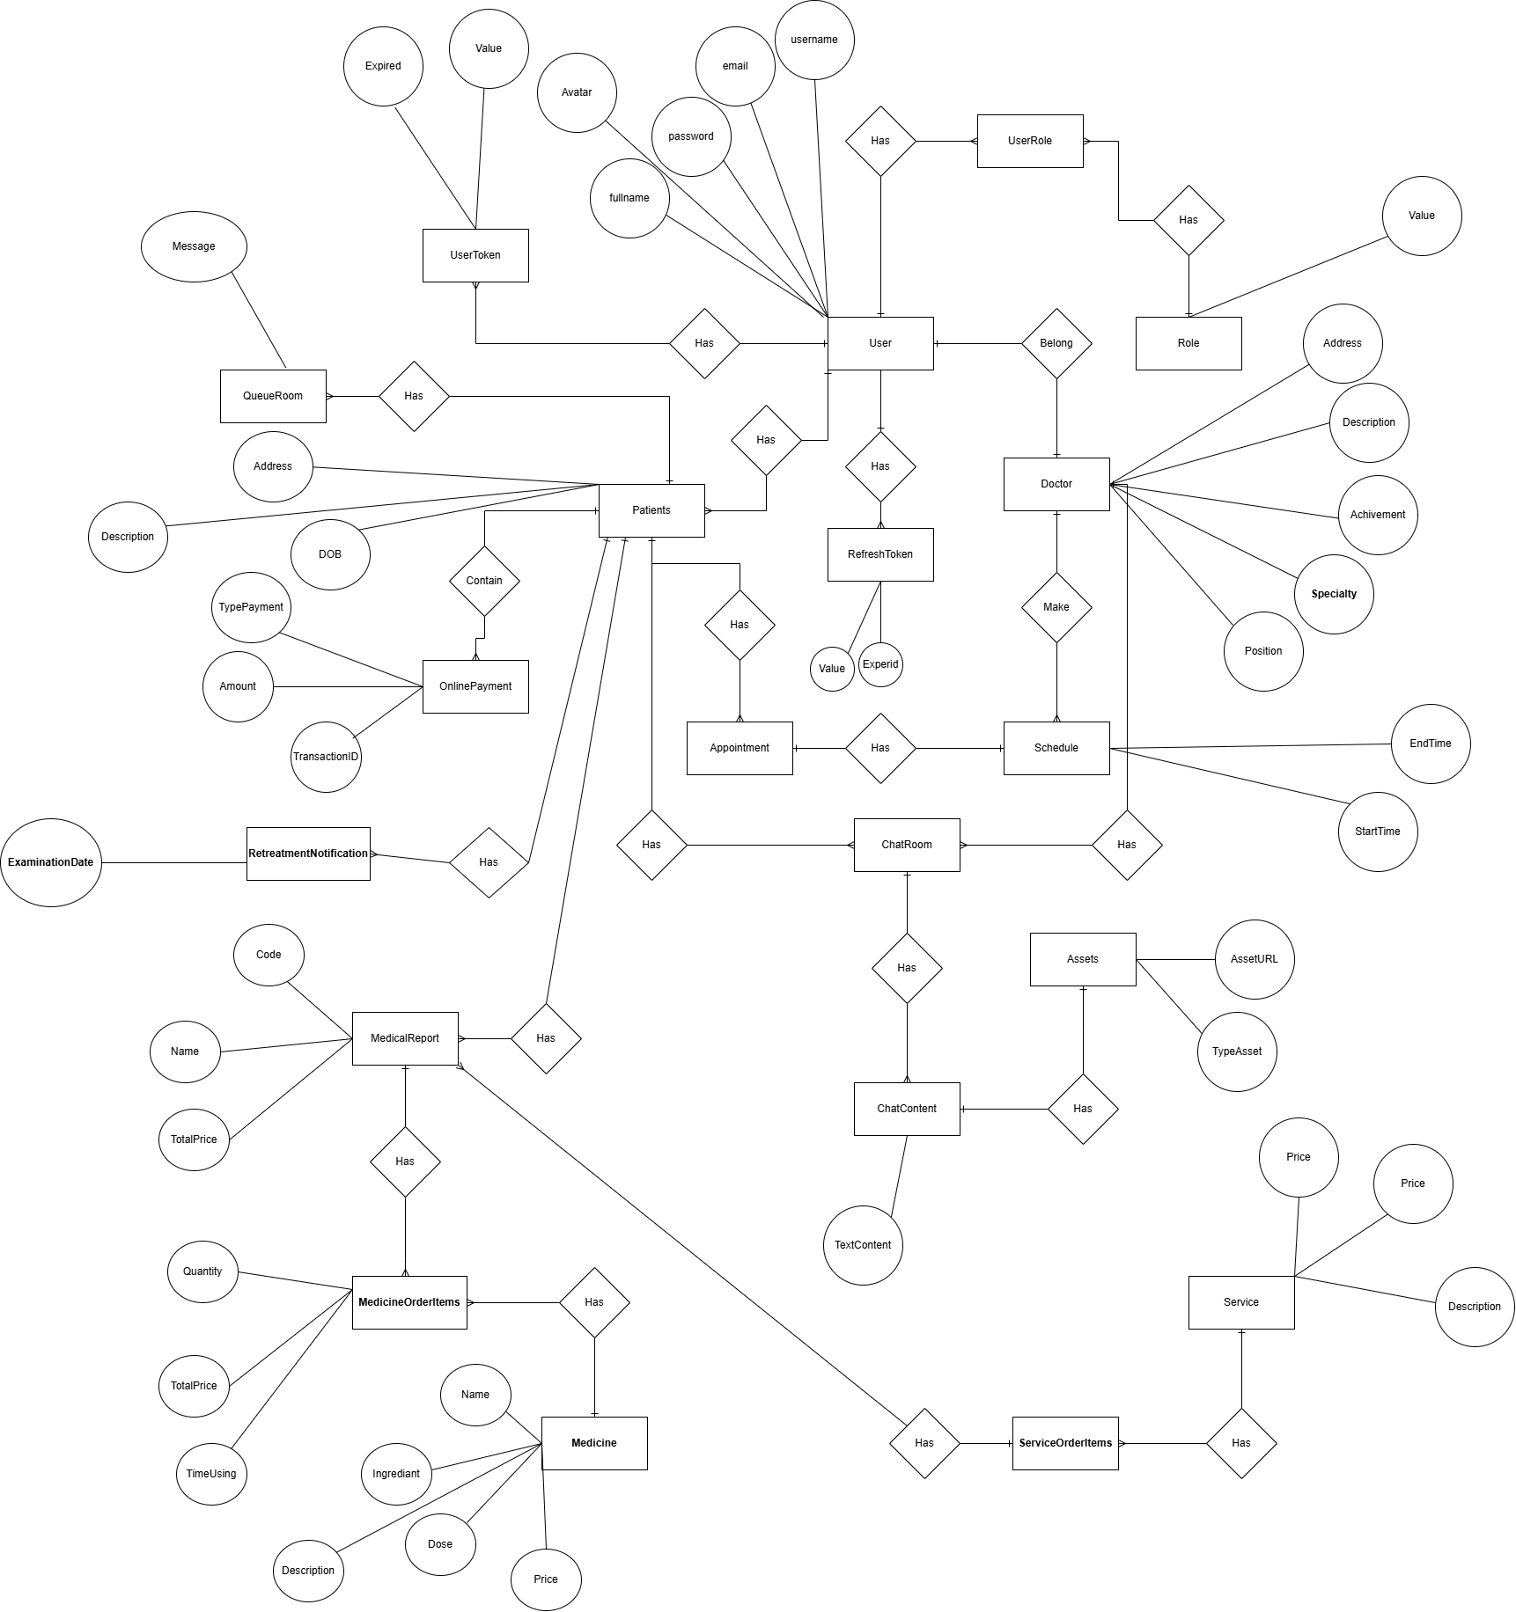

**Entities Description**

|  |  |  |
| --- | --- | --- |
| **#** | **Entity** | **Description** |
| 1 | User | Represents individuals in the system, including patients, doctors, and other staff. Contains personal information such as name, email, phone number, and address. It is associated with roles and user tokens for authentication. |
| 2 | Patient | Represents a patient who uses the healthcare services. It stores patient-specific details such as medical history, insurance information, and contact information. This entity is linked to users who are patients. |
| 3 | Doctor | Represents a medical professional providing healthcare services. It contains information such as specialisation, qualifications, and availability. This entity is linked to users who are doctors. |
| 4 | Appointment | Represents a booking for a consultation between a patient and a doctor. Contains details like date, time, status (e.g., scheduled, completed), and associated medical reports. |
| 5 | Schedule | The working schedule of a doctor, detailing available times and dates, allowing patients to book appointments accordingly. |
| 6 | OnlinePayment | Captures information related to online payments for healthcare services, including payment method, amount, and transaction status. |
| 7 | RetreatmentNotification | Notifications sent to patients to remind them about follow-up treatments or check-ups, potentially including timing and related information. |
| 8 | Role | Defines the permissions for users in the system, determining access rights and capabilities to manage patient information, appointments, |
| 9 | UserToken | Information about the user's authentication token, used to verify identity and maintain active sessions within the system. |
| 10 | RefreshToken | A token used to obtain a new access token when the current one expires, allowing users to remain logged in without re-entering credentials. |
| 11 | Medical Report | A report documenting a patient's health status, including test results, diagnoses, and treatment recommendations. |
| 12 | ChatQueue | A queue for chats between patients and doctors, tracking conversations that are pending processing. |
| 13 | ChatRoom | A chat room where patients and doctors can communicate directly, including information about the start time and conversation content. |
| 14 | ChatContent | The content of messages within the chat room, recording details like timestamps, sender information, and message content. |
| 15 | AssetContent | Content related to healthcare assets, such as images or documents that support treatment, used during consultations. |
| 16 | MedicineOrderItem | Records information about medication items in a patient’s order, including the medication name, dosage, and quantity. |
| 17 | Medicine | Detailed information about medications, including name, ingredients, indications, contraindications, and pricing. |
| 18 | ServiceOrderItem | Records details about healthcare services in a patient’s order, including service type, scheduled time, and status. |
| 19 | Service | Detailed information about healthcare services, such as consultations, tests, and treatments, including service name, description, and pricing. |

### 

### 3.2 Authentication

#### 3.2.1 Login

**Function Trigger**:

* Trigger method: The login function is triggered when a user navigates to the login page.
* Navigation path: From the home page or any restricted page, the user is redirected to the login page via a "Login" button or link in the navigation bar.
* Trigger frequency: The user is prompted to log in when they attempt to access restricted content or services that require authentication.

**Function Description**:

* **Actors/Roles**: All types of users can access this screen to view or update their personal information.
* **Purpose**: To allow users to authenticate themselves and access personalized or restricted content/services.
* **Interface**: The login screen has fields for the user to input their email/username and password. There is also a "Forgot Password" link for account recovery, and a "Sign Up" link for new users, Or Login by Google….

**Data Processing**:

1. Input fields: Username or email. Password.
2. Validation: Input fields are validated (e.g., correct format for email). Passwords are encrypted.
3. Database interaction: The system checks the entered credentials against stored values in the user database.
4. Authentication: If the credentials match, the user is authenticated, and a session token is created. If credentials don’t match, an error message is displayed.
5. Redirection: Authenticated users are redirected to the appropriate page based on their role (e.g., dashboard, home page).
6. If user input wrong password more than 5 time, the system will block user for 30 minutes

**Screen Layout**:

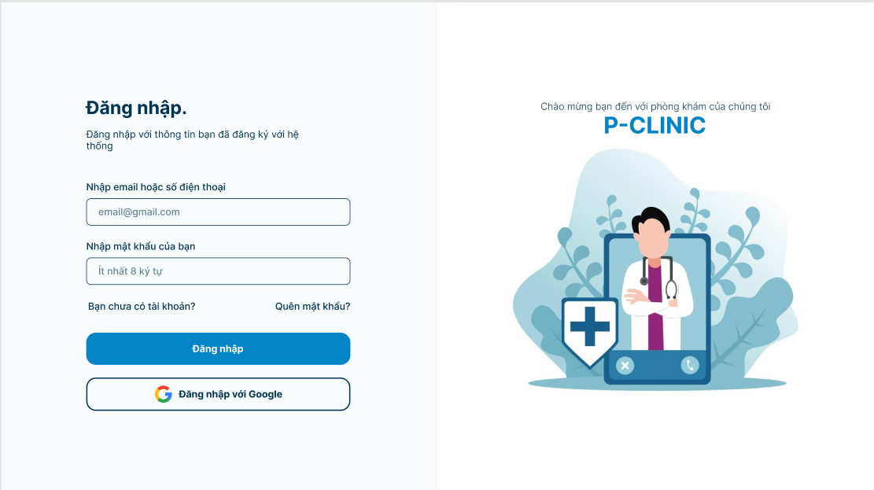

**Function Detail**:

| **#** | **Component** | **Comp. Type** | **Editable** | **Mandatory** | **Default Value** | **Description** |
| --- | --- | --- | --- | --- | --- | --- |
| 1 | Login Form | | | | | |
| Email | Text | Yes | Yes | “” | Email format, notify wrong format if input invalid |
| Password | Text | Yes | Yes | “” | Include capitals, numbers, notify wrong format if input invalid |
| 2 | Register Account | Text-Link | No | Yes | “Don't have an account yet?” |  |
| Forgot Password | Text-Link | No | Yes | “Forgot Password” |  |
| Sign In Button | Text-Link | No | Yes | “Login” |  |
| Sign In Google | Icon | No | Yes | “Login with Google” | Using Google Api |
| **Action** | | | | | | |
| **Name** | | **Success** | | **Failure** | | **Description** |
| Login | | Display login successfully | | Display message “Login failed” | | Press login button with username and password |

#### 

#### 3.2.2 Register

**Function Trigger**:

* Trigger method: The register function is triggered when user clicks the “you have an account” link.
* Navigation path: Users can access the registration page via a "you have an account" button or link found in the navigation bar or login page.
* Trigger frequency: Users are prompted to register when they are new and want to create an account for accessing the system.

**Function Description**:

* **Actors/Roles: New User** (Patient) is a user which can register. System: Handles the registration process, stores the user's information, and ensures the registration follows the validation rules.
* **Purpose:** To allow new users to create an account by providing personal details such as name, email, and password.
* **Interface:** The registration screen consists of input fields for user details (e.g., name, email, phone, password, confirm password) and a submit button to register the user.

**Data Processing**:

1. Input fields: Full Name. Email (must be unique in the system). Password. Confirm Password.
2. Validation: All fields are required. Email format must be valid and unique. Password must meet certain strength criteria (e.g., minimum length, special characters). Password and Confirm Password must match.
3. Database interaction: The system checks if the email already exists in the database. If valid, the new user data is saved in the user table.
4. Verify Email: The system will send a link contain token, user will click to that link email will redirect to screen verify email.
5. Redirection: Upon successful registration, the user is redirected to the login page or toast a notification successfully register.

**Screen Layout**:

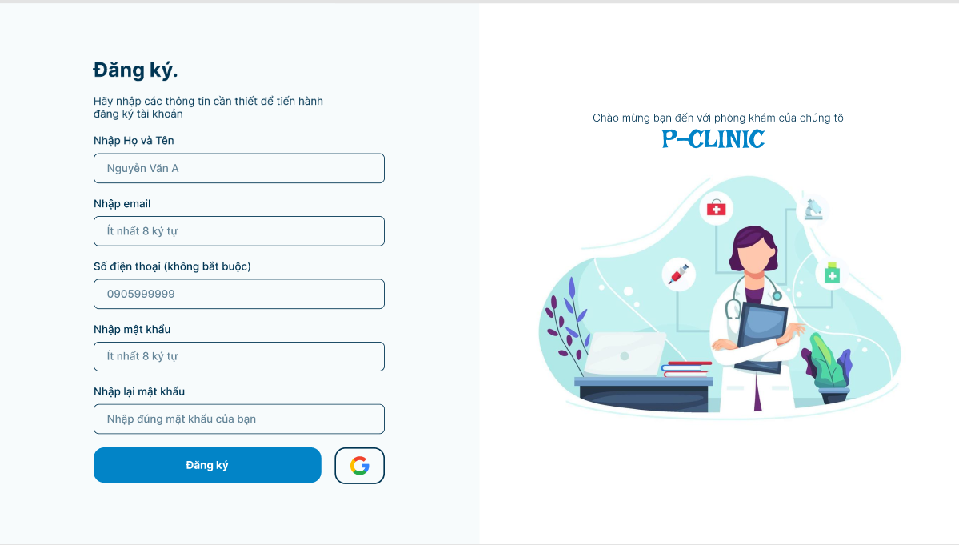

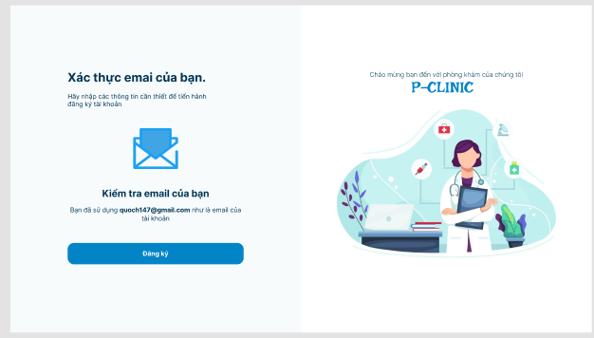

**Function Detail**:

| **#** | **Component** | **Comp. Type** | **Editable** | **Mandatory** | **Default Value** | **Description** |
| --- | --- | --- | --- | --- | --- | --- |
| 1 | Register Form | | | | | |
| FullName | Text | Yes | Yes | “” |  |
| Email | Text | Yes | Yes | “” | Email Format, notify wrong format if input invalid |
| PhoneNumber | Number | Yes | No | “” | 10 or 11 number, notify wrong format if input invalid |
| Password | Text | Yes | Yes | “” | Include capitals, numbers, notify wrong format if input invalid |
|  | Confirm Password | Text | Yes | Yes |  | Include capitals, numbers, notify wrong format if input invalid |
|  | Register Button | Text-Link | Yes | Yes | “Sign Up” |  |
|  | Login with Google | Icon | Yes | Yes | “” | Using google api login |
| **Action** | | | | | | |
| **Name** | | **Success** | | **Failure** | | **Description** |
| Register | | Display register successfully | | Display message “Register failed” | | Press register button with needed information. |

### 

#### 3.2.3 Request forgot password

**Function Trigger**:

* **Trigger method:** The "Enter Email for Password Reset" function is triggered when a user requests to reset their password.
* **Navigation path:** Users access this screen by clicking on the "Forgot Password" link, typically found on the “Login” page.
* **Trigger frequency:** This function is triggered when users forget their password and need to reset it.

**Function Description**:

**Actors/Roles:**

* **User (Patient):** A user who has forgotten their password and wishes to reset it.
* **System:** Sends an OTP (One-Time Password) to the user's registered email to allow password resetting.

**Purpose:** To enable users to request a password reset by providing their registered email address.

**Interface:** The screen consists of an input field where users can enter their email address. A submit button labelled (Change Password) is used to proceed with the reset process.

**Data Processing**:

**Input fields:**

* Email Address.

**Validation:**

* The email field is required, notify “not match format” if email invalid.
* The system checks if the email is registered in the system.

**Database interaction:**

* The system verifies the provided email against the database.
* If the email does not exist, then notify email not found
* If the email is valid, an OTP is sent to the user's email address for further verification.

**Screen Layout**:

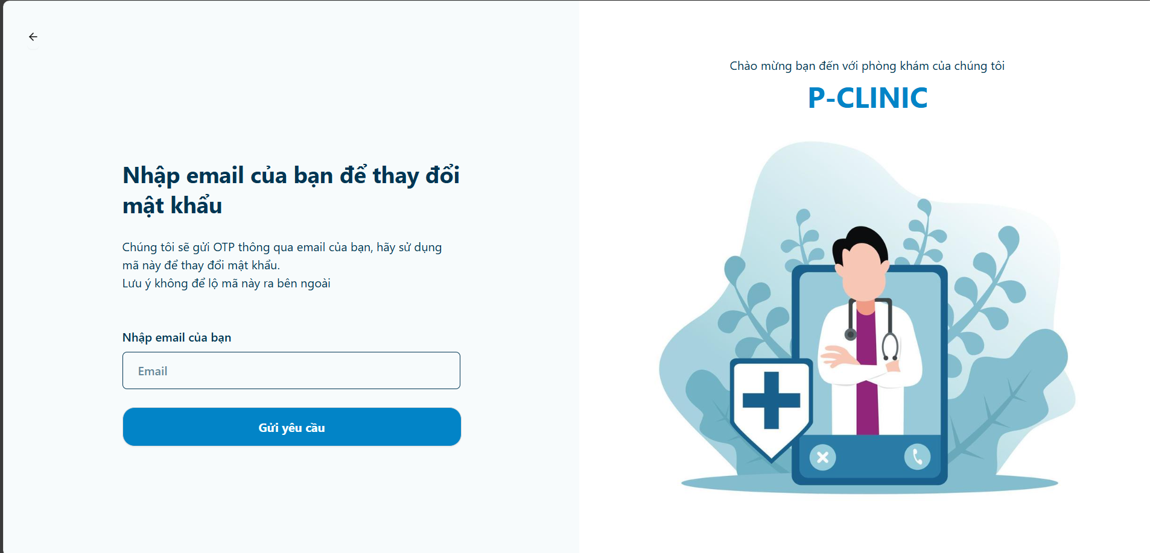

**Function Detail**:

| **#** | **Component** | **Comp. Type** | **Editable** | **Mandatory** | **Default Value** | **Description** |
| --- | --- | --- | --- | --- | --- | --- |
| 1 | Request Changing Password Form | | | | | |
| Email | Text | Yes | Yes | “” | Email Format, notify wrong format if input invalid |
| **Action** | | | | | | |
| **Name** | | **Success** | | **Failure** | | **Description** |
| Request Changing Password | | Display OTP to input | | Display message “Email Not Found” | | Request Email to Reset Password |

#### 

#### 3.2.4 Forgot Password

**Function Trigger**:

* **Trigger method:** The forgot password function is triggered when a user selects the option to forgot their password button at page “Login”.
* **Navigation path:** Users access this page after initiating a password reset request, typically by clicking a link sent to their email.
* **Trigger frequency:** Users trigger this function when they need to update or reset their password due to a forgotten password or security concern.

**Function Description**:

* **User:** A user who wishes to reset their password.
* **Purpose:** To allow users to securely change their password by verifying the OTP sent to them.
* **Interface:** The change password screen consists of input fields for entering the OTP, new password, and confirming the new password. The "Change Password" button finalizes the process.

**Data Processing**:

1. **Input fields:**

* OTP (One-Time Password).
* New Password (must meet security criteria).
* Confirm New Password.

1. **Validation:**

* All fields are required.
* OTP must match the code sent to the user.
* Password must meet specific strength requirements (e.g., minimum length of 8 characters).
* New Password and Confirm New Password must match.

1. **Database interaction:**

* The system checks if the OTP is valid and has not expired.
* If valid, the new password is saved in the user table.

**Screen Layout**:

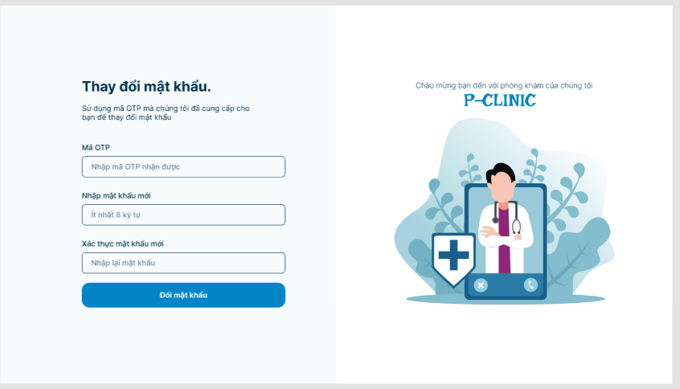

**Function Detail**:

| **#** | **Component** | **Comp. Type** | **Editable** | **Mandatory** | **Default Value** | **Description** |
| --- | --- | --- | --- | --- | --- | --- |
| 1 | Forgot Password Form | | | | | |
| OTP Code | Text | Yes | Yes | “” | Length is 6, notify wrong format if input invalid |
| Password | Text | Yes | Yes | “” | Include capitals, numbers, notify wrong format if input invalid |
|  | Confirm Password | Text | Yes | Yes | “” | Include capitals, numbers, notify wrong format if input invalid and does not match password |
|  | Changing Button | Text-Link | Yes | Yes | “Changing Password” |  |
| **Action** | | | | | | |
| **Name** | | **Success** | | **Failure** | | **Description** |
| Changing Password | | Display login successfully | | Display message “Changing Password failed” | | Press Changing Password button with password and confirm password |

#### 3.2.5 Login admin

**Function Trigger**:

* Trigger method: The login function is triggered when admin navigates to the login admin page.
* Navigation path: From the home page or any restricted page, the admin is redirected to the login page via a "Login" button.
* Trigger frequency: The user is prompted to log in when they attempt to access restricted content or services that require authentication.

**Function Description**:

* **Actors/Roles**: Only admin can access this screen to manage the system.
* **Purpose**: To allow admin to authenticate themselves and access personalized or restricted content/services.
* **Interface**: The login screen has fields for the user to input their email/username and password.
* **Data Processing**:

1. Input fields: Username or email. Password.
2. Validation: Input fields are validated (e.g., correct format for email). Passwords are encrypted.
3. Database interaction: The system checks the entered credentials against stored values in the admin database.
4. Authentication: If the credentials match, the user is authenticated, and a session token is created. If credentials don’t match, an error message is displayed.
5. Redirection: Authenticated users are redirected to admin dashboard

**Screen Layout**:

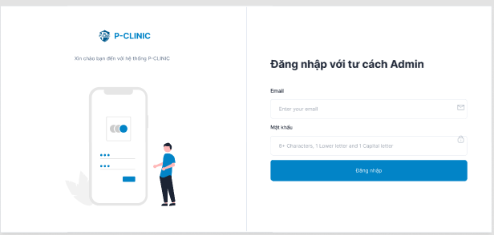

**Function Detail**:

| **#** | **Component** | **Comp. Type** | **Editable** | **Mandatory** | **Default Value** | **Description** |
| --- | --- | --- | --- | --- | --- | --- |
| 1 | Login Form | | | | | |
| Email | Text | Yes | Yes | “” | Email format. |
| Password | Text | Yes | Yes | “” | Include capitals, numbers |
|  | Sign In Button | Text-Link | No | Yes | “Login” |  |
| **Action** | | | | | | |
| **Name** | | **Success** | | **Failure** | | **Description** |
| Login | | Display login successfully | | Display message “Login failed” | | Press login button with username and password |

### 

### 3.3 Landing Page

#### 3.3.1 Overview

**Function Trigger**:

* The ***Overview page screen*** is triggered when a user (everyone) access first the system and it contains all of the introduced information of the website, such as: doctors information, business, feedback, medical news,...

**Data Processing**:

1. The system retrieves the basic clinic data information and displays it in the respective fields.

**Screen Layout:**

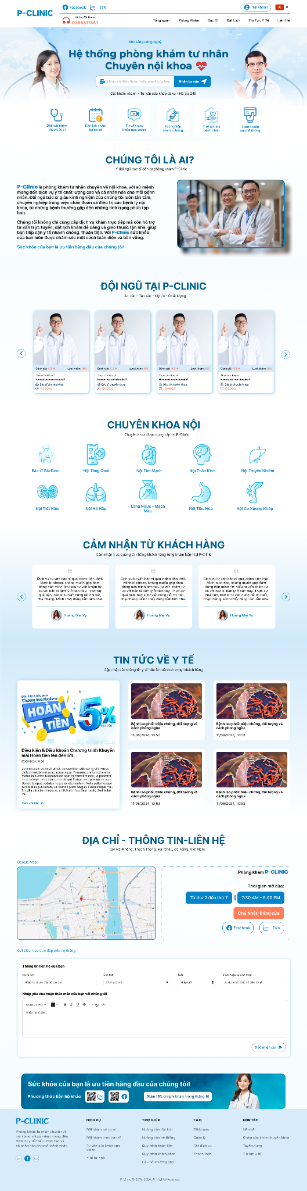

**Function Detail:**

| **#** | **Component** | **Comp. Type** | **Editable** | **Mandatory** | **Default Value** | **Description** |
| --- | --- | --- | --- | --- | --- | --- |
| 1 | Banner section | | | | | Display basic information |
| 2 | Doctor introduction section | | | | | This component allows user to know about p-clinic |
| 3 | Doctors team section | | | | | Display doctors information |
| 4 | Name specialty section | | | | | List the clinic’s specialties |
| 5 | Feedback of user section | | | | | Display some significant feedback of users |
| 6 | News section | | | | | Display about medical or clinic news |
| 7 | Contact section | | | | | Everyone can send their contact information through email |

#### 3.3.2 Book Appointment

**Function Trigger**:

* The ***Book Appointment page screen*** is triggered when a user (everyone) access first the system and clicks on the “***Book Appointment***” option on navbar, it contains information of doctors for booking.

**Data Processing**:

1. The system retrieves the doctors data information and displays it in the respective fields.

**Screen Layout:**

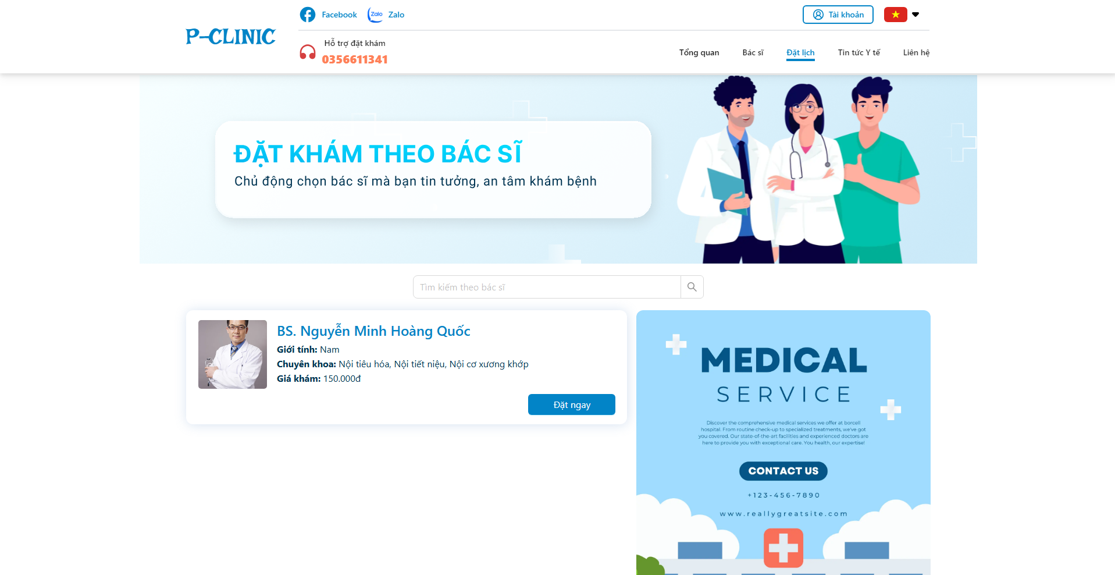

**Function Detail:**

| **#** | **Component** | **Comp. Type** | **Editable** | **Mandatory** | **Default Value** | **Description** |
| --- | --- | --- | --- | --- | --- | --- |
| 1 | ‘Doctor currently working’ Cards | | | | | Display information about doctors that are on duty for user to book |
| Full name | String | No | N/A. | N/A. |  |
|  | Avatar | Image | No | N/A. | N/A. |  |
|  | Gender | String | No | N/A. | N/A. |  |
|  | Specialty | String | No | N/A. | N/A. |  |
|  | Price | Number | No | N/A. | N/A. |  |
|  | “Book appointment” button | Button | No | N/A. | N/A. | ‘Clicking to this button’ allows user to navigate to ‘Make appointment screen‘ |

#### 3.3.3 News

**Function Trigger**:

* The ***News page screen*** is triggered when a user (everyone) first accesses the system and clicks on the “***News***” option on navbar, it contains information about news and blogs of healthcare in the world and in our clinic.

**Data Processing**:

1. The system retrieves the news data information and displays it in the respective fields.

**Screen Layout:**

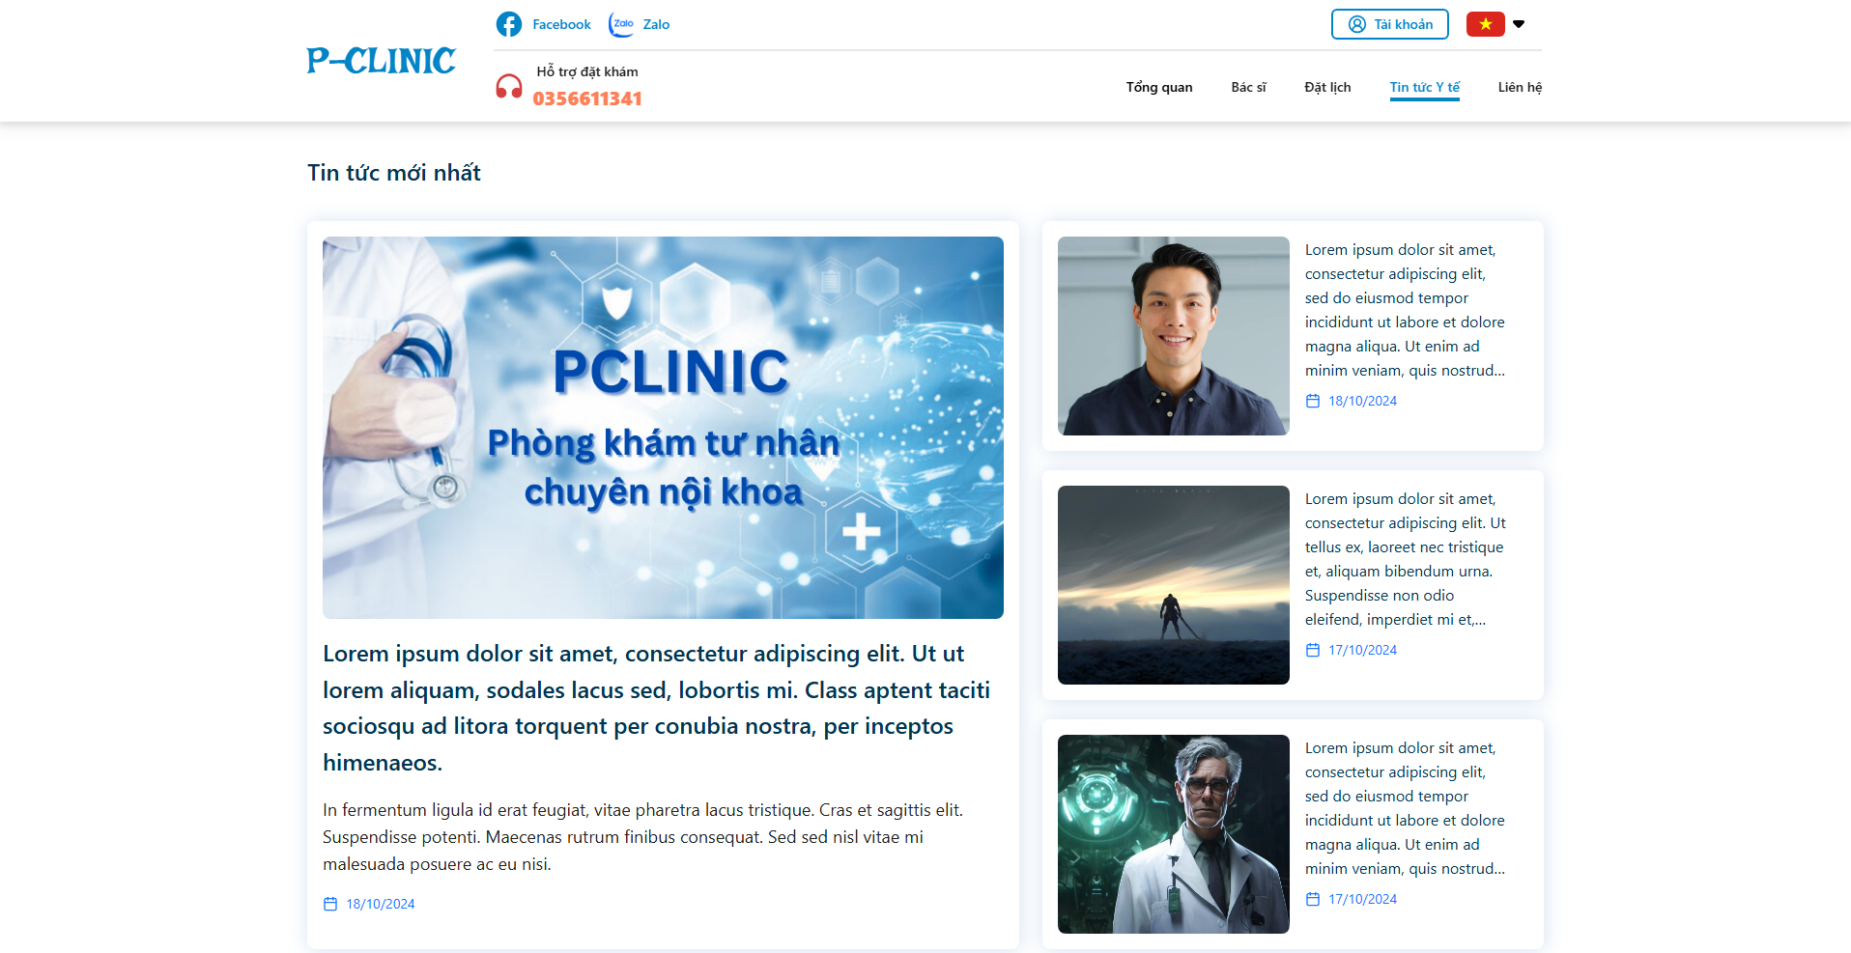

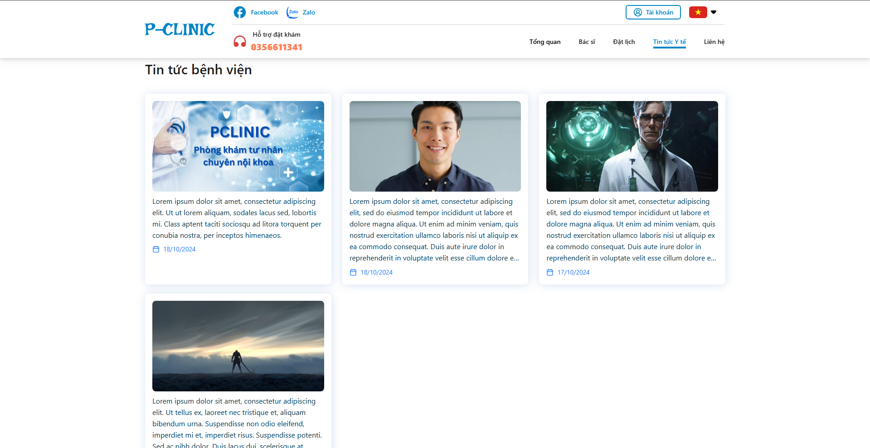

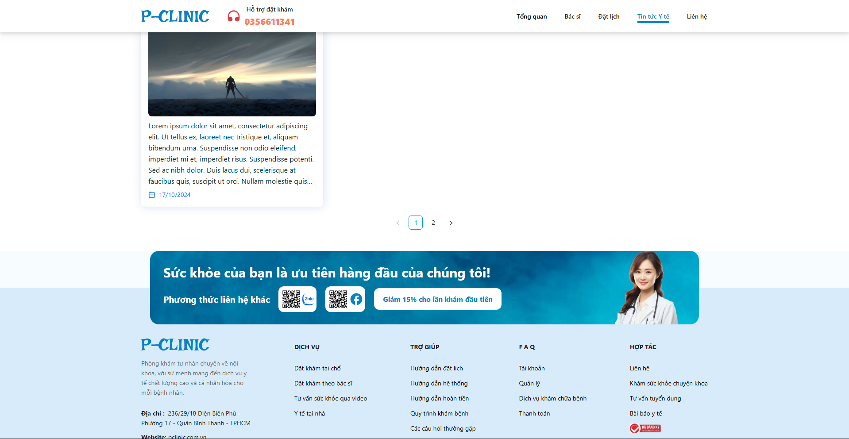

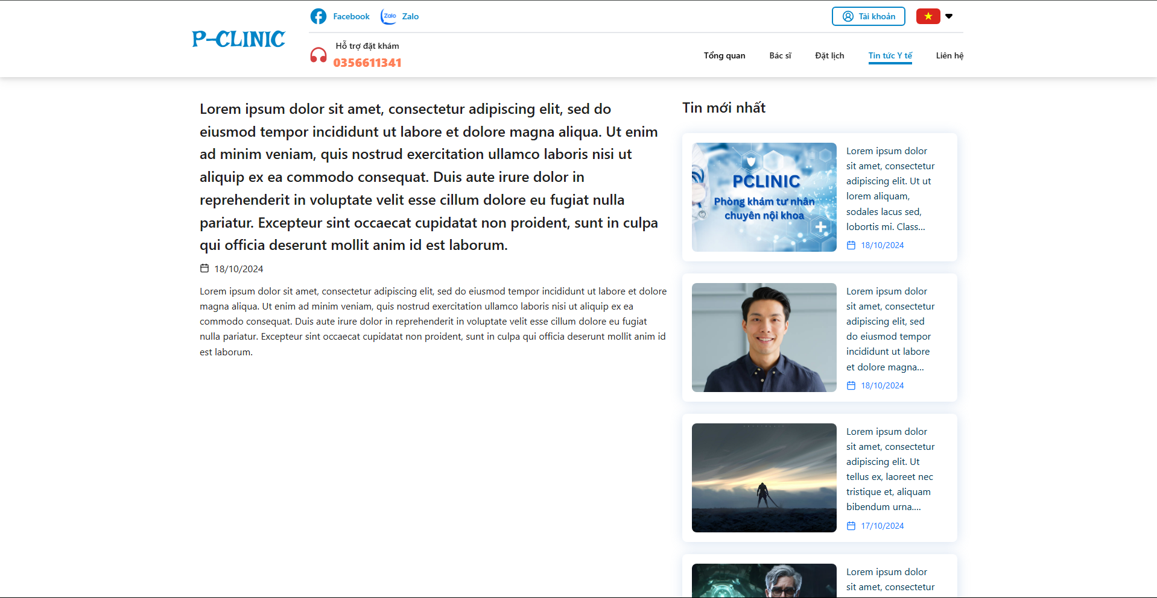

**Function Detail:**

| **#** | **Component** | **Comp. Type** | **Editable** | **Mandatory** | **Default Value** | **Description** |
| --- | --- | --- | --- | --- | --- | --- |
| 1 | ‘News’ Cards | | | | | Display information about news and blogs of healthcare in the world and in our clinic. If you click on this component, it will link to a detailed page about this blog. |
| Title | String | No | N/A. | N/A. |  |
|  | Image | Image | No | N/A. | N/A. |  |
|  | Description | String | No | N/A. | N/A. |  |
|  | Date | DateTime | No | N/A. | N/A. |  |

#### 3.3.4 Contact

**Function Trigger**:

* The ***Contact page screen*** is triggered when a user (everyone) first accesses the system and clicks on the “***Contact***” option on navbar, it contains information of our clinic for contacts.

**Data Processing**:

1. The system retrieves the contacts data information and displays it in the respective fields.

**Screen Layout:**

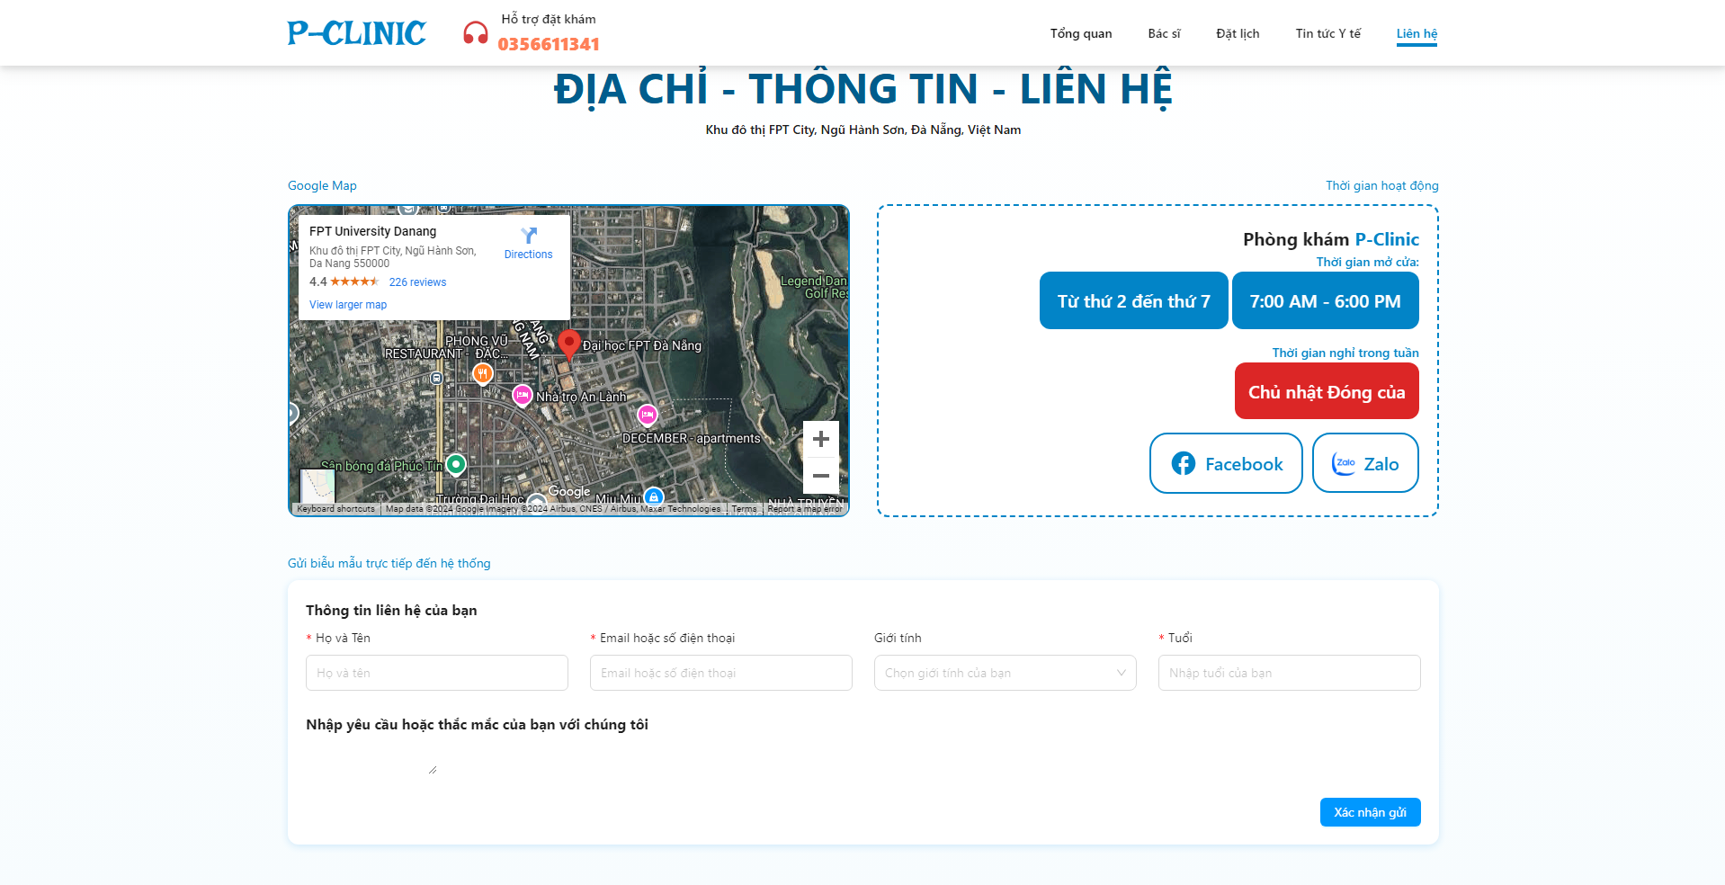

**Function Detail:**

| **#** | **Component** | **Comp. Type** | **Editable** | **Mandatory** | **Default Value** | **Description** |
| --- | --- | --- | --- | --- | --- | --- |
| 1 | ‘Google Map’ Cards | | | | | Display information about our location. |
| Map section | | | | | User can use mouse to move position on map |
| Zoom in | Button | No | N/A. | N/A. | Click to zoom in on map |
| Zoom out | Button | No | N/A. | N/A. | Click to zoom out on map |
| 2 | Active Time and our social media | | | | | Display open and close time of our clinic |
| Open time and close time | DateTime | No | N/A. | N/A. |  |
| Facebook information | | | | | Click to link to our fanpage on Facebook |
| Zalo information | | | | | Clink to link to our Zalo page contact |
| 3 | Form | | | | | Submit form directly to the system |
| Full Name | String | Yes | Yes | N/A. |  |
| Email or Phone number | String | Yes | Yes | N/A. |  |
| Gender | Enum | Yes | N/A | N/A. |  |
| Age | Number | Yes | Yes | N/A. |  |

### 3.4 Patient

#### 3.4.1 User Overview Screen

**Function Trigger**:

* The ***User Overview Screen*** is triggered when a user (patient) login the system or selects the "Overview" option from the side bar menu. Navigation path: **Home → Overview**

**Function Description**:

* **Actors/Roles**: Patient
* **Purpose**: The **User Overview Screen** allows users to overview user’s activities, such as the next appointment, total of appointments they took.
* **Interface**: The screen is divided into sections such as profile card, recent appointment history, private information and message from doctors

**Data Processing**:

1. The system retrieves the current user’s profile data and displays it in the respective fields.

**Screen Layout:**

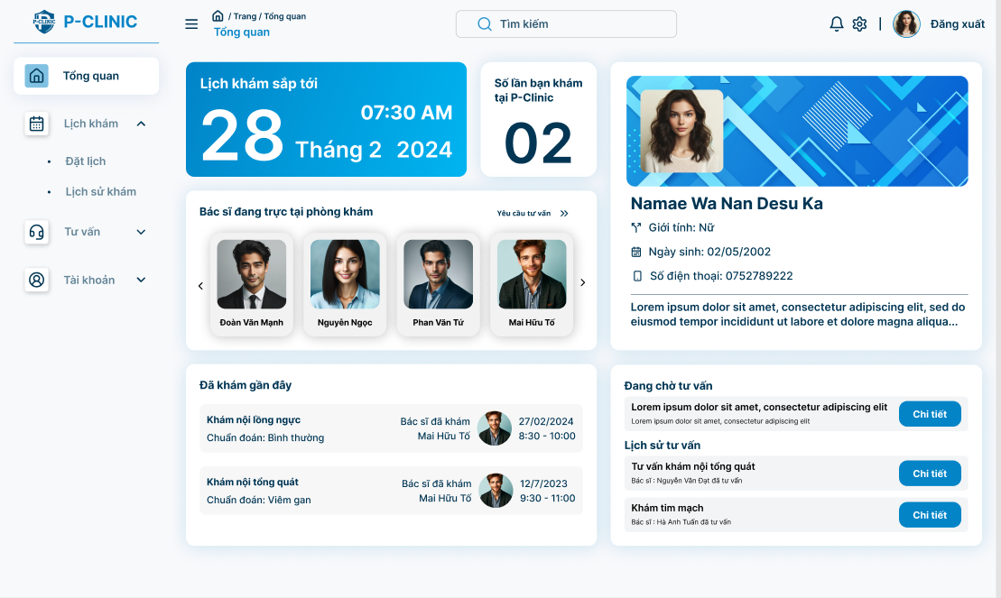

**Function Detail:**

| **#** | **Component** | **Comp. Type** | **Editable** | **Mandatory** | **Default Value** | **Description** |
| --- | --- | --- | --- | --- | --- | --- |
| 1 | Upcoming appointments: display the next appointment which patient make | | | | |  |
| Appointment’s time | DateTime | No | Yes | N/A |  |
| 2 | Statics number of appointment that patient made | | | | | This component allows user to know number of times they making appointment |
| 3 | Profile card: Display basic information of user | | | | | ‘Clicking to this card’ allows user to navigate to “User Profile Screen” |
| Full Name | Text | No | Yes | N/A. |  |
| Gender | Text | No | Yes | N/A. |  |
| Date of birth | DateTime | No | Yes | N/A. | DOB format: dd/MM/yyyy |
| Phone number | Text | No | Yes | N/A. |  |
| Avatar | FileUpload | No | Yes | Yes |  |
| Description | TextField - String | No | N/A | N/A |  |
| 4 | ‘Doctor currently working’ component | | | | | ‘Clicking to this component‘ allows user to navigate to ‘Make appointment screen‘ |
|  | Full name | String | No | N/A. | N/A. |  |
|  | Avatar | Image | No | N/A. | N/A. |  |
|  | Request consultation | text-link | No | N/A. | N/A. | This link allow users to navigate to ‘Request consultation screen’ |
| 5 | User appointment history | | | | | Display user some record of recent appointment |
| Doctor’s full name | String | No | N/A. | N/A. |  |
| Doctor’s avatar | Image | No | N/A. | N/A. |  |
| Appointment’s date time | DateTime | No | N/A. | N/A. |  |
| 6 | Message | TextField - String | No | N/A. | N/A. | Display message with clinic |
| Detail | Button | No | N/A | N/A | This button allows user to navigate to ‘Message screen’ |

### 

#### 3.4.2 User general information screen

**Function Trigger**:

* The **User general informationScreen** is triggered when a user (patient) selects the "Account" option from the side bar menu or clicks their username/avatar. Navigation path: **Home → Account → User Profile**.

**Function Description**:

* **Actors/Roles**: Patient
* **Purpose**: The **User Profile Screen** allows users to view their personal details, such as contact information, profile avatar and description.
* **Interface**: The screen is divided into sections such as profile card, recent appointment history, private information and message from doctors

**Data Processing**:

1. The system retrieves the current user’s profile data and displays it in the respective fields.

**Screen Layout**:

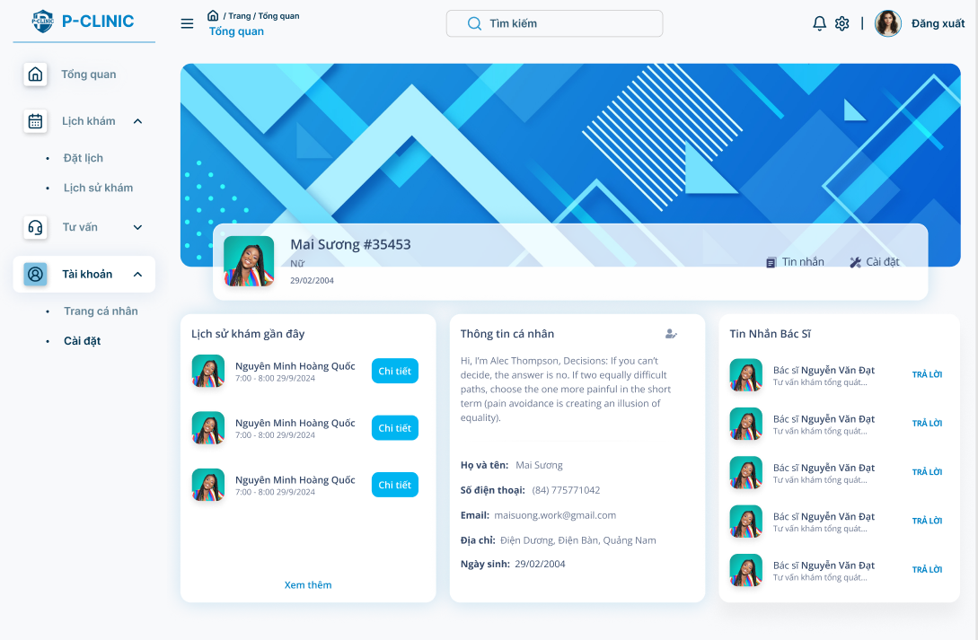

**Function Detail:**

| **#** | **Component** | **Comp. Type** | **Editable** | **Mandatory** | **Default Value** | **Description** |
| --- | --- | --- | --- | --- | --- | --- |
| 1 | Profile card: Display basic information of user | | | | | |
| Avatar | FileUpload | No | Yes | N/A. |  |
| Full Name | Text | No | Yes | N/A. |  |
| Gender | Text | No | N/A. | N/A. |  |
| Date of birth | DateTime | No | N/A. | N/A. | Dob format: dd/MM/yyyy |
| Message | Icon | No | Yes | Yes | This button allow user to navigate to “message screen” |
| 2 | Appointment history card: Display the recent appointment of user | | | | | |
| Recent appoint history | Label | No | Yes | N/A |  |
| Doctor’s avatar | FileUpload | No | Yes | N/A. |  |
| Doctor’s full name | Text | No | Yes | N/A |  |
| Appointment’s datetime | DateTime | No | Yes | N/A | Dob format: dd/MM/yyyy |
| Detail | Button | No | Yes | N/A. | This button allows user to view details of appointment (medical report screen) |
| View more | Link | No | Yes | N/A. | This link allow user to navigate to “user appointment history’s screen” |
| 3 | User’s information card | | | | | |
| User’s private information | Label | No | Yes | N/A |  |
| Full name | Text | No | Yes | N/A |  |
| Phone number | Text | No | Yes | N/A |  |
| Email | Text | No | Yes | N/A |  |
| Address | Text | No | Yes | N/A |  |
| Date of birth | DateTime | No | Yes | N/A | DOB format: dd/MM/yyyy |
| Description | Text | No | N/A | N/A |  |
| Edit profile | Icon | No | Yes | N/A | This icon allow user to navigate to “user profile screen” |
| 4 | Doctor’s message card | | | | | |
| Doctor’s avatar | FileUpload | No | N/A | N/A |  |
| Doctor’s full name | Text | No | Yes | N/A |  |
| Latest message | Text | No | Yes | N/A |  |
| Answer | Link | No | Yes | N/A | This link allows user to navigate to “message screen” |

### 

#### 3.4.3 Manage User Profile

##### 3.4.3.1 User profile screen

**Function Trigger**:

* The **User Profile Screen** is triggered when a user (clinic staff, doctor, or patient) selects the "Profile" option from the side bar menu, then clicks the icon ‘edit profile’ or clicks on the avatar of the user. Navigation path: **Home → Account → User Profile**.

**Function Description**:

* **Actors/Roles**: Patients
* **Purpose**: The **User Profile Screen** allows users to view, edit their personal details, such as contact information, profile avatar, and password. It helps keep user information up to date in the system.
* **Interface**: The screen is divided into sections such as profile card, personal information, changing password. Users can edit the information in the respective fields, and changes are saved by clicking the "Save" button.

**Data Processing**:

1. The system retrieves the current user’s profile data and displays it in the respective fields.
2. Users can update fields like contact number, address, or change their password.
3. Upon submitting, the system validates the input and updates the user's profile in the database.
4. A confirmation message appears once changes are successfully saved.

**Screen Layout**:

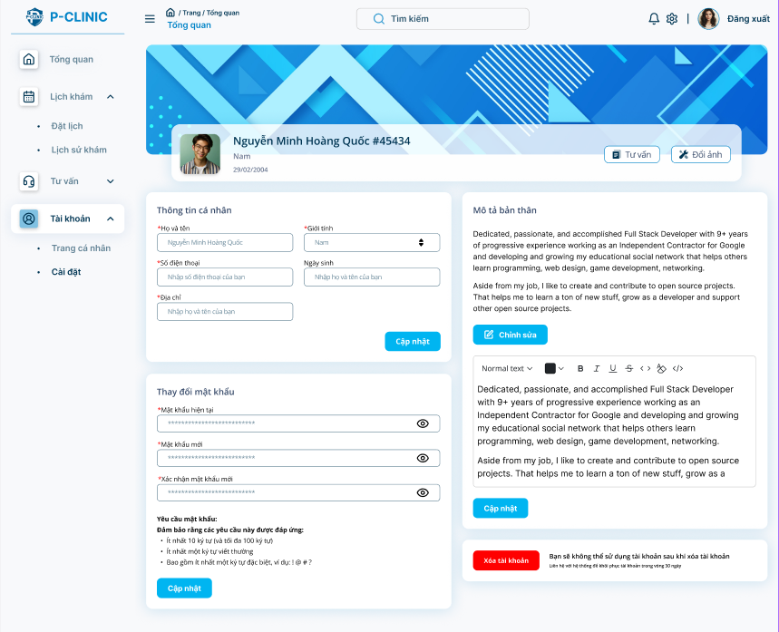

**Function Detail**:

| **#** | **Component** | **Comp. Type** | **Editable** | **Mandatory** | **Default Value** | **Description** |
| --- | --- | --- | --- | --- | --- | --- |
| 1 | Profile card: Display basic information of user | | | | | |
| Full Name | String | No | Yes | N/A. |  |
| Gender | Dropdown list - String | No | Yes | N/A. | Display option for user (Male, Female, Other) |
| Date of birth | DateTime | No | Yes | N/A. | DOB format: dd/MM/yyyy |
| Avatar | Image | Yes | Yes | Yes |  |
| Change avatar | Button | No | Yes | N/A | This button allow user to change new avatar |
| 2 | User’s private information form: Display private information about the user. | | | | | |
| Full Name | String | Yes | Yes | N/A. |  |
| Gender | Dropdown menu | Yes | Yes | N/A. | Display option for user (Male, Female, Other) |
| Phone Number | String | Yes | Yes | N/A. | The phone number must consist of digits only (0-9). No spaces, special characters or letters are allowed.  Max length: 11 digits |
| Date of birth | DateTime | Yes | N/A | N/A. | DOB format: dd/MM/yyyy |
| Address | String | Yes | Yes | N/A. |  |
| Edit | Button | No | Yes | N/A. | This button allows user to edit private information |
| 3 | Description | Text Editor | Yes | N/A | N/A. |  |
| Edit | Button | No | Yes | N/A. | This button allows user to edit descriptions only. |
| 4 | Delete | Button | Yes | Yes | N/A. | This button allows user to delete the account permanently. |
| 5 | Changing password | Label | No | Yes | N/A. |  |
| Current password | Input | Yes | Yes | N/A. |  |
| New password | Input | Yes | Yes | N/A. |  |
| Confirm new password | Input | Yes | Yes | N/A. |  |
| New password requirement | TextField - String | No | Yes | N/A. | This text allows users to know the suitable requirement of password. |
| Update | Button | No | Yes | N/A. | This button allows user to change their password. |

##### 3.4.3.2 Change user’s avatar

**Function Trigger**:

* The **Change Avatar Function** is triggered when a user clicks the "Change Avatar" button on the **User Profile Screen**. This allows users to update their profile picture. Navigation path: **Home → User Profile → Edit Profile → Change Avatar**.

**Function Description**:

* **Actors/Roles**: Patient.
* **Purpose**: The **Change Avatar Function** allows users to personalise their profile by uploading a new profile avatar, which is displayed throughout the clinic management system.
* **Interface**: Users are presented with an image upload interface where they can select a new image from their device. The uploaded image is displayed as a preview before saving.
* **Data Processing**:
  1. **Image Selection**: The user selects an image file from their device.
  2. **Image Validation**:
     + The system validates the image format (e.g., PNG, JPEG) and file size (e.g., maximum 2 MB).
     + If the image does not meet the criteria, an error message is displayed.
  3. **Saving the Image**:
     + Once the user confirms the avatar change by clicking the "Save" button, the image is uploaded to the server.
     + The server stores the image, and the user's profile is updated with the new avatar.
     + A success message is displayed upon completion.

**Screen Layout**:



**Function Detail**:

| **#** | **Component** | **Comp. Type** | **Editable** | **Mandatory** | **Default Value** | **Description** |
| --- | --- | --- | --- | --- | --- | --- |
| 1 | Change avatar | Button | No | Yes | “Change Avatar” | This button allow user to change new avatar |
| **Action** | | | | | | |
| **Name** | | **Success** | | **Failure** | | **Description** |
| Change avatar | | Display message “Update avatar successfully.” | | Display message “Update avatar failed.” | | Update user’s avatar |

##### 3.4.3.3 Edit user’s informations

**Function Trigger**:

* The **Edit User Information Function** is triggered when the user clicks the "Edit" button in the **User Profile** screen. This allows the user to modify their personal details (such as name, contact information, and address). The navigation path is: **Home → User Profile → Edit Profile**.

**Function Description**:

* **Actors/Roles**: Patient.
* **Purpose**: The **Edit User Information Function** allows users to update personal details like full name, email address, phone number, and address. This ensures that user information in the clinic system remains accurate and current.
* **Interface**: The function provides an editable form interface with input fields for the user to update their personal information.
* **Data Processing**:
  1. **Data Loading**: The system retrieves the user’s current information (full name, email, phone number, and address) and populates the respective fields.
  2. **Input Validation**:
     + The system checks that required fields (e.g., full name, email, and phone number) are filled.
     + Validates the format of fields such as email and phone number.
  3. **Saving Changes**:
     + Once the user clicks "Save", the system validates the input and updates the user’s information in the database.
     + If the input is valid, a success message is displayed. If there are issues (e.g., invalid email), an error message is shown.
  4. **Cancel Action**:
     + If the user clicks "Cancel", any changes made are discarded and the system navigates back to the **User Profile Screen** without saving the information.

**Screen Layout**:



**Function Detail**:

| **#** | **Component** | **Comp. Type** | **Editable** | **Mandatory** | **Default Value** | **Description** |
| --- | --- | --- | --- | --- | --- | --- |
| 1 | Full Name | String | Yes | Yes | N/A. |  |
| Gender | Dropdownlist - String | Yes | Yes | N/A. |  |
| Phone Number | String | Yes | Yes | N/A. |  |
| Date of birth | DateTime | Yes | N/A | N/A. |  |
| Address | String | Yes | No | N/A. |  |
| Update | Button | No | Yes | “Update” | This button allows user to update private information |
| 2 | Description | TextField - String | Yes | N/A | N/A. |  |
| Edit | Button | No | Yes | “Edit” | This button allows user to edit description by text editor |
| Update | Button | No | Yes | “Update” | This button allows user to confirm update private information |
| **Action** | | | | | | |
| **Name** | | **Success** | | **Failure** | | **Description** |
| Update user information | | Display message “Update profile successfully.” | | Display message “Update profile failed.” | | Update user’s profile |

##### 3.4.3.4 Delete user’s account

**Function Trigger**:

* The **Delete Account Function** is triggered when a user selects the "Delete Account" button from the **User Profile** screen. This action allows users to permanently delete their account and remove their data from the clinic management system. The navigation path is: **Home → User Profile → Edit Profile → Delete Account**.

**Function Description**:

* **Actors/Roles**: Patient
* **Purpose**: The **Delete Account Function** provides users the ability to permanently remove their account and associated data from the system. Once the account is deleted, the user will no longer be able to log in, and their profile and data will be permanently erased.
* **Interface**:
  1. A confirmation modal/dialog is shown to confirm if the user really wants to delete the account.
  2. Upon confirmation, the system processes the request and removes the user’s account and related data.
* **Data Processing**:
  1. **Confirmation Dialog**:
     + A confirmation prompt is displayed, asking the user to confirm the deletion with a warning that the action is irreversible.
  2. **Deletion**:
     + After confirming, the system processes the request by removing the user's data from the database.
     + The user’s login credentials, personal information, and any related records are deleted.
  3. **Account Lockout**:
     + Once the account is deleted, the user is immediately logged out, and they will no longer have access to the system.
     + A success message or email confirmation may be sent indicating the account has been successfully deleted.

**Screen Layout:**



**Function Detail:**

| **#** | **Component** | **Comp. Type** | **Editable** | **Mandatory** | **Default Value** | **Description** |
| --- | --- | --- | --- | --- | --- | --- |
| 1 | Delete | Button | No | Yes | “Delete Account” | This button allows user to delete the account permanently. |
| **Action** | | | | | | |
| **Name** | | **Success** | | **Failure** | | **Description** |
| Delete user’s account | | Log out of the system | | Display message “Delete account failed.” | | Display pop up confirmation before deleting account |

##### 3.4.3.5 Changing user password

**Function Trigger**:

* The **Change Password Function** is triggered when a user selects the "Change Password" option from their **User Profile** screen. This allows users to update their account password. The navigation path is: **Home → User Profile → Edit Profile → Change Password**.

**Function Description**:

* **Actors/Roles**: Patient
* **Purpose**: The **Change Password Function** enables users to update their password for security purposes, ensuring that only authorised individuals can access their accounts.
* **Interface**: The function presents a form with fields for the current password, new password, and confirmation of the new password.
* **Data Processing**:
  1. **Input Fields**:
     + Users must enter their current password to verify their identity.
     + Users enter their new password and confirm it by re-entering the same password.
  2. **Input Validation**:
     + The system checks that the current password is correct.
     + The new password must meet security criteria (It is described on the component).
     + The new password and confirmation must match.
  3. **Password Update**:
     + If all validations pass, the system updates the user’s password in the database.
     + A success message is displayed, confirming the change.
     + If validation fails, appropriate error messages are shown to guide the user.

**Screen Layout**:



**Function Detail:**

| **#** | **Component** | **Comp. Type** | **Editable** | **Mandatory** | **Default Value** | **Description** |
| --- | --- | --- | --- | --- | --- | --- |
| 1 | Changing password | Label | N/A. | N/A. | N/A. |  |
| Current password | String | Yes | Yes | N/A. |  |
| New password | String | Yes | Yes | N/A. |  |
| Confirm new password | String | Yes | Yes | N/A. |  |
| New password requirement | TextField - String | No | N/A. | Yes | This text allows users to know the suitable requirement of password. |
| Update | Button | N/A. | N/A. | “Update password” | This button allows user to change password. |
| **Action** | | | | | | |
| **Name** | | **Success** | | **Failure** | | **Description** |
| Change password | | Display message “Change password successfully.” | | Display message “Change password failed.” | | Change account’s password |

#### 3.4.4 Make an appointment screen

##### 3.4.4.1 Doctor Selection

**Function Trigger**:

* This screen is triggered when a user navigates to make an appointment via the **Appointment -> Make an appointment**  option on the side bar menu

**Function Description**:

* **Actors**: Patient
* **Purpose**: Allows users to select a doctor for the appointment based on criteria like name, specialisation, or gender.
* **Interface**: A list of doctor’s card profiles for selecting the doctor by criteria.
* **Data Processing**: Retrieves and displays the list of doctors from the database based on filters. The selected doctor is then passed to the next screen.

**Screen Layout**:

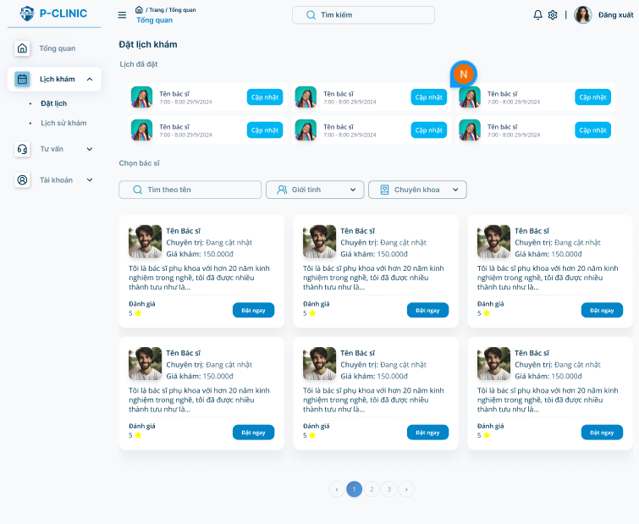

**Function Detail:**

| **#** | **Component** | **Comp. Type** | **Editable** | **Mandatory** | **Default Value** | **Description** |
| --- | --- | --- | --- | --- | --- | --- |
| 1 | Doctor’s profile card | | | | | |
| Avatar | FileUpload | No | Yes | Yes |  |
| Full Name | Text | No | Yes | N/A. |  |
| Specialty | Text | No | Yes | N/A. |  |
| Price | Number | No | Yes | N/A. |  |
| Description | Text | No | Yes | N/A. |  |
| Find by name | Text | No | Yes | N/A. | This filter allows users to search by name. |
| Find by specialty | Dropdown list - Text | No | Yes | N/A. | This filter allows users to search by specialty. |
| Find by gender | Dropdown list - Text | No | Yes | N/A. | This filter allows users to search by gender. |
| Book now | Button | No | Yes | “Book now” | This button allows user to choose a doctor who they want to make an appointment with. |
| 2 | Booked Appointment | | | | | |
|  | Avatar | FileUpload | No | Yes | Yes |  |
| Full Name | Text | No | Yes | N/A. | Display full name of doctor |
| Appointment’s Date | DateTime | No | Yes | N/A | Display start time and end time with the day of the booked appointment. |
| Update | Button | No | Yes | “Update” | Allow user to reschedule appointment |
| **Action** | | | | | | |
| **Name** | | **Success** | | **Failure** | | **Description** |
| Search doctor | | Display searched doctor. | | Display message “No doctor is suitable.” | | Display doctor by field |
| Choose doctor | | Display ‘Date Picker Screen’ | | Display message “This doctor is not available.” | | Choose a doctor who the patient wants to make an appointment with. |
| Reschedule appointment | | Display message “Reschedule successfully” | | Display message “Reschedule failed” | | Users can reschedule appointments only 1 time for each one. |

##### 3.4.4.2 Date Picker

**Function Trigger**:

* This screen is triggered once a user has selected a doctor from the **Doctor Selection Screen**.

**Function Description**:

* **Actors**: Patient
* **Purpose**: Allows users to select a date for the appointment with the chosen doctor.
* **Interface**: Calendar and available date slots for the selected doctor.
* **Data Processing**: Fetches and displays the available date slots for the selected doctor. Validates that the selected slot is available.

**Screen Layout**:

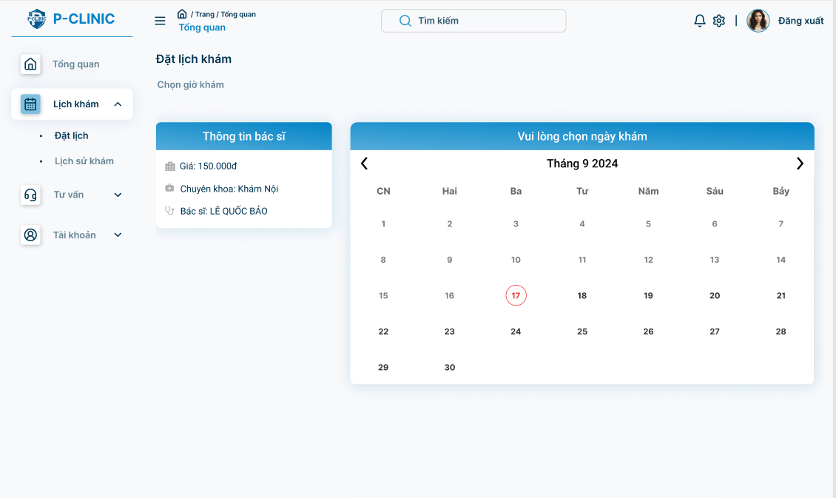

**Function Detail:**

| **#** | **Component** | **Comp. Type** | **Editable** | **Mandatory** | **Default Value** | **Description** |
| --- | --- | --- | --- | --- | --- | --- |
| 1 | Doctor’s information | Label | No | Yes | N/A |  |
| Full Name | Text | No | Yes | N/A. |  |
| Specialty | Text | No | Yes | N/A. |  |
| Price | Number | No | Yes | N/A. |  |
| 2 | Doctor’s working date | DateTime | No | N/A. | N/A. | This field allows user to know that available date of doctor you can make an appointment with. |
| **Action** | | | | | | |
| **Name** | | **Success** | | **Failure** | | **Description** |
| Choose appointment’s day | | Display ‘Time Picker Screen’ | | Disable date picker if day is not available | | Choose a day when the patient wants to make an appointment. |

##### 3.4.4.3 Time Picker

**Function Trigger**:

* This screen is triggered once a user has selected a doctor from the **Date Picker Screen**.

**Function Description**:

* **Actors**: Patient
* **Purpose**: Allows users to select a time for the appointment with the chosen doctor.
* **Interface**: Available time slots for the selected date.
* **Data Processing**: Fetches and displays the available time slots for the selected doctor and chosen date. Validates that the selected slot is available.

**Screen Layout**:

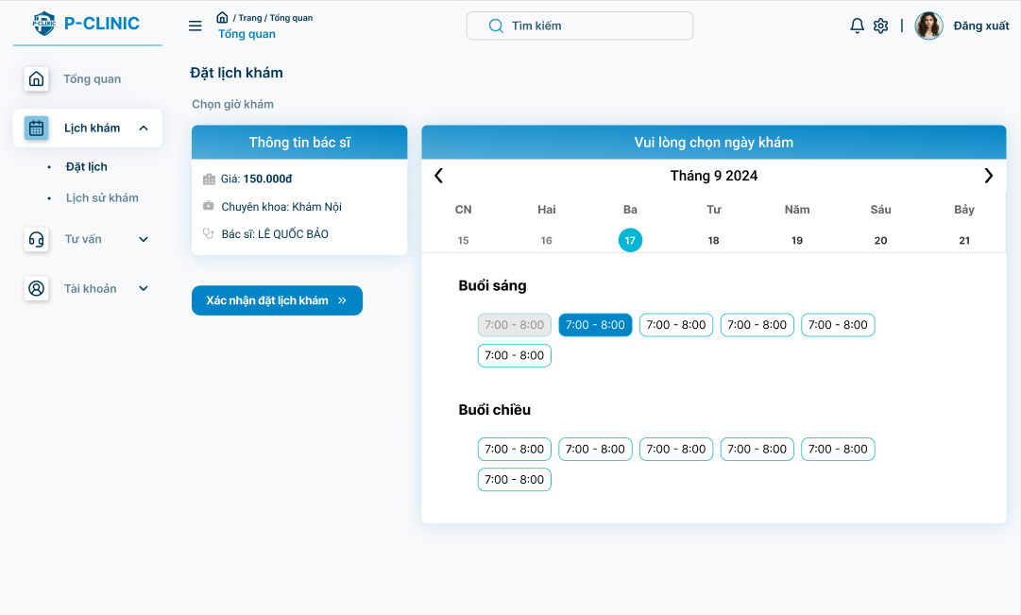

**Function Detail:**

| **#** | **Component** | **Comp. Type** | **Editable** | **Mandatory** | **Default Value** | **Description** |
| --- | --- | --- | --- | --- | --- | --- |
| 1 | Doctor’s information | Label | No | N/A | N/A |  |
| Full Name | Text | No | N/A. | N/A. |  |
| Specialty | Text | No | N/A. | N/A. |  |
| Price | Number | No | N/A. | N/A. |  |
| 2 | Doctor’s working hour | DateTime | No | N/A. | N/A. | This field allows users to know that available time on the date of doctor you can make an appointment with. |
| 3 | Confirm appointment | Button | No | Yes | N/A. | This button allows users to navigate to ‘Confirmation Screen’. |
| **Action** | | | | | | |
| **Name** | | **Success** | | **Failure** | | **Description** |
| Choose appointment’s time | | Display ‘Confirmation Screen’ | | N/A | | Choose time on the day when the patient wants to make an appointment. |

##### 3.4.4.4 Confirmation

**Function Trigger**:

* This screen is triggered after selecting a date and time from the **Date-Time Picker Screen** and clicking the "**Confirmation appointment**" button.

**Function Description**:

* **Actors**: Patient
* **Purpose**: Displays the summary of the selected appointment for final confirmation.
* **Interface**: Shows the selected doctor, date, time, and an optional field for additional notes.
* **Data Processing**: Confirms the booking by storing the selected data into the database and triggers a notification to the patient.

**Screen Layout**:

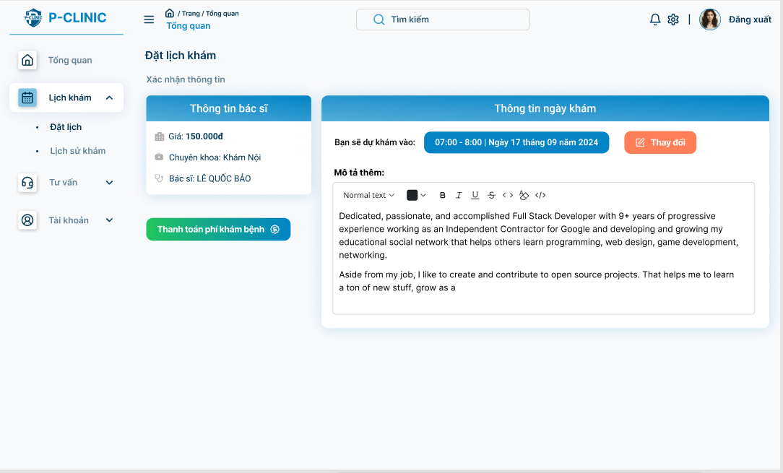

**Function Detail:**

| **#** | **Component** | **Comp. Type** | **Editable** | **Mandatory** | **Default Value** | **Description** |
| --- | --- | --- | --- | --- | --- | --- |
| 1 | Doctor’s information | Label | No | N/A | N/A |  |
| Full Name | String | No | N/A. | N/A. |  |
| Specialty | String | No | N/A. | N/A. |  |
| Price | Number | No | N/A. | N/A. |  |
| 2 | Appointment;’s date | DateTime | No | N/A. | N/A. | This field allows users to know the date of appointment. |
| 3 | Description | TextField - String | Yes | N/A. | N/A. | This field allows users to note anything to appointment. |
| 4 | Payment | Button | No | N/A. | N/A. | This button allows users to navigate to ‘Payment Screen’. |
| **Action** | | | | | | |
| **Name** | | **Success** | | **Failure** | | **Description** |
| Confirm booking | | Display ‘Proceed to Payment Screen’ | | Display message ’You must choose examined date’ | | Confirm information. |

##### 3.4.4.5 Proceed to Payment

**Function Trigger:**

* This screen is triggered after the user confirms the appointment details on the **Confirmation Screen** and clicks "**Proceed to Payment**".

**Function Description:**

* **Actors:** Patients
* **Purpose:** Allows users to complete the payment for their appointment. The payment screen ensures the transaction is processed before finalising the appointment booking.
* **Interface:** Displays payment options such as credit/debit card, online banking, or e-wallets, along with the total amount due (using VNPAY).
* **Data Processing:**
  + Validates payment details.
  + Processes the payment via the chosen payment method.
  + Updates the appointment status to "Paid" upon successful transaction.
  + Send a receipt or confirmation to the patient.

**Screen Layout: (VNPAY Screen)**

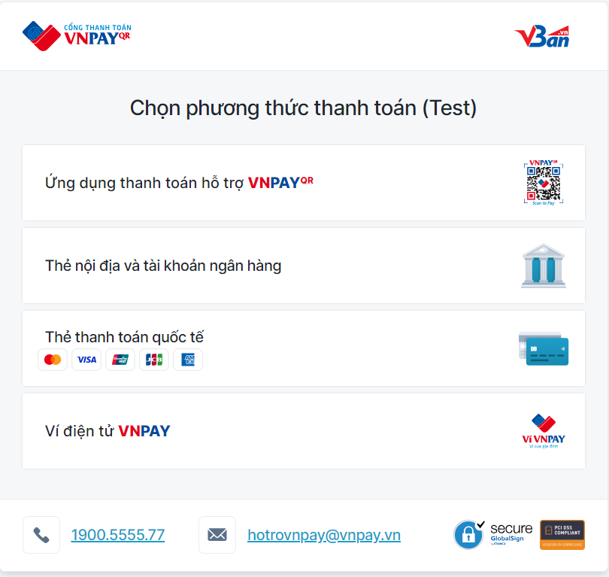

| **Action** | | | |
| --- | --- | --- | --- |
| **Name** | **Success** | **Failure** | **Description** |
| Process to payment | Display ‘Payment successfully’ bellow | Display ‘Payment failed’ bellow | Screen return based on result of payment |

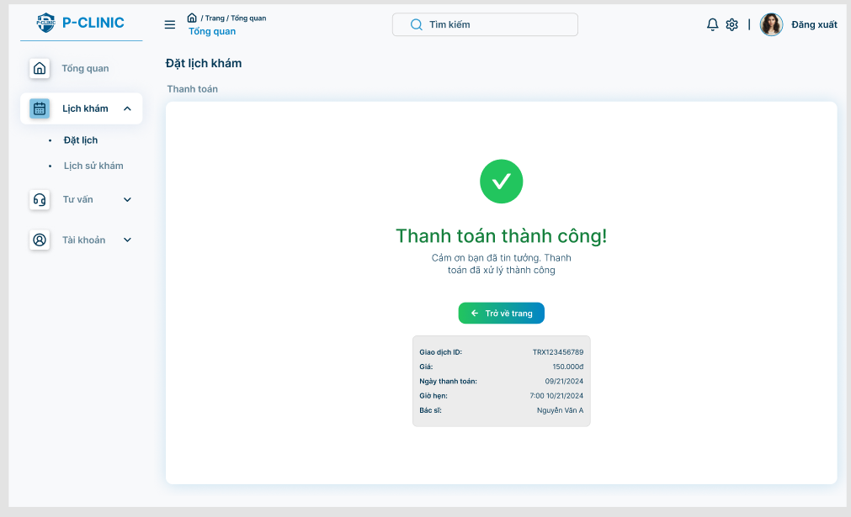

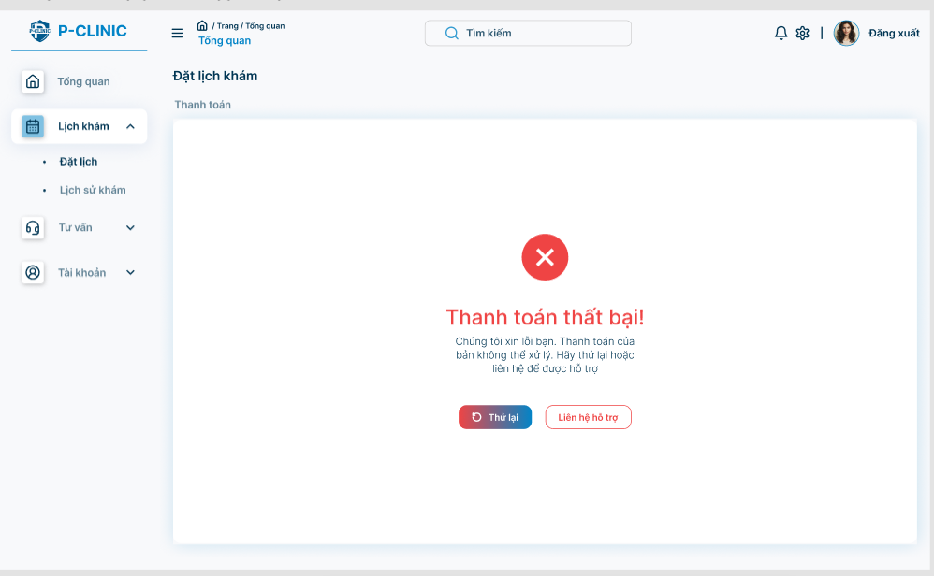

#### 3.4.5 Examined Information

##### 3.4.5.1 User appointment history

**Function Trigger:**

* This screen is accessed when a user (typically a patient) clicks on "**Appointment History**" from the side bar menu

**Function Description:**

* **Actors:** Patients
* **Purpose:** Displays a history of past appointments for the user.
* **Interface:** Shows appointment details such as doctor name, date, time, and consultation notes if applicable.
* **Data Processing:**
  + Retrieves the user’s appointment data from the database.
  + Filters and displays the data in reverse chronological order (most recent first).
  + Provides options to view details of each appointment

**Screen Layout:**

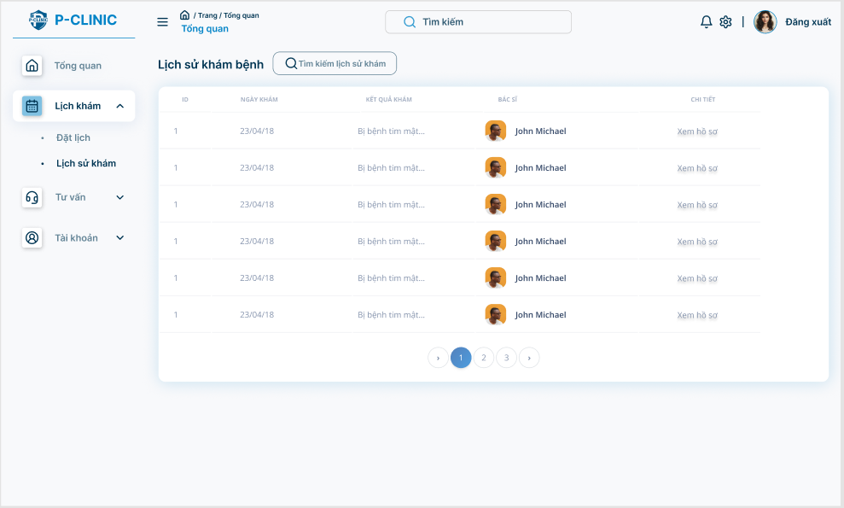

**Function Detail:**

| **#** | **Component** | **Comp. Type** | **E**d**itable** | **Mandatory** | **Default Value** | **Description** |
| --- | --- | --- | --- | --- | --- | --- |
| 1 | Appointment History | Label | No | Yes | N/A. |  |
| 2 | Id | Guid | No | Yes | N/A. |  |
| 3 | Diagnosis | Text | No | Yes | N/A. |  |
| 4 | Doctor's Avatar | FileUpload | No | Yes | N/A. |  |
| Doctor’s Name | Text | No | Yes | N/A. |  |
| 5 | Detail | Link | No | Yes | “View detail” | This link allow user to view detail of medical report (meaning navigate user to medical report screen) |
| **Action** | | | | | | |
| **Name** | | **Success** | | **Failure** | | **Description** |
| View detail | | Navigate to specific medical screen | | Stay at current screen | | Click specific link will show medical report’s detail of this appointment |

#### 

##### 3.4.5.2 Medical report screen

**Function Trigger:**

* This screen is accessed when a user (typically a patient) clicks on "**View Detail**" from **User appointment history screen**

**Function Description:**

* **Actors:** Patients
* **Purpose:** Displays a detail of medical report.
* **Interface:** Shows medical report details such as doctor information, patient information, appointment information and diagnosis of treatment
* **Data Processing:**
  + Retrieves the user’s medical report data from the database.
  + Displays the data
  + Provides options to view details of indication and prescription.

**Screen Layout:**

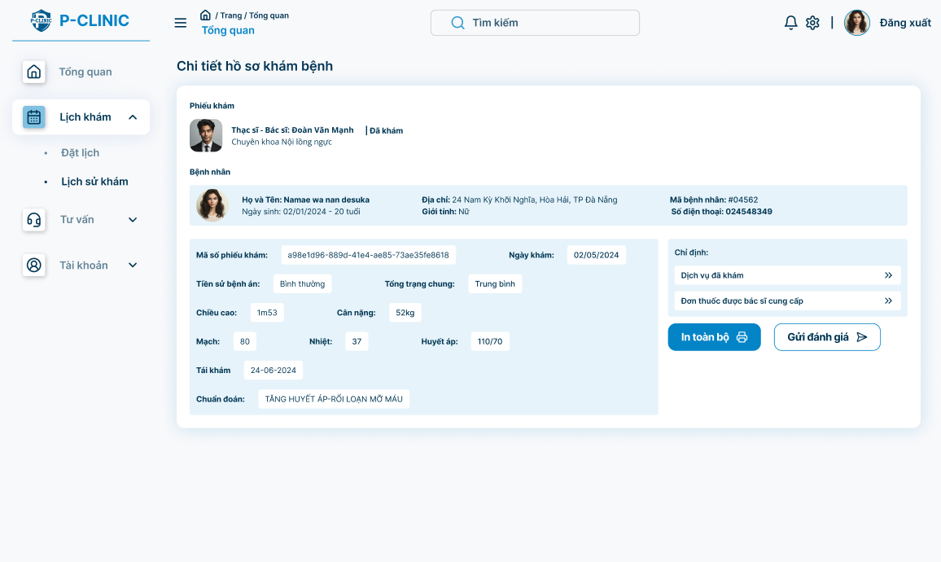

**Function Detail:**

| **#** | **Component** | **Comp. Type** | **Editable** | **Mandatory** | **Default Value** | **Description** |
| --- | --- | --- | --- | --- | --- | --- |
| 1 | Medical Report | Label | No | Yes | N/A |  |
| 2 | Doctor’s avatar | File Upload | No | N/A | N/A |  |
| Doctor's Name | Text | No | Yes | N/A |  |
| Doctor’s specialty | Text | No | Yes | N/A |  |
| 3 | Appointment’s status | Text | No | Yes | N/A | This field show status of appointment (on processing, done, absent) |
| 4 | Patient’s avatar | File Upload | No | N/A | N/A |  |
| Patient’s date of birth | DateTime | No | Yes | N/A |  |
| Patient’s age | Text | No | Yes | N/A |  |
| Patient’s address | Text | No | Yes | N/A |  |
| Patient’s gender | Text | No | Yes | N/A |  |
| Patient’s phone number | Text | No | Yes | N/A |  |
| 5 | Medical report code | Guid | No | Yes | N/A |  |
| Appointment’s date | DateTime | No | Yes | N/A |  |
| Medical History | Text | No | Yes | N/A |  |
| General Condition | Text | No | Yes | N/A |  |
| Weight | Text | No | Yes | N/A |  |
| Height | Text | No | Yes | N/A |  |
| Pulse | Text | No | Yes | N/A | Example: 80 |
| Temperature | Text | No | Yes | N/A | Example: 37 |
| Blood Pressure | Text | No | Yes | N/A | Example: 110/70 |
| Diagnosis | Text | No | Yes | N/A |  |
| 6 | Indication | Label | No | Yes | N/A |  |
| Service | Link | No | Yes | “Examined service” | Navigate user to “Service indication” screen |
| Prescription | Link | No | Yes | “Prescription providing by doctor” | Navigate user to “Prescription of treatment” screen |
| 7 | Print | Button | No | Yes | “Print” | Allow user to print medical report |
| 8 | Feedback | Button | No | Yes | “Send feedback” | Allow user to send feedback to doctor |
| **Action** | | | | | | |
| **Name** | | **Success** | | **Failure** | | **Description** |
| View Service Indication | | Navigate to “Service indication screen” | | Stay at current screen | | Allow patient to view service indication |
| View prescription | | Navigate to “Prescription indication screen” | | Stay at current screen | | Allow patient to view prescription |
| Send feedback | | Navigate to feedback screen | | Stay at current screen | | Allow patient feedback doctor through appointment |
| Print | | Print medical report | | N/A | | Print medical report |

#### 

##### 3.4.5.3 Service indication

**Function Trigger:**

* This screen is accessed when a user (typically a patient) clicks on "**Service**" link from **Medical Report Screen**

**Function Description:**

* **Actors:** Patients
* **Purpose:** Displays an indication’s service.
* **Interface:** Shows examined service details such as code, name and price of service.
* **Data Processing:**
  + Retrieves the user’s service data which they order from the database.
  + Displays the data.
  + Provides options to view results of the service.

**Screen Layout:**

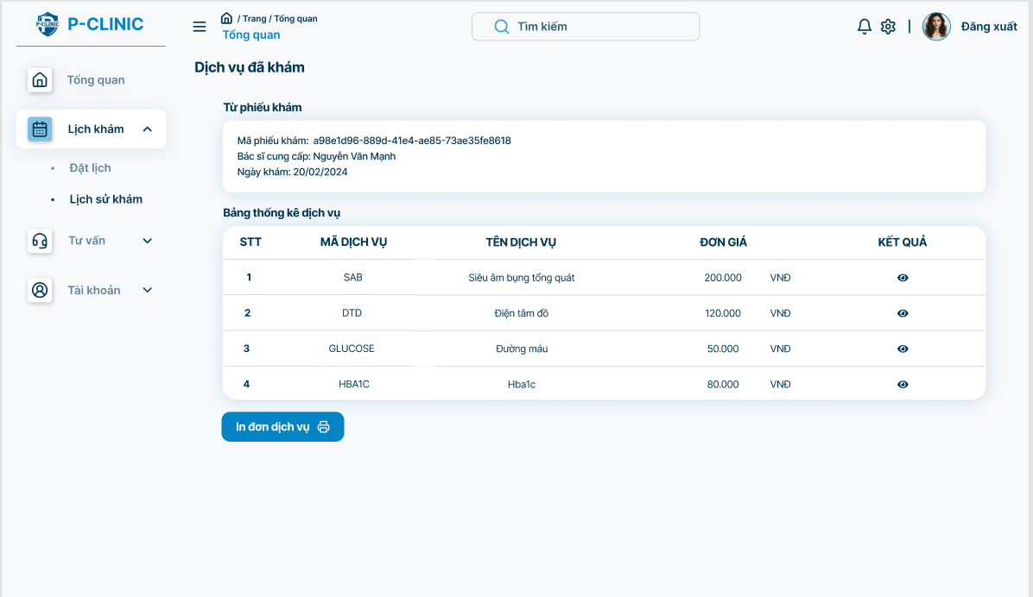

**Function Layout:**

| **#** | **Component** | **Comp. Type** | **Editable** | **Mandatory** | **Default Value** | **Description** |
| --- | --- | --- | --- | --- | --- | --- |
| 1 | From Medical Report | Label | No | Yes | N/A |  |
| Medical Report’s code | Guid | No | Yes | N/A |  |
| Doctor’ Full name | Text | No | Yes | N/A | Display name of doctor providing the medical report. |
| Appointment’s Date | DateTime | No | Yes | N/A | Format Date: dd/MM/yyyy |
| 2 | Static Service Table | Label | No | Yes | N/A |  |
|  | Code | Text | No | Yes | N/A | Display code of service |
|  | Name | Text | No | Yes | N/A | Display name of service |
|  | Price | Number | No | Yes | N/A | Display price of service |
| 3 | View result | Icon | No | Yes | N/A | View result of service |
| 4 | Print | Button | No | Yes | “Print service order” |  |
| **Action** | | | | | | |
| **Name** | | **Success** | | **Failure** | | **Description** |
| View result | | View result of each service | | Display message “Result is not available yet” | | Allow the patient to view the result of each service. |
| Print | | Print medical report | | N/A | | Print medical report |

#### 

##### 3.4.5.4 Prescription indication

**Function Trigger:**

* This screen is accessed when a user (typically a patient) clicks on "**Prescription**" link from **Medical Report Screen**

**Function Description:**

* **Actors:** Patients
* **Purpose:** Displays an indication's medicine.
* **Interface:** Shows examined medicine details such as name, using way, quantity of medicine
* **Data Processing:**
  + Retrieves the user’s indication medicine data from the database.
  + Displays the data.

**Screen Layout:**

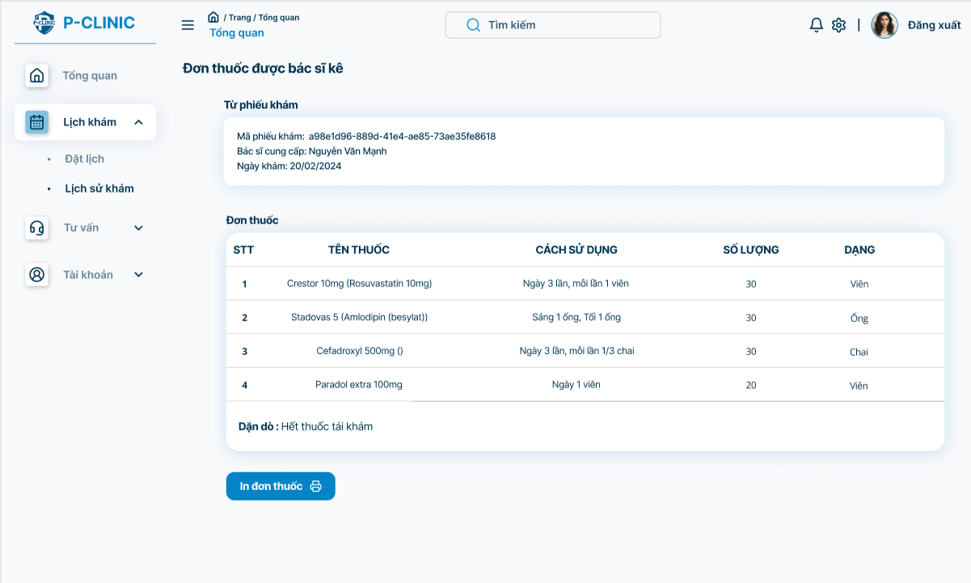

**Detail Function:**

| **#** | **Component** | **Comp. Type** | **Editable** | **Mandatory** | **Default Value** | **Description** |
| --- | --- | --- | --- | --- | --- | --- |
| 1 | From Medical Report | Label | No | Yes | N/A |  |
| Medical Report’s code | Guid | No | Yes | N/A |  |
| Doctor’ Full name | Text | No | Yes | N/A | Display name of doctor providing the medical report. |
| Appointment’s Date | DateTime | No | Yes | N/A | Format Date: dd/MM/yyyy |
| 2 | Medicine’s indication | Label | No | Yes | N/A |  |
|  | Name | Text | No | Yes | N/A | Display name of medicine |
|  | Type | Text | No | Yes | N/A | Display type of medicine |
|  | Quantity | Number | No | Yes | N/A | Display dosage of medicine |
| 3 | Description | Text | No | Yes | N/A | Display doctor’s note for patient |
| 4 | Print | Button | No | Yes | “Print service order” |  |
| **Action** | | | | | | |
| **Name** | | **Success** | | **Failure** | | **Description** |
| Print | | Print prescription | | N/A | | Print prescription |

#### 

##### 3.4.5.5 Feedback

**Function Trigger:**

* This screen is accessed when a user (typically a patient) clicks on "**Feedback**" button from **Medical Report Screen**

**Function Description:**

* **Actors:** Patients
* **Purpose:** Patient can feedback doctor through appointment.
* **Interface:** The function provides an editable form interface with input fields for the user to feedback doctor
* **Data Processing:**
  + Retrieves the doctor’s rating data from the database.
  + Displays the data.
  + Provides options to send feedback to the doctor.

**Screen Layout:**

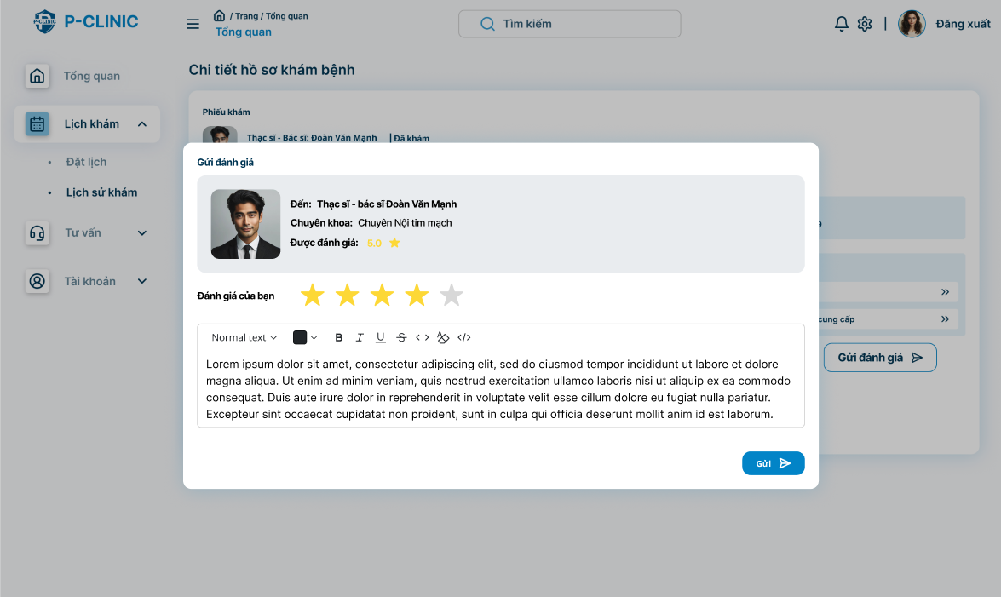

**Function Detail:**

| **#** | **Component** | **Comp. Type** | **Editable** | **Mandatory** | **Default Value** | **Description** |
| --- | --- | --- | --- | --- | --- | --- |
| 1 | Send feedback | Label | No | Yes | N/A |  |
| 2 | Doctor’s Full name | Text | No | Yes | N/A | Display full name of doctor |
| Doctor’s Specialty | Text | No | Yes | N/A | Display specialty of doctor |
| Doctor’s Rating | Number | No | Yes | N/A | Show rating of doctor |
| 3 | Rating’s point | Number | Yes | Yes | N/A | Display 5 stars related to 5 marks of rating. |
| Rating’s content | Text | Yes | No | N/A |  |
| **Action** | | | | | | |
| **Name** | | **Success** | | **Failure** | | **Description** |
| Send feedback | | Display message “Send feedback to doctor successfully” | | Display message “Send feedback to doctor failed” | | Send feedback to the doctor |

#### 

#### 3.4.6 Consultation Screen

##### 3.4.6.1 Create Consultation Request

**Function Trigger:**

* This screen is accessed when a user (typically a patient) clicks on the "**Consultation**" option -> “**Waiting room**” from the side bar menu then clicks the “**Create request consultation**” button.

**Function Description:**

* **Actors:** Patients
* **Purpose:** Patient wants to create a request consultation with a clinic.
* **Interface:** The function provides an editable form interface with input fields for the user to create their consultation’s topic and information.
* **Data Processing**:
  + **Data Loading**: The system retrieves the user’s current information (full name, phone number, and address) and populates the respective fields.
  + **Input Validation**: The system checks that required fields (topic) are filled.
  + **Create Request**:
    - Once the user clicks "Send request", the system validates the input and updates the user’s information in the database.
    - If the input is valid, a success message is displayed. If there are issues (e.g., invalid email), an error message is shown.

**Screen Layout:**

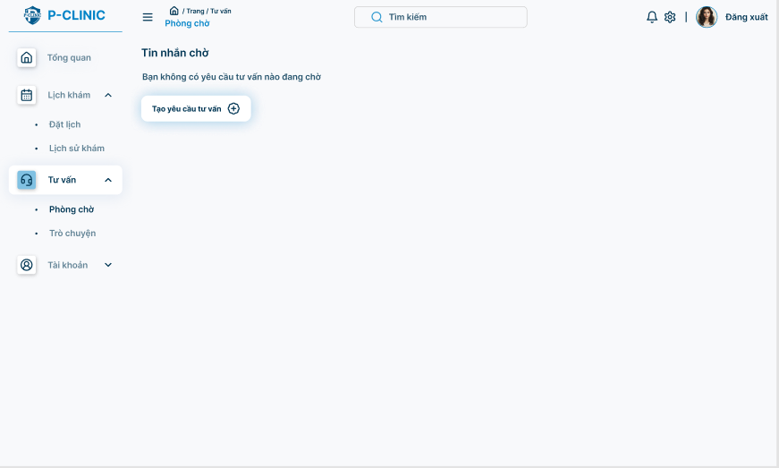

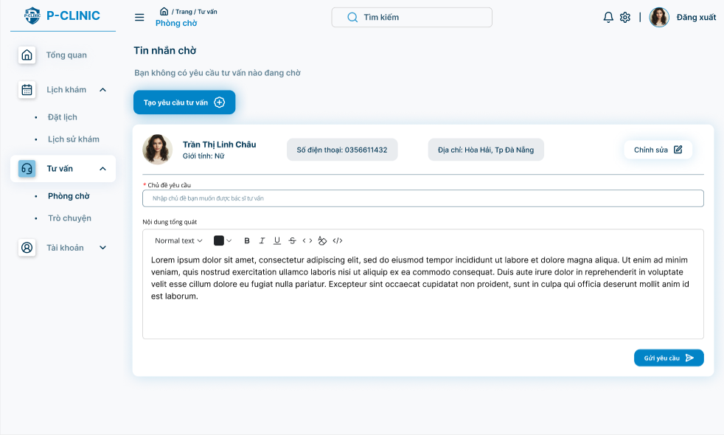

**Function Detail**

| **#** | **Component** | **Comp. Type** | **Editable** | **Mandatory** | **Default Value** | **Description** |
| --- | --- | --- | --- | --- | --- | --- |
| 1 | Waiting message | Label | No | Yes | N/A |  |
| 2 | Create consultation request | Button | No | Yes | “Create consultation request” | The button allows user to show ‘Create consultation request’ form |
| 3 | Avatar | File Upload | No | Yes |  | Display avatar of user |
| Name | Text | No | Yes |  | Display name of user |
| Gender | Text | No | Yes |  | Display gender of user |
| Phone Number | Text | Yes | Yes |  | Display phone number of user |
| Address | Text | Yes | Yes |  | Display address of user |
| Edit | Button - Icon | Yes | Yes |  | This button allows users to update phone number and address in this form. |
| 4 | Topic | Text | Yes | Yes |  | Input topic of consultation |
|  | Content | Text | Yes | Yes |  | Input content of consultation |
|  | Send request | Button | No | Yes |  | This button allows users to send a request consultation to clinic |
| **Action** | | | | | | |
| **Name** | | **Success** | | **Failure** | | **Description** |
| Create consultation request | | Display text editor to create consultation | | N/A | | Patient can create a request if he/she does not have any request consultation at the moment. |
| Edit | | Display message “Update profile successfully.” | | Display message “Update profile failed.” | | Number and address field will be enabled to be edited. |
| Send request | | Display message “Create consultation request successfully” | | Display message “Create consultation request failed” | | Send a request consultation to clinic |

#### 

##### 3.4.6.2 View Consultation Request

**Function Trigger:**

* This screen is accessed when a user (typically a patient) clicks on the "**Consultation**" option -> “**Waiting room**” from the side bar menu.

**Function Description:**

* **Actors:** Patients
* **Purpose:** Patient wants to view request consultation with a clinic.
* **Interface:** The function provides an editable form interface with input fields for the user to create their consultation’s topic and information.
* **Data Processing**: The system retrieves the user’s request consultation (topic, content …)

**Screen Layout:**

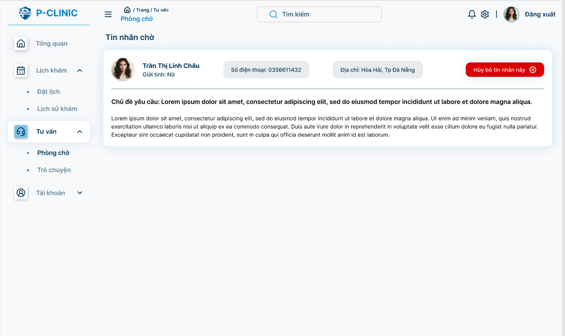

**Function Detail:**

| **#** | **Component** | **Comp. Type** | **Editable** | **Mandatory** | **Default Value** | **Description** |
| --- | --- | --- | --- | --- | --- | --- |
| 1 | Waiting message | Label | No | Yes | N/A |  |
| 2 | Create consultation request | Button | No | Yes | “Create consultation request” | The button allows user to show ‘Create consultation request’ form. |
| 3 | Avatar | File Upload | No | Yes |  | Display avatar of user. |
| Name | Text | No | Yes |  | Display name of user. |
| Gender | Text | No | Yes |  | Display gender of user. |
| Phone Number | Text | No | Yes |  | Display phone number of user. |
| Address | Text | No | Yes |  | Display address of user. |
| 2 | Topic | Text | No | Yes |  | Display topic of consultation. |
|  | Content | Text | No | Yes |  | Display content of consultation. |
| 3 | Delete | Button | No | Yes |  | This button allows user to delete consultation request. |
| **Action** | | | | | | |
| **Name** | | **Success** | | **Failure** | | **Description** |
| Delete | | Display message “Delete consultation request successfully.” | | Display message “Delete consultation request failed.” | | Delete consultation request of user. |

#### 

##### 3.4.6.3 Message

**Function Trigger:**

* This screen is accessed when a doctor/staff clicks on the “**Consultation**” **->** “**Message**” option from the sidebar menu.

**Function Description:**

* **Actors:** Patient
* **Purpose:** User can view messages with the doctor.
* **Interface:** Display chat box with doctor.

**Screen Layout:**

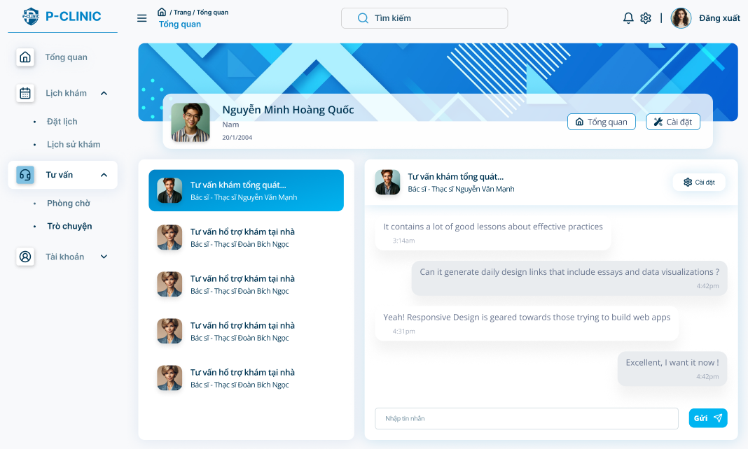

**Detail Function:**

|  |  |  |  |  |  |  |
| --- | --- | --- | --- | --- | --- | --- |
| **#** | **Component** | **Comp. Type** | **Editable** | **Mandatory** | **Default Value** | **Description** |
| 1 | Profile card: display user profile’s card | | | | | |
| Full name | Text | No | Yes | N/A. | Display the name of doctor |
| Gender | Text | No | Yes | N/A. | Display the gender of doctor |
| Avatar | File Upload | No | N/A. | N.A | Display the avatar of doctor |
| 2 | Send message | Input - Textbox | Yes | Yes | N/A | Input the message |
| 3 | Send | button | No | Yes | “Send” | Allow patient to send message to doctor |
| 4 | Call | Button | No | Yes | “Call” | Allow patient to make a call with doctor |
| **Action** | | | | | | |
| **Name** | | **Success** | | **Failure** | | **Description** |
| Send message | | “Message display on screen” | | Display message “Send message fail” | | AI can hint doctor who suitable with their problem |
| Call | | “Display call screen” | | ‘N/A’ | | Patient can meet doctor through video call method |

##### 3.4.6.4 Video call

**Function Trigger:**

* This screen is accessed when a doctor/staff clicks on the “**Consultation**” **->** “**Message**” option from the sidebar menu.

**Function Description:**

* **Actors:** Patient
* **Purpose:** User can receive a video call with the doctor.
* **Interface:** Display video call screen modal

**Screen Layout:**

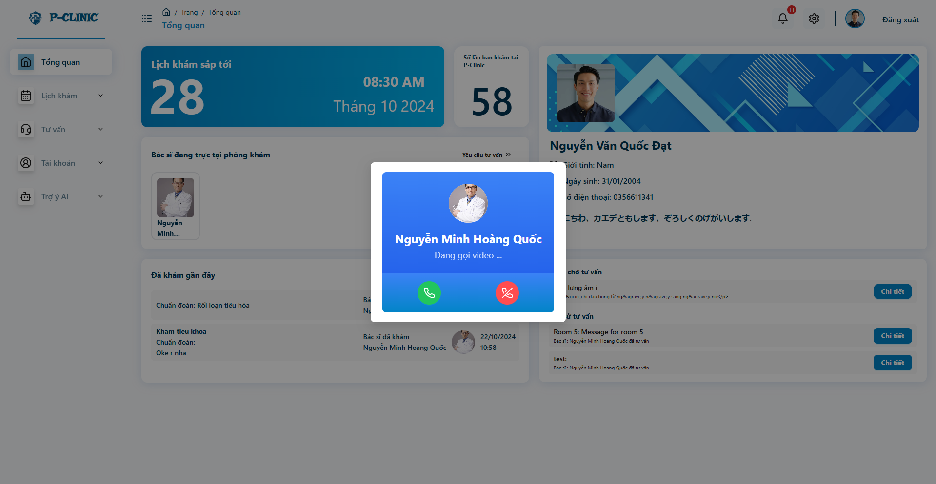

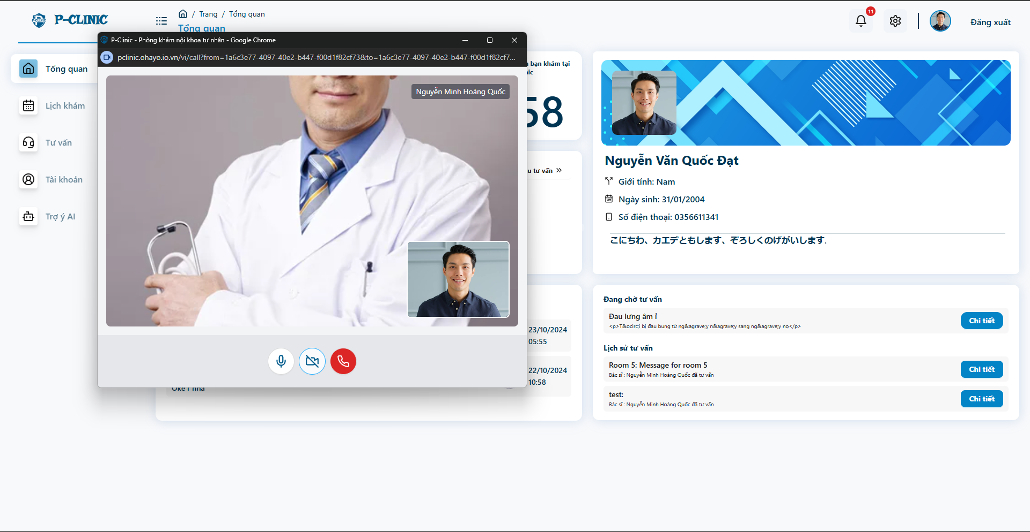

**Detail Function:**

|  |  |  |  |  |  |  |
| --- | --- | --- | --- | --- | --- | --- |
| **#** | **Component** | **Comp. Type** | **Editable** | **Mandatory** | **Default Value** | **Description** |
| 1 | Pending receive modal | | | | | |
| Full name | Text | No | Yes | N/A. | Display the name of doctor |
| Avatar | File Upload | No | Yes | N/A. | Display the avatar of doctor |
| Pending call status | Text | No | N/A. | N.A | Display the status of the call |
| Reject Button | Button | No | N/A | Rejected | Click to reject the call |
| Receive Button | Button | No | N/A | Received | Click to receive the call |
| 2 | Calling window popup | | | | | |
|  | Doctor Figure | File Upload / Stream Data | No | N/A | N/A | Display doctor Avatar Or Video Stream Data |
|  | Self Figure | File Upload/ Stream Data | No | N/A | N/A | Display seft avatar or video stream data |
|  | Micro Button | Button | No | N/A | On | To turn off/on voice input |
|  | Video button | Button | No | N/A | On/Off | To turn off/on video input |
|  | End call button | Button | No | N/A | No | Click to end the call |
| **Action** | | | | | | |
| **Name** | | **Success** | | **Failure** | | **Description** |
| Rejected | | Open call window | | Back to normal screen | | Reject the call time from doctor and back to the normal screen |
| Receive | | Appear call window | | Back to normal screen | | Receive the call time from doctor, can turn off/on video call or voice call |

#### 3.4.7 AI chat box

**Function Trigger:**

* This screen is accessed when a doctor/staff clicks on the “**AI**” **->** “**Chat with AI**” option from the sidebar menu.

**Function Description:**

* **Actors:** Patient
* **Purpose:** Users can chat with AI about their problems.
* **Interface:** Display chat box with AI.

**Screen Layout:**

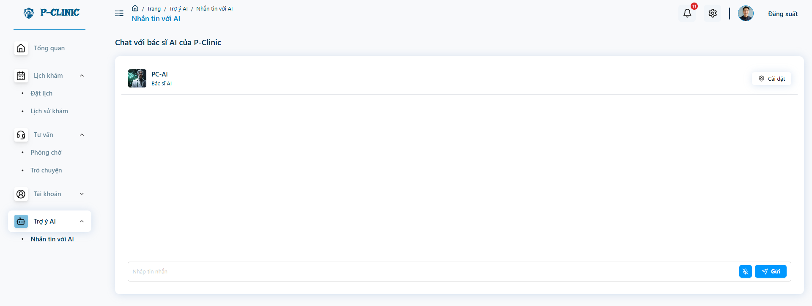

**Detail Function:**

|  |  |  |  |  |  |  |
| --- | --- | --- | --- | --- | --- | --- |
| **#** | **Component** | **Comp. Type** | **Editable** | **Mandatory** | **Default Value** | **Description** |
| 1 | Send message | Input - Textbox | Yes | Yes | N/A | Input the message |
| 2 | Send | button | No | Yes | “Send” | Allow doctor/staff to send message to patient |

### 3.5 Doctor

#### 3.5.1 Doctor Overview Screen

**Function Trigger**:

* The ***Doctor Overview Screen*** is triggered when a doctor login the system or selects the "**Overview**" option from the side bar menu.

**Function Description**:

* **Actors/Roles**: Doctor
* **Purpose**: The **Doctor Overview Screen** allows doctors to overview doctor’s activities, such as the schedule working hours, available state, queue room, information doctor .
* **Interface**: The screen is divided into sections such as profile card, schedule working calendar, private information and messages from patients…

**Data Processing**:

1. The system retrieves the current doctor’s profile data and displays it in the respective fields.

**Screen Layout:**

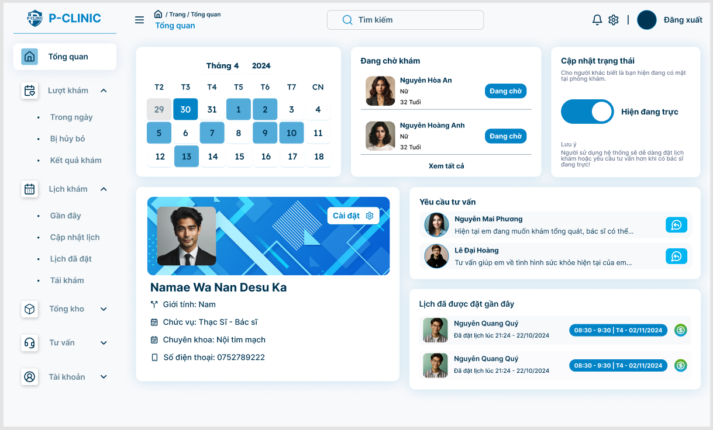

**Function Detail:**

| **#** | **Component** | **Comp. Type** | **E**d**itable** | **Mandatory** | **Default Value** | **Description** |
| --- | --- | --- | --- | --- | --- | --- |
| 1 | Upcoming appointments: display the schedule of doctor | | | | |  |
| Appointment’s time | DateTime | No | N/A | N/A |  |
| 2 | Profile card: Display basic information of doctor | | | | | ‘Clicking to this card’ allows user to navigate to ‘Doctor profile screen’ |
| Full Name | Text | No | Yes | N/A. |  |
| Gender | Text | No | Yes | N/A. |  |
| Specialty | Text | No | Yes | N/A. | DOB format: dd/MM/yyyy |
| Avatar | Image | No | Yes | Yes |  |
| 3 | Doctor’s status | Button | Yes | Yes | N/A. | Display status of doctor (is on duty or not). Click to change status. |
| 4 | ‘Appointment on day’ component | | | | | ‘Clicking to this component‘ allows user to navigate to ‘Appointment on day screen‘ |
| Patient’s Full name | Text | No | Yes | N/A. |  |
| Patient’s Avatar | Image | No | Yes | N/A. |  |
| Patient’s Gender | Text | No | Yes | N/A. |  |
| Patient’s age | Text | No | Yes | N/A. |  |
| Appointment’s status | Text | No | Yes. | N/A. |  |
| 5 | User appointment upcoming | | | | | Display user some record of upcoming appointment |
| Patient’s full name | String | No | Yes | N/A. |  |
| Patient’s avatar | Image | No | Yes | N/A. |  |
| Appointment’s date time | DateTime | No | Yes | N/A. |  |
| 6 | Consultation request | TextField - String | No | Yes | N/A. | Display message with clinic |
| Detail | Button | No | Yes | N/A | This button allows user to navigate to “Waiting room screen’ |

#### 3.5.2 Doctor general information screen

**Function Trigger**:

* The **User general informationScreen** is triggered when a user (patient) selects the "Account" option from the side bar menu or clicks their username/avatar.

**Function Description**:

* **Actors/Roles**: Doctor/Staff
* **Purpose**: The **User Profile Screen** allows users to view their personal details, such as contact information, profile avatar and description.
* **Interface**: The screen is divided into sections such as profile card, recent appointment history, private information and message from doctors

**Data Processing**:

1. The system retrieves the current user’s profile data and displays it in the respective fields.

**Screen Layout**:

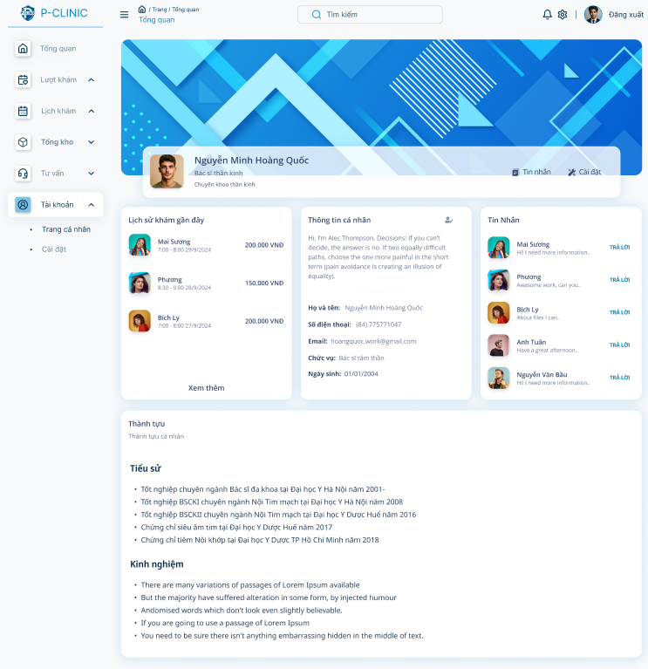

**Function Detail:**

| **#** | **Component** | **Comp. Type** | **Editable** | **Mandatory** | **Default Value** | **Description** |
| --- | --- | --- | --- | --- | --- | --- |
| 1 | Profile card: Display basic information of user | | | | | |
| Avatar | FileUpload | No | Yes | N/A. |  |
| Full Name | Text | No | Yes | N/A. |  |
| Gender | Text | No | N/A. | N/A. |  |
| Date of birth | DateTime | No | N/A. | N/A. | Dob format: dd/MM/yyyy |
| Message | Icon | No | Yes | Yes | This button allow user to navigate to ‘message screen’ |
| 2 | Appointment history card: Display the recent appointment of user | | | | | |
| Recent appoint history | Label | No | Yes | N/A |  |
| Patient’s avatar | FileUpload | No | Yes | N/A. |  |
| Patient’s full name | Text | No | Yes | N/A |  |
| Appointment’s datetime | DateTime | No | Yes | N/A |  |
| View more | Link | No | Yes | N/A. | This link allow user to navigate to user ‘appointment history screen’ |
| 3 | User’s information card | | | | | |
| User’s private information | Label | No | Yes | N/A |  |
| Full name | Text | No | Yes | N/A |  |
| Phone number | Text | No | Yes | N/A |  |
| Email | Text | No | Yes | N/A |  |
| Specialty | Text | No | Yes | N/A |  |
| Date of birth | DateTime | No | Yes | N/A | DOB format: dd/MM/yyyy |
| Description | Text | No | N/A | N/A |  |
| Edit profile | Icon | No | Yes | N/A | This icon allow user to navigate to edit user profile screen |
| 4 | Patient’s message card | | | | | |
| Patient’s avatar | FileUpload | No | N/A | N/A |  |
| Patient’s full name | Text | No | Yes | N/A |  |
| Latest message | Text | No | Yes | N/A |  |
| Answer | Link | No | Yes | N/A | This link allows user to navigate to message screen |
| 5 | Achievement | Text | No | Yes | N/A |  |

### 

#### 3.5.3 Manage Doctor Profile

##### 3.5.3.1 Doctor profile screen

**Function Trigger**:

* The **User Profile Screen** is triggered when a user (clinic staff, doctor, or patient) selects the "Profile" option from the side bar menu, then clicks the icon ‘**edit profile**’ or clicks on the **avatar** of the user.

**Function Description**:

* **Actors/Roles**: Doctor/Staff.
* **Purpose**: The **User Profile Screen** allows users to view, edit their personal details, such as contact information, profile avatar, and password. It helps keep user information up to date in the system.
* **Interface**: The screen is divided into sections such as profile card, personal information, changing password. Users can edit the information in the respective fields, and changes are saved by clicking the "Save" button.

**Data Processing**:

1. The system retrieves the current user’s profile data and displays it in the respective fields.
2. Users can update fields like contact number, address, or change their password.
3. Upon submitting, the system validates the input and updates the user's profile in the database.
4. A confirmation message appears once changes are successfully saved.

**Screen Layout**:

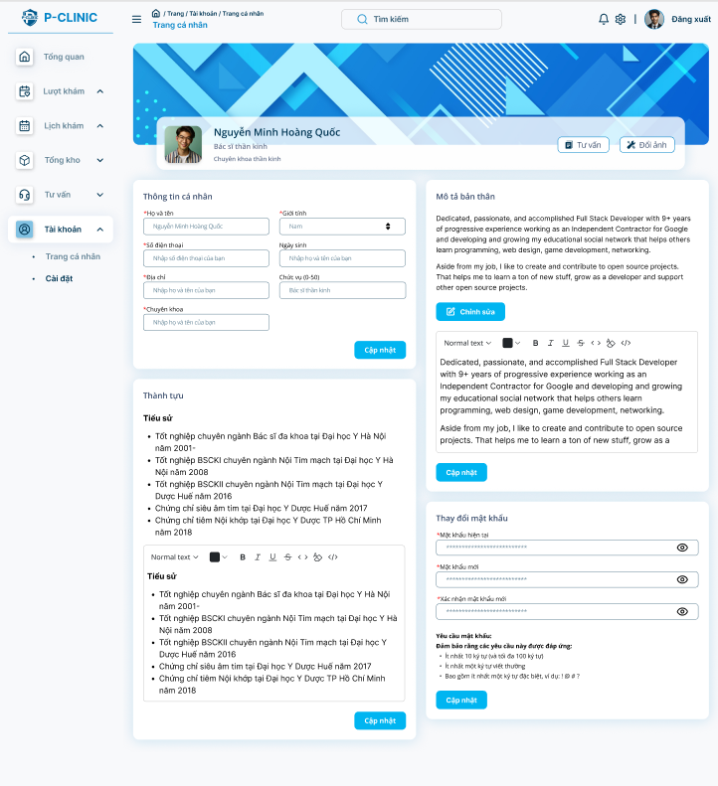

**Function Detail:**

| **#** | **Component** | **Comp. Type** | **Editable** | **Mandatory** | **Default Value** | **Description** |
| --- | --- | --- | --- | --- | --- | --- |
| 1 | Profile card: Display basic information of user | | | | | |
| Full Name | String | No | Yes | N/A. |  |
| Gender | Dropdown list - String | No | Yes | N/A. | Display option for user (Male, Female, Other) |
| Date of birth | DateTime | No | Yes | N/A. | DOB format: dd/MM/yyyy |
| Avatar | Image | Yes | Yes | Yes |  |
| Change avatar | Button | No | Yes | N/A | This button allow user to change new avatar |
| 2 | User’s private information form: Display private information about the user. | | | | | |
| Full Name | String | Yes | Yes | N/A. |  |
| Gender | Dropdown menu | Yes | Yes | N/A. | Display option for user (Male, Female, Other) |
| Phone Number | String | Yes | Yes | N/A. | The phone number must consist of digits only (0-9). No spaces, special characters or letters are allowed.  Max length: 11 digits |
| Date of birth | DateTime | Yes | Yes | N/A. | DOB format: dd/MM/yyyy |
| Address | String | Yes | Yes | N/A. |  |
| Edit | Button | No | Yes | N/A. | Allow user to edit private informations |
| 3 | Description | Text Editor | Yes | No | N/A. | This text editor allows user to edit descriptions only. |
| 4 | Achievement | Text Editor | Yes | No | N/A. | This text editor allows user to edit achievements only. |
| 5 | Changing password | Label | No | Yes | N/A. |  |
| Current password | Input | Yes | Yes | N/A. |  |
| New password | Input | Yes | Yes | N/A. |  |
| Confirm new password | Input | Yes | Yes | N/A. |  |
| New password requirement | TextField - String | No | Yes | N/A. | This text allows users to know the suitable requirement of password. |
| Update | Button | No | Yes | N/A. | This button allows user to change their password. |

##### 

#### 

#### 3.5.4 Appointments during the day

##### 3.5.4.1 View appointment

**Function Trigger:**

* This screen is accessed when a doctor/staff clicks on "**Appointments**” **-> “On day”** option on the side bar menu.

**Function Description:**

* **Actors:** Doctor/Staff
* **Purpose:** User can view his/her appointments during the day, make a medical report for each appointment, set appointment status, view medical reports of completed appointments.
* **Interface:** A list of appointment’s cards. Users can make a medical report or to set appointment status or to view a medical report of completed appointment.
* **Data Processing:**
  + Retrieves the appointment during the day data from the database.
  + Displays the data.
  + Provides options to make a medical report for each appointment, set appointment status, view medical reports of completed appointments.

**Screen Layout**:

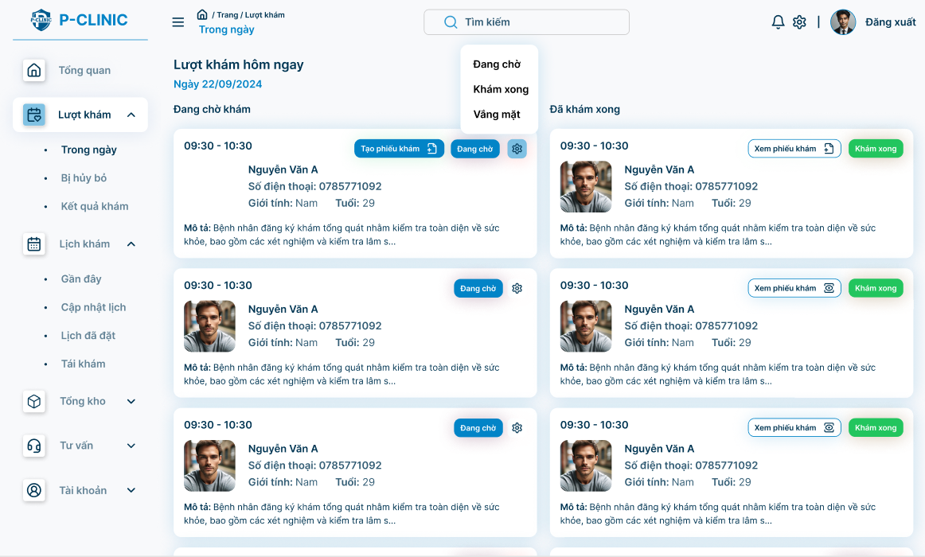

**Function Detail**:

|  |  |  |  |  |  |  |
| --- | --- | --- | --- | --- | --- | --- |
| **#** | **Component** | **Comp. Type** | **Editable** | **Mandatory** | **Default Value** | **Description** |
| 1 | On-going appointment cards: Display information about on-going appointments. | | | | | |
| Start time | DateTime | No | Yes | N/A. | Display the start time of an appointment |
| End time | DateTime | No | Yes |  | Display the end time of an appointment |
| Full name | Text | No | Yes | N/A. | Display the name of patient |
| Phone number | Text | No | Yes | N/A. | Display the phone number of patient |
| Gender | Text | No | Yes | N/A. | Display the gender of patient |
| Avatar | File Upload | No | N/A. | N.A | Display the avatar of patient |
| Description | Label | No | Yes | N/A. | Display the description of appointment |
| 2 | Status | Dropdown list - Text | Yes | Yes | N/A. | Display the status of appointment(done, pending, cancelled) |
| 3 | Create medical report | Button | No | Yes | N/A. | Allow doctors to create medical report based on current appointment. |
| 4 | View medical report | Button | No | Yes | N/A. | Allow doctors to view/update medical report if they created them before. |
| **Action** | | | | | | |
| **Name** | | **Success** | | **Failure** | | **Description** |
| Create medical report | | Navigate to “create medical report” screen | | Stay at current screen | | If medical do not exist, it will display “create medical report” |
| View medical report | | Navigate to “update medical report” screen | | Stay at current screen | | If medical do exist, it will display “view medical report” |
| Print | | Print medical report | | N/A | | Print medical report |

##### 3.5.4.2 Create/Update medical report

**Function Trigger:**

* This screen is accessed when a doctor/staff clicks on "**Appointment**" **->** “**On day**” option on the side bar menu.

**Function Description:**

* **Actors:** Doctor/Staff
* **Purpose:** Allows the user to create a medical report with diagnosis, treatment, prescriptions, and recommendations.
* **Interface:**  A form-based screen where the doctor fills in consultation details such as diagnosis, treatment, and any additional notes.
* **Data Processing:**
  + Retrieves patient details from the system.
  + Validates required fields (e.g., diagnosis, treatment).
  + Saves the report into the system.

**Layout screen**

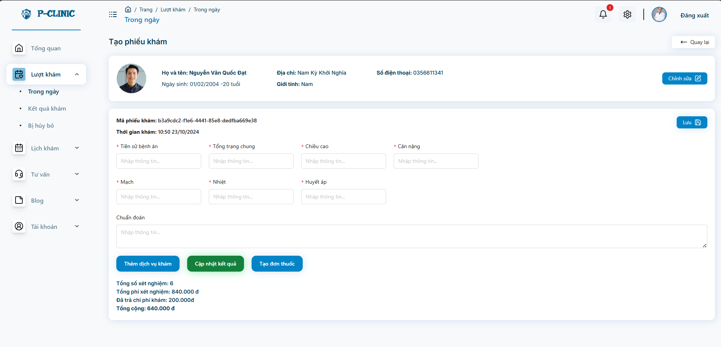

**Function Detail**

|  |  |  |  |  |  |  |
| --- | --- | --- | --- | --- | --- | --- |
| **#** | **Component** | **Comp. Type** | **Editable** | **Mandatory** | **Default Value** | **Description** |
| 1 | Avatar | File Upload | No | N/A. | N.A | Display avatar picture of patient |
| Full Name | Text | Yes | Yes | N/A. | Display full name of patient |
| Date of birth | DateTIme | Yes | Yes | N/A. | Display dob of patient |
| Address | Text | Yes | Yes | N/A. | Display phone number of patient |
| Gender | Text | Yes | Yes | N/A. | Display gender of patient |
| Code | Text | Yes | Yes | N/A. | Display code of patient |
| Phone Number | Text | Yes | Yes | N/A. | Display phone number of patient |
| Edit | Button | No | Yes | “Edit” | Allow user enable to save patient’s information on medical report |
| 2 | Medical report’s Code | Guid | No | N/A | N/A |  |
| Medical History | Text | Yes | Yes | N/A |  |
| General Condition | Text | Yes | Yes | N/A |  |
| Weight | Text | Yes | Yes | N/A |  |
| Height | Text | Yes | Yes | N/A |  |
| Pulse | Text | Yes | Yes | N/A | Example: 80 |
| Temperature | Text | Yes | Yes | N/A | Example: 37 |
| Blood Pressure | Text | Yes | Yes | N/A | Example: 110/70 |
| Diagnosis | Text | Yes | Yes | N/A |  |
| Save | Button | No | Yes | “Save” |  |
| 3 | Create Service Indication | Button | No | Yes | “Create Service Indication” | Allow doctor to create service indication |
| 4 | Create Prescription Indication | Button | No | Yes | “Create Prescription Indication” | Allow doctor to create prescription indication |
| **Action** | | | | | | |
| **Name** | | **Success** | | **Failure** | | **Description** |
| Create Service Indication | | Navigate to “create/update service indication” screen | | Stay at current screen | | Allow doctor to create service indication |
| Create Prescription Indication | | Navigate to “create/update prescription indication” screen | | Stay at current screen | | Allow doctor to create prescription indication |

##### 

##### 

##### 3.5.4.3 Create/Update service indication

**Function Trigger:**

* This screen is accessed when a doctor/staff clicks on "**View medical report**" from the “**Create medical report**” screen.

**Function Description:**

* **Actors:** Doctor/Staff
* **Purpose:** Allows the user to add service into indication
* **Interface:**  A form-based screen divided into 2 sections. The one on the right is a list of services. The other is the list of services which are indicated by doctor/staff.
* **Data Processing:**
  + Retrieves service details from the system.
  + Provide option to add service into indication
  + Saves the service indication into the system.

**Layout screen**

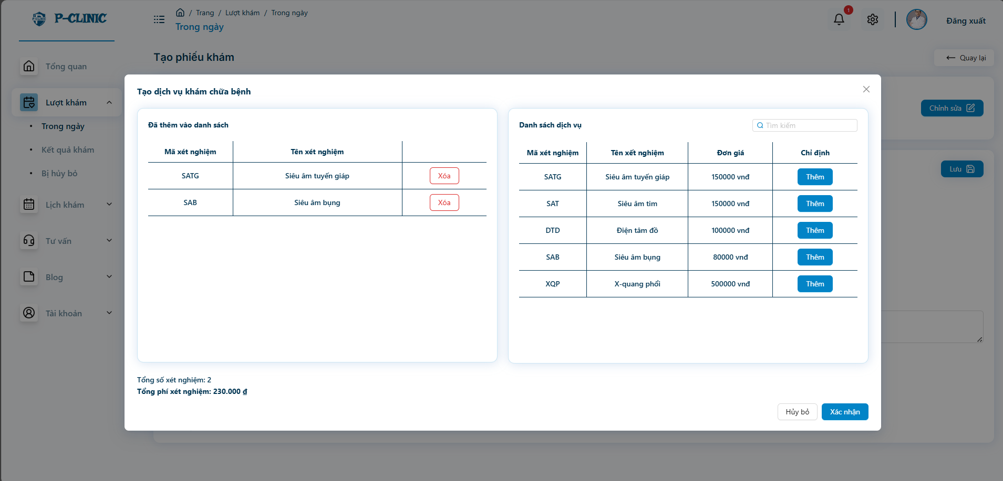

**Function Detail:**

|  |  |  |  |  |  |  |
| --- | --- | --- | --- | --- | --- | --- |
| **#** | **Component** | **Comp. Type** | **Editable** | **Mandatory** | **Default Value** | **Description** |
| 1 | Service Table | Label | No | Yes |  |  |
| Code | Text | No | Yes | N/A. | Display code of service |
| Name | Text | No | Yes | N/A. | Display name of service |
| Do service | Button | No | Yes | “Do” | Allow user to add service to service indication |
| Find by name | Search input | No | Yes | “Find by name” | Filter service by name |
| 2 | Service Indication | Label | No | Yes |  |  |
| Code | Text | No | Yes | N/A. | Display code of service |
| Name | Text | No | Yes | N/A. | Display name of service |
| Total of service | Number | No | Yes | N/A. | Display total of service in service indication which doctor/staff choose |
| Total Fee | Number | No | Yes | N/A. | Display total fee of service indication |
| 3 | Confirm | Button | No | Yes | N/A. | Save service indication into medical report. |
| 4 | Cancel | Button | No | Yes | N/A. | Cancel action. |
| **Action** | | | | | | |
| **Name** | | **Success** | | **Failure** | | **Description** |
| Do service | | Service from right component will be added into left component | | N/A | | Allow doctor to add service into indication |
| Confirm | | Navigate to “create/update medical report” screen | | N/A | | Save service indication into medical report |
| Cancel | | Navigate to “create/update medical report” screen | | N/A | | Cancel addition before |

##### 3.5.4.4 Create/Update prescription indication

**Function Trigger:**

* This screen is accessed when a doctor/staff clicks on "**Create prescription indication**" from “**Create medical repor**t” screen

**Function Description:**

* **Actors:** Doctor/Staff
* **Purpose:** Allows the user to add medicine into medicine indication
* **Interface:**  A form-based screen divided into 2 sections. The one on the right is a list of services. The other is the list of medicines which are indicated by doctor/staff.
* **Data Processing:**
  + Retrieves medicine details from the system.
  + Provide option to add medicine into indication
  + Saves the prescription indication into the system.

**Layout screen**

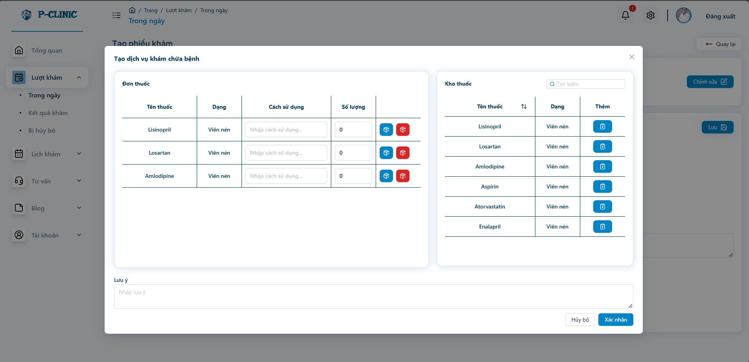

**Function Detail:**

|  |  |  |  |  |  |  |
| --- | --- | --- | --- | --- | --- | --- |
| **#** | **Component** | **Comp. Type** | **Editable** | **Mandatory** | **Default Value** | **Description** |
| 1 | Medicine warehouse | Label | No | Yes |  |  |
| Name | Text | No | Yes | N/A. | Display name of service |
| Type | Text | No | Yes | N/A | Display type of medicine |
| Add medicine | Button | No | Yes | “Add” | Allow user to add medicine to Prescription indication |
| Find by name | Search Input | No | Yes | “Find by name” | Filter medicine by name |
| 2 | Prescription Indication | Label | No | Yes |  |  |
| Name | Text | No | Yes | N/A. | Display name of service |
| Type | Text | No | Yes | N/A | Display type of medicine |
| Usage | Text | Yes | Yes | N/A. | Display usage of medicine |
| Quantity | Number | Yes | Yes | N/A. | Display quantity of specific medicine |
| 3 | Note | Text | Yes | N/A | N/A | Allow doctor/staff note for a patient |
| 4 | Confirm | Button | No | Yes | N/A. | Save prescription into medical report. |
| 5 | Cancel | Button | No | Yes | N/A. | Cancel action. |
| **Action** | | | | | | |
| **Name** | | **Success** | | **Failure** | | **Description** |
| Add medicine | | Medicine from right component will be added into left component | | N/A | | Allow doctor to add medicine into indication |
| Confirm | | Navigate to “create/update medical report” screen | | N/A | | Save prescription into medical report |
| Cancel | | Navigate to “create/update medical report” screen | | N/A | | Cancel addition before |

#### 3.5.5 Cancelled Appointment

##### 3.5.5.1 View cancelled appointment

**Function Trigger:**

* This screen is accessed when a doctor/staff clicks on "**Appointments**” **-> “Cancelled”** option on the side bar menu.

**Function Description:**

* **Actors:** Doctor/Staff
* **Purpose:** User can view his/her cancel appointments during the day then make notification for patients
* **Interface:** A list of appointment’s cards with status “cancelled”. Doctors can make a medical report or to set appointment status or to view a medical report of completed appointment.
* **Data Processing:**
  + Retrieves the appointment with status “cancelled” from the database.
  + Displays the data.
  + Provides options to send notification to them.

**Screen Layout:**

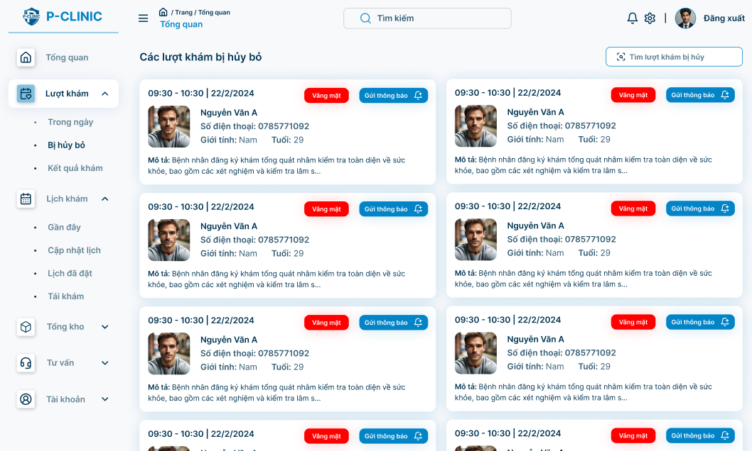

**Function Detail:**

|  |  |  |  |  |  |  |
| --- | --- | --- | --- | --- | --- | --- |
| **#** | **Component** | **Comp. Type** | **Editable** | **Mandatory** | **Default Value** | **Description** |
| 1 | On-going appointment cards: Display information about on-going appointments. | | | | | |
| Start time | DateTime | No | Yes | N/A. | Display the start time of an appointment |
| End time | DateTime | No | Yes | N/A | Display the end time of an appointment |
| Full name | Text | No | Yes | N/A. | Display the name of patient |
| Phone number | Text | No | Yes | N/A. | Display the phone number of patient |
| Gender | Text | No | Yes | N/A. | Display the gender of patient |
| Avatar | File Upload | No | N/A. | N.A | Display the avatar of patient |
| Description | Label | No | Yes | N/A. | Display the description of appointment |
| 2 | Status | Text | No | Yes | N/A. | Display the status of appointment(done, pending, cancelled) |
| 3 | Send notification | Button | No | Yes | “Send notification” | Allows doctor/staff to send notification to patient |
| **Action** | | | | | | |
| **Name** | | **Success** | | **Failure** | | **Description** |
| Send notification | | “Send notification successfully” | | N/A | | Allows doctor/staff to send notification to patient through system, sms. |

#### 3.5.6 Treatment Resultation

##### 3.5.6.1 View all medical report

**Function Trigger:**

* This screen is accessed when a doctor/staff clicks on "**Appointments**” **-> “*Treatment Resultation*”** option on the side bar menu.

**Function Description:**

* **Actors:** Doctor/Staff
* **Purpose:** Users can view medical reports of patients who they treat.
* **Interface:** A list of patient’s cards. Doctors can view all patients who they treat and information about appointments by day.
* **Data Processing:**
  + Retrieves the patient who they treat from the database.
  + Displays the data.
  + Provides options to view a medical report for each appointment.

**Screen Layout:**

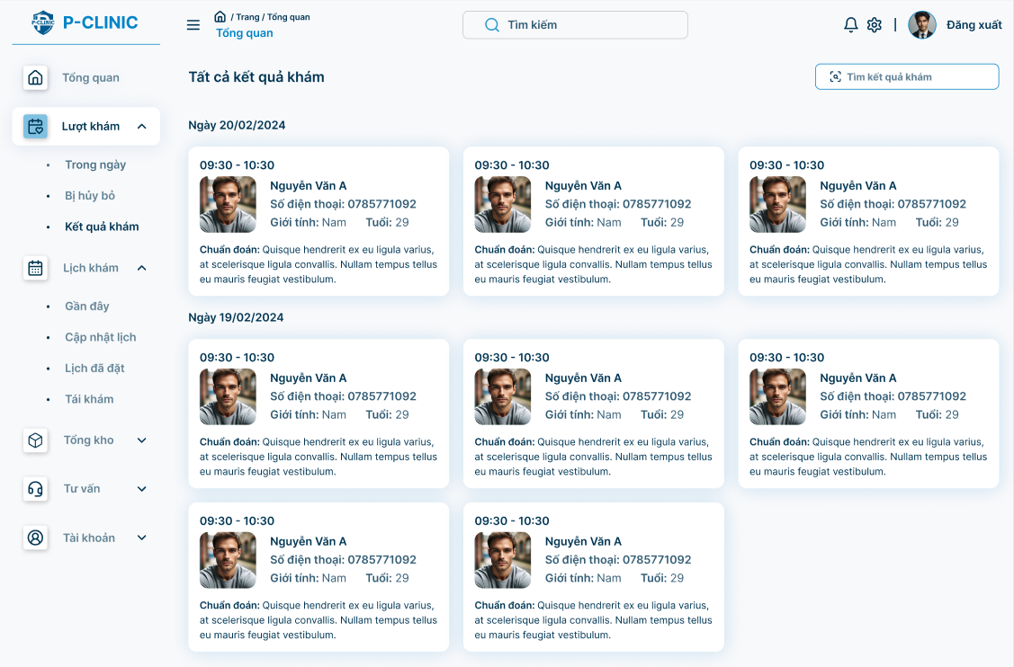

**Function Detail:**

|  |  |  |  |  |  |  |
| --- | --- | --- | --- | --- | --- | --- |
| **#** | **Component** | **Comp. Type** | **Editable** | **Mandatory** | **Default Value** | **Description** |
| 1 | Appointment’s Date | Label | No | Yes |  |  |
| Patient’s informations | Text | No | Yes | N/A. | Display patient's name, phone number, gender. |
| Type | Text | No | Yes | N/A | Display type of medicine |
| Diagnosis | Text | No | Yes |  | Display diagnosis from specific medical reports. |
| Card | Link | No | Yes | N/A | Each card is a link to related medical report |
| 2 | Search | Search Input | Yes | Yes | “Search by name” | Search medical result by patient’s name |
| **Action** | | | | | | |
| **Name** | | **Success** | | **Failure** | | **Description** |
| Click to specific card | | Navigate to specific “View medical report” screen | | N/A | | Allow doctor/staff to view specific medical report |

##### 3.5.6.2 View medical report

**Function Trigger:**

* This screen is accessed when a doctor/staff clicks on “ Patient’s Card” from the “**View all medical report**” screen.

**Function Description:**

* **Actors:** Doctor/Staff
* **Purpose:** Users can view specific medical reports of patients.
* **Interface:** Shows medical report details such as patient information, appointment’s information and diagnosis of treatment
* **Data Processing:**
  + Retrieves the user’s medical report data from the database.
  + Displays the data
  + Provides options to view details of indication and prescription.

**Screen Layout:**

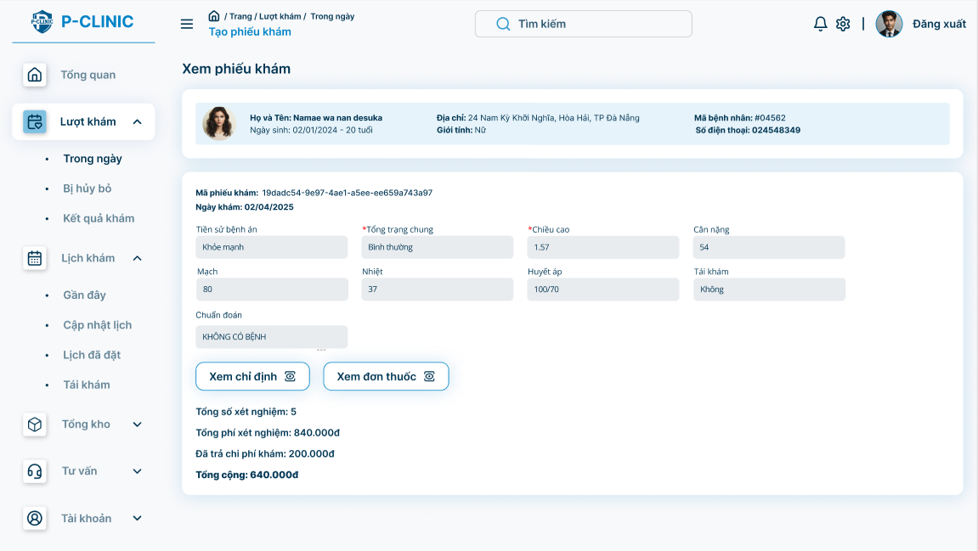

**Function Detail:**

| **#** | **Component** | **Comp. Type** | **Editable** | **Mandatory** | **Default Value** | **Description** |
| --- | --- | --- | --- | --- | --- | --- |
| 1 | Medical Report | Label | No | Yes | N/A |  |
| 2 | Patient’s avatar | File Upload | No | N/A | N/A |  |
| Patient’s date of birth | DateTime | No | Yes | N/A |  |
| Patient’s age | Text | No | Yes | N/A |  |
| Patient’s address | Text | No | Yes | N/A |  |
| Patient’s gender | Text | No | Yes | N/A |  |
| Patient’s phone number | Text | No | Yes | N/A |  |
| 3 | Medical report code | Guid | No | Yes | N/A |  |
| Appointment’s date | DateTime | No | Yes | N/A |  |
| Medical History | Text | No | Yes | N/A |  |
| General Condition | Text | No | Yes | N/A |  |
| Weight | Text | No | Yes | N/A |  |
| Height | Text | No | Yes | N/A |  |
| Pulse | Text | No | Yes | N/A | Example: 80 |
| Temperature | Text | No | Yes | N/A | Example: 37 |
| Blood Pressure | Text | No | Yes | N/A | Example: 110/70 |
| Diagnosis | Text | No | Yes | N/A |  |
| 5 | Service | Button | No | Yes | “View service” | Show service indication |
| Prescription | Button | No | Yes | “View Prescription” | Show prescription |
| 7 | Total of service | Number | No | Yes | N/A |  |
| Total Fee of service | Number | No | Yes | N/A |  |
| Deposit of appointment | Number | No | Yes | N/A | Display a payment when a patient makes an appointment. |

#### 

##### 3.5.6.3 View service indication

**Function Trigger:**

* “**View all medical reports**” screen will be shown more information about service indication when doctor/staff click the “**View service**” button.

**Function Description:**

* **Actors:** Doctor/Staff
* **Purpose:** Users can view service indications of a patient.
* **Interface:** Shows service details such as name, price of service.
* **Data Processing:**
  + Retrieves the service which the user orders from the database.
  + Displays the data

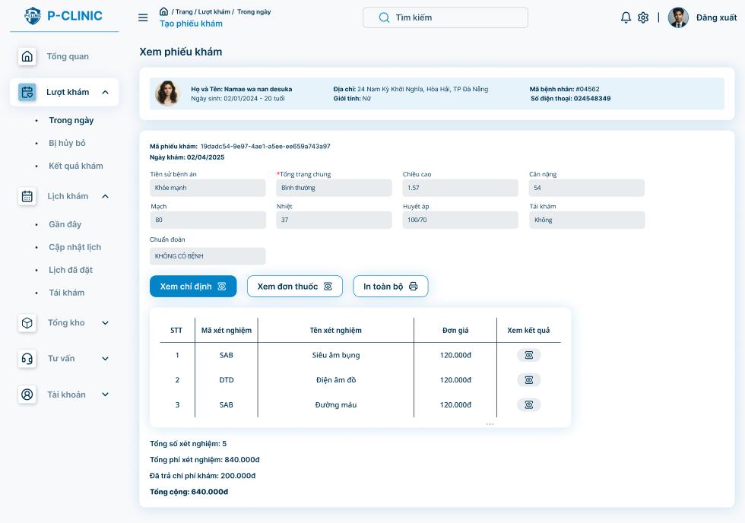

**Function Detail:**

|  |  |  |  |  |  |  |
| --- | --- | --- | --- | --- | --- | --- |
| **#** | **Component** | **Comp. Type** | **Editable** | **Mandatory** | **Default Value** | **Description** |
| 1 | Code | Text | No | Yes | N/A. | Display code of service |
| Name | Text | No | Yes | N/A. | Display name of service |
| Price | Number | No | Yes | N/A. | Display price of service |
|  | View result | Icon | No | Yes | N/A | View result of the service |

##### 3.5.6.4 View prescription

**Function Trigger:**

* “**View all medical reports**” screen will be shown more information about prescription when doctor/staff click the “**View prescription**” button.

**Function Description:**

* **Actors:** Doctor/Staff
* **Purpose:** Users can view prescription of a patient.
* **Interface:** Shows service details such as name, usage, quantity of medicine.
* **Data Processing:**
  + Retrieves the prescription of the patient from the database.
  + Displays the data

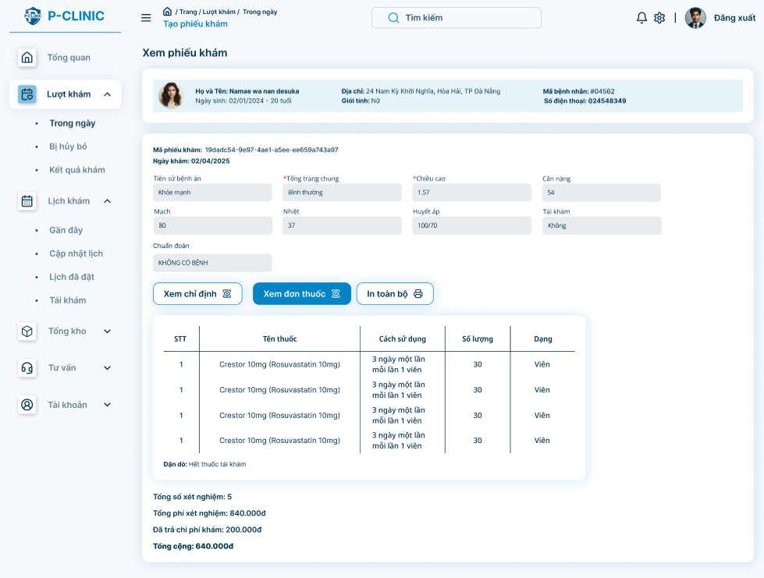

**Function Detail:**

|  |  |  |  |  |  |  |
| --- | --- | --- | --- | --- | --- | --- |
| **#** | **Component** | **Comp. Type** | **Editable** | **Mandatory** | **Default Value** | **Description** |
| 1 | Name | Text | No | Yes | N/A. | Display name of service |
| Type | Text | No | Yes | N/A | Display type of medicine |
| Usage | Text | Yes | Yes | N/A. | Display usage of medicine |
| Quantity | Number | Yes | Yes | N/A. | Display quantity of specific medicine |
| 2 | Note | Text | Yes | N/A | N/A | Allow doctor/staff note for a patient |

#### 3.5.7 Manage Personal Schedule

##### 3.5.7.1 View Recently

**Function Trigger:**

* This screen is accessed when a doctor/staff clicks on “**Appointment schedule**” -> “**In week**” option from sidebar menu

**Function Description:**

* **Actors:** Doctor
* **Purpose:** Doctors can view their calendar in week.
* **Interface:** Shows calendar of the doctor
* **Data Processing:**
  + Displays the calendar

**Screen Layout:**

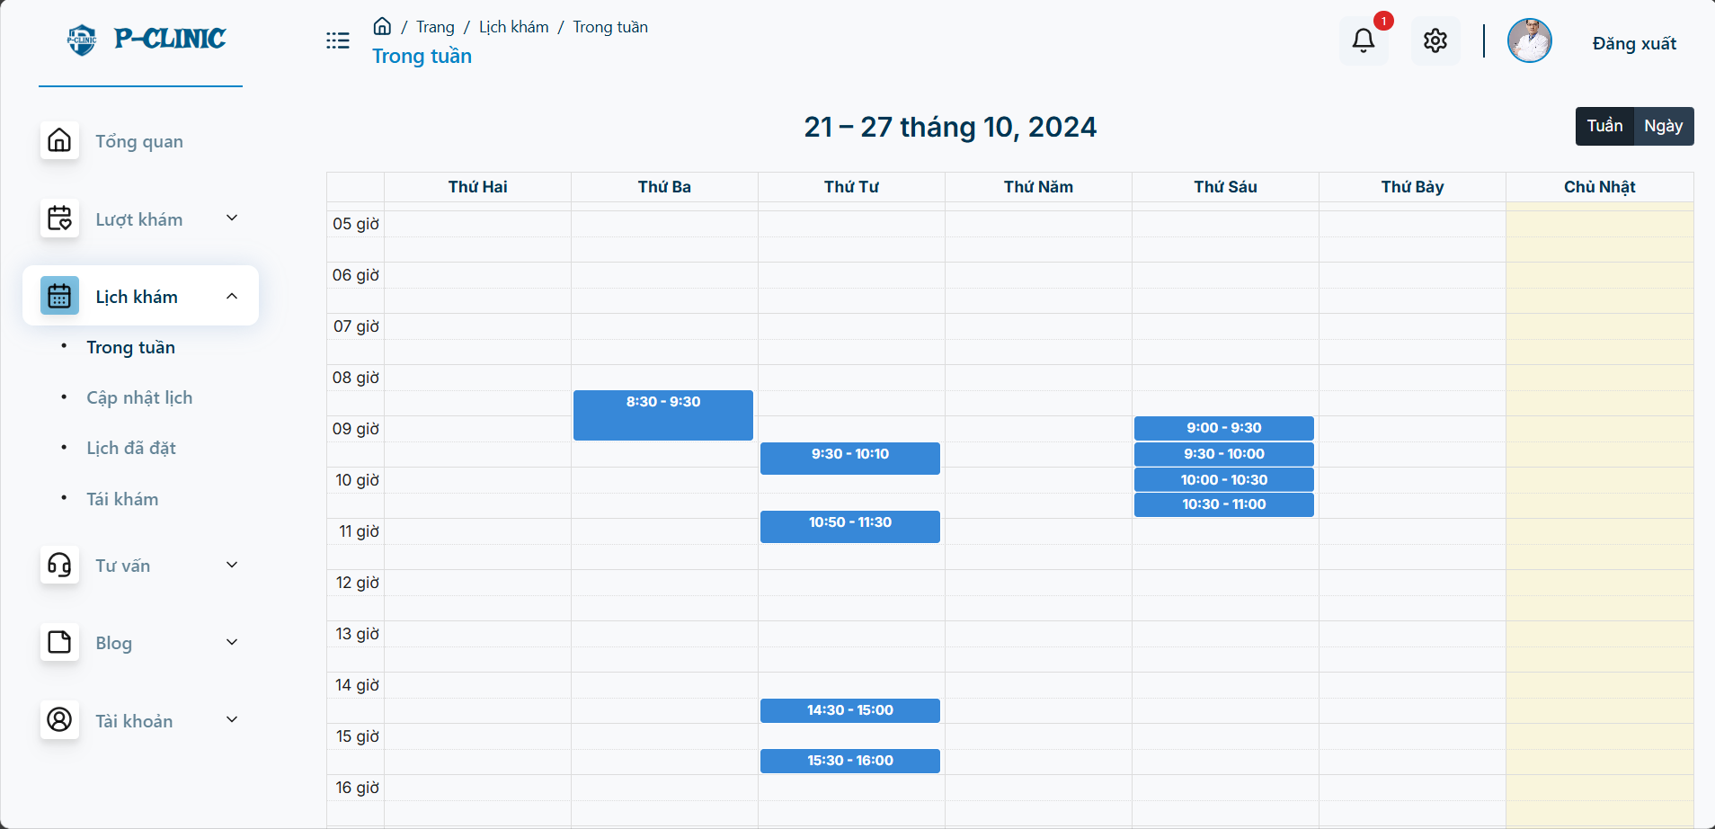

##### 3.5.7.2 View calendar

**Function Trigger:**

* This screen is accessed when a doctor/staff clicks on “**Appointment schedule**” -> “**Update schedule**” option from sidebar menu

**Function Description:**

* **Actors:** Doctor/Staff
* **Purpose:** Users can view their calendar.
* **Interface:** Shows calendar of the doctor
* **Data Processing:**
  + Displays the calendar
  + Provides options to choose a specific day to make working hours.

**Screen Layout:**

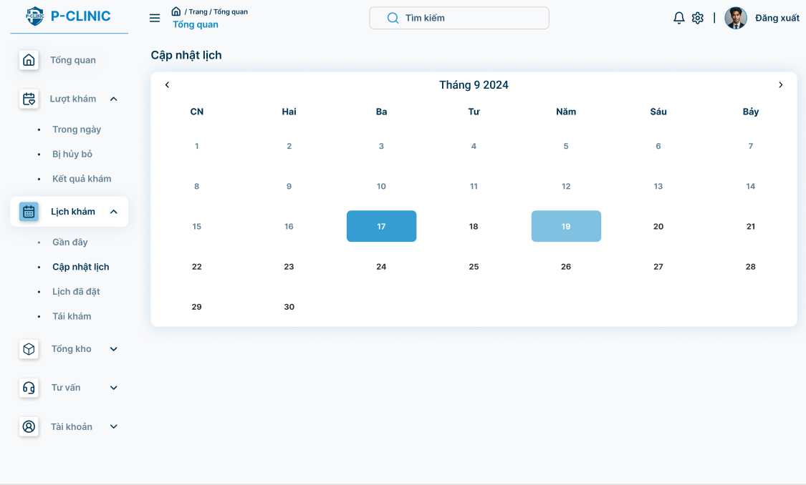

##### 3.5.7.2 Create working hours:

**Function Trigger:**

* This screen is accessed when a doctor/staff clicks on a specific day from view calendar screen

**Function Description:**

* **Actors:** Doctor/Staff
* **Purpose:** Users can create working hours (this will display when patient make appointment and choose date suitably with working hours of doctor)
* **Interface:** Shows all working hours in that day and a form to create working hours.
* **Data Processing:**
  + Displays the calendar
  + Provides options to choose a specific day to make working hours.

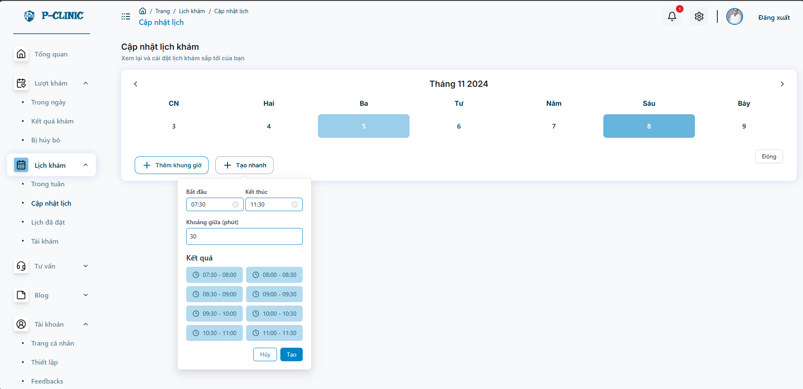

**Function Detail:**

|  |  |  |  |  |  |  |
| --- | --- | --- | --- | --- | --- | --- |
| **#** | **Component** | **Comp. Type** | **Editable** | **Mandatory** | **Default Value** | **Description** |
| 1 | Add | Icon | No | Yes | “+” | Allow doctor/staff to create 1 working hour each time |
| Start time | Number | Yes | Yes | N/A | Start time of the working hour |
| End time | Number | Yes | Yes | N/A | End time of the working hour |
| Save | Button | No | Yes | “Save” | Save working hour in day |
| 2 | Working hour frame | DateTime | Yes | Yes | N/A | Display start time and end time of working hour. |
| 3 | Add quickly | Button | No | Yes | “Add quickly” | Allow doctor/staff to create many working hour each time |
| Start time | Number | Yes | Yes | N/A |  |
| End time | Number | Yes | Yes | N/A |  |
| Gap time | Number | Yes | Yes | N/A | Duration of each appointment |
| Result | Text | No | Yes | N/A | Display all working hours frame will be made |
| Save | Button | No | Yes | “Save” | Save working hour in day |

#### 3.5.8 View history appointment

**Function Trigger:**

* This screen is accessed when a doctor/staff clicks on the “**Booked appointment**” option from the sidebar menu.

**Function Description:**

* **Actors:** Doctor/Staff
* **Purpose:** Users can view all appointments which were made by patients.
* **Interface:** Shows all appointments by day.
* **Data Processing:**
  + Displays appointments by day
  + Provides options to choose a specific day and display all appointments on that day.

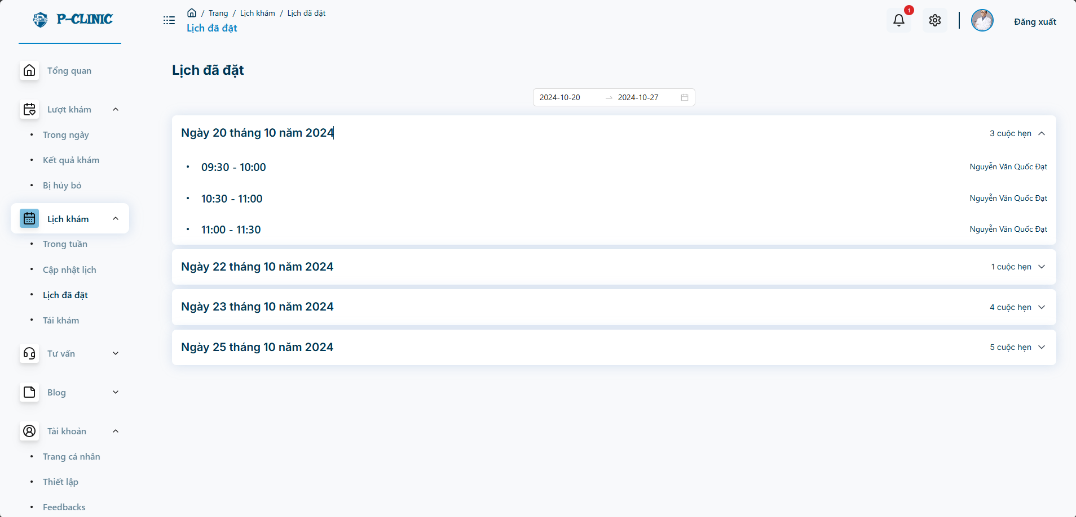

**Function Detail:**

|  |  |  |  |  |  |  |
| --- | --- | --- | --- | --- | --- | --- |
| **#** | **Component** | **Comp. Type** | **Editable** | **Mandatory** | **Default Value** | **Description** |
| 1 | StartTime | DateTime | Yes | Yes | N/A | Allow doctor/staff to search all appointments between these days. |
| Endtime | DateTime | Yes | Yes | N/A |
| 2 | Datetime | Text | No | Yes | N/A | Display Date that has an appointment. |
| Patient’s information | Text | No | Yes | N/A | Display patient’s information (name, phone number, avatar) |
| Diagnosis | Text | No | Yes | N/A | Display diagnosis from a medical report of a specific appointment. |

#### 3.5.9 Re-Examination notification

##### 3.5.9.1 View all patients

**Function Trigger:**

* This screen is accessed when the user clicks on the “**Re-Examination**” option from the sidebar menu.

**Function Description:**

* **Actors:** Doctor/Staff
* **Purpose:** User can view all patients.
* **Interface:** Shows all patient profile cards.
* **Data Processing:**
  + Retrieve all patient from data
  + Provides options to view all appointments of patients.
  + Provides options to make notification to patients.

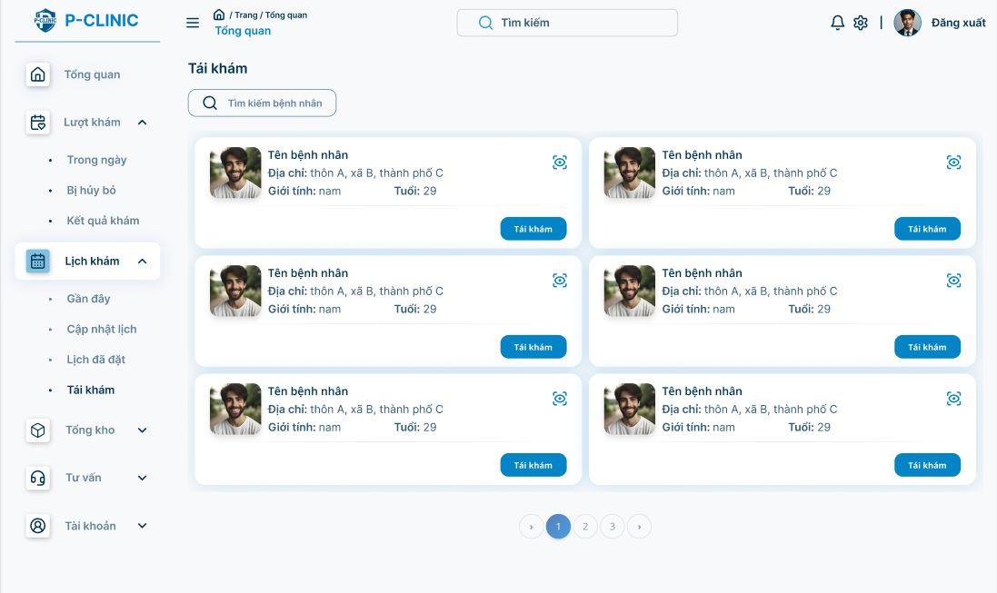

|  |  |  |  |  |  |  |
| --- | --- | --- | --- | --- | --- | --- |
| **#** | **Component** | **Comp. Type** | **Editable** | **Mandatory** | **Default Value** | **Description** |
| 1 | Patient’s information | Text | No | Yes | N/A | Display patient’s information (name, phone number, avatar) |
| 2 | View all appointment | Icon | No | Yes | Eye icon | Allow doctor/staff to view all appointments of patient |
| 3 | Re-examination | Button | No | Yes | N/A | Allow doctor/staff to notify patient that he/she will re-examine in specific date |
| 4 | Find by name | Search input | Yes | Yes | “Find by name” | Allow doctor/staff to search patients by name. |
| **Action** | | | | | | |
| **Name** | | **Success** | | **Failure** | | **Description** |
| View all appointment | | Popup screen “view all appointment” | | Stay at current screen | | Allow doctor/staff to view all appointments of patients. |
| Re-examination | | Popup screen “Create re-examination notification” | | Stay at current screen | | Allow doctor/staff to notify the patient that he/she will re-examine on a specific date. |
| Find by name | | View all patient filter by name | | “No patient available” | | Allow doctor/staff to search patients by name. |

##### 3.5.9.2 View all appointment

**Function Trigger:**

* This screen is accessed when a doctor/staff clicks on the “**View all appointment**” eye icon from the “**View all patient**” screen .

**Function Description:**

* **Actors:** Doctor/Staff
* **Purpose:** User can view all appointments of a specific patient and re-examination date.
* **Interface:** Shows all patient profile cards.
* **Data Processing:**
  + Retrieve all appointment, re-examination date of patient from data
  + Provides options to view detailed appointments of patients.

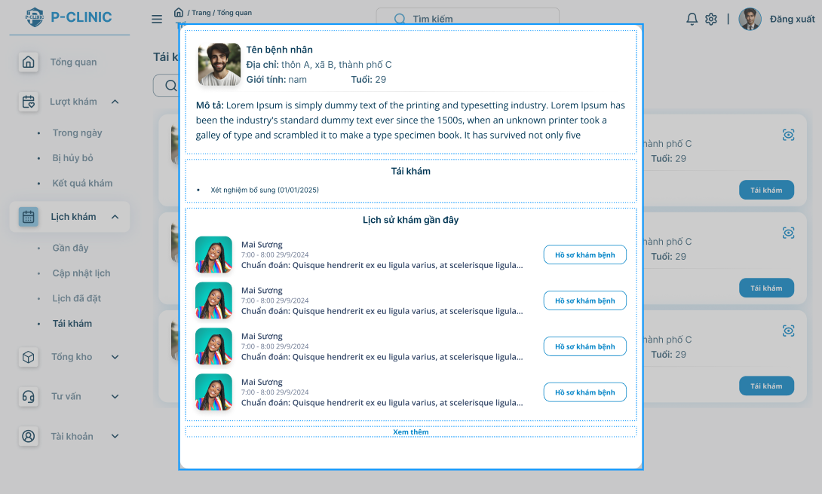

**Function Detail:**

|  |  |  |  |  |  |  |
| --- | --- | --- | --- | --- | --- | --- |
| **#** | **Component** | **Comp. Type** | **Editable** | **Mandatory** | **Default Value** | **Description** |
| 1 | Patient’s information | Text | No | Yes | N/A | Display patient’s information (name, phone number, avatar) |
| 2 | Re-examination | Text | No | Yes | N/A |  |
| 3 | Avatar’s doctor | File Upload | No | Yes | Eye icon | Display related information about appointments. |
| Full name’s doctor | Text | No | Yes | N/A |
| Appointment’s datetime | DateTime | No | Yes | N/A |
| Diagnosis | Text | No | Yes | N/A |
| View medical report | Button | No | Yes | “View medical report” | Navigate to the “View Medical Report” screen. |

##### 3.5.9.3 Create re-examination notification

**Function Trigger:**

* This screen is accessed when a doctor/staff clicks on the “**Re-examination**” button from the “**View all patient**” screen .

**Function Description:**

* **Actors:** Doctor/Staff
* **Purpose:** User can create re-examination notification of a specific patient
* **Interface:** Shows a popup form to create re-examination notification.
* **Data Processing:**
  + Create a re-examination notification and save it into system.

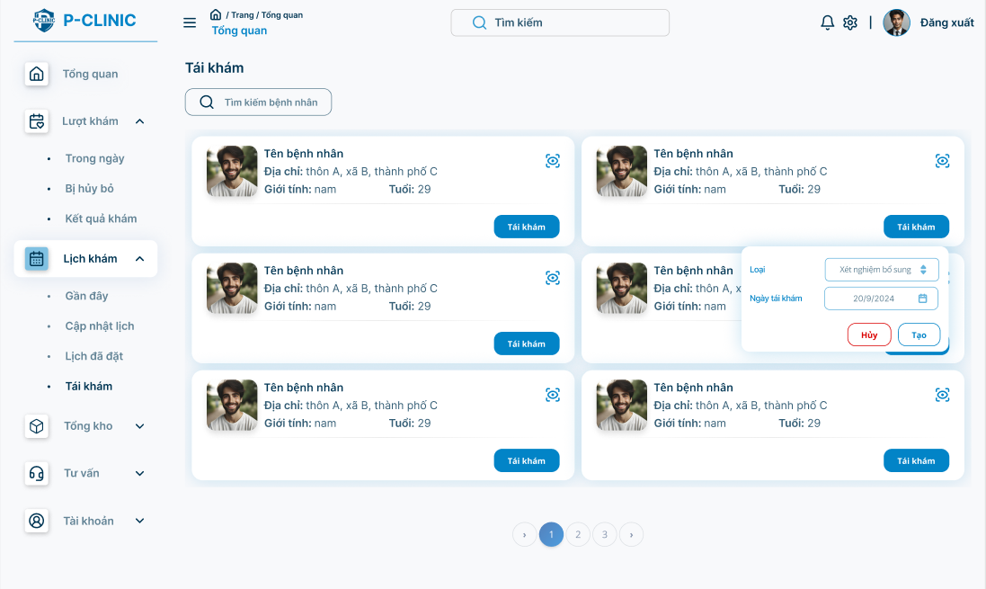

**Function Detail:**

|  |  |  |  |  |  |  |
| --- | --- | --- | --- | --- | --- | --- |
| **#** | **Component** | **Comp. Type** | **Editable** | **Mandatory** | **Default Value** | **Description** |
| 1 | Re-examination Date | DateTime | Yes | Yes | N/A |  |
| Type | Dropdown list - Text | Yes | Yes | N/A |  |
| Create | Button | No | Yes | “Create” | Allow doctor/staff to confirm create |
| Cancel | Button | No | Yes | “Cancel” | Allow doctor/staff to cancel action before |

#### 3.5.10 Chat with patients

##### 3.5.10.1 View waiting room

**Function Trigger:**

* This screen is accessed when a doctor/staff clicks on the “**Consultation**” **->** “**Waiting room**” option from the sidebar menu.

**Function Description:**

* **Actors:** Doctor/Staff
* **Purpose:** User can view all consultations from patients.
* **Interface:** Shows all patient’s consultations.
* **Data Processing:**
  + Retrieve all consultation request from data
  + Provides options to answer specific consultation.

**Screen Layout:**

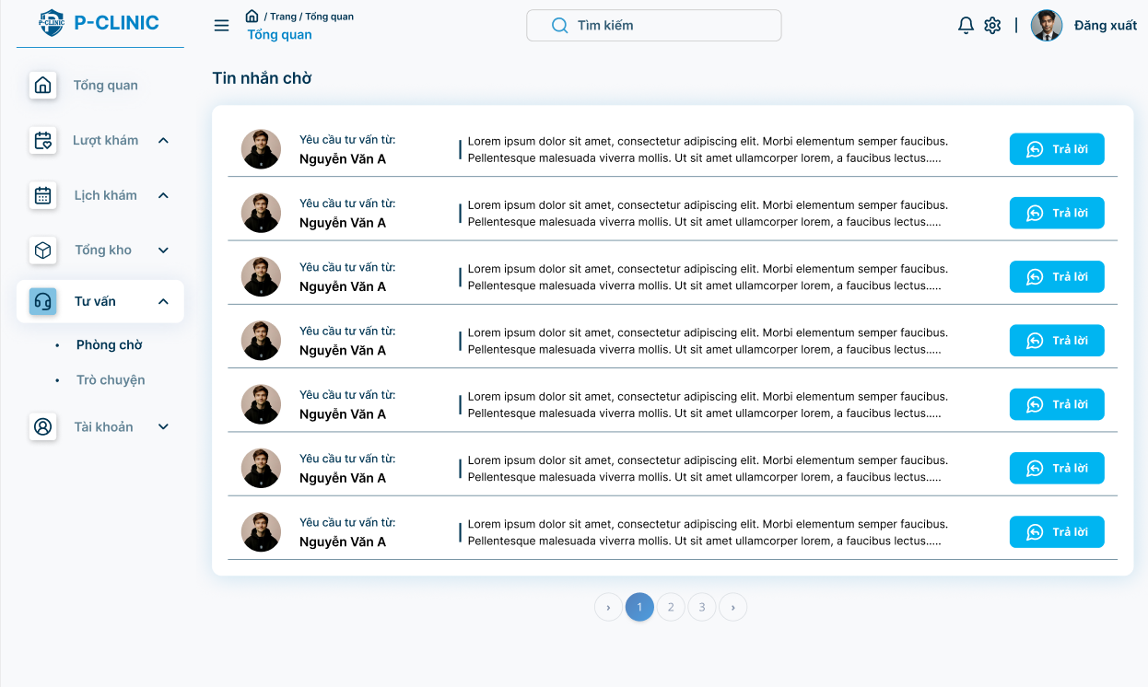

**Function Detail:**

|  |  |  |  |  |  |  |
| --- | --- | --- | --- | --- | --- | --- |
| **#** | **Component** | **Comp. Type** | **Editable** | **Mandatory** | **Default Value** | **Description** |
| 1 | Patient’s information | | | | | |
| Full name | Text | No | Yes | N/A. | Display the name of patient |
| Avatar | File Upload | No | Yes | N.A | Display the avatar of patient |
| 2 | Message | Text | No | Yes | N/A | Display consultation request of patient |
| 3 | Answer | Button | No | Yes | “Answer” | Allow doctor/staff to answer patient |
| **Action** | | | | | | |
| **Name** | | **Success** | | **Failure** | | **Description** |
| Answer | | Redirect to “Message” screen | | N/A | | Allow doctor/staff to answer patient |

##### 3.5.10.2 Message

**Function Trigger:**

* This screen is accessed when a doctor/staff clicks on the “**Consultation**” **->** “**Message**” option from the sidebar menu.

**Function Description:**

* **Actors:** Doctor/Staff
* **Purpose:** User can view all patients.
* **Interface:** Shows all patient profile cards.
* **Data Processing:**
  + Retrieve all consultation request from data
  + Provides options to answer specific consultation.

**Screen Layout:**

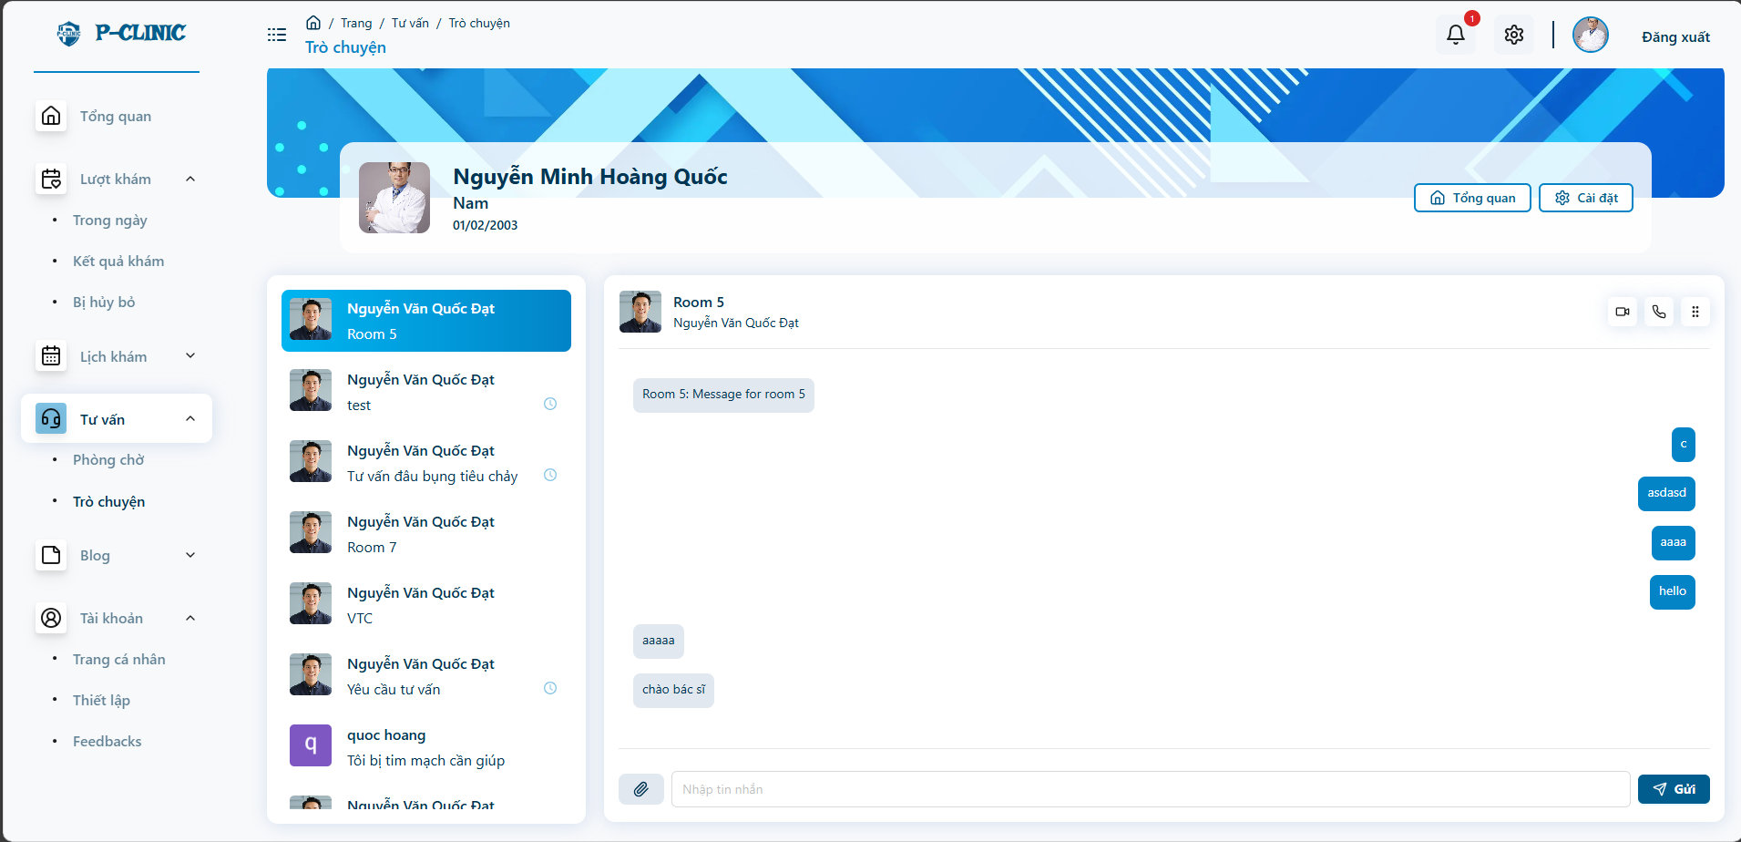

**Detail Function:**

|  |  |  |  |  |  |  |
| --- | --- | --- | --- | --- | --- | --- |
| 1 | Profile card: display user profile’s card | | | | | |
| Full name | Text | No | Yes | N/A. | Display the name of doctor |
| Position | Text | No | Yes | N/A. | Display the phone number of doctor |
| Specialty | Text | No | Yes | N/A. | Display the specialty of doctor |
| Avatar | File Upload | No | N/A. | N.A | Display the avatar of doctor |
| 2 | Send message | Input - Textbox | Yes | Yes | N/A | Input the message |
| 3 | Send | button | No | Yes | “Send” | Allow doctor/staff to send message to patient |

##### 3.5.10.3 Video call

**Function Trigger:**

* This screen is accessed when a doctor/staff clicks on the “**Consultation**” **->** “**Message**” -> “**Video call**” option from the sidebar menu.

**Function Description:**

* **Actors:** Doctor/Staff
* **Purpose:** Doctor/staff can call videos with patients.
* **Interface:** Show window for call video..

**Screen Layout:**

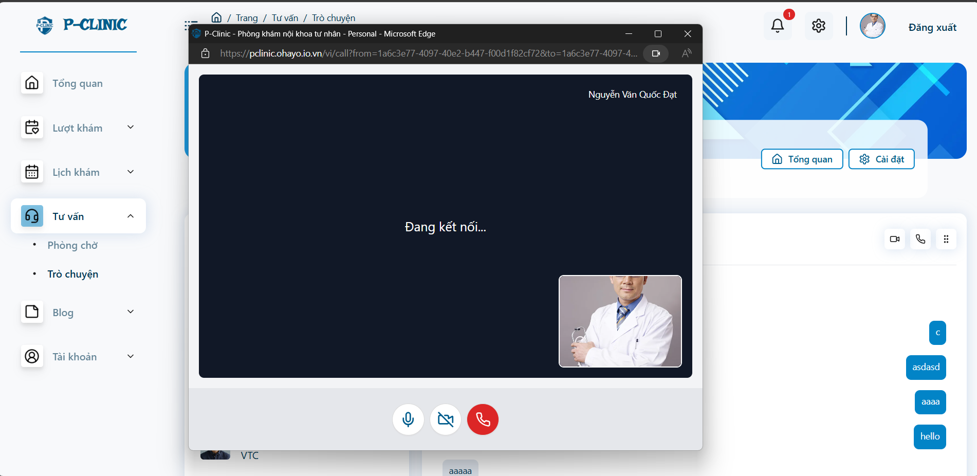

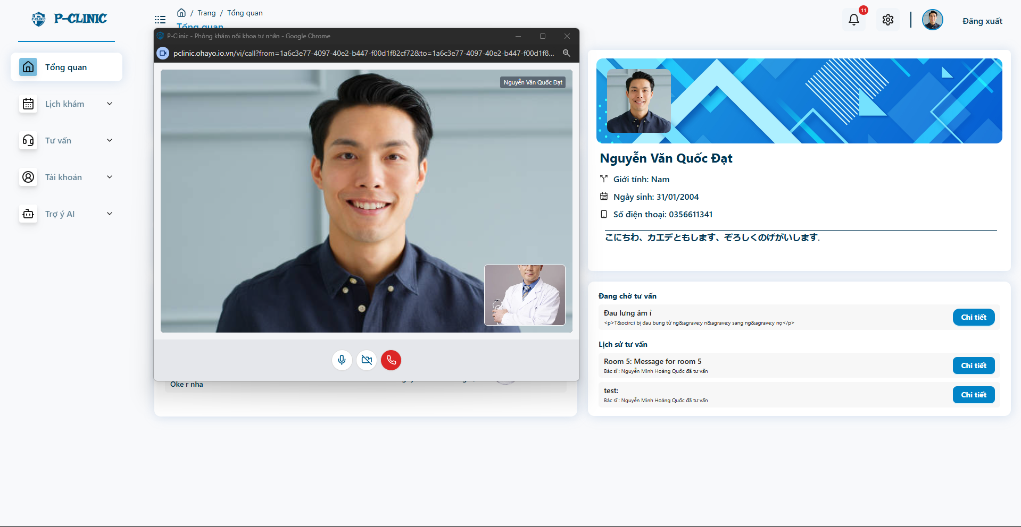

**Detail Function:**

| **#** | **Component** | **Comp. Type** | **Editable** | **Mandatory** | **Default Value** | **Description** |
| --- | --- | --- | --- | --- | --- | --- |
| 1 | Screen video call | | | | | |
| Voice | Button | No | Yes | N/A. | Turn off/on voice |
| Camera | Button | No | Yes | N/A. | Turn off/on camera |
| End | Button | No | Yes | N/A. | End call |

#### 3.5.11 Feedback

**Function Trigger:**

* This screen is accessed when the user clicks on the “**Account**” **->** “**Feedback**” option from the sidebar menu.

**Function Description:**

* **Actors:** Doctor/Staff
* **Purpose:** User can view all feedback from patients.
* **Interface:** Shows all patient’s feedback.
* **Data Processing:**
  + Retrieve all feedback from database.

**Screen Layout:**

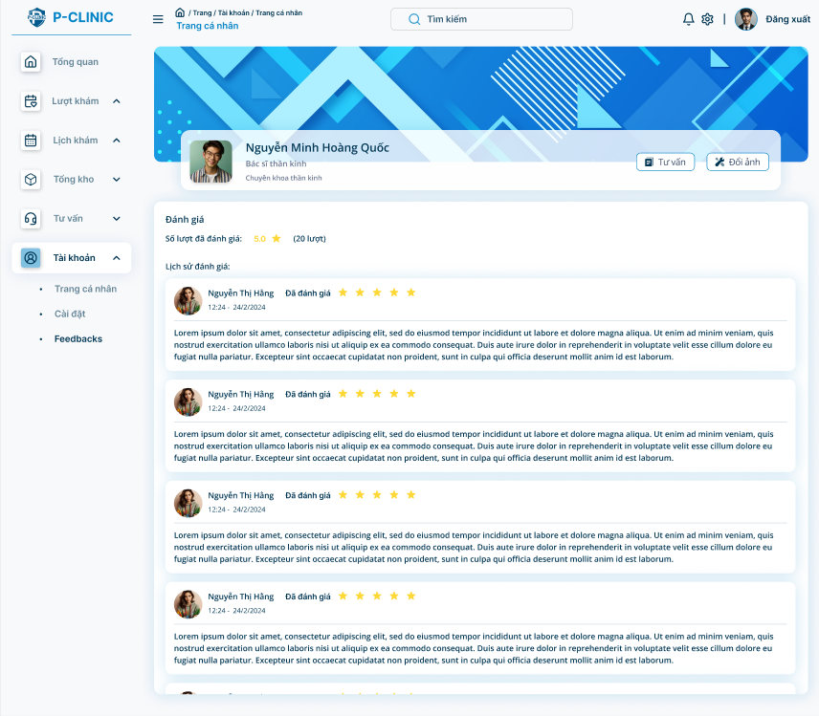

**Detail Function:**

| **#** | **Component** | **Comp. Type** | **Editable** | **Mandatory** | **Default Value** | **Description** |
| --- | --- | --- | --- | --- | --- | --- |
| 1 | Profile card: Display basic information of user | | | | | |
| Full Name | String | No | Yes | N/A. | Display name of doctor/staff |
| Gender | Text | No | Yes | N/A. | Display name of doctor/staff |
| Date of birth | DateTime | No | Yes | N/A. | DOB format: dd/MM/yyyy |
| Avatar | File Upload | Yes | Yes | Yes | Display name of doctor/staff |
| 2 | Rating | Number | No | Yes | ‘0’ | Display average rating of doctor/staff |
| 3 | Feedback card | | | | |  |
|  | Avatar | File Upload | No | Yes | N/A. | Display avatar of user feedback |
|  | Full Name | Text | No | Yes | N/A. | Display name of user feedback |
|  | Date | DateTime | No | Yes | N/A. | Display datetime of feedback |
|  | Rating | Number | No | Yes | N/A. | Display name of feedback |
|  | Content | Text | No | Yes | N/A. | Display name of feedback |

#### 3.5.12 Blog

**Function Trigger:**

* This screen is accessed when the user clicks on the “**Account**” **->** “**Blog**” option from the sidebar menu.

**Function Description:**

* **Actors:** Doctor/Staff
* **Purpose:** User can view all/ create posts from the blog.
* **Interface:** Shows all posts in blogs and creates a new post by staff or doctor.
* **Data Processing:**
  + Retrieve all posts from database.

**Screen Layout:**

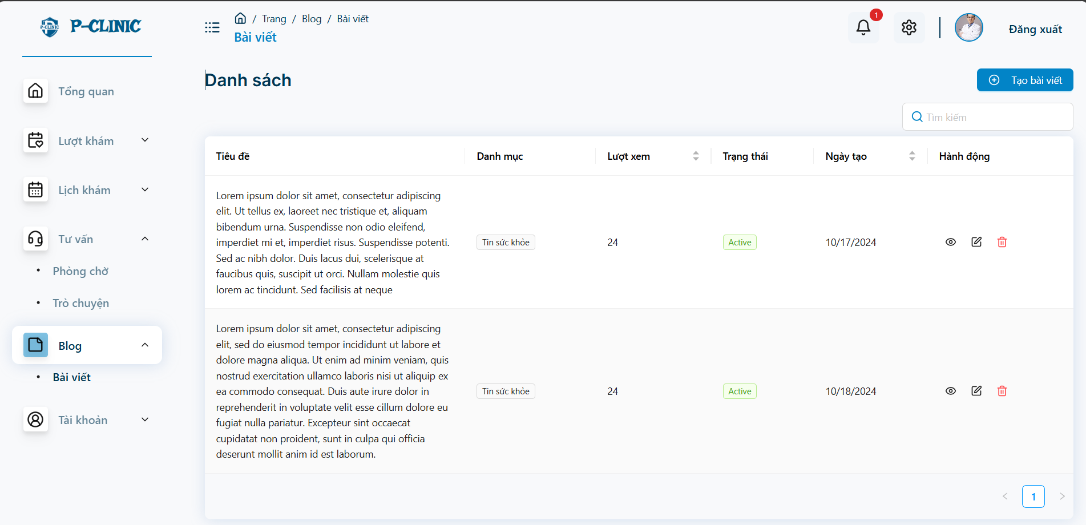

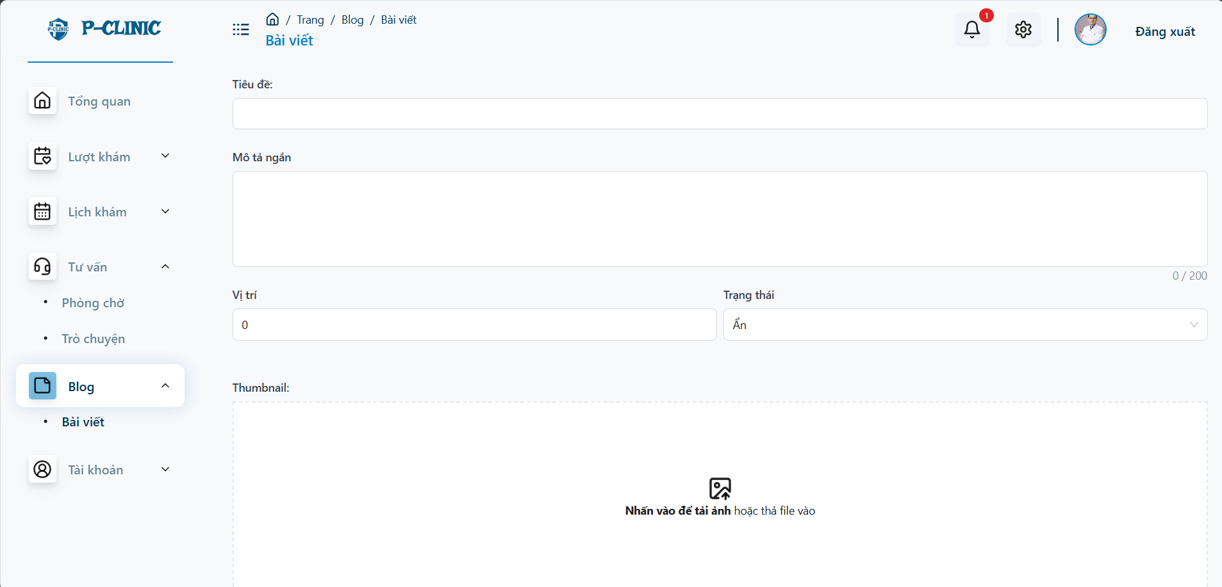

### 3.6 Staff

#### 3.6.1 Staff Overview Screen

**Function Trigger**:

* The ***Staff Overview Screen*** is triggered when a staff login the system or selects the "**Overview**" option from the side bar menu.

**Function Description**:

* **Actors/Roles**: Staff
* **Purpose**: The **Staff Overview Screen** allows staff to overview staff’s activities, such as the appointment that patient is absent, queue room, information staff, recent appointment, on-duty doctors.
* **Interface**: The screen is divided into sections such as profile card, appointment not-show list, on-duty doctor’s cards, recent appointment, private information and messages from patients…

**Data Processing**:

1. The system retrieves the current staff’s profile data and displays it in the respective fields.

**Screen Layout:**

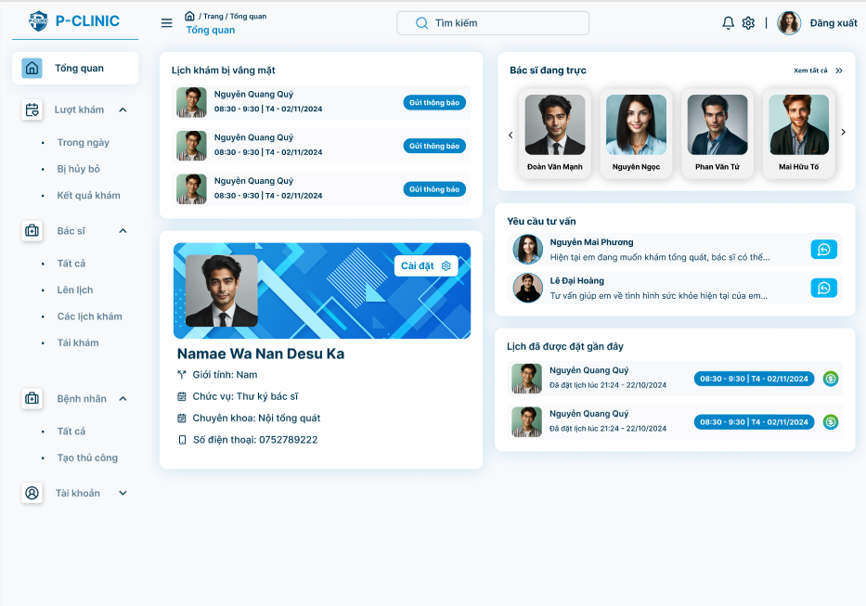

**Function Detail:**

| **#** | **Component** | **Comp. Type** | **E**d**itable** | **Mandatory** | **Default Value** | **Description** |
| --- | --- | --- | --- | --- | --- | --- |
| 1 | Appointments that patient is absent | | | | |  |
| Appointment’s time | DateTime | No | N/A | N/A |  |
| Avatar | Image | No | N/A | Yes |  |
| Full name | String | No | N/A. | N/A. |  |
| Send notification | Button | No | N/A | N/A | Send SMS to patient to notify that they miss the appointment |
| 2 | Profile card: Display basic information of staff | | | | | ‘Clicking to this card’ allows user to navigate to ‘Staff profile screen’ |
| Full Name | String | No | N/A. | N/A. |  |
| Gender | String | No | N/A. | N/A. |  |
| Specialty | String | No | N/A. | N/A. | DOB format: dd/MM/yyyy |
| Avatar | Image | No | N/A | Yes |  |
| 3 | ‘Doctors on-duty’ component | | | | |  |
| Full name | String | No | N/A. | N/A. |  |
| Avatar | Image | No | N/A. | N/A. |  |
| 4 | User appointment history | | | | | Display user some record of recent appointment |
| Doctor’s full name | String | No | N/A. | N/A. |  |
| Doctor’s avatar | Image | No | N/A. | N/A. |  |
| Appointment’s date time | DateTime | No | N/A. | N/A. |  |
| 5 | Consultation request | | | | |  |
| Detail | Button | No | N/A | N/A | This button allows user to navigate to ‘Chat screen’ |
| Avatar | Image | No | N/A | Yes |  |
| Full name | String | No | N/A. | N/A. |  |
| Chat content | Text | No | N/A. | N/A. |  |

#### 3.6.2 Patient of system

##### 3.6.2.1 View list of patient

**Function Trigger**:

* This screen is accessed when a doctor/staff clicks on "**Patients**” **-> “All”** option on the side bar menu.

**Function Description**:

* **Actors:** Staff
* **Purpose:** Users can view a list of patients, select a specific patient to view his/her detailed information.
* **Interface:** A search bar and a list of patient’s cards.
* **Data Processing:**
  + Retrieves the patient data from the database.
  + Displays the data.
  + Provides options to search for a certain patient.

**Screen Layout**:

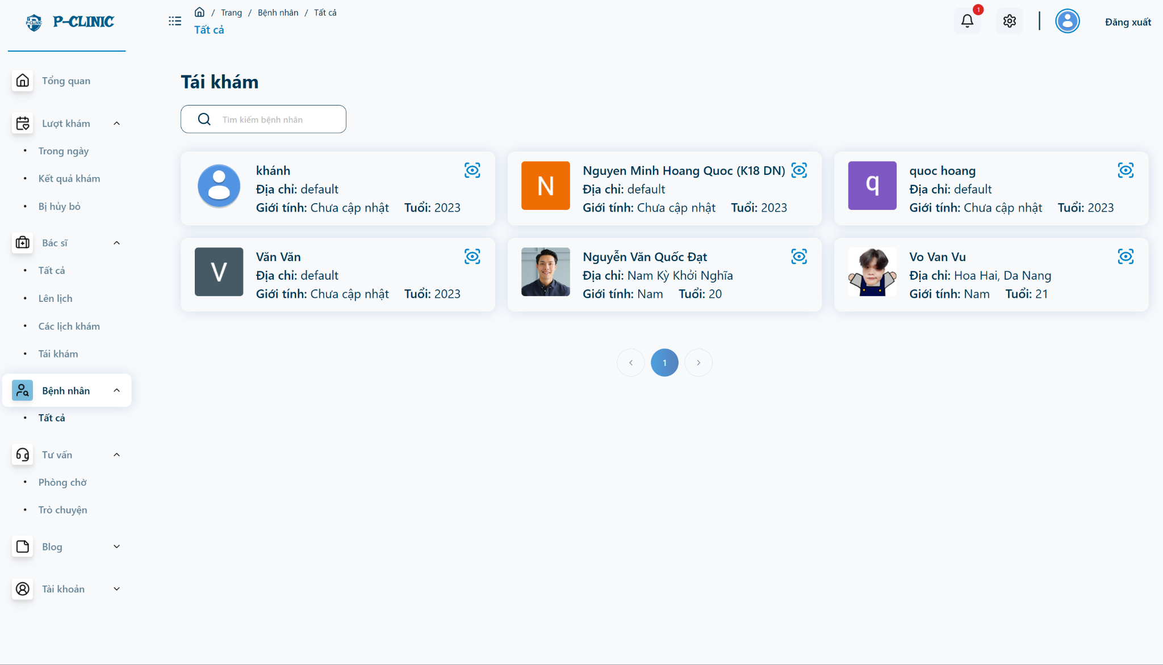

**Function Detail**:

|  |  |  |  |  |  |  |
| --- | --- | --- | --- | --- | --- | --- |
| **#** | **Component** | **Comp. Type** | **Editable** | **Mandatory** | **Default Value** | **Description** |
| 1 | Patient cards: Display information about patients. | | | | | |
| Full name | Text | No | Yes | N/A. | Display the full name of the patient. |
| Address | Text | No | Yes | N/A. | Display the address of the patient. |
| Gender | Text | No | Yes | N/A. | Display the gender of the patient. |
| Age | Number | No | Yes | N/A. | Calculate age from date of birth. |
| Avatar | File Upload | No | N/A. | N.A | Display the avatar of the patient. |
| 2 | Search bar | | | | | |
| Search button | Button | No | Yes | N/A. | Allow staff to search for a certain patient. |
| **Action** | | | | | | |
| **Name** | | **Success** | | **Failure** | | **Description** |
| Search for patient | | Show the found patient | | Show on screen: result not found. | |  |

##### 3.6.3.2 View detail a patient

**Function Trigger**:

* This screen is accessed when a doctor/staff clicks on "**Patients**” **-> “All”** option on the side bar menu and then selects a patient.

**Function Description**:

* **Actors:** Staff
* **Purpose:** Users can view a specific patient to view his/her detailed information.
* **Interface:** A modal shows patient information.
* **Data Processing:**
  + Retrieves the patient data from the database.
  + Displays the data.

**Screen Layout**:

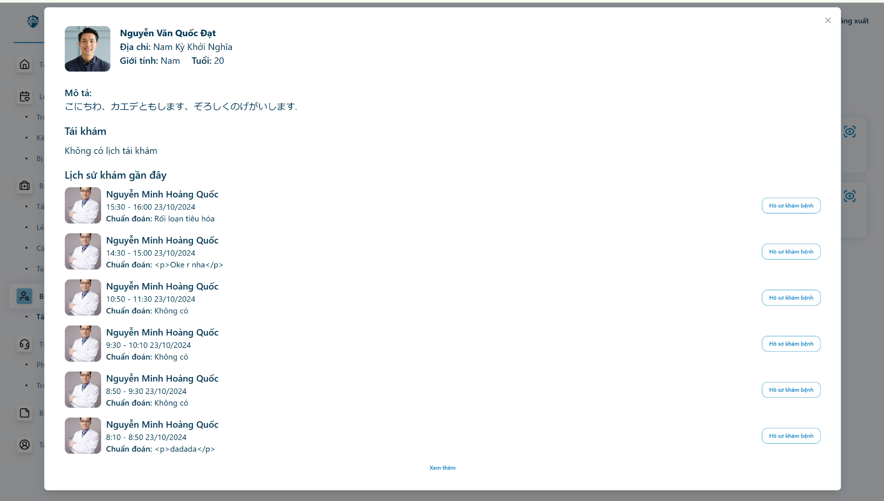

**Function Detail**:

|  |  |  |  |  |  |  |
| --- | --- | --- | --- | --- | --- | --- |
| **#** | **Component** | **Comp. Type** | **Editable** | **Mandatory** | **Default Value** | **Description** |
| 1 | Patient card: Display information about a patient. | | | | | |
| Full name | Text | No | Yes | N/A. | Display the full name of the patient. |
| Address | Text | No | Yes | N/A. | Display the address of the patient. |
| Gender | Text | No | Yes | N/A. | Display the gender of the patient. |
| Age | Number | No | Yes | N/A. | Calculate age from date of birth. |
| Avatar | File Upload | No | N/A. | N.A | Display the avatar of the patient. |
| Description | Text | No | Yes | N.A | Display the description of the patient. |
| 2 | Medical report cards | | | | | |
| View detail medical report | Button | No | Yes | N/A. | Allow staff to redirect to this detailed medical report page. |
| Doctor’s Full Name | Text | No | Yes | N/A. | Display the full name of the doctor. |
| Date | Text | No | Yes | N/A. | Display the slot time of the appointment. |
| Diagnosis | Text | No | Yes | N/A. | Display the diagnosis from the doctor. |
| 3 | Follow up appointment: display all follow up appointment in the future | | | | | |
| Reason | Text | No | Yes | N/A. | The reason that the patient needs to make a next appointment. |
| Date | Date | No | Yes | N/A. | The date of the next appointment |
| 4 | Load more | Button | No | Yes | N/A. | Load more medical report |
| **Action** | | | | | | |
| **Name** | | **Success** | | **Failure** | | **Description** |
| View detail medical report | | Navigate to detail medical report | | Navigate back to previous page | |  |
| Load more medical report | | More medical reports are loaded. | | A toast error message display “Something error” | |  |

##### 

#### 3.6.3 Appointments during the day

##### 3.6.3.1 View doctors on duty

**Function Trigger**:

* This screen is accessed when a doctor/staff clicks on "**Appointments**” **-> “On day”** option on the side bar menu.

**Function Description**:

* **Actors:** Staff
* **Purpose:** Users can view a list of doctors who are or are not on duty, select a specific doctor to view that doctor's schedule and search for the doctor.
* **Interface:** A search bar and a list of doctor’s cards showing that they are or are not on duty.
* **Data Processing:**
  + Retrieves the doctor data from the database.
  + Displays the data.
  + Provides options to search for a certain doctor.

**Screen Layout**:

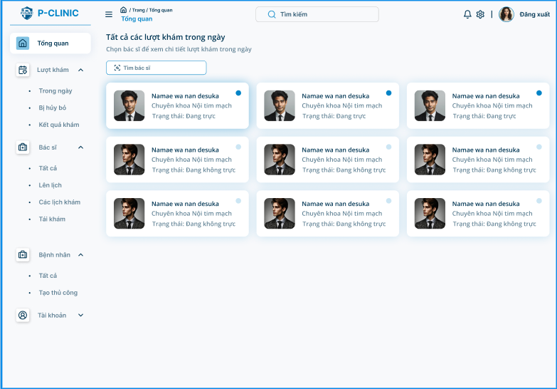

**Function Detail**:

|  |  |  |  |  |  |  |
| --- | --- | --- | --- | --- | --- | --- |
| **#** | **Component** | **Comp. Type** | **Editable** | **Mandatory** | **Default Value** | **Description** |
| 1 | Doctors cards: Display information about doctors who are or are not on duty. | | | | | |
| Full name | Text | No | Yes | N/A. | Display the full name of doctor |
| Specialty | Text | No | Yes | N/A. | Display the specialty of the doctor. |
| Status | Text | No | Yes | N/A. | Display the status of the doctor, is on duty or not. |
| Avatar | File Upload | No | N/A. | N.A | Display the avatar of the doctor. |
| 2 | Search bar | | | | | |
| Search button | Button | No | Yes | N/A. | Allow staff to search for a certain doctor. |
| **Action** | | | | | | |
| **Name** | | **Success** | | **Failure** | | **Description** |
| Search for doctor | | Show the found doctor | | Show on screen: result not found. | |  |

##### 3.6.3.2 View appointment

(This function like view appointment at doctor title)

##### 3.6.3.3 Create/Update medical report

(This function like create/update medical report at doctor title)

##### 3.6.3.4 Create/Update service indication

(This function like create/update service indication at doctor title)

##### 3.6.3.5 Create/Update prescription indication

(This function like create/update prescription at doctor title)

#### 3.6.4 Cancelled Appointments

(This feature like Cancelled appointments at doctor title)

#### 3.6.5 Treatment Resultation

##### 3.6.5.1 View all medical report

(This function like View All Medical Report at doctor title)

##### 3.6.5.2 View medical report

(This function like View Medical Report at doctor title)

##### 3.6.5.3 View service indication

(This function like View Service Indication at doctor title)

##### 3.6.5.4 View prescription

(This function like View Prescription at doctor title)

#### 3.6.6 Doctor Management

##### 3.6.6.1 View all doctors

**Function Trigger:**

* This screen is accessed when a user clicks on "**Doctor**” **-> “All”** option on the side bar menu.

**Function Description:**

* **Actors:** Staff
* **Purpose:** Staff can view doctors that are working in their clinic .
* **Interface:** A list of doctor’s cards. Staff can view all doctors who are on-duty or not.
* **Data Processing:**
  + Retrieves the doctor from the database.
  + Displays the data.
  + Provides options to search for doctors.

**Screen Layout:**

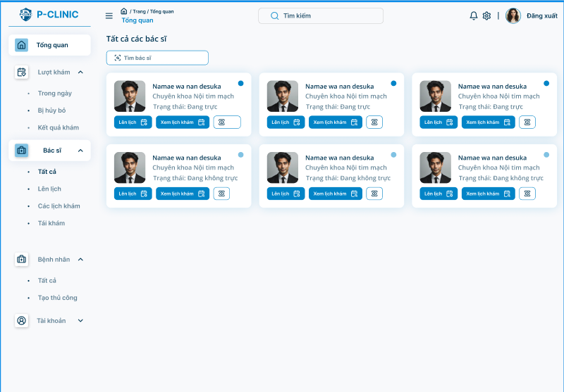

**Function Detail:**

|  |  |  |  |  |  |  |
| --- | --- | --- | --- | --- | --- | --- |
| **#** | **Component** | **Comp. Type** | **Editable** | **Mandatory** | **Default Value** | **Description** |
| 1 | List of doctor’s profile cards | | | | |  |
| Specialty | Text | No | Yes | N/A. | Display specialty of doctor |
| Name | Text | No | Yes | N/A. | Display name of doctor |
| Status | Text | No | Yes | N/A | Display status of doctor |
| Schedule | Button | No | Yes | N/A. | Schedule a doctor's appointment |
| View schedule | Button | No | Yes | N/A. | View doctor's schedule |
| 2 | Search for doctor | | | | |  |
| Search bar | Input | No | Yes | N/A. |  |
| **Action** | | | | | | |
| **Name** | | **Success** | | **Failure** | | **Description** |
| Schedule | | Navigate to “schedule doctor appointment” screen | | N/A | | Allow staff to schedule doctor appointments. |
| View schedule | | Navigate to “scheduled appointment” screen | | N/A | | View scheduled appointments of a doctor |

#### 3.6.7 Schedule Management

##### 3.6.7.1 Schedule doctor’s appointment overview

**Function Trigger:**

* This screen is accessed when a doctor/staff clicks on "**Doctor**” **-> “Schedule”** option on the side bar menu.

**Function Description:**

* **Actors:** Staff
* **Purpose:** Users can schedule doctor’s appointments .
* **Interface:** A list of doctor’s cards. Staff can view all doctors who are on-duty or not.
* **Data Processing:**
  + Retrieves the doctor from the database.
  + Displays the data.
  + Provides options to search for doctors.

**Screen Layout:**

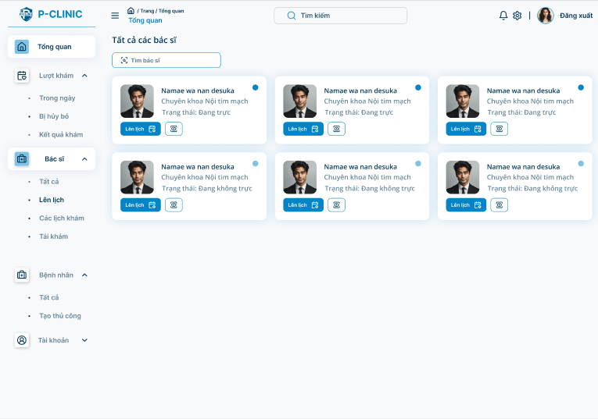

**Function Detail:**

|  |  |  |  |  |  |  |
| --- | --- | --- | --- | --- | --- | --- |
| **#** | **Component** | **Comp. Type** | **Editable** | **Mandatory** | **Default Value** | **Description** |
| 1 | List of doctor’s profile cards | | | | |  |
| Specialty | Text | No | Yes | N/A. | Display specialty of doctor |
| Name | Text | No | Yes | N/A. | Display name of doctor |
| Status | Text | No | Yes | N/A | Display status of doctor |
| Schedule | Button | No | Yes | N/A. | Schedule a doctor's appointment |
| 2 | Search for doctor | | | | |  |
| Search bar | Input | No | Yes | N/A. |  |
| **Action** | | | | | | |
| **Name** | | **Success** | | **Failure** | | **Description** |
| Schedule | | Navigate to “schedule doctor appointment” screen | | N/A | | Allow staff to schedule doctor appointments. |

##### 3.6.7.2 Schedule doctor’s appointment

**Function Trigger:**

* This screen is accessed when a doctor/staff clicks on "**Doctor**” **-> “Schedule”** option on the side bar menu, chooses a doctor and then clicks on “**Schedule**” option.

**Function Description:**

* **Actors:** Staff
* **Purpose:** Users can schedule doctor’s appointments .
* **Interface:** A doctor profile card and a timetable. Staff can choose Date and Working hour for doctor’s appointments.
* **Data Processing:**
  + Retrieves the doctor’s schedule from the database.
  + Displays the data.

**Screen Layout:**

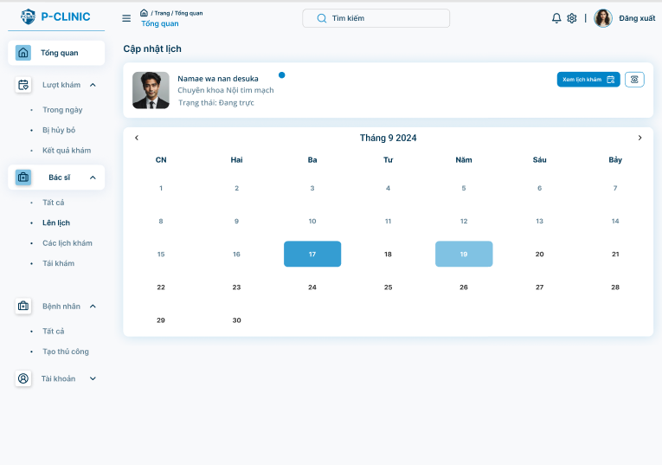

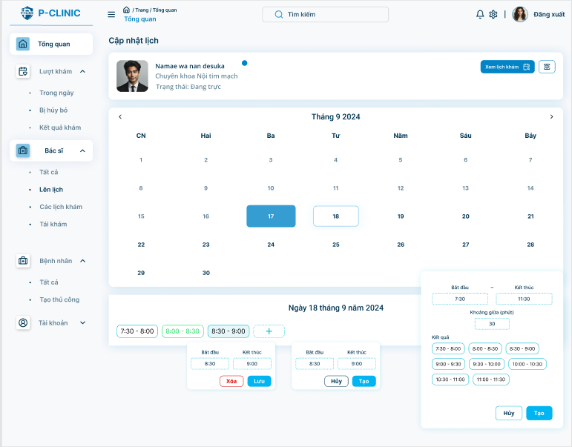

**Function Detail:**

|  |  |  |  |  |  |  |
| --- | --- | --- | --- | --- | --- | --- |
| **#** | **Component** | **Comp. Type** | **Editable** | **Mandatory** | **Default Value** | **Description** |
| 1 | Doctor’s profile card | | | | |  |
| Specialty | Text | No | Yes | N/A. | Display specialty of doctor |
| Name | Text | No | Yes | N/A. | Display name of doctor |
| Status | Text | No | Yes | N/A | Display status of doctor |
| Schedule | Button | No | Yes | N/A. | Schedule a doctor's appointment |
| 2 | Timetable | | | | |  |
| Appointment’s time | DateTime | No | N/A | N/A |  |
| 3 | Working hours | | | | |  |
| Create | Button | No | N/A | N/A |  |
| Cancel | Button | No | N/A | N/A |  |
| Delete | Button | No | N/A | N/A |  |
| Appointment’s time | DateTime | No | N/A | N/A |  |
| **Action** | | | | | | |
| **Name** | | **Success** | | **Failure** | | **Description** |
| Create | | Generate a working hour | | N/A | | Allow staff to generate a period of time for scheduling. |
| Cancel | | Cancel generating a working hour | | N/A | | Allow staff to cancel generating a period of time for scheduling. |
| Delete | | Delete a working hour | | N/A | | Allow staff to delete a working hour. |

##### 3.6.7.3 Schedule doctor

**Function Trigger:**

* This screen is accessed when the user clicks on "**Doctor**” **-> “Schedule”** option on the side bar menu, chooses a doctor and then clicks on “Schedule” option.

**Function Description:**

* **Actors:** Doctor/Staff
* **Purpose:** Staff can schedule doctor’s appointments .
* **Interface:** A doctor profile card and a timetable. Staff can.
* **Data Processing:**
  + Retrieves the doctor from the database.
  + Displays the data.
  + Provides options to search for doctors.

**Screen Layout:**



**Function Detail:**

|  |  |  |  |  |  |  |
| --- | --- | --- | --- | --- | --- | --- |
| **#** | **Component** | **Comp. Type** | **Editable** | **Mandatory** | **Default Value** | **Description** |
| 1 | List of doctor’s profile cards | | | | |  |
| Specialty | Text | No | Yes | N/A. | Display specialty of doctor |
| Name | Text | No | Yes | N/A. | Display name of doctor |
| Status | Text | No | Yes | N/A | Display status of doctor |
| Schedule | Button | No | Yes | N/A. | Schedule a doctor's appointment |
| 2 | Search for doctor | | | | |  |
| Search bar | Input | No | Yes | N/A. |  |
| **Action** | | | | | | |
| **Name** | | **Success** | | **Failure** | | **Description** |
| Schedule | | Navigate to “schedule doctor appointment” screen | | N/A | | Allow staff to schedule doctor appointments. |

#### 3.6.8 Scheduled Appointment

##### 3.6.8.1 View all doctors

**Function Trigger:**

* This screen is accessed when a doctor/staff clicks on "**Doctor**” **-> “Scheduled Appointment”** option on the side bar menu.

**Function Description:**

* **Actors:** Staff
* **Purpose:** Staff can schedule doctor’s appointments .
* **Interface:** A list of doctor’s cards. Staff can view all doctors who are on-duty or not.
* **Data Processing:**
  + Retrieves the doctor from the database.
  + Displays the data.
  + Provides options to search for doctors.

**Screen Layout:**

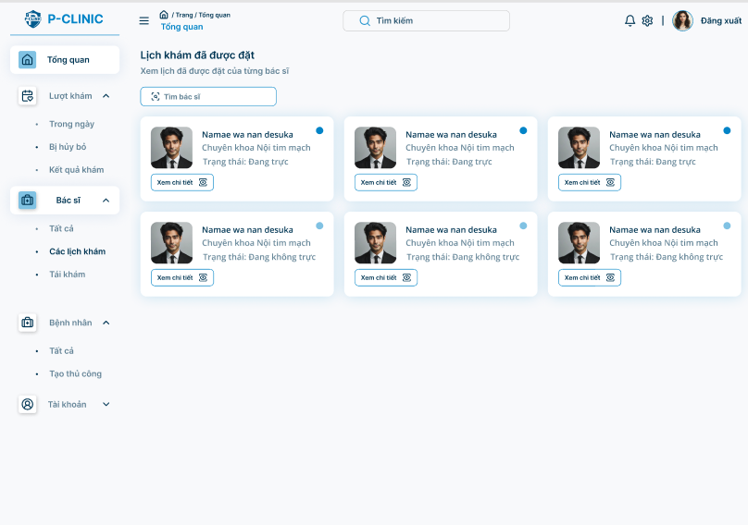

**Function Detail:**

|  |  |  |  |  |  |  |
| --- | --- | --- | --- | --- | --- | --- |
| **#** | **Component** | **Comp. Type** | **Editable** | **Mandatory** | **Default Value** | **Description** |
| 1 | List of doctor’s profile cards | | | | |  |
| Specialty | Text | No | Yes | N/A. | Display specialty of doctor |
| Name | Text | No | Yes | N/A. | Display name of doctor |
| Status | Text | No | Yes | N/A | Display status of doctor |
| View | Button | No | Yes | N/A. | View a doctor's appointment |
| 2 | Search for doctor | | | | |  |
| Search bar | Input | No | Yes | N/A. |  |
| **Action** | | | | | | |
| **Name** | | **Success** | | **Failure** | | **Description** |
| View | | Navigate to “scheduled appointment” screen | | N/A | | Allow staff to view scheduled appointments. |

##### 3.6.8.2 Scheduled doctor’s appointment view

**Function Trigger:**

* This screen is accessed when a doctor/staff clicks on "**Doctor**” **-> “Scheduled appointment”** option on the side bar menu and clicks on the “**view**” button.

**Function Description:**

* **Actors:** Staff
* **Purpose:** Users can view scheduled doctor’s appointments .
* **Interface:** A doctor profile card list of scheduled appointments.
* **Data Processing:**
  + Retrieves the doctors and appointments from the database.
  + Displays the data.
  + Provides options to filter by date.

**Screen Layout:**

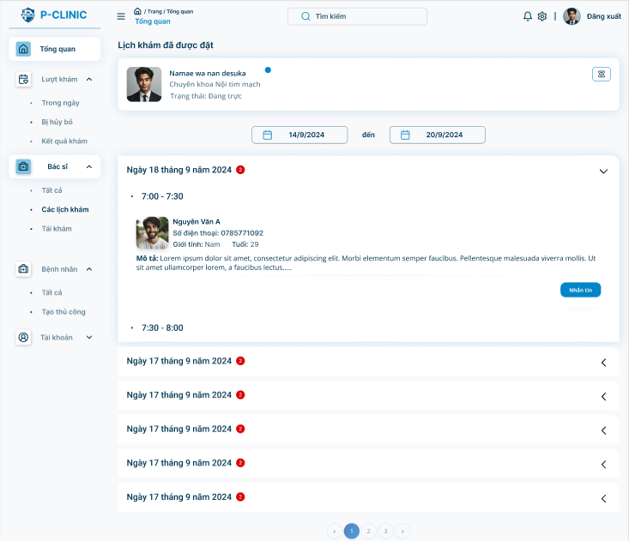

**Function Detail:**

|  |  |  |  |  |  |  |
| --- | --- | --- | --- | --- | --- | --- |
| **#** | **Component** | **Comp. Type** | **Editable** | **Mandatory** | **Default Value** | **Description** |
| 1 | Doctor’s profile card | | | | |  |
| Specialty | Text | No | Yes | N/A. | Display specialty of doctor |
| Name | Text | No | Yes | N/A. | Display name of doctor |
| Status | Text | No | Yes | N/A | Display status of doctor |
| Avatar | Image | No | Yes | N/A |  |
| 2 | List of scheduled appointments | | | | |  |
| Date | DateTime | No | Yes | N/A. |  |
|  | Working hour | DateTime | No | Yes | N/A. |  |
|  | Name | Text | No | Yes | N/A. |  |
|  | Avatar | Image | No | Yes | N/A. |  |
|  | Phone | Text | No | Yes | N/A. |  |
|  | Gender | Text | No | Yes | N/A. |  |
|  | Age | Number | No | Yes | N/A. |  |
|  | Description | Text | No | Yes | N/A. |  |
|  | Send message | Button | No | Yes | N/A. | Send message to patient |
| **Action** | | | | | | |
| **Name** | | **Success** | | **Failure** | | **Description** |
| Send message | | Navigate to “Message” screen | | N/A | | Allow staff to send messages to patients. |

#### 3.6.9 Re-Examination notification

##### 3.6.9.1 View all patients

(This function like View All Patients at doctor title)

##### 3.6.9.2 View all appointment

(This function like View All Appointment at doctor title)

##### 3.6.9.3 Create re-examination notification

(This function like Create Re-examination notification at doctor title)

#### 3.6.10 Patient Management

##### 3.6.10.1View all patients

**Function Trigger:**

* This screen is accessed when a doctor/staff clicks on "**Patient**” **-> “All patients”** option on the side bar menu.

**Function Description:**

* **Actors:** Staff
* **Purpose:** Staff view all patients that have been treated at this clinic.
* **Interface:** A list of patient’s profile cards.
* **Data Processing:**
  + Retrieves the patients from the database.
  + Displays the data.
  + Provides options to search for patients.

**Screen Layout:**

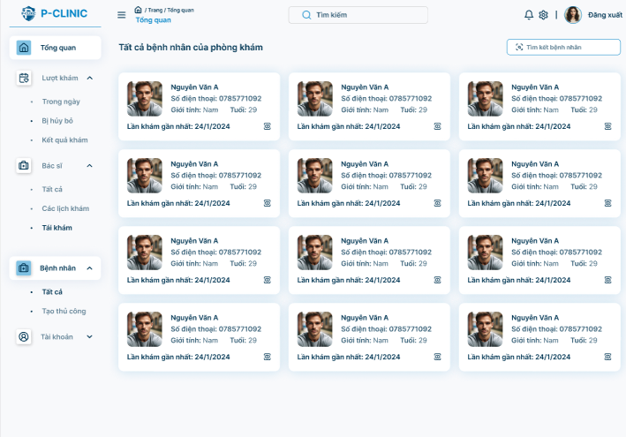

**Function Detail:**

| **#** | **Component** | **Comp. Type** | **Editable** | **Mandatory** | **Default Value** | **Description** |
| --- | --- | --- | --- | --- | --- | --- |
| 1 | List of patient’s profile cards | | | | |  |
| Gender | Text | No | Yes | N/A. | Display gender of patient |
| Name | Text | No | Yes | N/A. | Display name of patient |
| Phone number | Text | No | Yes | N/A | Display phone number of patient |
| Age | Number | No | Yes | N/A | Display age of patient |
| Recent appointment | DateTime | No | Yes | N/A | Display recent appointment of patient |
| Avatar | Image | No | Yes | N/A |  |
| View appointment | Button | No | Yes | N/A. | View patient’s medical reports |
| 2 | Search bar | | | | |  |
|  | Search | Button | No | Yes | N/A. | Search for patients |
| **Action** | | | | | | |
| **Name** | | **Success** | | **Failure** | | **Description** |
| Search | | Found patients show below | | “Patient not found” | | Allow staff to search for patients. |
| View appointment | | Show recent appointments | | N/A | | Allow staff to view patient’s recent appointments in detail |

##### 3.6.10.2 View patient’s appointment

**Function Trigger:**

* This screen is accessed when a doctor/staff clicks on "**Patient**” **-> “All patients”** option on the side bar menu and then clicks on the “**View appointment**” button.

**Function Description:**

* **Actors:** Staff
* **Purpose:** Staff view all patient’s recent appointments.
* **Interface:** A list of a patient's recent appointments.
* **Data Processing:**
  + Retrieves the patient’s appointments from the database.
  + Displays the data.
  + Provides options to search for patients.

**Screen Layout:**

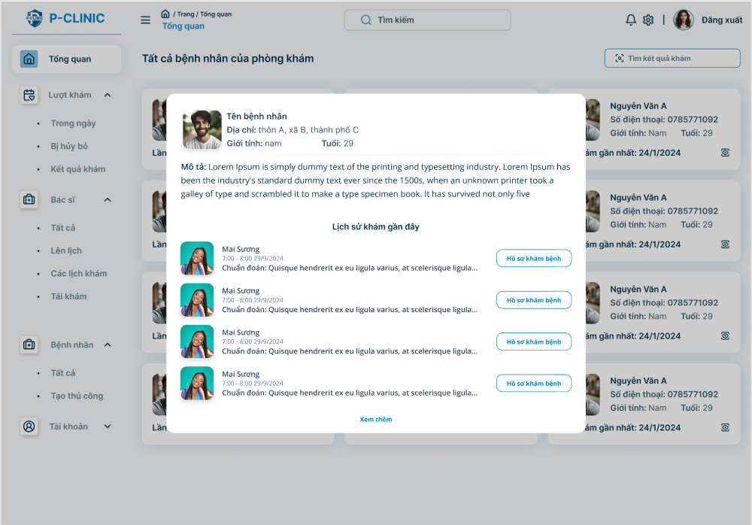

**Function Detail:**

| **#** | **Component** | **Comp. Type** | **Editable** | **Mandatory** | **Default Value** | **Description** |
| --- | --- | --- | --- | --- | --- | --- |
| 1 | Patient’s profile cards | | | | |  |
| Gender | Text | No | Yes | N/A. | Display gender of patient |
| Name | Text | No | Yes | N/A. | Display name of patient |
| Address | Text | No | Yes | N/A | Display address of patient |
| Age | Number | No | Yes | N/A | Display age of patient |
| Description | Text | No | Yes | N/A | Display description of patient |
| Avatar | Image | No | Yes | N/A |  |
| 2 | Recent appointment | | | | |  |
| Name | Text | No | Yes | N/A. | Display name of doctor |
| Avatar | Image | No | Yes | N/A |  |
| Diagnosis | Text | No | Yes | N/A | Display diagnosis of medical report |
| Date | DateTime | No | Yes | N/A | Display time of appointment |
| View treatment resultation | Button | No | Yes | N/A | View patient’s treatment resultation |
| **Action** | | | | | | |
| **Name** | | **Success** | | **Failure** | | **Description** |
| Search | | Found patients show below | | “Patient not found” | | Allow staff to search for patients. |
| View treatment resultation | | Navigate to “View medical report” screen | | N/A | | Allow staff to view patient’s treatment resultation |

##### 

##### 3.6.10.3 Create patient’s account manually

**Function Trigger:**

* This screen is accessed when a doctor/staff clicks on "**Patient**” **-> “*Create patient’s account manually*”** option on the side bar menu.

**Function Description:**

* **Actors:** Staff
* **Purpose:** Staff create patients manually to store their data.
* **Interface:** A form to create a patient’s account .
* **Data Processing:**
  + Retrieves data from the form.
  + Inserts the data into the database.

**Screen Layout:**

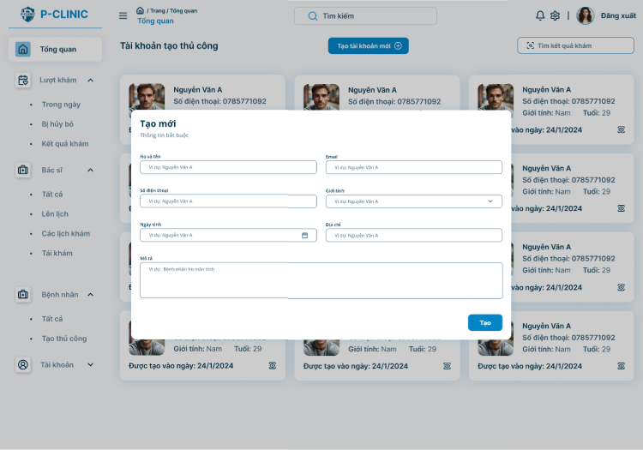

**Function Detail:**

| **#** | **Component** | **Comp. Type** | **Editable** | **Mandatory** | **Default Value** | **Description** |
| --- | --- | --- | --- | --- | --- | --- |
| 1 | Patient form | | | | |  |
| Gender | Input | No | Yes | N/A. |  |
| Name | Input | No | Yes | N/A. |  |
| Phone number | Input | No | Yes | N/A |  |
| Date of birth | Input | No | Yes | N/A |  |
| Email | Input | No | Yes | N/A |  |
| Address | Input | No | Yes | N/A |  |
| Description | Input | No | Yes | N/A |  |
| Confirm | Button | No | Yes | N/A. | Confirm to create a patient. |
| **Action** | | | | | | |
| **Name** | | **Success** | | **Failure** | | **Description** |
| Confirm | | Creating patient successfully | | N/A | | Allow staff to a patient manually |

#### 3.6.11 Chat with patients

##### 3.6.11.1 View waiting room

(This function like view waiting room function at doctor title)

##### 3.6.1.2 Message

(This function like message function at doctor title)

### 3.7 Admin

#### 3.7.1 Overview

**Function Trigger**:

* The ***Admin Overview Screen*** is triggered when a staff login the system or selects the "**Overview**" option from the side bar menu.

**Function Description**:

* **Actors/Roles**: Admin
* **Purpose**: The **Admin Overview Screen** allows Admin to overview clinic activities
* **Interface**: The screen is divided into sections such as profile card, appointment not-show list, on-duty doctor’s cards, recent appointment, private information and messages from patients…

**Data Processing**: The system retrieves the currentfclinic profile data and displays it in the respective fields.

**Screen Layout:**

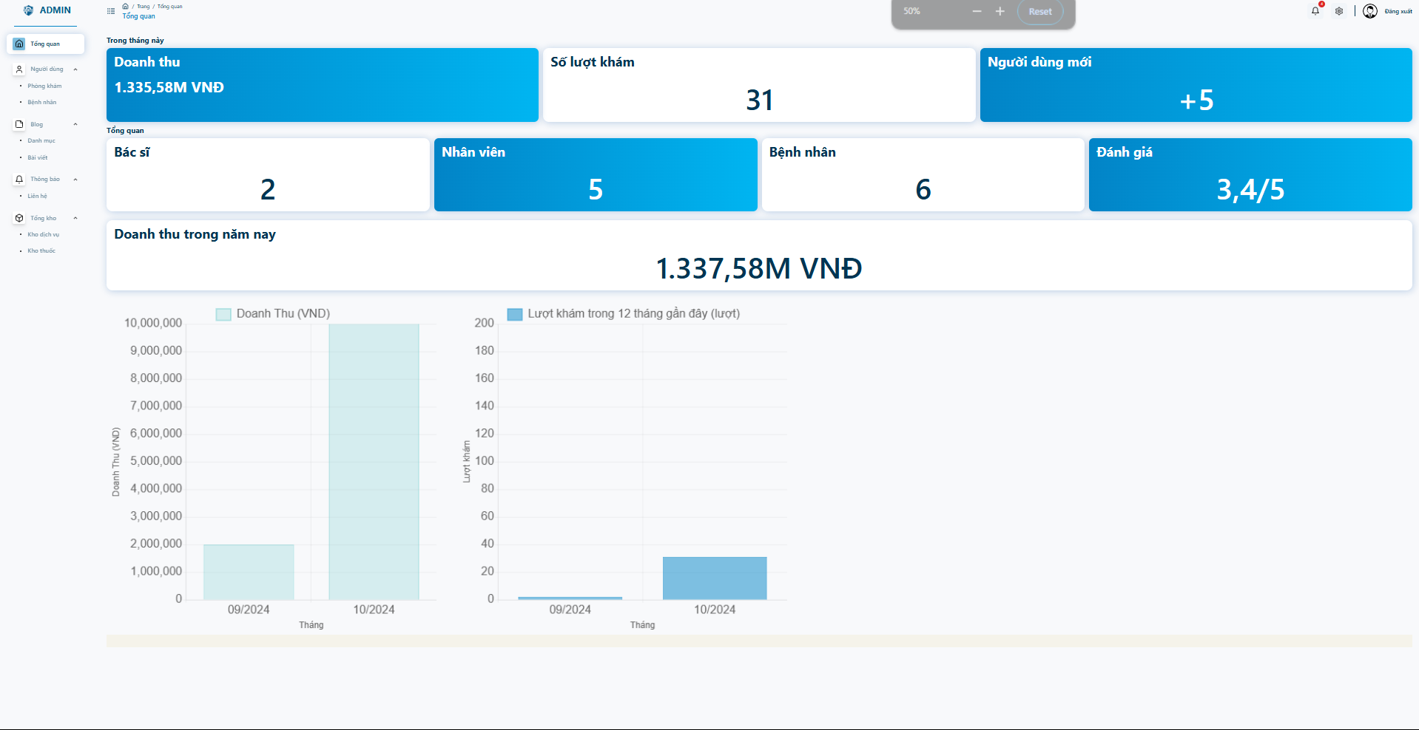

**Function Detail:**

|  |  |  |  |  |  |  |
| --- | --- | --- | --- | --- | --- | --- |
| **#** | **Component** | **Comp. Type** | **Editable** | **Mandatory** | **Default Value** | **Description** |
| 1 | Card | | | | | |
| Revenue | Text | No | No | N/A. | Display Revenue |
| Number of treatment turn | Text | No | No | N/A | Display Number of treatment turn |
| Doctor | Number | No | No | N/A | Display number of doctor |
| Staff | Number | No | No | N/A | Display number of staff. |
|  | Patient | Number | No | No | N/A | Display number of patients |
|  | Revenue in the year | Number | No | No | N/A | Display Revenue in the year |

#### 3.7.2 Manage doctor

##### 3.7.2.1 View Doctor List

**Function Trigger**:

* The ***Doctor List Screen*** is triggered when admin login the system or selects the "Doctors" option from the side bar menu.

**Function Description**:

* **Actors/Roles**: Admin
* **Purpose**: The ***Doctor List Screen***  allow admin to view all doctors in the system with some information about them
* **Interface**: The screen is a list of many doctors with some information such as patient info (name, avatar, phone number, etc.. ) and some action adding, temporarily delete. Most importantly is the button “Create doctor” that works for the add doctor to system
* **Data Processing**: The system will retrieve the list of doctors and then map all the information on the screen.

**Screen Layout:**

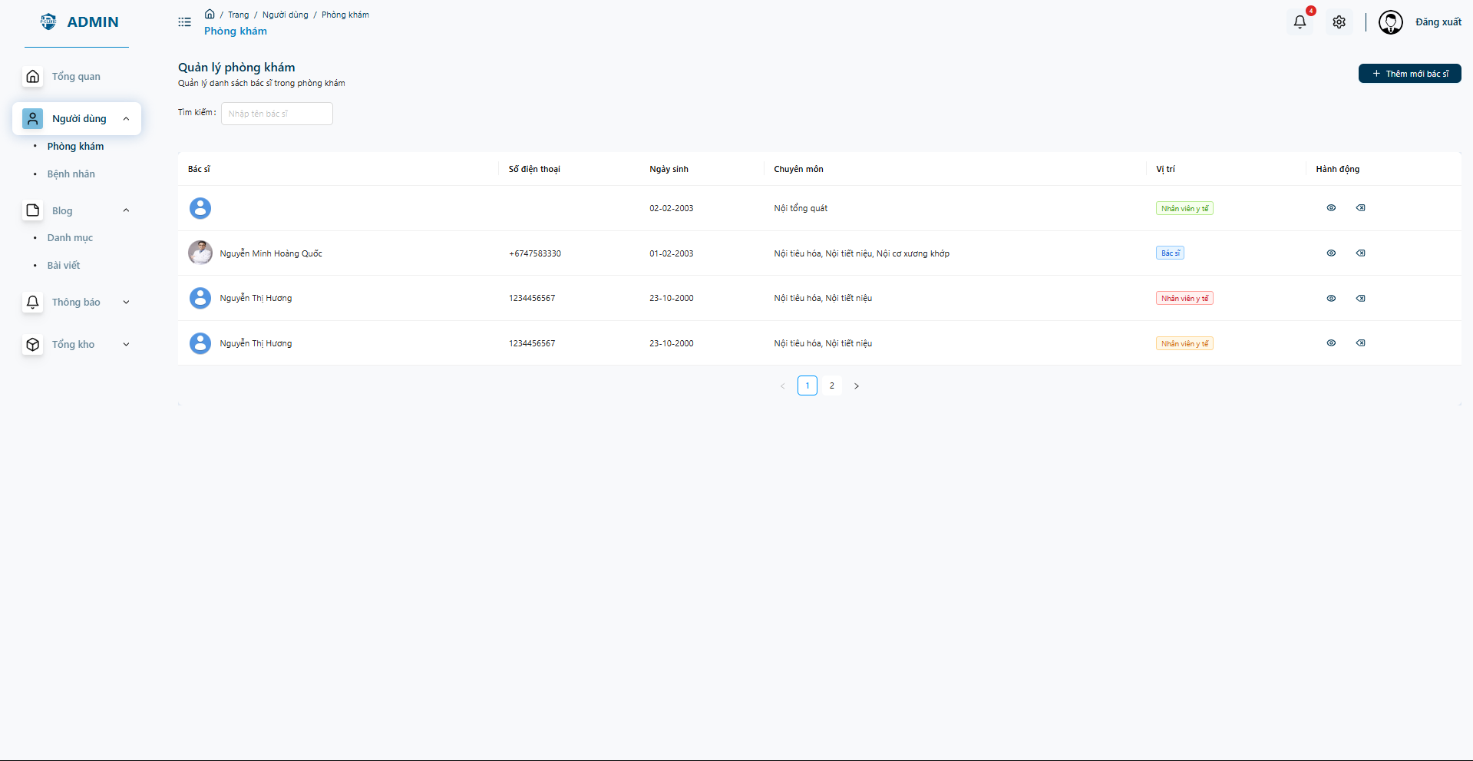

**Function Detail:**

|  |  |  |  |  |  |  |
| --- | --- | --- | --- | --- | --- | --- |
| **#** | **Component** | **Comp. Type** | **Editable** | **Mandatory** | **Default Value** | **Description** |
| 1 | Specialty | Text | Yes | No |  | Filter by specialty |
| Position | Text | Yes | No | N/A. | Filter by position |
| Search | Text | Yes | No | N/A | Search by keyword |
| DoctorName | Label | No | Yes |  | Display doctor name |
| PhoneNumber | Label | No | Yes |  | Display phone number |
|  | DOB | Label | No | Yes |  | Display date of birth |
| Action | Buttons | No | Yes | N/A. | Choose actions to add or remove doctor |
| Page | TextLink | No | Yes | N/A | Navigation to other pages |
| **Action** | | | | | | |
| **Name** | | **Success** | | **Failure** | | **Description** |
| Filter | | “” | | N/A | | Allow admin filter doctors list |
| Search | | “” | | N/A | | Allow admin search doctor |
| Navigation | |  | | N/A | | Navigation to other pages |

##### 3.7.2.2 Create new doctor’s account

**Function Trigger**:

* The ***Create Doctor Screen*** is triggered when admin login the system or selects the "**Create new doctors**" option from doctor list screen.

**Function Description**:

* **Actors/Roles**: Admin
* **Purpose**: The ***Create Doctor Screen***  allows the admin to add a new doctor or staff.
* **Interface**: The screen is a list of many fields to input the information about a new doctor.
* **Data Processing**: Admin click to create a new doctor and then the screen displays some field to input the information about the doctor, finally click the “Create” button to finish.

**Screen Layout:**

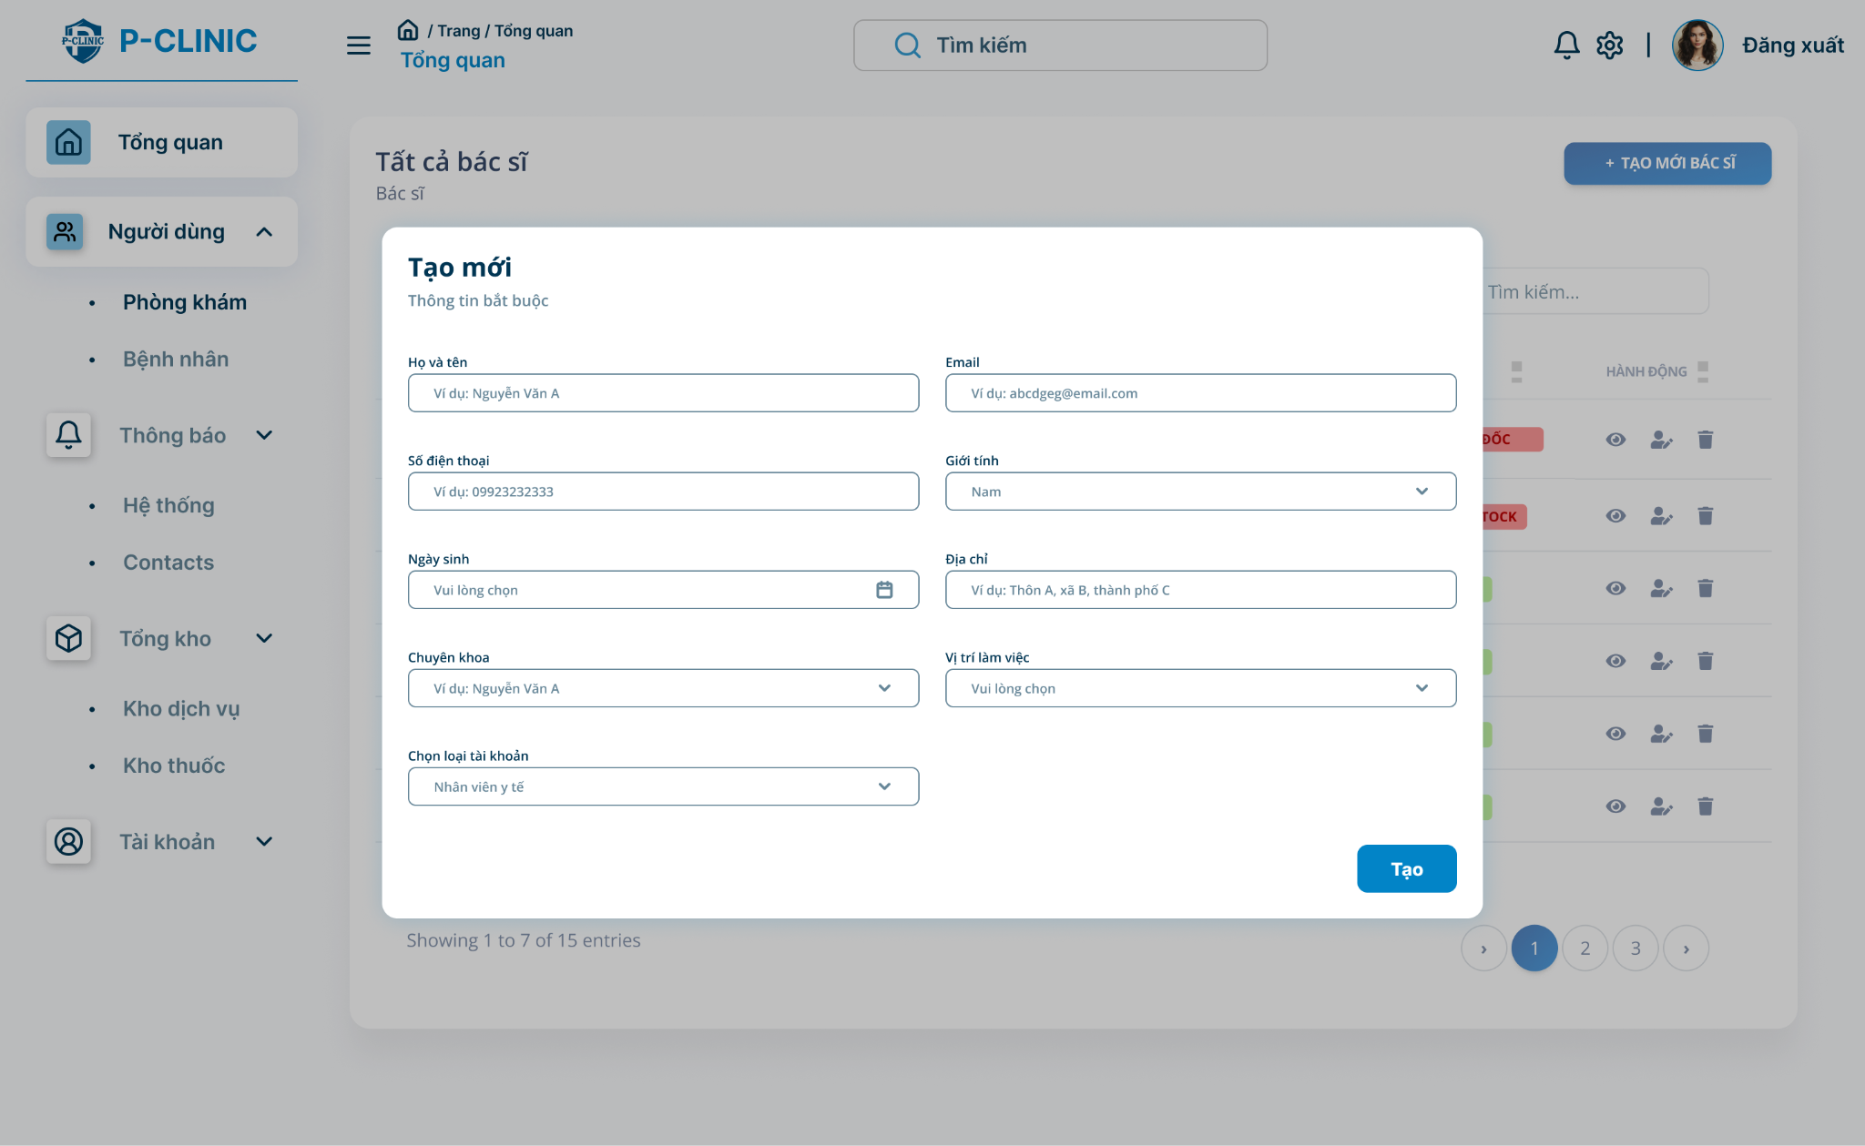

**Function Detail:**

|  |  |  |  |  |  |  |
| --- | --- | --- | --- | --- | --- | --- |
| **#** | **Component** | **Comp. Type** | **Editable** | **Mandatory** | **Default Value** | **Description** |
| 1 | FullName | Text | Yes | Yes |  | Input FullName |
| Email | Text | Yes | Yes | N/A. | Input |
| PhoneNumber | Text | Yes | Yes | N/A | Input |
| Gender | Text | Yes | Yes |  | Input |
| DOB | Text | Yes | Yes |  | Input |
|  | Address | Text | Yes | Yes |  | Input |
| Specialty | Text | Yes | Yes | N/A. | Input |
| Position | Text | Yes | Yes | N/A | Input |
|  | TypeDoctor | Text | Yes | Yes |  | Input |
|  | Create | Button |  |  |  | Click to create doctor |
| **Action** | | | | | | |
| **Name** | | **Success** | | **Failure** | | **Description** |
| Create | | “Create successfully” | | “Create fail” | | Create doctor successfully |

##### 

##### 3.7.2.3 Update staff or doctor’s account

**Function Trigger**:

* The ***Update Staff or Doctor***  is triggered when admin login the system or selects the "**Update**" option from doctor list.

**Function Description**:

* **Actors/Roles**: Admin
* **Purpose**: The ***Update Staff or Doctor***  allows the admin to update the doctor or staff.
* **Interface**: The screen is a list of many fields to update the information about a new doctor.
* **Data Processing**: Admin click to update doctor and then the screen displays some field to input the information about doctor, finally click “Update” button to finish.

**Screen Layout:**

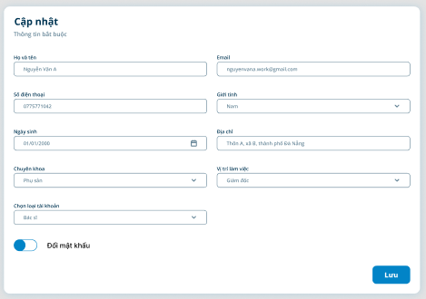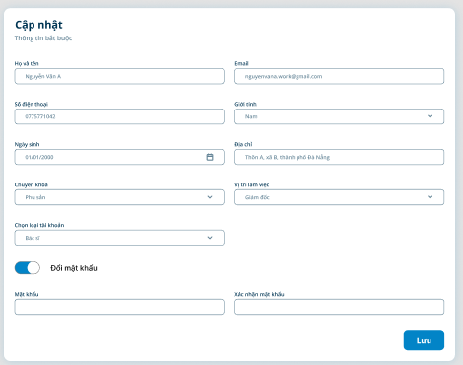

**Function Detail:**

|  |  |  |  |  |  |  |
| --- | --- | --- | --- | --- | --- | --- |
| **#** | **Component** | **Comp. Type** | **Editable** | **Mandatory** | **Default Value** | **Description** |
| 1 | FullName | Text | Yes | Yes |  | Input FullName |
| Email | Text | Yes | Yes | N/A. | Input |
| PhoneNumber | Text | Yes | Yes | N/A | Input |
| Gender | Text | Yes | Yes |  | Input |
| DOB | Text | Yes | Yes |  | Input |
|  | Address | Text | Yes | Yes |  | Input |
| Specialty | Text | Yes | Yes | N/A. | Input |
| Position | Text | Yes | Yes | N/A | Input |
|  | TypeDoctor | Text | Yes | Yes |  | Input |
|  | Create | Button |  |  |  | Click to create doctor |
| **Action** | | | | | | |
| **Name** | | **Success** | | **Failure** | | **Description** |
| Update | | “Update successfully” | | “Update failed” | | Update doctor or staff information |

#### 3.7.3 Manage patient

##### 3.7.3.1 View Patient List

**Function Trigger**:

* The **Patient List Screen**is triggered when admin login the system or selects the "**patients**" option from the side bar menu.

**Function Description**:

* **Actors/Roles**: Admin
* **Purpose**: The ***Doctor List Screen***  allow admin to view all patients in the system with some information about them
* **Interface**: The screen is a list of many patients with some information such as patient info (name, avatar, phone number, etc.. ) and some action adding, temporarily delete.
* **Data Processing**: The system will retrieve the list of patients and then map all the information on the screen.

**Screen Layout:**

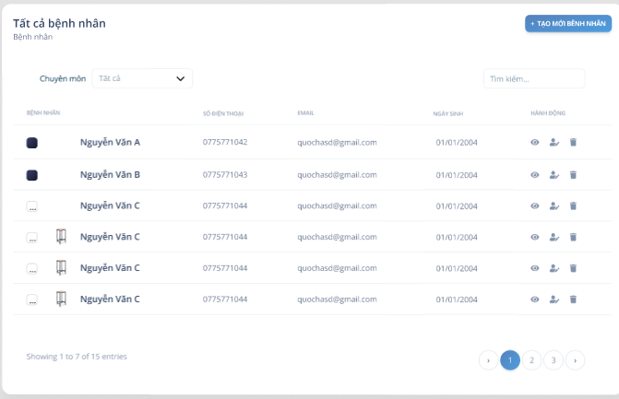

**Function Detail:**

|  |  |  |  |  |  |  |
| --- | --- | --- | --- | --- | --- | --- |
| **#** | **Component** | **Comp. Type** | **Editable** | **Mandatory** | **Default Value** | **Description** |
| 1 | Specialty | Text | Yes | No |  | Filter by specialty |
| Position | Text | Yes | No | N/A. | Filter by position |
| Search | Text | Yes | No | N/A | Search by keyword |
| PatientName | Label | No | Yes |  | Display patient name |
| PhoneNumber | Label | No | Yes |  | Display phone number |
|  | DOB | Label | No | Yes |  | Display date of birth |
| Action | Buttons | No | Yes | N/A. | Choose actions to add or remove patient |
| Page | TextLink | No | Yes | N/A | Navigation to other pages |
| **Action** | | | | | | |
| **Name** | | **Success** | | **Failure** | | **Description** |
| Filter | | “” | | N/A | | Allow admin filter patient list |
| Search | | “” | | N/A | | Allow admin search patient |
| Navigation | |  | | N/A | | Navigation to other pages |

#### 

#### 3.7.4 Manage medicine

##### 3.7.4.1 View List Medicine

**Function Trigger**:

* The ***Medicine List Screen*** is triggered when admin login the system or selects the "**medicine**" option from the side bar menu.

**Function Description**:

* **Actors/Roles**: Admin
* **Purpose**: The ***Medicine List Screen***  allow admin to view all medicine in the system with some information about them
* **Interface**: The screen is a list of many medicines with some information and some action added, temporarily deleted.
* **Data Processing**: The system will retrieve the list of medicine and then map all the information on the screen.

**Screen Layout:**

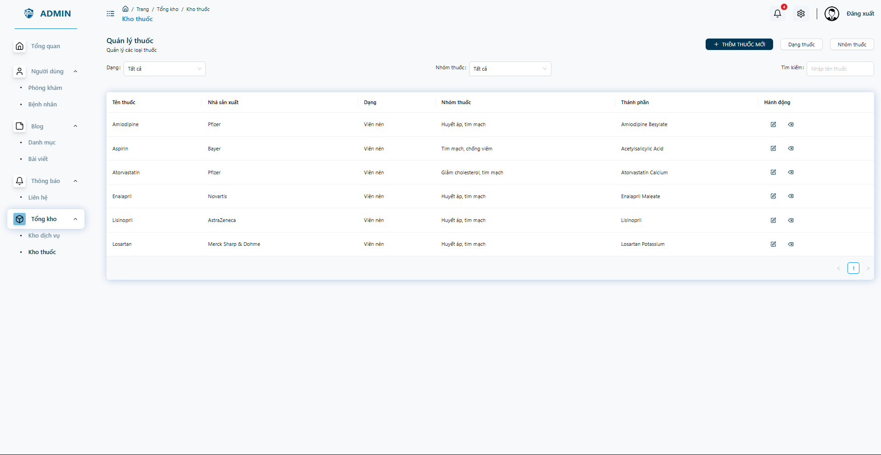

**Function Detail:**

|  |  |  |  |  |  |  |
| --- | --- | --- | --- | --- | --- | --- |
| **#** | **Component** | **Comp. Type** | **Editable** | **Mandatory** | **Default Value** | **Description** |
| 1 | Type | Text | Yes | No |  | Filter by Type |
| Publisher | Text | Yes | No | N/A. | Filter by publisher |
| Search | Text | Yes | No | N/A | Search by keyword |
| MedicineName | Label | No | Yes |  | Display medicine name |
|  | View | Icon | No | Yes | N/A. | Choose actions to add or remove medicine |
| Create | Icon | No | Yes | N/A. |  |
| Update | Icon | No | Yes | N/A. |  |
| Delete | Icon | No | Yes | N/A. |  |
| Pagination | TextLink | No | Yes | N/A | Navigation to other pages |
| **Action** | | | | | | |
| **Name** | | **Success** | | **Failure** | | **Description** |
| Filter | | “” | | N/A | | Allow admin filter medicine list by type and publisher |
| Search | | “” | | N/A | | Allow admin search medicine by name |
| View | | Popup view medicine screen | | N/A | | Allow to view medicine |
| Create | | Popup create medicine screen | | N/A | | Allow to create new medicine |
| Update | | Popup update medicine screen | | N/A | | Allow to update medicine |
| Delete | | Popup delete confirmation | | N/A | | Allow to delete medicine |

##### 3.7.4.2 Create medicine

**Function Trigger**:

* The ***Create Medicine Screen*** is triggered when admin login the system or selects the "**Create new medicine**" option from medicine list screen.

**Function Description**:

* **Actors/Roles**: Admin
* **Purpose**: The ***Create Medicine Screen***  allows admin to add medicine.
* **Interface**: The screen is a list of many fields to input the information about the medicine.
* **Data Processing**: Admin clicks to create a medicine and then the screen displays some field to input the information about medicine, finally clicking the “Create” button to finish.

**Screen Layout:**

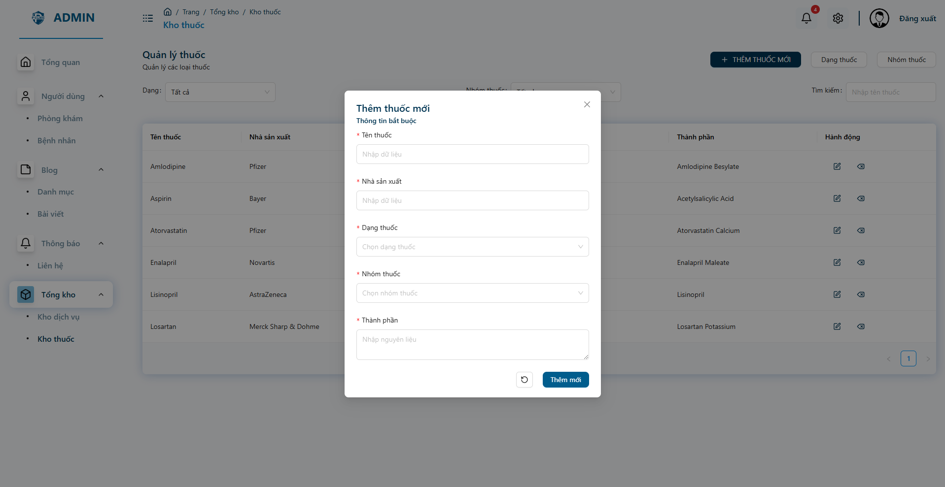

**Function Detail:**

|  |  |  |  |  |  |  |
| --- | --- | --- | --- | --- | --- | --- |
| **#** | **Component** | **Comp. Type** | **Editable** | **Mandatory** | **Default Value** | **Description** |
| 1 | MedicineFull | Text | Yes | Yes |  | Input FullName |
| Publisher | Text | Yes | Yes | N/A. | Input |
| Ingredients | Text | Yes | Yes | N/A | Input |
|  | Create | Button |  |  |  | Click to create doctor |
| **Action** | | | | | | |
| **Name** | | **Success** | | **Failure** | | **Description** |
| Create | | “Create successfully” | | “Create fail” | | Create medicine successfully |

##### 

##### 3.7.4.3 Update medicine

**Function Trigger**:

* The ***Update Medicine***  is triggered when admin login the system or selects the "**Update**" option from the medicine list.

**Function Description**:

* **Actors/Roles**: Admin
* **Purpose**: The ***Update Medicine***  allows the admin to update the medicines.
* **Interface**: The screen is a list of many fields to update the information about a new medicine.
* **Data Processing**: Admin click to update medicine and then the screen displays some field to input the information about medicine , finally click the “Update” button to finish.

**Screen Layout:**

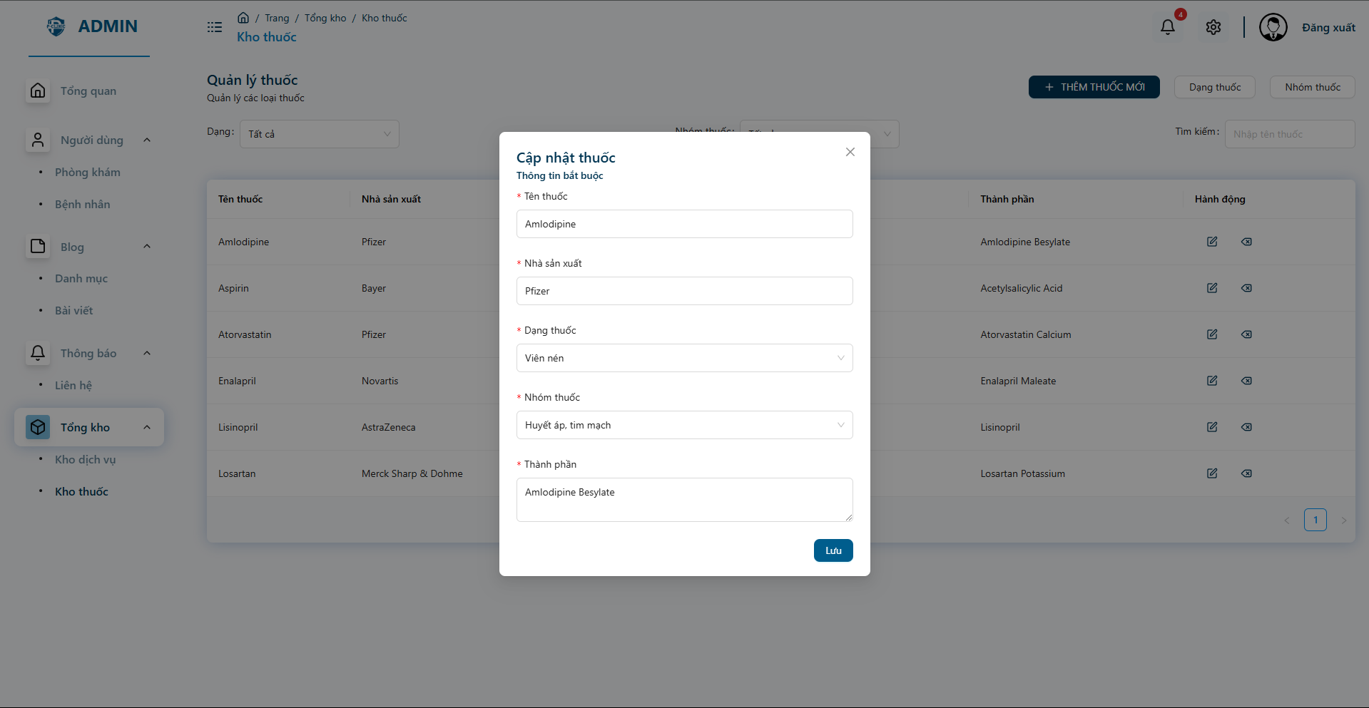

**Function Detail:**

|  |  |  |  |  |  |  |
| --- | --- | --- | --- | --- | --- | --- |
| **#** | **Component** | **Comp. Type** | **Editable** | **Mandatory** | **Default Value** | **Description** |
| 1 | MedicineFull | Text | Yes | Yes |  | Input FullName |
| Publisher | Text | Yes | Yes | N/A. | Input |
| Ingredients | Text | Yes | Yes | N/A | Input |
|  | Create | Button |  |  |  | Click to create doctor |
| **Action** | | | | | | |
| **Name** | | **Success** | | **Failure** | | **Description** |
| Update | | “Update successfully” | | “Update fail” | | Update medicine successfully |

##### 

##### 3.7.4.4 View detail

**Function Trigger**:

* The ***Medicine Detail Screen*** is triggered when admin login the system or selects the view icon from the medicine list screen.

**Function Description**:

* **Actors/Roles**: Admin
* **Purpose**: The ***Medicine Detail Screen***  allow admin to view detail medicine in the system with some information about them
* **Interface**: The screen is detailed medicines with some information and some action added, temporarily deleted.
* **Data Processing**: The system will retrieve the list of medicine and then map all the information on the screen.

**Screen Layout:**



**Function Detail:**

|  |  |  |  |  |  |  |
| --- | --- | --- | --- | --- | --- | --- |
| **#** | **Component** | **Comp. Type** | **Editable** | **Mandatory** | **Default Value** | **Description** |
| 1 | Type | Text | No | No |  | Display type |
| Publisher | Text | No | No | N/A. | Display publisher |
| Ingredients | Text | No | No | N/A | Display ingredient |
| MedicineName | Label | No | Yes |  | Display medicine name |

#### 3.7.5 Manage service

##### 3.7.5.1 View List Service

**Function Trigger**:

* The ***Service List Screen*** is triggered when admin login the system or selects the "**service**" option from the side bar menu.

**Function Description**:

* **Actors/Roles**: Admin
* **Purpose**: The ***Service List Screen***  allow admin to view all services in the system with some information about them
* **Interface**: The screen is a list of many services with some information and some action added, temporarily deleted.
* **Data Processing**: The system will retrieve the list of services and then map all the information on the screen.

**Screen Layout:**

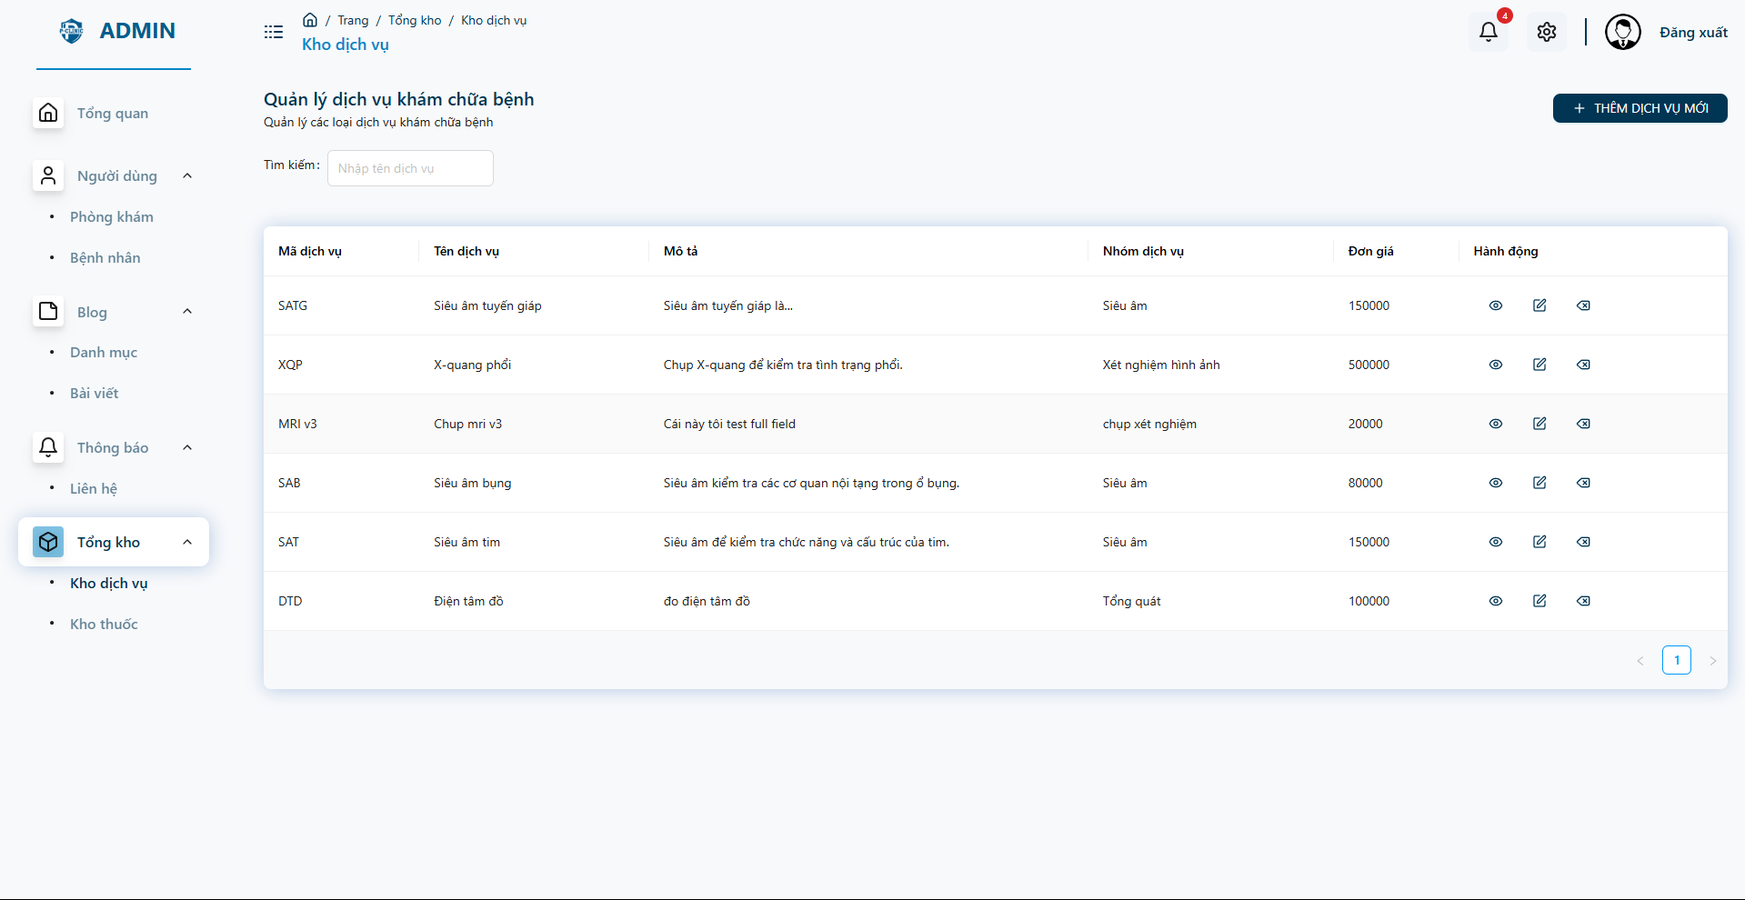

**Function Detail:**

|  |  |  |  |  |  |  |
| --- | --- | --- | --- | --- | --- | --- |
| **#** | **Component** | **Comp. Type** | **Editable** | **Mandatory** | **Default Value** | **Description** |
| 1 | Code | Text | Yes | No |  |  |
| Name | Text | Yes | No | N/A. |  |
| Description | Text | Yes | No | N/A |  |
| Price | Number | No | Yes |  |  |
|  | Action | Icons | No | Yes | N/A. | Choose actions to add or remove service |
| Page | TextLink | No | Yes | N/A | Navigation to other pages |
| **Action** | | | | | | |
| **Name** | | **Success** | | **Failure** | | **Description** |
| Search | | “” | | N/A | | Allow admin search service by name |
| View | | Popup view service screen | | N/A | | Allow to view service |
| Create | | Popup create service screen | | N/A | | Allow to create new service |
| Update | | Popup update service screen | | N/A | | Allow to update service |
| Delete | | Popup delete confirmation | | N/A | | Allow to delete service |

##### 3.7.5.2 Create service

**Function Trigger**:

* The ***Create Service Screen*** is triggered when admin login the system or selects the "**Create new service**" option from service list screen.

**Function Description**:

* **Actors/Roles**: Admin
* **Purpose**: The ***Create Medicine Screen***  allows admin to add medicine.
* **Interface**: The screen is a list of many fields to input the information about the medicine.
* **Data Processing**: Admin clicks to create a medicine and then the screen displays some field to input the information about medicine, finally clicking the “Create” button to finish.

**Screen Layout:**

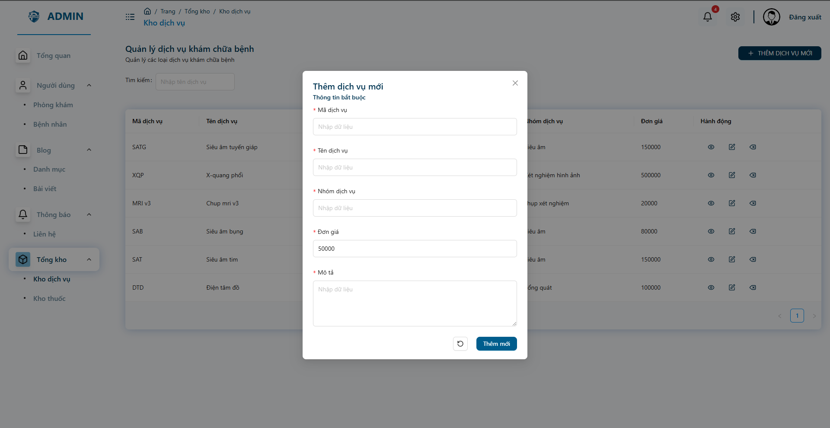

**Function Detail:**

|  |  |  |  |  |  |  |
| --- | --- | --- | --- | --- | --- | --- |
| **#** | **Component** | **Comp. Type** | **Editable** | **Mandatory** | **Default Value** | **Description** |
| 1 | Code | Text | Yes | Yes |  |  |
| Name | Text | Yes | Yes | N/A. |  |
| Price | Text | Yes | Yes | N/A |  |
| Description | Text | Yes | Yes |  |  |
| Create | Button | No | Yes |  |  |
| **Action** | | | | | | |
| **Name** | | **Success** | | **Failure** | | **Description** |
| Create | | “Create successfully” | | “Create failed” | | Create service successfully |

##### 

##### 3.7.5.3 Update service

**Function Trigger**:

* The ***Update Service***  is triggered when admin login the system or selects the "**Update**" option from the medicine list.

**Function Description**:

* **Actors/Roles**: Admin
* **Purpose**: The ***Update Service*** allows the admin to update the medicines.
* **Interface**: The screen is a list of many fields to update the information about a new medicine.
* **Data Processing**: Admin click to update medicine and then the screen displays some field to input the information about medicine , finally click the “Update” button to finish.

**Screen Layout:**

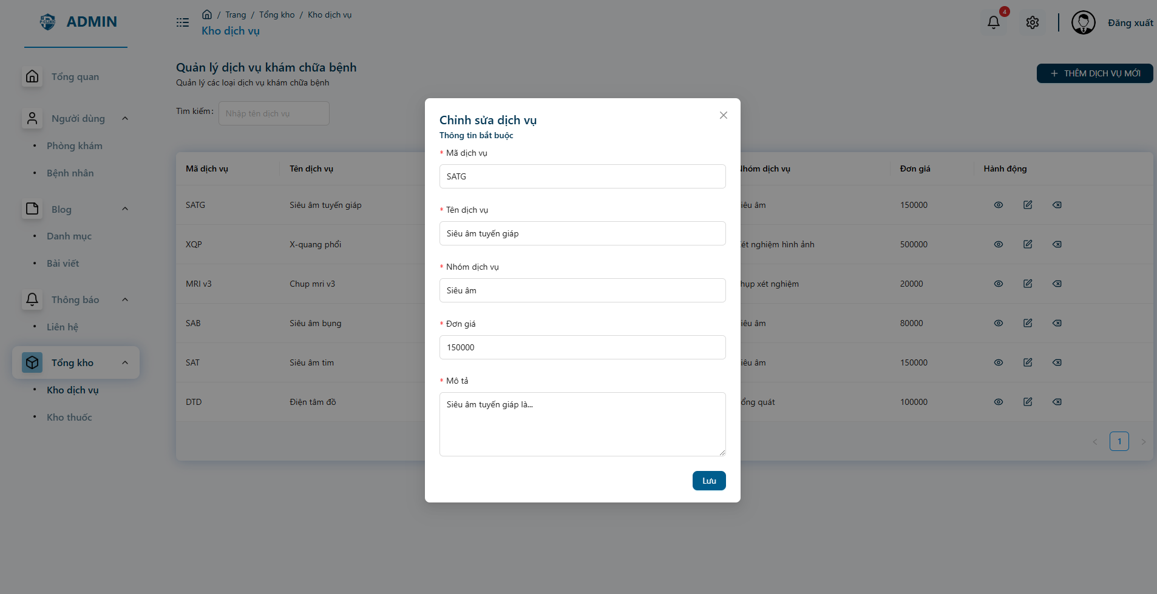

**Function Detail:**

|  |  |  |  |  |  |  |
| --- | --- | --- | --- | --- | --- | --- |
| **#** | **Component** | **Comp. Type** | **Editable** | **Mandatory** | **Default Value** | **Description** |
| 1 | Code | Text | Yes | Yes |  |  |
| Name | Text | Yes | Yes | N/A. |  |
| Price | Text | Yes | Yes | N/A |  |
| Description | Text | Yes | Yes |  |  |
| Update | Button | No | Yes |  |  |
| **Action** | | | | | | |
| **Name** | | **Success** | | **Failure** | | **Description** |
| Update | | “Update successfully” | | “Update failed” | | Update service successfully |

##### 

##### 3.7.5.4 View detail

**Function Trigger**:

* The ***Service Detail Screen*** is triggered when admin login the system or selects the view icon from the medicine list screen.

**Function Description**:

* **Actors/Roles**: Admin
* **Purpose**: The ***Service Detail Screen***  allow admin to view detail medicine in the system with some information about them
* **Interface**: The screen is detailed services with some information and some action added, temporarily deleted.
* **Data Processing**: The system will retrieve the list of medicine and then map all the information on the screen.

**Screen Layout:**

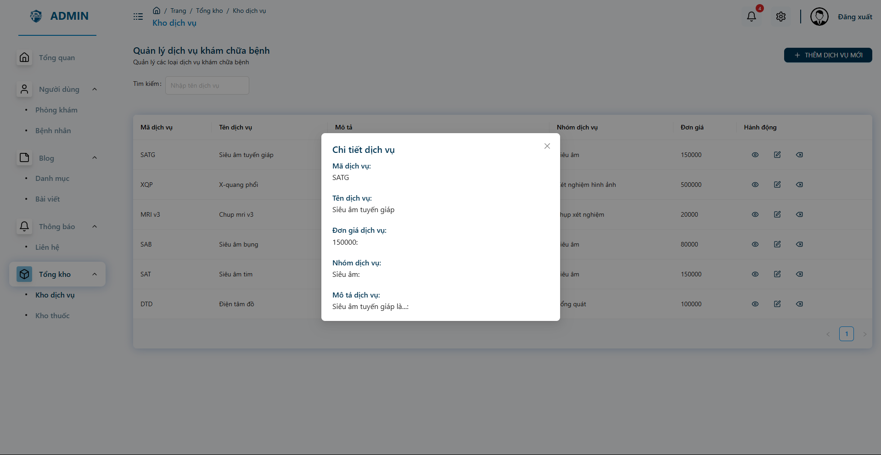

**Function Detail:**

|  |  |  |  |  |  |  |
| --- | --- | --- | --- | --- | --- | --- |
| **#** | **Component** | **Comp. Type** | **Editable** | **Mandatory** | **Default Value** | **Description** |
| 1 | Code | Text | Yes | Yes |  |  |
| Name | Text | Yes | Yes | N/A. |  |
| Price | Text | Yes | Yes | N/A |  |
| Description | Text | Yes | Yes |  |  |

##### 

#### 3.7.6 Manage Contact

**Function Trigger**:

* The ***Contacts List Screen*** is triggered when admin login the system or selects the "**Contacts**" option from the side bar menu.

**Function Description**:

* **Actors/Roles**: Admin
* **Purpose**: The ***Contact List Screen***  allow admin to view all contacts in the system with some information about them
* **Interface**: The screen is a list of many services with some information and some action added, temporarily deleted.
* **Data Processing**: The system will retrieve the list of contacts and then map all the information on the screen.

**Screen Layout:**

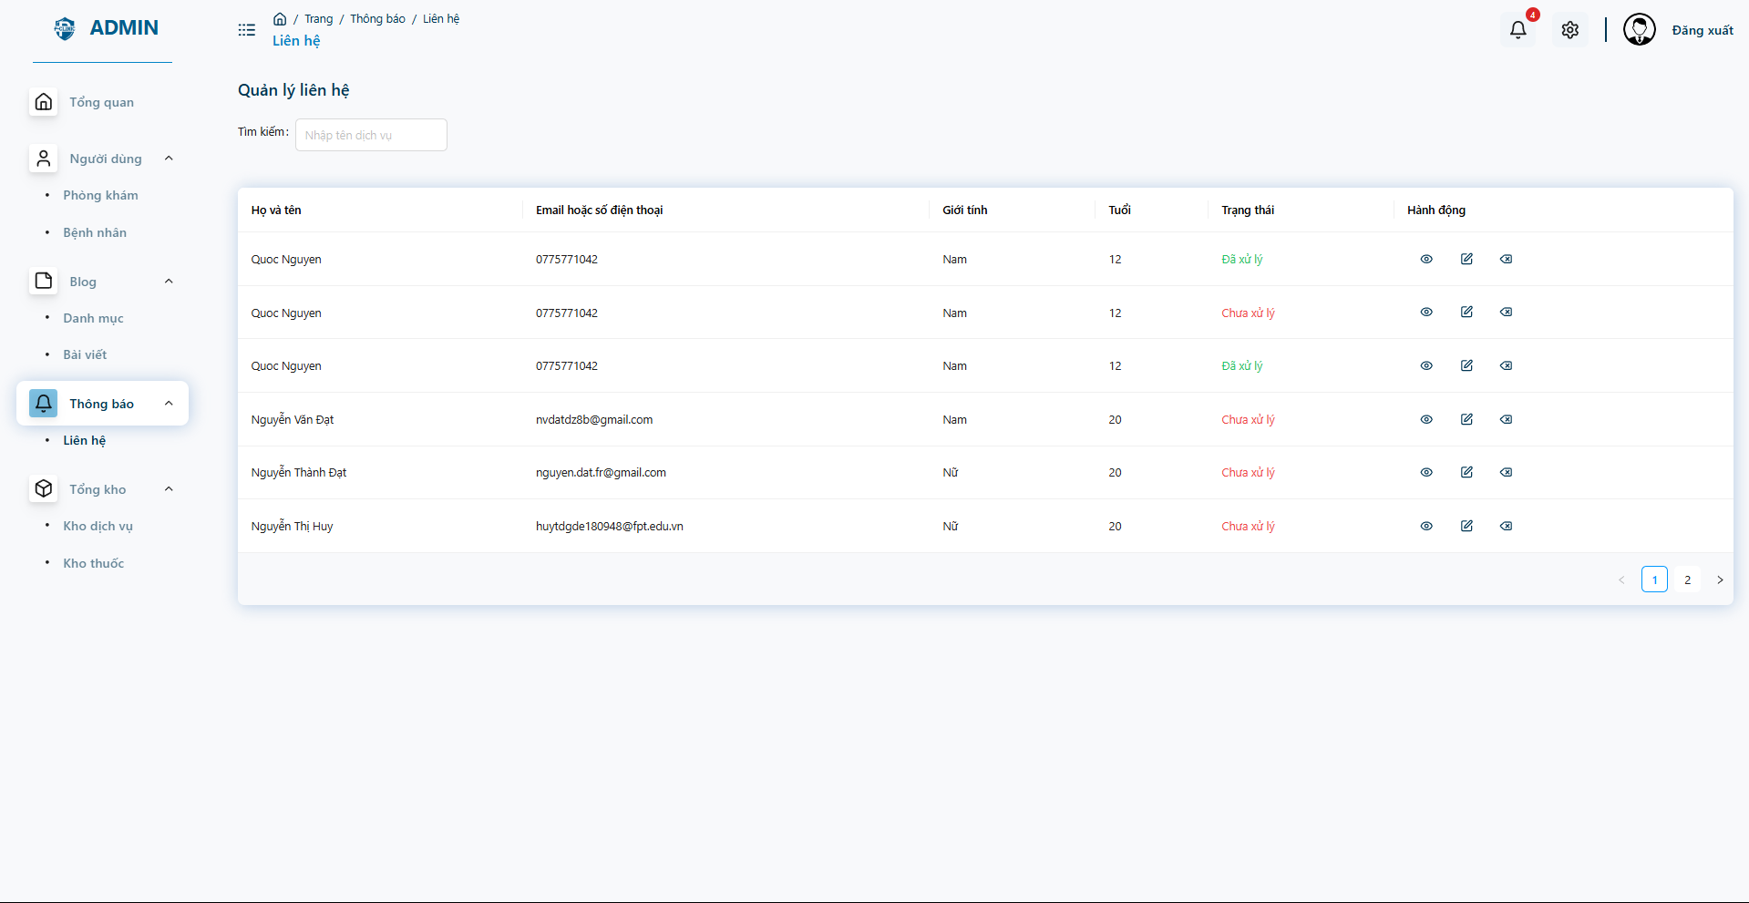

**Function Detail:**

|  |  |  |  |  |  |  |
| --- | --- | --- | --- | --- | --- | --- |
| **#** | **Component** | **Comp. Type** | **Editable** | **Mandatory** | **Default Value** | **Description** |
| 1 | Fullname | Text | Yes | No |  |  |
| Email or Phone number | Text | Yes | No | N/A. |  |
| Gender | Text | Yes | No | N/A |  |
| Age | Number | No | Yes |  |  |
|  | Status | Text | No | Yes | N/A. | Appear status of the contact |
| Action | Icon | No | Yes | N/A | Perform action (view edit delete) |
| **Action** | | | | | | |
| **Name** | | **Success** | | **Failure** | | **Description** |
| Search | | “” | | N/A | | Allow admin search search by name |

#### 3.7.7 Manage Blog Categories

##### 3.7.7.1 View Categories table

**Function Trigger**:

* The ***View categories*** is triggered when admin login the system or selects the "**Blogs - Categories**" option from the side bar menu.

**Function Description**:

* **Actors/Roles**: Admin
* **Purpose**: The ***Categories List Screen***  allow admin to view all contacts in the system with some information about them
* **Interface**: The screen is a list of many services with some information and some action added, temporarily deleted.
* **Data Processing**: The system will retrieve the list of categories and then map all the information on the screen.

**Screen Layout:**

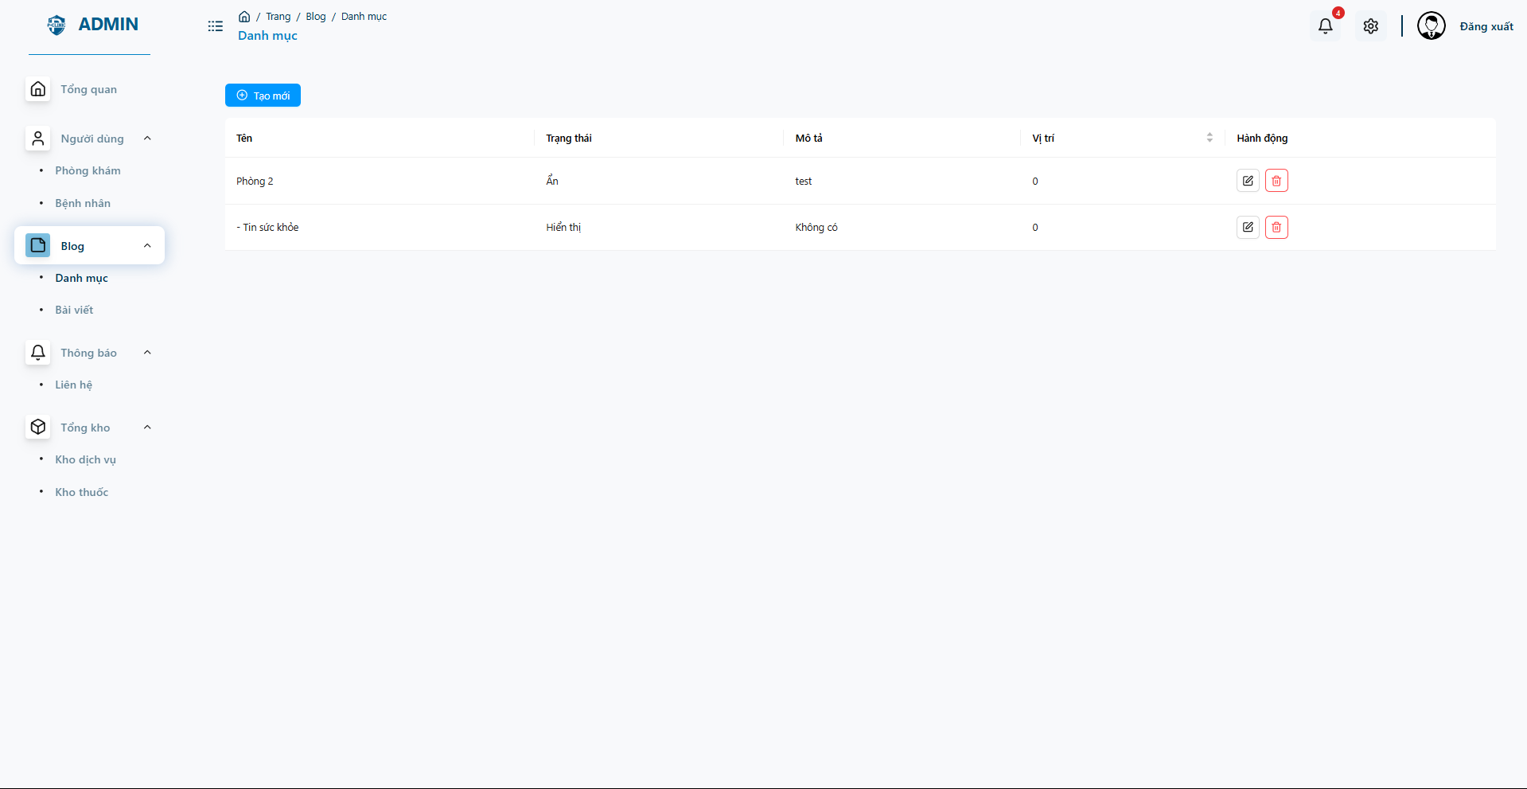

**Function Detail:**

|  |  |  |  |  |  |  |
| --- | --- | --- | --- | --- | --- | --- |
| **#** | **Component** | **Comp. Type** | **Editable** | **Mandatory** | **Default Value** | **Description** |
| 1 | Name | Text | Yes | No |  |  |
| Status | Text | Yes | No | N/A. |  |
| Description | Text | Yes | No | N/A |  |
| Position | Number | No | Yes |  |  |
|  | Action | Text | No | Yes | N/A. | Perform action |
|  | Add new | Button | No | No | N/A | Perform add new item |

##### 3.7.7.2 Add new categories

**Function Trigger**:

* The ***Add new categories*** is triggered when admin login the system or selects the "**Blogs - Categories- Click Add New**" option from the side bar menu.

**Function Description**:

* **Actors/Roles**: Admin
* **Purpose**: The ***Categories List Screen***  allow admin to view all contacts in the system with some information about them
* **Interface**: The screen is a list of many services with some information and some action added, temporarily deleted.
* **Data Processing**: The system will retrieve the list of categories and then map all the information on the screen.

**Screen Layout:**

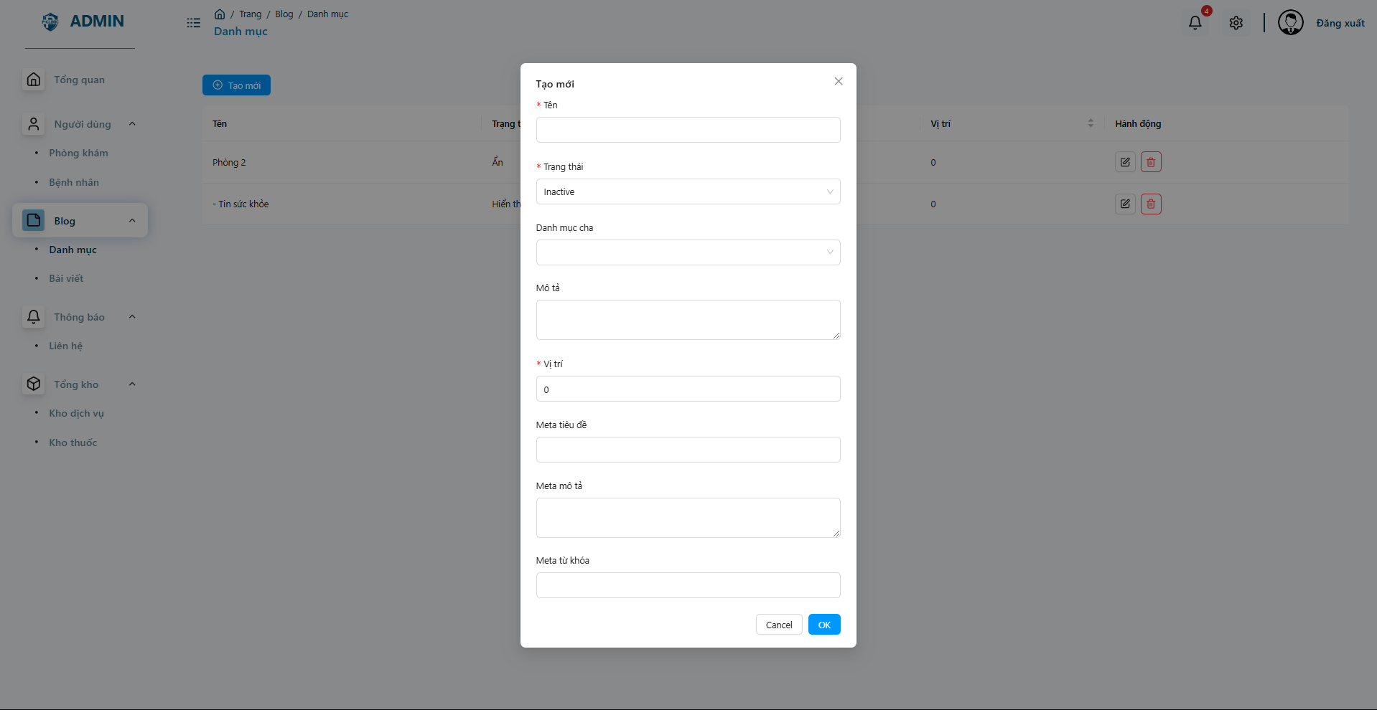

**Function Detail:**

|  |  |  |  |  |  |  |
| --- | --- | --- | --- | --- | --- | --- |
| **#** | **Component** | **Comp. Type** | **Editable** | **Mandatory** | **Default Value** | **Description** |
| 1 | Name | Text | Yes | No |  |  |
| Status | Text | Yes | No | N/A. |  |
| Description | Text | Yes | No | N/A |  |
| Parent Category | Text |  |  |  |  |
| Position | Number | No | Yes |  |  |
|  | Meta Title | Text | No | Yes | N/A. |  |
|  | Meta description | Text | No | Yes | N/A |  |
|  | Oke | Button | No | No | N/A | Submit forms |
|  | Cancel | Button | No | No | N/A | Cancel add new form |

#### 

#### 3.7.8 Medical Articles

##### 3.7.8.1 View Medical Articles table

**Function Trigger**:

* The ***View medical articles*** is triggered when admin login the system or selects the "**Blogs -Articles** " option from the side bar menu.

**Function Description**:

* **Actors/Roles**: Admin
* **Purpose**: The ***Articles List Screen***  allow admin to view all contacts in the system with some information about them
* **Interface**: The screen is a list of many articles with some information and some action added, temporarily deleted.
* **Data Processing**: The system will retrieve the list of articles and then map all the information on the screen.

**Screen Layout:**

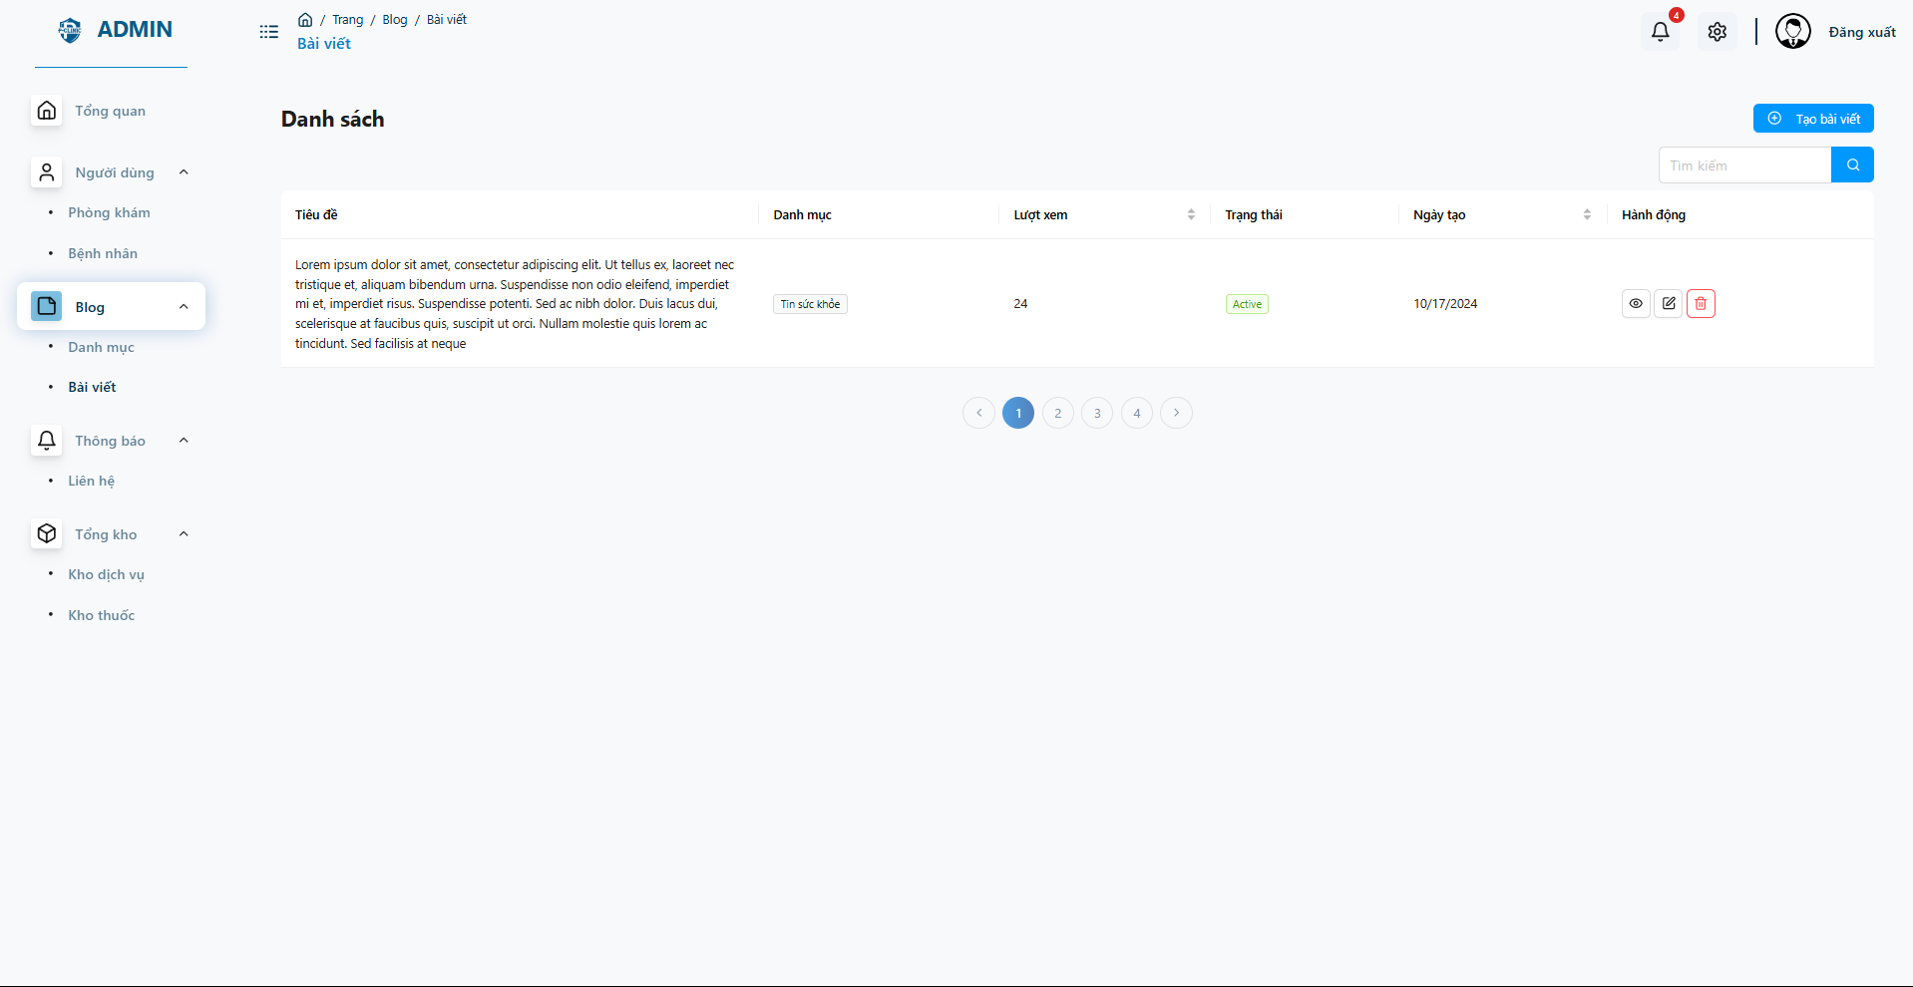

**Function Detail:**

|  |  |  |  |  |  |  |
| --- | --- | --- | --- | --- | --- | --- |
| **#** | **Component** | **Comp. Type** | **Editable** | **Mandatory** | **Default Value** | **Description** |
| 1 | Title | Text | Yes | No |  |  |
| Categories | Text | Yes | No | N/A. |  |
| Views | Text | Yes | No | N/A |  |
| Status | Text | No | Yes |  |  |
|  | Create day | Text | No | Yes | N/A. |  |
|  | Actions | Button | No | No | N/A | Perform actions (view, edit, delete) |

##### 

##### 3.7.8.2 Add New Medical Articles

**Function Trigger**:

* The ***View medical articles*** is triggered when admin login the system or selects the "**Blogs -Articles** " option from the side bar menu.

**Function Description**:

* **Actors/Roles**: Admin
* **Purpose**: The ***Articles List Screen***  allow admin to view all contacts in the system with some information about them
* **Interface**: The screen is a list of many articles with some information and some action added, temporarily deleted.
* **Data Processing**: The system will retrieve the list of articles and then map all the information on the screen.

**Screen Layout:**

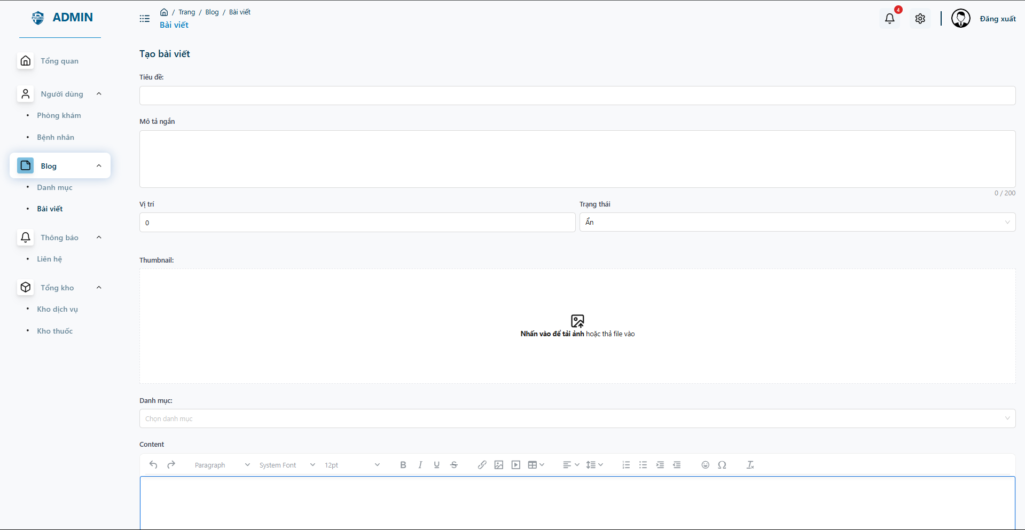

**Function Detail:**

|  |  |  |  |  |  |  |
| --- | --- | --- | --- | --- | --- | --- |
| **#** | **Component** | **Comp. Type** | **Editable** | **Mandatory** | **Default Value** | **Description** |
| 1 | Title | Text | Yes | No |  |  |
| Short Description | Text | Yes | No | N/A. |  |
| Position | Text | Yes | No | N/A |  |
| Status | Text | No | Yes |  |  |
|  | Thumbnails | Text | No | Yes | N/A. |  |
|  | Categories | Select | No | No | N/A |  |
|  | Meta title | Text | No | No | N/A |  |
|  | Meta description | Text | No | No | N/A |  |
|  | Meta tag | Text | No | No | N/A |  |
|  | Save | Button | No | No | N/A | Save new articles |

##### 

##### 3.7.8.2 View and Update Medical Articles

**Function Trigger**:

* The ***View medical articles*** is triggered when admin login the system or selects the "**Blogs -Articles** " option from the side bar menu.

**Function Description**:

* **Actors/Roles**: Admin
* **Purpose**: The ***Articles List Screen***  allow admin to view all contacts in the system with some information about them
* **Interface**: The screen is a list of many articles with some information and some action added, temporarily deleted.
* **Data Processing**: The system will retrieve the list of articles and then map all the information on the screen.

**Screen Layout:**

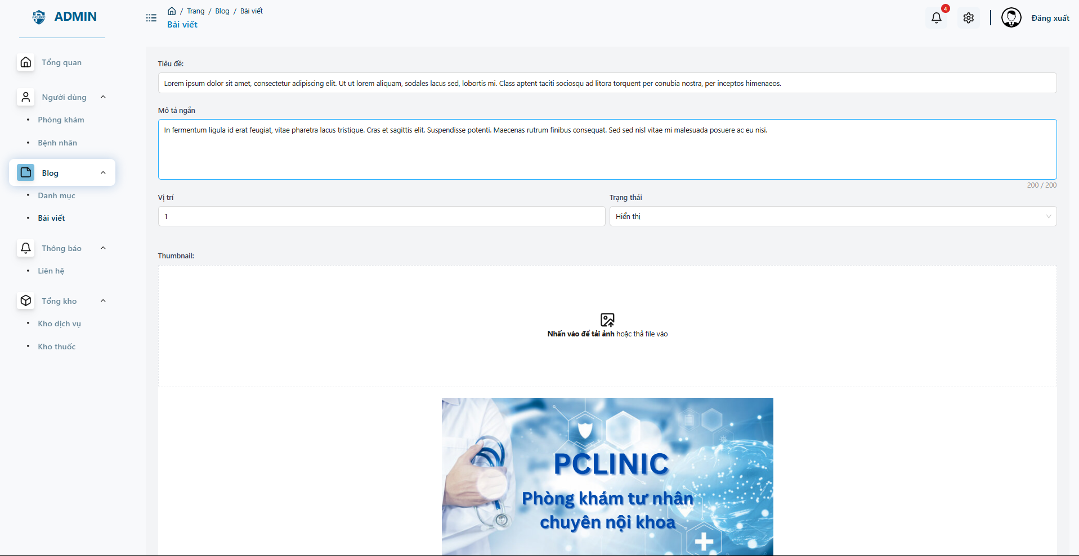

**Function Detail:**

|  |  |  |  |  |  |  |
| --- | --- | --- | --- | --- | --- | --- |
| **#** | **Component** | **Comp. Type** | **Editable** | **Mandatory** | **Default Value** | **Description** |
| 1 | Title | Text | Yes | No |  |  |
| Short Description | Text | Yes | No | N/A. |  |
| Position | Text | Yes | No | N/A |  |
| Status | Text | No | Yes |  |  |
|  | Thumbnails | Text | No | Yes | N/A. |  |
|  | Categories | Select | No | No | N/A |  |
|  | Meta title | Text | No | No | N/A |  |
|  | Meta description | Text | No | No | N/A |  |
|  | Meta tag | Text | No | No | N/A |  |
|  | Save | Button | No | No | N/A | Save update |

##### 

## 4. Non-Functional Requirements

### 4.1 External Interfaces

***User Interface (UI) Responsiveness***

* *The system must provide a responsive user interface that adapts to various devices (e.g., desktops, tablets, smartphones) with different screen resolutions and orientations.*

***API Integration***

* *The system must provide a RESTful API for external systems (pharmacies) to communicate and exchange data securely.*
* *All API endpoints should support secure communication using HTTPS and include token-based authentication for external services.*

***Data Exchange Formats***

* *External systems must exchange data in standard formats such as JSON or XML for structured data and CSV for bulk data transfers.*
* *The system should support versioning of APIs to ensure backward compatibility when updates are made to the system.*

***Error Handling and Recovery***

* *External interfaces must handle communication failures gracefully, including retry mechanisms and clear error reporting.*
* *In case of external system downtime, the system should provide notifications to users and ensure data is not lost, with recovery mechanisms in place once the external service is restored.*

### 4.2 Quality Attributes

#### 4.2.1 Usability

***Training Time***

* ***Normal Users (Patients/Guests)****:*
  + *Patients and guests should require no more than* ***15 minutes*** *of interaction with the system to become familiar with the basic operations, such as booking an appointment, viewing treatment history, and searching for services.*
  + *Tutorials or tooltips should be available to guide first-time users through key features (e.g., making an appointment, online consultation).*
* ***Power Users (Doctors/Staff)****:*
  + *Doctors and staff should require a maximum of* ***2 hours of training*** *to be productive in daily tasks, including updating patient records, managing appointment schedules, and checking in patients.*
  + *Role-specific training modules should be provided to allow efficient use of advanced features such as prescription management and patient queue handling.*

***Measurable Task Times***

* ***Appointment Booking****:*
  + *Patients should be able to book an appointment within* ***2 minutes****, including selecting a doctor, date, and time slot.*
* ***Viewing Treatment History****:*
  + *Patients should be able to review their treatment history within* ***30 seconds*** *by accessing the appropriate section of the system.*
* ***Updating Patient Records (Doctors)****:*
  + *Doctors should be able to update patient records (e.g., add notes, prescribe medications) in under* ***2 minutes*** *per patient entry.*
* ***Patient Check-In (Staff)****:*
  + *Staff should complete a patient check-in process in* ***less than 1 minute****, ensuring a smooth and efficient workflow for high-traffic periods.*
* ***Service Search (Guests/Patients)****:*
  + *Users searching for services should receive search results within* ***3 seconds*** *after entering keywords or selecting categories.*

***Familiarity with Other Systems***

* *The system’s user interface (UI) should follow* ***modern usability standards*** *based on widely recognized systems that users are familiar with, such as* ***Microsoft’s GUI standards*** *and* ***Apple’s iOS design principles****.*
* *The design should emphasize user-friendly navigation with familiar elements like* ***hamburger menus****,* ***search bars****, and* ***action buttons*** *similar to commonly used platforms (e.g., Google, Facebook).*
* *The clinic management interface for staff and doctors should follow intuitive layouts based on* ***Electronic Health Record (EHR)*** *systems that healthcare professionals commonly use.*

***Compliance with Usability Standards***

* *The system must adhere to industry-standard usability guidelines such as the* ***ISO 9241*** *standard for ergonomic requirements and* ***Microsoft’s GUI standards*** *for visual consistency and navigation.*
* *The system should also follow* ***Web Content Accessibility Guidelines (WCAG 2.1)*** *to ensure the interface is accessible to users with disabilities, including keyboard navigation, contrast ratios, and screen reader compatibility.*

***Error Prevention and Recovery***

* *The system should implement user-friendly error messages that guide users toward correcting mistakes (e.g., incomplete form fields, invalid inputs).*
* *Undo or cancel options should be available where applicable (e.g., canceling an appointment or correcting a patient record), reducing the risk of accidental errors.*
* ***Confirmation dialogs*** *should be used for critical actions like deleting patient data or confirming medical orders to prevent accidental submissions.*

***Consistency and Feedback***

* *Consistent placement of key interface elements (e.g., buttons, menus) across the system will ensure familiarity and ease of use.*
* *Immediate feedback (within 500 milliseconds) should be provided after user actions (e.g., form submissions, button clicks), clearly indicating success, failure, or loading status.*

#### 4.2.2 Reliability

***Availability***

* *The system must have an availability of* ***99.9%*** *during clinic operating hours (e.g., 7 AM to 9 PM), meaning it should be down for no more than* ***8.77 hours per year****.*
* *Maintenance windows should be scheduled* ***outside of regular clinic hours*** *(e.g., between 10 PM and 6 AM) to minimize disruption to users.*
* *In case of server or system issues, a* ***degraded mode*** *should be available, allowing essential functions such as appointment booking and patient check-in to continue operating.*

***Mean Time Between Failures (MTBF)***

* *The system should achieve a* ***minimum MTBF of 1,000 hours*** *under normal usage conditions, ensuring reliability for long periods without critical failures.*
* *The system should be stress-tested to ensure stability under peak loads (e.g., high traffic during clinic opening hours or appointment rushes).*

***Mean Time To Repair (MTTR)***

* *In case of a system failure, the system must be restored to full functionality within a* ***maximum of 1 hour****.*
* *Critical system failures (e.g., data loss, system crashes) should trigger automatic alerts to the IT team, enabling rapid intervention.*
* *Automatic failover mechanisms should be in place to reduce downtime during system failures, rerouting operations to backup systems.*

***Accuracy***

* *The system must ensure* ***100% accuracy*** *in critical operations such as handling patient records, appointment schedules, and prescription data.*
* *Financial transactions (e.g., payments for services) must comply with* ***industry-standard precision*** *and show no rounding errors, ensuring financial accuracy.*
* *Medical data (e.g., diagnosis, lab results) should adhere to established healthcare standards (e.g., HL7, FHIR) to ensure data accuracy and compatibility with external systems.*

***Maximum Bugs or Defect Rate***

* *The system must maintain a defect rate of* ***fewer than 5 bugs per thousand lines of code (bugs/KLOC)****.*
* ***Critical bugs*** *(e.g., complete loss of functionality, data corruption, inability to access core features) must not exceed* ***0.5 bugs/KLOC****.*
* ***Significant bugs*** *(e.g., features not functioning as expected but with workarounds available) should not exceed* ***2 bugs/KLOC****.*

***Bug or Defect Classification***

* ***Critical bugs*** *are defined as issues that result in complete system failure, data corruption, or a total inability to use essential functions such as booking appointments or accessing patient records.*
* ***Significant bugs*** *are those that impede major features, but do not completely block their use (e.g., slow system response, UI glitches).*
* ***Minor bugs*** *are low-priority issues, such as cosmetic errors or non-essential features not working as expected (e.g., display issues or incorrect formatting).*
* *All* ***critical bugs*** *must be resolved within* ***24 hours****, significant bugs within* ***5 business days****, and minor bugs within* ***14 business days****.*

***Error Handling***

* *The system should include comprehensive logging mechanisms to track and document system errors and failures, providing detailed reports for troubleshooting.*
* *Automatic alerts should be sent to the support team in case of critical failures, ensuring rapid resolution.*
* *The system should gracefully handle minor failures by notifying the user and allowing them to retry or continue their task without major disruption.*

#### 4.2.3 Performance

***Response Time***

* ***Average Response Time****: The system must provide an average response time of* ***less than 2 seconds*** *for standard user actions (e.g., appointment booking, viewing treatment history, searching for services).*
* ***Maximum Response Time****: Under heavy load conditions (e.g., peak clinic hours), the maximum response time for any user request should not exceed* ***5 seconds****.*
* ***Critical Transaction Response Time****: For high-priority transactions like submitting patient records, confirming appointments, or processing payments, the system should respond within* ***1 second****.*

***Throughput***

* *The system must support a minimum throughput of* ***100 transactions per second (TPS)*** *during peak operating hours, ensuring that users experience minimal delay even during high traffic times.*

***Capacity***

* ***Concurrent Users****: The system should be capable of supporting* ***up to 1000 concurrent users****, including patients, doctors, staff, and guests interacting with the system simultaneously.*
* ***Appointments****: The system should be able to manage and process* ***at least 10,000 appointments per day*** *without affecting performance.*
* ***Data Storage****: The system must accommodate at least* ***1 million patient records****, including medical history, treatment details, and billing information, with room for expansion as the clinic grows.*

***Resource Utilization***

* ***Memory Usage****: The system’s memory utilization should remain below* ***70%*** *under normal operation, and below* ***90%*** *during peak usage, ensuring no memory leaks or crashes.*
* ***Disk Utilization****: Disk space usage must be optimized for storing large volumes of patient data, images, and medical records, with a maximum disk utilization of* ***80%*** *before scaling measures are triggered.*
* ***CPU Utilization****: CPU usage should remain under* ***75%*** *during normal operation and under* ***85%*** *during high-demand periods, with the ability to scale resources as needed.*

***Scalability***

* *The system must scale horizontally and vertically to handle* ***increased traffic*** *or data demands without sacrificing performance, allowing the addition of more servers or cloud instances as needed.*
* *The system must be able to* ***dynamically allocate resources*** *(e.g., memory, CPU) based on usage patterns to maintain optimal performance during spikes in traffic (e.g., mornings or afternoons when most appointments occur).*

***Performance Under Load***

* *The system should maintain consistent performance with* ***up to 2000 simultaneous transactions per minute*** *during peak load periods, including heavy user interaction with appointment booking and records retrieval.*
* *Stress tests should ensure the system can sustain peak performance for a* ***minimum of 8 hours of continuous high demand*** *without crashes or severe slowdowns.*

***Latency for External Interfaces***

* *For* ***external system integrations*** *(e.g., medical devices, insurance providers), API response times should be under* ***1 second*** *for most transactions, with no response exceeding* ***3 seconds****.*
* *Data synchronization between the clinic system and external systems should occur with a latency of no more than* ***5 seconds****.*

#### 4.2.4 Security

***Authentication and Authorization***

* *The system must implement* ***multi-factor authentication (MFA)*** *for doctors and staff, ensuring secure access to sensitive patient data and management functions.*
* *Role-based access control (RBAC) must be enforced, where each user type (e.g., doctors, staff, patients, guests) has access only to the information and functionality necessary for their role. For example:*
  + ***Doctors****: Full access to patient records, appointments, and prescriptions.*
  + ***Staff****: Access to patient check-in, appointment scheduling, and queue management, but no access to medical records.*
  + ***Patients****: Access to their own medical records, appointment history, and treatment results.*
  + ***Guests****: Limited access to public information, such as services and doctor profiles.*
* *All login attempts and session activities should be logged for auditing purposes, and the system should block access after* ***5 failed login attempts****.*

***Data Encryption***

* *All data in transit must be encrypted using* ***SSL/TLS protocols*** *to protect against eavesdropping or interception, especially for sensitive communications such as online consultations and patient-doctor interactions.*
* ***AES-256 encryption*** *must be applied for data at rest, including patient records, appointment data, and financial information.*
* *Encryption keys should be managed securely, with automatic key rotation every* ***90 days*** *to further enhance data protection.*

***Data Privacy and Compliance***

* *The system must comply with healthcare data protection regulations, such as* ***HIPAA*** *(for the US) or* ***GDPR*** *(for Europe), ensuring that patient data is handled, stored, and transferred according to legal standards.*
* *Users must consent to the storage and use of their personal and medical data, and the system should provide clear terms and conditions outlining data use policies.*
* *Patients must be able to request the deletion or export of their personal data as per data privacy regulations, and these requests must be processed within* ***30 days****.*

***Auditing and Logging***

* *All access to sensitive data (e.g., patient records, financial transactions) must be logged and time-stamped, including the user’s identity, the data accessed, and the nature of the transaction.*
* ***Audit trails*** *should be tamper-proof and easily accessible to authorized administrators for compliance checks and forensic investigations.*
* *Logs of critical operations (e.g., data modifications, user logins, and system failures) must be retained for at least* ***1 year****.*

***Vulnerability Management***

* *Regular* ***vulnerability scans*** *must be conducted to identify security risks, and any discovered vulnerabilities should be addressed within* ***72 hours****.*
* ***Penetration testing*** *must be performed annually to identify potential security loopholes, and remediation efforts should be prioritized based on the criticality of the findings.*
* *A* ***patch management policy*** *must be in place to ensure all software dependencies (e.g., operating systems, third-party libraries) are kept up to date with the latest security patches, applied within* ***48 hours*** *of release.*

***Incident Response***

* *The system must have an established* ***incident response plan****, outlining the steps to be taken in case of a data breach or security incident.*
* *Real-time monitoring and alerts must be in place for detecting suspicious activity, unauthorized access, or potential breaches. Any security incident must trigger an alert to administrators within* ***5 minutes*** *of detection.*
* *After an incident, the system should support a* ***forensic investigation*** *by preserving logs, user activity, and system state as evidence.*

***Backup and Disaster Recovery***

* ***Daily backups*** *of all critical data, including patient records, appointment schedules, and financial transactions, must be performed and securely stored in an offsite location or cloud storage.*
* *In the event of a catastrophic failure or security breach, the system should be able to restore operations from a backup within* ***2 hours*** *without data loss.*
* *Regular disaster recovery drills should be conducted at least once every* ***6 months*** *to ensure readiness for emergency situations.*

***Session Management***

* *User sessions should automatically expire after* ***15 minutes of inactivity*** *for patients and guests, and after* ***30 minutes of inactivity*** *for doctors and staff.*
* *Secure session cookies must be used to prevent session hijacking, and all sensitive data should be cleared when a session ends.*

#### 4.2.5 Scalability

***Horizontal Scalability***

* *The system architecture must support horizontal scaling, allowing additional servers or instances to be added to accommodate increased user load without significant downtime or performance degradation.*
* *The application should be designed to distribute traffic evenly across multiple servers using a load balancer, ensuring efficient resource utilization and responsiveness during peak times.*

***Vertical Scalability***

* *The system should allow for vertical scaling by upgrading existing server resources (e.g., increasing CPU, memory, and storage) to handle increased demand without the need for major architectural changes.*
* *Resource upgrades should be implemented with minimal disruption to ongoing operations, ideally during scheduled maintenance windows.*

***Database Scalability***

* *The database must support sharding and partitioning to efficiently manage growing volumes of patient data, appointments, and transactions as the clinic expands.*
* *The system should be capable of handling a minimum of* ***1 million records*** *while maintaining performance, with plans for future growth (e.g., up to* ***10 million records****) without degradation in response times.*

***User Load Handling***

* *The system must maintain performance levels with an increasing number of concurrent users, supporting at least* ***2000 concurrent users*** *without noticeable latency or system failures during peak usage periods.*
* *Stress testing should be conducted regularly to assess the system’s ability to handle increased loads, simulating scenarios such as special promotions or health campaigns that may lead to a spike in appointments.*

***Service Integration***

* *The system should be designed to easily integrate new services and functionalities (e.g., telemedicine, patient portals) as the clinic’s needs evolve, allowing for the addition of features without major system overhauls.*
* *APIs must be built to allow seamless integration with third-party systems (e.g., insurance providers, laboratories) and should be designed to scale as new integrations are added.*

***Cloud Scalability***

* *If hosted in the cloud, the system should leverage cloud service features (e.g., auto-scaling, elastic load balancing) to automatically adjust resource allocation based on current demand.*
* *The architecture should support multi-cloud deployments, allowing flexibility in resource allocation and redundancy for disaster recovery.*

***Performance Monitoring***

* *The system must include performance monitoring tools that track resource utilization, user load, and system performance metrics, providing alerts when thresholds are approached that indicate the need for scaling.*
* *Regular reports should be generated to analyze trends in usage and performance, helping to inform proactive scaling decisions.*

***Cost-Effective Scaling***

* *The system should be designed for cost-effective scalability, ensuring that resources are only allocated as needed, minimizing unnecessary expenditure while maintaining performance.*
* *Regular assessments of resource utilization should be conducted to identify opportunities for optimization, including downsizing unused resources during off-peak periods.*

#### 4.2.6 Maintainability

***Modular Design***

* *The system should be designed using a modular architecture, enabling easy updates or modifications to specific components (e.g., appointment management, patient records) without impacting the entire system. This ensures the flexibility to add new features or fix issues with minimal disruption.*

***Code Readability and Documentation***

* *All code must follow standardized naming conventions and best practices, ensuring it is easy to read and maintain by different development teams. Comprehensive documentation should be provided for all key modules and functionalities to support future development and maintenance.*

***Error Handling and Logging***

* *The system should have robust error handling mechanisms to capture and log errors with sufficient detail, making it easy to identify and fix issues. Logs should be centralized and regularly monitored for maintenance purposes.*

***Automated Testing and Deployment***

* *Automated unit and integration tests must be included as part of the system, ensuring that changes or updates do not break existing functionality. The system should also support automated deployment pipelines, making updates and bug fixes faster and more reliable.*

***Ease of Configuration***

* *The system should allow for easy configuration changes (e.g., clinic hours, service prices, user permissions) through a user-friendly admin interface, reducing the need for technical intervention when updates are required.*

#### 4.2.7 Availability

***System Uptime***

* *The system must achieve an uptime of* ***99.9%****, ensuring that it is available for use during all operating hours (e.g., 7 AM to 9 PM). This equates to a maximum allowable downtime of approximately* ***8.77 hours per year****.*

***Scheduled Maintenance***

* *Scheduled maintenance activities should occur during off-peak hours (e.g., between 10 PM and 6 AM) to minimize disruption to users, with advance notifications provided to all stakeholders.*

***Failover Mechanisms***

* *The system should implement automatic failover mechanisms to switch to backup servers in case of hardware or software failures, allowing critical services to remain operational without noticeable interruption.*

***Degraded Mode Operations***

* *In the event of partial system failures, a degraded mode should allow essential functionalities (e.g., appointment booking, patient check-in) to continue operating, ensuring that critical services remain accessible.*

***Monitoring and Alerts***

* *Continuous monitoring tools must be in place to track system performance and availability, with real-time alerts generated for the technical team to address any issues immediately.*

#### 4.2.8 Portability

***Platform Independence***

* *The system must be developed to operate across multiple platforms (e.g., Windows, macOS, Linux) and devices (e.g., desktops, tablets, smartphones), ensuring accessibility for all users regardless of their preferred technology.*

***Containerization***

* *The application should utilize containerization (e.g., Docker) to facilitate deployment across different environments, allowing for consistent performance and easy migration between on-premises and cloud infrastructures.*

***Adaptable Architecture***

* *The system architecture must support configuration adjustments to accommodate different operating environments or hardware setups, enabling seamless transitions as the clinic’s needs evolve.*

***Documentation for Migration***

* *Comprehensive documentation should be provided to assist with the installation and configuration of the system in new environments, detailing any dependencies or specific requirements for deployment.*

***Compliance with Standards***

* *The system should adhere to industry standards and protocols (e.g., RESTful APIs, web standards) to ensure compatibility with various third-party services and facilitate integration with external systems.*

## 5. Requirement Appendix

### 5.1 Business Rules

|  |  |
| --- | --- |
| **ID** | **Rule Definition** |
| BR-01 | Users can update personal information, including full name, location, and personal status (bio/description). |
| BR-02 | All required fields must be filled out before saving changes. |
| BR-03 | The user's profile information must be updated in the database after clicking “Save Changes.” |
| BR-04 | If there is a database connection error, the system will display an error message and not update the information. |
| BR-05 | Users will receive a confirmation message on the profile page after a successful update. |
| BR-06 | Users can schedule an appointment with a doctor based on available working days and time slots. |
| BR-07 | Users must select a valid date and time for the appointment |
| BR-08 | Users must provide their personal information |
| BR-09 | Users will receive a confirmation notification (via email or system notification) |
| BR-10 | Users must have the appropriate permissions to do the actions |
| BR-11 | The system will validate that the input is not empty |
| BR-12 | User will receive a confirm notification |
| BR-13 | The system will validate that all required fields |

### 5.3 Application Messages List

|  |  |  |  |  |
| --- | --- | --- | --- | --- |
| **#** | **Message code** | **Message Type** | **Context** | **Content** |
| 1 | MSG01 | In red, under the text box | Input-required fields are empty | *This field is required.* |
| 2 | MSG02 | Toast message | Updating asset(s) information successfully | *Update successfully.* |
| 3 | MSG03 | Toast message | Adding new asset successfully | *Add successfully.* |
| 4 | MSG04 | Toast message | Confirming email of asset hand-over is sent successfully | *A confirmation email has been sent.* |
| 5 | MSG05 | Toast message | Deleting asset information successfully | *Delete successfully.* |
| 6 | MSG06 | In red, under the input text box | Password is not valid | *Password is not val*  *id* |
| 7 | MSG07 | Toast | Username or password is not correct when clicking sign-in | *Incorrect username or password. Please check again.* |
| 8 | MSG08 | Toast | An error has been occurs | An error has been occurs |
| 9 | MSG09 | Toast | Verify jwt token is valid or do not error, expired. | Verified user access successfully |
| 10 | MSG10 | Toast | Verify jwt token is valid or do not error, expired. | Verified user access has been failed, please login again |
| 11 | MSG11 | Toast | Sending notification to other | Sent notification successfully |
| 12 | MSG12 | App notification | Sending app notification to doctor | Patient {name} recently make an appointment at {datetime} |
| 13 | MSG13 | App Notification | Sending app notifications to doctor | Patient {name} recently made a request for consulting. |
| 14 | MSG14 | App Notification | Sending app notification to patient | Doctor/Staff {name} has joined the consulting request. |
| 15 | MSG15 | App notification | Sending app notification to patient | {Patient name} you has an retreatment notify on the date of {Date time} |
| … | … | … | … | … |